**Assignment no.12**

1. **Perform Helloworld program in Scala**

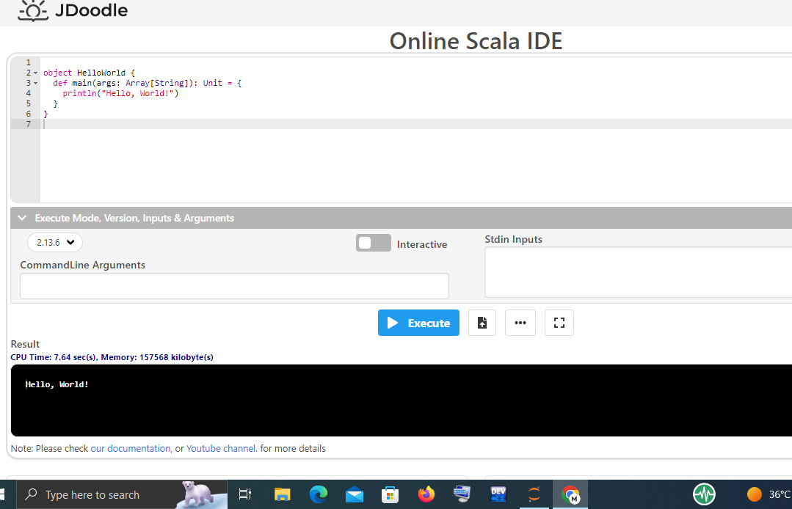

**2.Perform Addition of two numbers program in Scala**

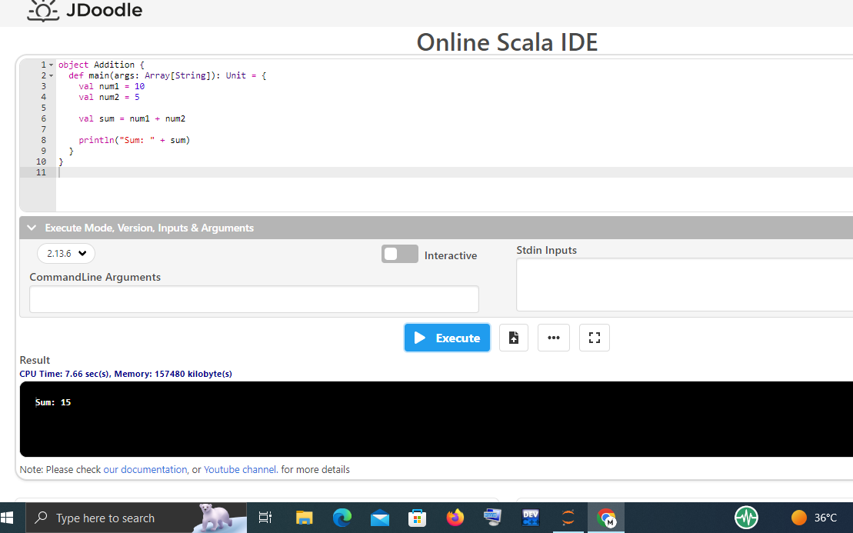

**3.Perform Multiplication table program in Scala**

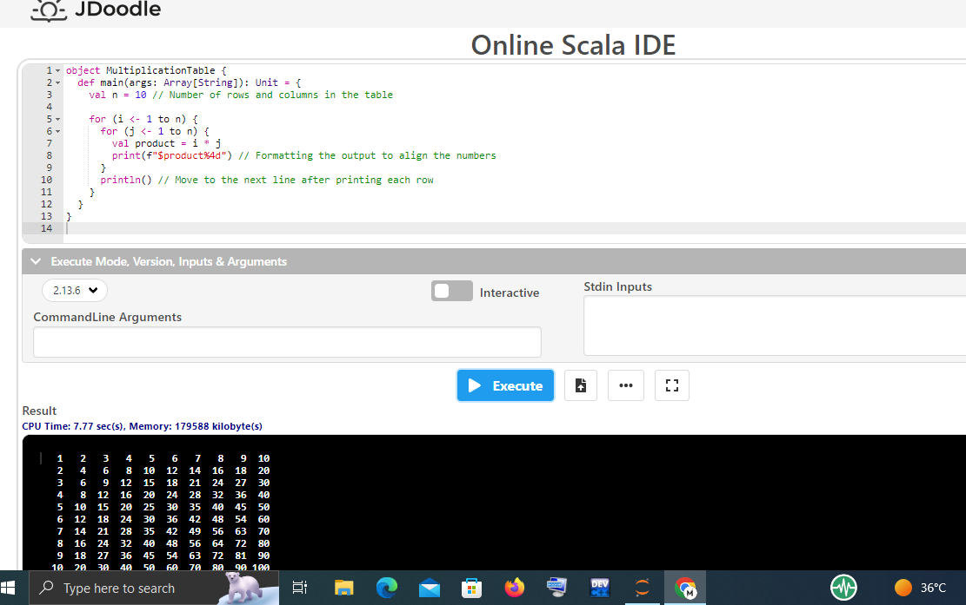

**4.Perform Odd & Even program in Scala**

