

Anekant Education Society’s

***Tuljaram Chaturchand College of Arts, Science And Commerce, Baramati (Autonomous)***

###### **A**

###### **“Online Supermarket System(Mandai)”**

Submitted in partial fulfillment of the requirement

For Degree of M.Sc.( Computer Science)-II

#### SUBMITTED BY

**Mr.Ghongade Pratik Balasaheb**

**Mr.Sonawane Somanath Navanath.**

UNDER THE GUIDANCE OF

**Prof.N.R.Shinde**

Dept. of Computer Science

Tuljaram Chaturchand College, Baramati (Autonomous)

Year 2019-20



## Anekant Education Society’s

**CERTIFICATE**

***Tuljaram Chaturchand College of Arts, Science And Commerce, Baramati (Autonomous)***

This is to certify that **Mr.Sonawane Somanath Navanath** of M.Sc. (Computer Science)-II has successfully completed the project–“Online Supermarket System(Mandai)” according to the Savitribai Phule University Pune during academic year 2019-20.

**University seat No:**

Date: /10/2019

Project Guide Internal examiner External Examiner HOD

(Comp-Sci)

**ACKNOWLEDGEMENT**

We are thankful to **Prof.U.D.Chaudhari** Head of Computer Science Department, Tuljaram Chaturchand College, Baramati (Autonomous) for making available all the required resources and co-operation in our project work.

It gives us great pleasure to express gratitude to **Prof.N.R.Shinde** for her valuable guidance and suggestion while preparing this project**.**

I wish to express my sincere thanks to the Principal, Head of Computer Science Department, and all teaching and non-teaching staff.

We are especially thankful to those who helped us directly-indirectly in completion of this work successfully.

Date:

Place: -Baramati

Yours Sincerely,

Mr.Sonawane Somanath Navanath

**Index**

|  |  |  |
| --- | --- | --- |
| **Sr.no** | **Contents** | **Page No** |
| 1 | Problem Defination | 5 |
| 2 | Purpose System | 6 |
| 3 | Need of System | 7 |
| 4 | Scope Of System | 8 |
| 5 | Feasibility Study | 9 |
| 6 | Software Configuration | 11 |
| 7 | Fact Finding Technique | 12 |
| 8 | Entity Relationship Diagram | 14 |
| 9 | Data Dictionary | 15 |
| 10 | Usecase Diagram | 26 |
| 11 | Class Diagram | 27 |
| 12 | Activity Diagram | 28 |
| 13 | Sequence Diagram | 30 |
| 14 | Input/Output | 31 |
| 15 | Limitation | 46 |
| 16 | Future Enhancement | 47 |
| 17 | Conclusion | 48 |
| 18 | Bibliography | 49 |

**Problem Defination**

The basic problems with the existing systems are the non-interactive environment they provide to the users.

Since the system is implemented in Manual, so the response is very slow.

The implementation are executed in off-line mode.

Use of traditional and non user friendly interfaces that are hard to use.

The Online Supermarket(Mandai) System eliminates most of the limitations. It has the following objectives:

**Accuracy:**

The main objective of this application is to make it interactive and its ease of use. It would make searching, viewing and selection of a product easier.

**User-Friendly:**

The software has a very user-friendly interface. Thus the users will feel very easy to work on it. The software provides accuracy along with a pleasant interface. Make the present manual system more interactive, speedy and user friendly.

**Maintenance Cost:**

Reduce the cost/time of maintenance.

**Purpose of the system**

* This project is one of the sincere by for time saving &giving the better service to the customer.
* In manual system there are various registers and complicated transactions. To avoiding this complication we computerized this system. To satisfy all users needs.

The system effectively maintains whole data. The system works fast. To save time and more accurate data processing. The system gives detail information about all types of Product details easily

**Need of System**

* As we know manual system are quite tedious, time consuming and less efficient and inaccurate in comparison to the computerized system.
* Some keywords in system are difficult to understand so the admin operator person should understand them thoroughly to use the system accurately.
* There are large numbers of commercial Online Shopping websites offering large number of products tailored to meet the shopping interests of large number of customers. These online marketplaces have thousands of products listed under various categories.
* The software makes the system easy to understand.

**Scope of System**

* The current system can be extended to allow the users to create accounts and save products in to wish list.
* The users could subscribe for price alerts which would enable them to receive messages when price for products fall below a particular level.
* The current system is confined only to the shopping cart process. It can be extended to have a easy to use check out process.

* Users can have multiple shipping and billing information saved. During checkout they can use the drag and drop feature to select shipping and billing information.
* The customer records are directly saved into databases and the databases can be maintained for a longer period of time.
* Each record can be retrieved and can be verified.
* Limited access is available to the operator.

**Feasibility Study**

The system feasibility can be divided into the following sections:

**A. Technical Feasibility:-**

To deploy the application, the only technical aspects needed are mentioned below:

Operating Environment Win 2000/XP

Platform : Asp.Net Framework

Database SQL Server 2005

**For Users:**

Internet Browser

Internet Connection

**B. Economical Feasibility:-**

The project is economically feasible as the only cost involved is having a computer with the minimum requirements mentioned earlier. For the users to access the application, the only cost involved will be in getting access to the Internet.

**C. Behavioral Feasibility:-**

The application requires no special technical guidance and all the views available in the application are self explanatory. The users are well guided with warning and failure messages for all the actions taken.

**SOFTWARE CONFIGURATION:-**

**Software required for Client Side:**

1. Operating System which supports the aforementioned.

2. Windows XP or greater version.

3. DOT NET Framework, Web Browser,Web Server.

**Backend:** SQL Server .

**Frontend:** .Net Framework

**HARDWARE CONFIGURATION:-**

* **Hardware requirement for development:**
* i) Computer
* ii) Hard drive : 10 GB.
* iii) Ram : 1 GB.

**Fact Finding Techniques**

Any software development life cycle first require systematic gathering and analysis data. To collect information for developing system we had done in following ways as,

* Questionnaires
* Interviews
* Record review
* Observations

**Questionnaires-**

1. Who is the owner of your Shop or Store ?
2. Do you have the software of Online Supermarket System?
3. If No, then how are the record maintained?
4. If Yes, then what would you expect from our system?
5. Do you have different Unit of this Store?
6. Do you give the bill of products to each customer?
7. How you feel the need of software of Online Supermarket System?

**Observation-**

On site observations means the observing the format of how the records are maintained, how the billings are formed, transaction process etc. We observed the total working of each and every employee in the store so that we can understand the exact requirements of the store from our system which is to be developed.

After carefully analyzing the requirements and functionality of the system , I had two important diagrams by the end of the analysis phase. They are the ER diagram and data flow diagram which were the basis for finding out entities and relationships between them, the flow of information.

**Record Review-**

Documents such as Order Deliver,Payments,,Delivery boy ,Address, Date etc. records were carefully examined and we placed its data where it was required.

**A.Entity Relationship Diagram:-**

Login

Customer

Admin

Has

Makes

Update

View

Order

Product

Supplies

Manage

Maintain

Vendor

Payment

Stock

Request

**Database Design:-**

1. **Data Dictionary-**

Data dictionary is information partitioning to the structure & use of data contains in the database. The metadata is maintained in the data dictionary. The term system catalog also describes this metadata. The data dictionary stores the information concerning the external, conceptual/logical & internal level/view level of database.

Thus data dictionary typically include the following-

1. Name of fields.

2. Data type of that field.

4. Constraints

* **Login Info :-**

|  |  |  |  |
| --- | --- | --- | --- |
| **Sr.no** | **Field Name** | **Data type** | **Constraints** |
| 1 | UserId | Varchar | Primary key |
| 2 | Password | Varchar |  |

* **Admin Registration :-**

|  |  |  |  |
| --- | --- | --- | --- |
| **Sr.no** | **Field Name** | **Data type** | **Constraints** |
| 1 | Ad_Id | Smallint | Primary Key |
| 2 | Ad_Name | nvarchar(50) |  |
| 3 | Ad_Password | nvarchar(50) |  |
| 4 | Ad_Mobile | bigint |  |
| 5 | Ad_email | nvarchar(50) |  |
| 6 | Ad_status | Smallint |  |
| 7 | Ad_createdby | Smallint |  |
| 8 | Ad_createddate | Smalldatetime |  |
| 9 | Ad_modifiedby | Smallint |  |
| 10 | Ad_modifieddate | Smalldatetime |  |

* **Customer Registration:-**

|  |  |  |  |
| --- | --- | --- | --- |
| **Sr.no** | **Field Name** | **Data type** | **Constraints** |
| 1 | C_Id | Smallint | Primary Key |
| 2 | C_Name | nvarchar(50) |  |
| 3 | C_Password | nvarchar(50) |  |
| 4 | C_Mobile | bigint |  |
| 5 | C_email | nvarchar(50) |  |
| 6 | C_Address | nvarchar(50) |  |
| 7 | C_status | Smallint |  |
| 8 | C_createdby | Smallint |  |
| 9 | C_createddate | Smalldatetime |  |
| 10 | C_modifiedby | Smallint |  |
| 11 | C_modifieddate | Smalldatetime |  |

* **Vendor Registration:-**

|  |  |  |  |
| --- | --- | --- | --- |
| **Sr.no** | **Field Name** | **Data type** | **Constraints** |
| 1 | Ven_Id | Smallint | Primary Key |
| 2 | Ven_Name | nvarchar(50) |  |
| 3 | Ven_Mobile | bigint |  |
| 4 | Ven_email | nvarchar(50) |  |
| 5 | Ven_Address | nvarchar(50) |  |
| 6 | Ven_DueAmt | Float |  |
| 7 | Ven_OpeningBal | Float |  |
| 8 | Ven_status | Smallint |  |
| 9 | Ven_createdby | Smallint |  |
| 10 | Ven_createddate | Smalldatetime |  |
| 11 | Ven_modifiedby | Smallint |  |
| 12 | Ven_modifieddate | Smalldatetime |  |

* **Delivery Boy:-**

|  |  |  |  |
| --- | --- | --- | --- |
| **Sr.no** | **Field Name** | **Data type** | **Constraints** |
| 1 | DelBoy_Id | Smallint | Primary Key |
| 2 | DelBoy_Name | nvarchar(50) |  |
| 3 | DelBoy_Mobile | bigint |  |
| 4 | DelBoy_email | nvarchar(50) |  |
| 5 | DelBoy_status | Smallint |  |
| 6 | DelBoy_createdby | Smallint |  |
| 7 | DelBoy_createddate | Smalldatetime |  |
| 8 | DelBoy_modifiedby | Smallint |  |
| 9 | DelBo_modifieddate | Smalldatetime |  |

* **Group Master :-**

|  |  |  |  |
| --- | --- | --- | --- |
| **Sr.no** | **Field Name** | **Data type** | **Constraints** |
| 1 | Grp_Id | Smallint | Primary Key |
| 2 | Grp_Name | nvarchar(50) |  |
| 3 | Grp_status | Smallint |  |
| 4 | Grp_createdby | Smallint |  |
| 5 | Grp_createddate | Smalldatetime |  |
| 6 | Grp_modifiedby | Smallint |  |
| 7 | Grp_modifieddate | Smalldatetime |  |

* **Unit Master :-**

|  |  |  |  |
| --- | --- | --- | --- |
| **Sr.no** | **Field Name** | **Data type** | **Constraints** |
| 1 | Unit_Id | Smallint | Primary Key |
| 2 | Unit_Name | nvarchar(50) |  |
| 3 | Unit_status | Smallint |  |
| 4 | Unit_createdby | Smallint |  |
| 5 | Unit_createddate | Smalldatetime |  |
| 6 | Unit_modifiedby | Smallint |  |
| 7 | Unit_modifieddate | Smalldatetime |  |

* **Product Master :-**

|  |  |  |  |
| --- | --- | --- | --- |
| **Sr.no** | **Field Name** | **Data type** | **Constraints** |
| 1 | Prod_Id | Smallint | Primary Key |
| 2 | Prod_Name | nvarchar(50) |  |
| 3 | Grp_Id | Smallint | FK_Key |
| 4 | Unit_Id | Smallint | FK_Key |
| 5 | Prod_status | Smallint |  |
| 6 | Prod_createdby | Smallint |  |
| 7 | Prod_createddate | Smalldatetime |  |
| 8 | Prod_modifiedby | Smallint |  |
| 9 | Prod_modifieddate | Smalldatetime |  |

* **Stock Master :-**

|  |  |  |  |
| --- | --- | --- | --- |
| **Sr.no** | **Field Name** | **Data type** | **Constraints** |
| 1 | Stk_Id | Smallint | Primary Key |
| 2 | Prod_Id | Smallint | FK_Key |
| 3 | Unit_Id | Smallint | FK_Key |
| 4 | Prod_Quantity | Float |  |
| 5 | Prod_rate | Float |  |
| 6 | Batch | nvarchar(50) |  |
| 7 | Stk_status | Smallint |  |
| 8 | Stk_createdby | Smallint |  |
| 9 | Stk_createddate | Smalldatetime |  |
| 10 | Stk_modifiedby | Smallint |  |
| 11 | Stk_modifieddate | Smalldatetime |  |

* **Image Master :-**

|  |  |  |  |
| --- | --- | --- | --- |
| **Sr.no** | **Field Name** | **Data type** | **Constraints** |
| 1 | Img_Id | Smallint | Primary Key |
| 2 | Prod_Id | Smallint | FK_Key |
| 3 | Img_path | nvarchar(50) |  |
| 4 | Img_status | Smallint |  |
| 5 | Img_createdby | Smallint |  |
| 6 | Img_createddate | Smalldatetime |  |
| 7 | Img_modifiedby | Smallint |  |
| 8 | Img_modifieddate | Smalldatetime |  |

* **UserSession :-**

|  |  |  |  |
| --- | --- | --- | --- |
| **Sr.no** | **Field Name** | **Data type** | **Constraints** |
| 1 | Sess_Id | Bigint | Primary Key |
| 2 | Sess_Date | smalldatetime |  |
| 3 | Start_Time | Smalldatetime |  |
| 4 | End_Time | Smalldatetime |  |
| 5 | Sess_status | nvarchar(50) |  |

* **Cart Master:-**

|  |  |  |  |
| --- | --- | --- | --- |
| **Sr.no** | **Field Name** | **Data type** | **Constraints** |
| 1 | CM_Id | Smallint | Primary Key |
| 2 | Sess_Id | Bigint | FK_Key |
| 3 | CM_Total | Float |  |
| 4 | CM_Date | Smalldatetime |  |
| 5 | CM_status | Smallint |  |

* **Bill Master:-**

|  |  |  |  |
| --- | --- | --- | --- |
| **Sr.no** | **Field Name** | **Data type** | **Constraints** |
| 1 | Bill_Id | Smallint | Primary Key |
| 2 | C_Id | Smallint | FK_Key |
| 3 | Bill_Date | Smalldatetime |  |
| 4 | Paid_Amt | Float |  |
| 5 | Rem_Amt | Float |  |
| 6 | Bill_TotAmt | Float |  |
| 7 | Bill_status | Smallint |  |
| 8 | Bill_createdby | Smallint |  |
| 9 | Bill_createddate | Smalldatetime |  |
| 10 | Bill_modifiedby | Smallint |  |
| 11 | Bill_modifieddate | Smalldatetime |  |

* **Bill Transaction :-**

|  |  |  |  |
| --- | --- | --- | --- |
| **Sr.no** | **Field Name** | **Data type** | **Constraints** |
| 1 | BillT_Id | Smallint | Primary Key |
| 2 | Bill_Id | Smallint | FK_Key |
| 3 | Prod_Id | Smallint | FK_Key |
| 4 | Prod_Quantity | Float |  |
| 5 | Unit_Id | Smallint | FK_Key |
| 6 | Prod_Rate | Float |  |
| 7 | BillT_Total | Float |  |
| 8 | Batch | nvarchar(50) |  |
| 9 | BillT_status | Smallint |  |
| 10 | BillT_createdby | Smallint |  |
| 11 | BillT_createddate | Smalldatetime |  |
| 12 | BillT_modifyby | Smallint |  |
| 13 | BillT_modifieddate | Smalldatetime |  |

* **Cart Transaction :-**

|  |  |  |  |
| --- | --- | --- | --- |
| **Sr.no** | **Field Name** | **Data type** | **Constraints** |
| 1 | CT_Id | Smallint | Primary Key |
| 2 | CM_Id | Smallint | FK_Key |
| 3 | Prod_Id | Smallint | FK_Key |
| 4 | Unit_Id | Smallint | FK_Key |
| 5 | Batch | nvarchar(50) |  |
| 6 | Prod_Quantity | Float |  |
| 7 | Prod_Rate | Float |  |
| 8 | Prod_Total | Float |  |
| 9 | CT_status | Smallint |  |

**B.Use Case Diagram:-**

Customer

Admin

**C.Class Diagram:-**

Customer

-Uname:String -Password:int Name:String Add: Address Mob: Mobile +View/Buy Product +Add/Remove to cart

Login

-uname -Password

Admin

-uname -Password +View/Add/Delete/Modified Product

Order

-Order id: int -orderdate:String -Customer id:int -status:String +place Order()

Product

-id:String(id) -name:String -Vendor:Vendor -Group:Group +Search Product

Payment

#Customer id: int -Pay date:String -Amount:int -status:String -Type :Char

Vendor

-id:String(id) -name:String +itemname:String +itemid:Integer +Discount:Integer +Category:Integer

Stock + id:String(id) +quantity:Integer +Group:String

**D.Activity Diagram for Admin Side:-**

Start

Login

Invalid

Valid

Manage user

Manage Order

Add item

Add Category

Confirm/Cancel Order

Change Rate/Quantity

Active/Inactive User

Edit item

Modify Details

Logout

**D.Activity Diagram for User Side:-**

Start

Login

Invalid

Valid

Edit Profile

View Reports

Search Product

My Account

Change Password

Add to Cart

Order Report

Payment Report

Make Payment

Cancel Order

Confirm Order

Logout

**E. Sequence Diagram:-**

**CUSTOMER**

**SYSTEM**

**DATABASE**

**ADMIN**

**Login Login Data**

**Wrong Username & Password OR SUCCESS Result**

**Add/modified/delete product product Acknowlehment**

**Display Product product Ack**

**Manage Profile Search Profile**

**Display profile Result of Search**

**View product Search product Data**

**Show product product Data**

**Add to Cart**

**Successfully Added**

**Remove to cart**

**Successfully Removed**

**Order**

**Confirm order**

**Pay Payment**

**Place Order**

**Logout**

**Success**

**INPUT & OUTPUT SCREEN’S**

* **HOME PAGE:-**





* **LOGIN FORM**

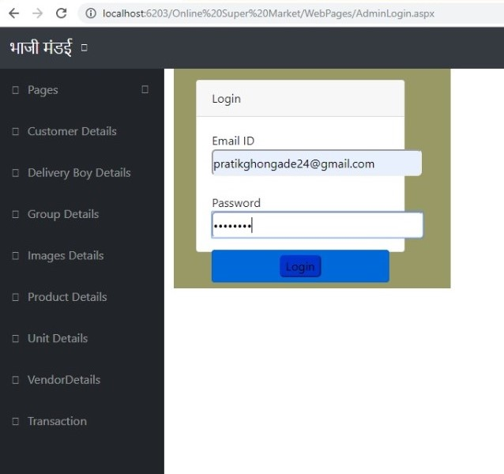

* **ADMIN REGISTRATION FORM**

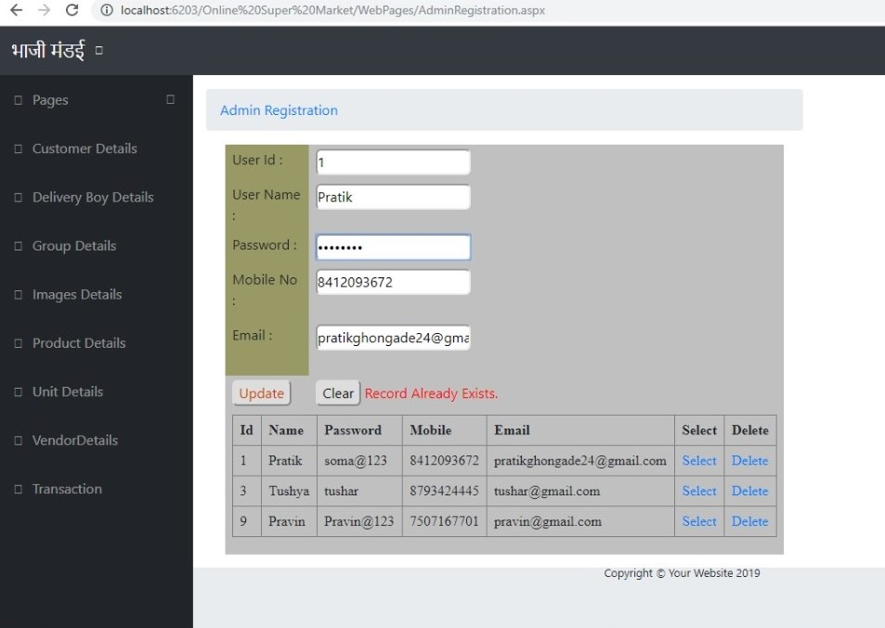

* **CUSTOMER REGISTRATION FORM**

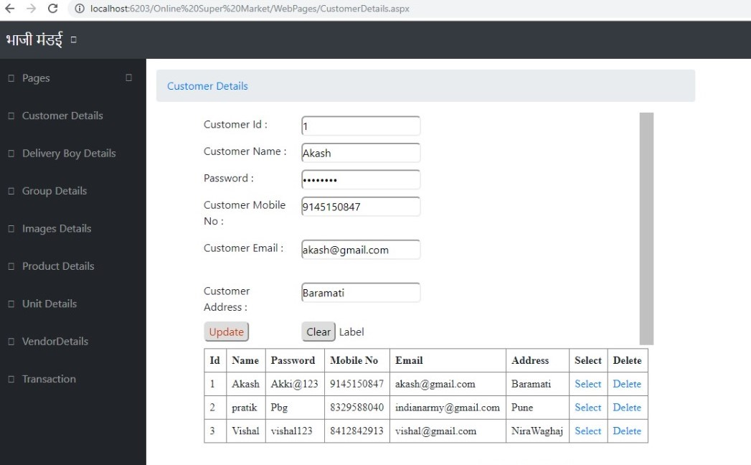

* **VENDOR REGISTRATION FORM**

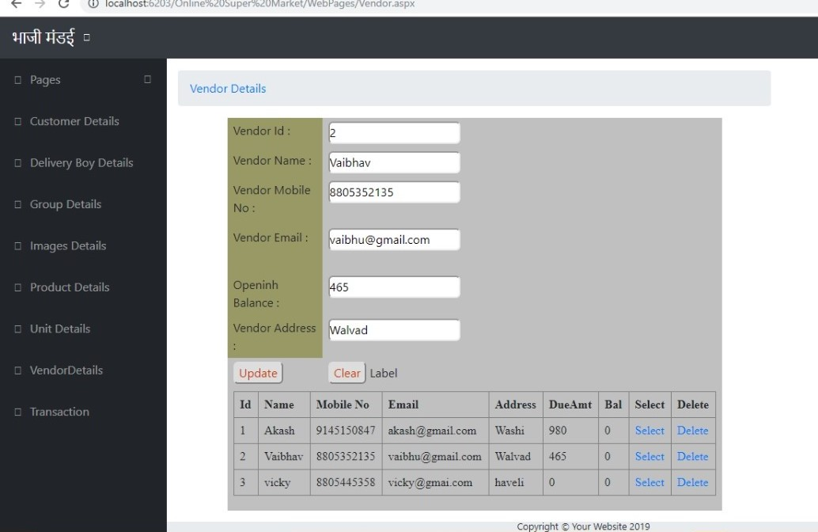

* **DELIVERY BOY DETAIL FORM**

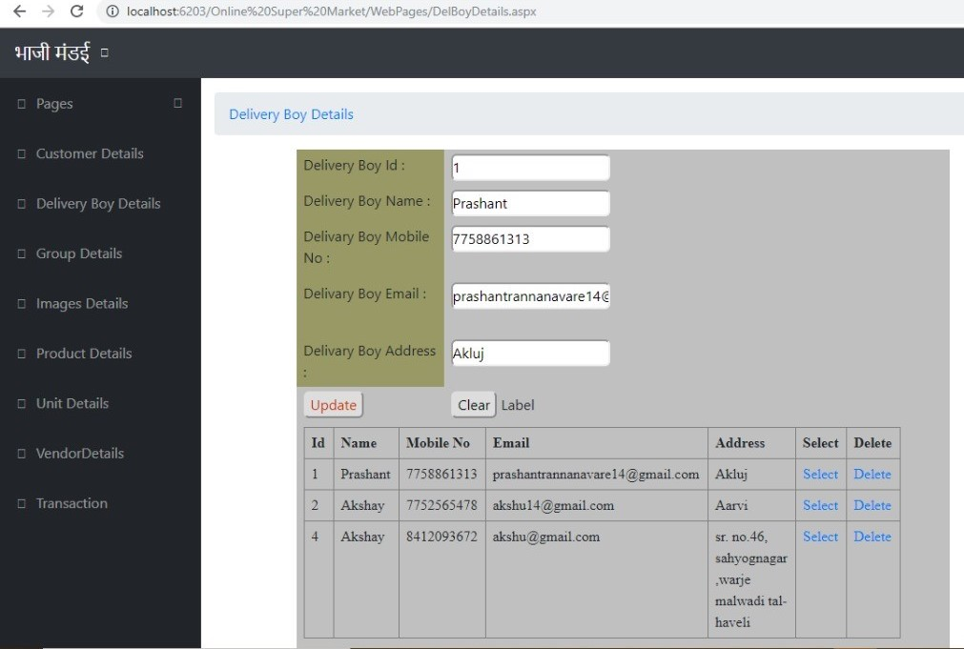

* **GROUP DETAILS**

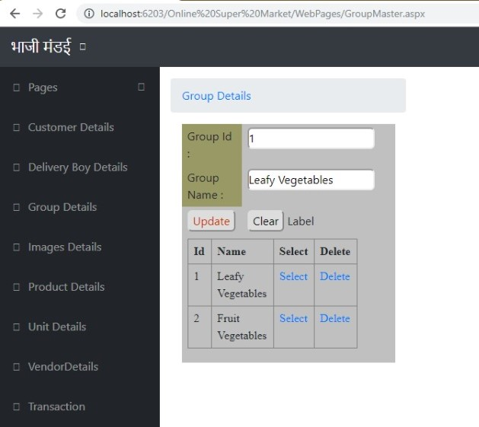

* **UNIT DETAILS**

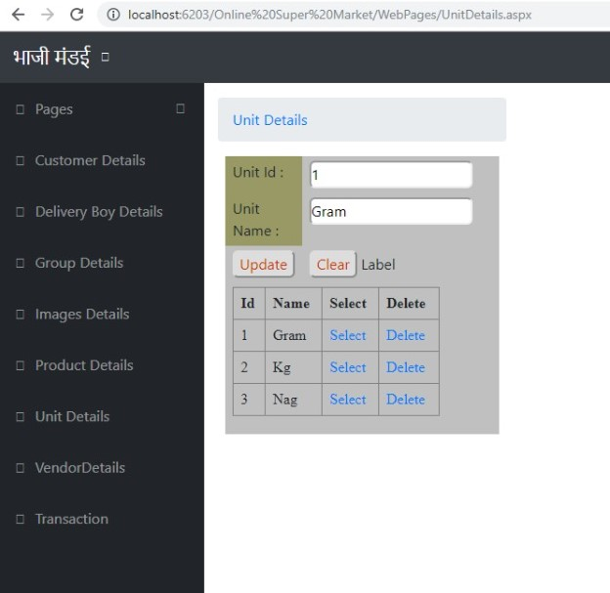

* **PRODUCT DETAILS**

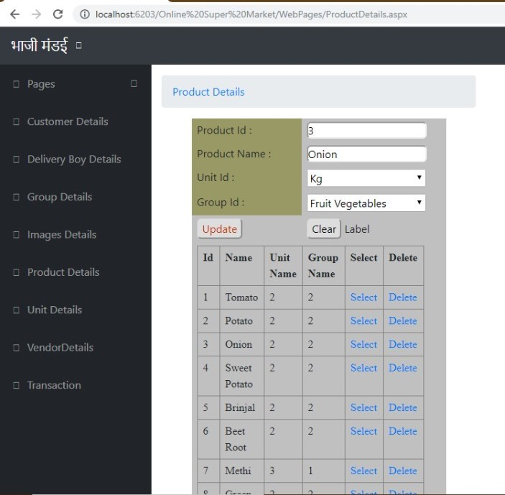

* **IMAGE DETAILS**

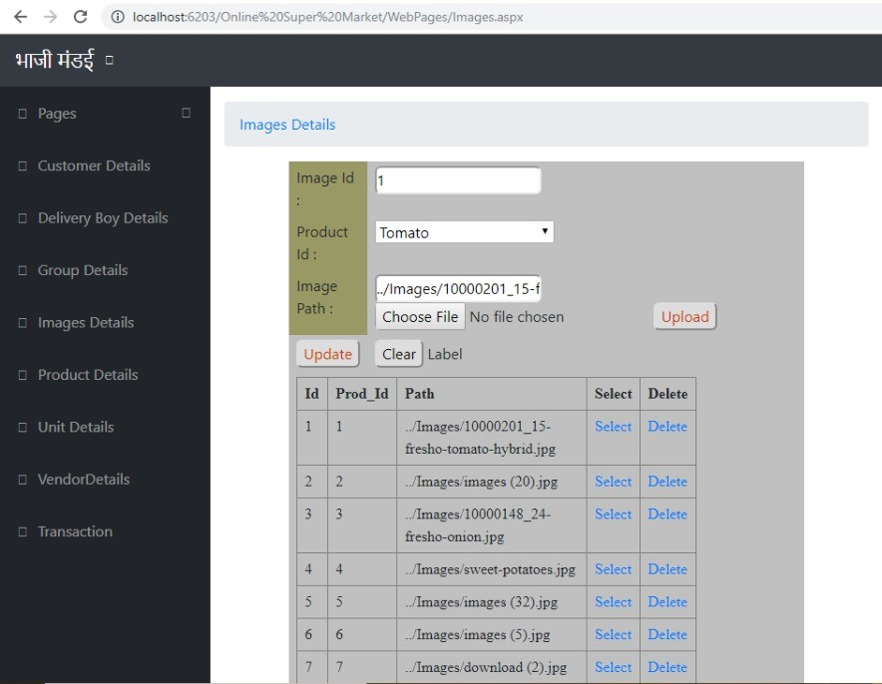

* **VEGETABLES**

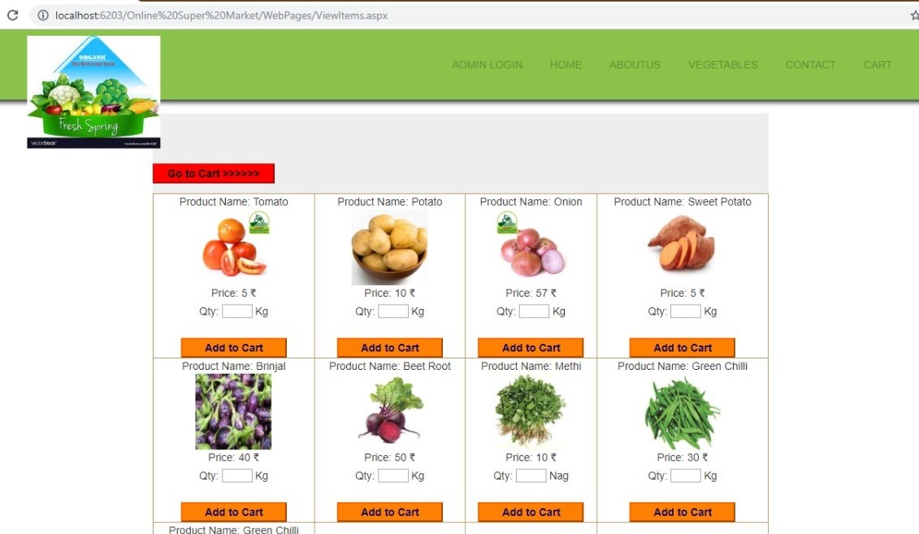

* **VIEW MY CART**

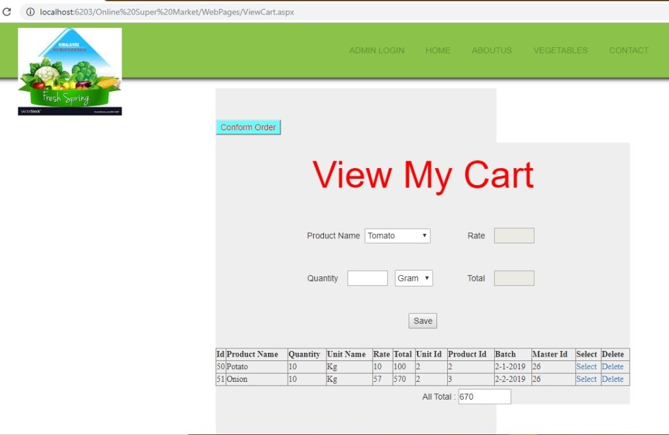

* **TRANSACTION MASTER**

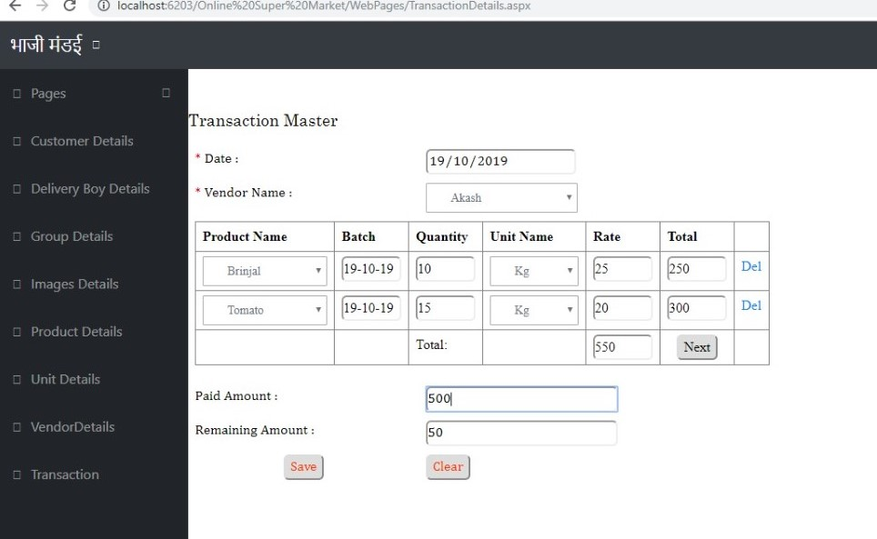

**Limitations**

* Since it is an online project, customers need internet connection to buy products.
* People who are not familiar with computers can’t use this software.
* Customer must have debit card or credit card or cash On Delivery to purchase products.
* This application does not have features by which user can set price ranges for products and receive alerts once the price reaches the particular range

**Future enhancement**

* This web application involves almost all the features of the online shopping.
* The future implementation will be online help for the customers and chatting with website administrator.
* The users could subscribe for price alerts which would enable them to receive messages when price for products fall below a particular level.

**Conclusion**

* The ‘Online Supermarket System(Mandai)’ is designed to provide a web based application that would make searching, viewing and selection of a product easier. The search engine provides an easy and convenient way to search for products where a user can Search for a product interactively and the search engine would refine the products available based on the user’s input.
* The user can then view the complete specification of each product.
* They can also view the product reviews and also write their own reviews.

**Bibliography**

1. Ajax Toolkit controls -http://asp.net
2. Visual Studio, C# Language --- Rajendra Salunkhe.
3. Visual Studio 2010, The Complete Reference Book ---Herbert Schildt.
4. Sql Server –Database.
5. www.google.com