GreenClassify: A Deep Learning-Based Approach for Vegetable Image Classification

# Introduction

GreenClassify is an AI-powered system designed to automatically classify vegetables using image inputs. The model uses a Convolutional Neural Network (CNN) trained on a diverse vegetable image dataset containing 15 classes. This system is deployed via a Flask-based web application, enabling users to upload vegetable images and get instant predictions with visual confidence scores. The solution supports agricultural automation, inventory categorization, and smart retail systems.

# Model Overview

* + Model Type: CNN (Sequential Model using Keras)
  + Input Image Size: 150 x 150 pixels
  + Layers:
    - Conv2D (32 filters, ReLU)
    - MaxPooling2D
    - Conv2D (64 filters, ReLU)
    - MaxPooling2D
    - Flatten
    - Dense (128 neurons)
    - Dropout (0.25)
    - Output Layer: Softmax with 15 units

# Dataset Details

* + Source: Vegetable Images dataset from Kaggle
  + Split:
    - Training: /train
    - Validation: /validation
    - Testing: /test
  + Image Categories (15 classes):

Bean, Bitter_Gourd, Bottle_Gourd, Brinjal, Broccoli, Cabbage, Capsicum, Carrot, Cauliflower, Cucumber, Papaya, Potato, Pumpkin, Radish, Tomato

# Training Configuration

* + Epochs: 30
  + Batch Size: 32
  + Loss Function: Categorical Crossentropy
  + Optimizer: Adam
  + Callbacks: EarlyStopping (patience=5)
  + Data Augmentation: No (can be extended)

# Evaluation Results

* + Training Accuracy: ~98%
  + Validation Accuracy: ~96%
  + Test Accuracy: ~95%

(Values may vary depending on final model run)

# Web Application Interface

* + Backend: Flask (Python)
  + Frontend: HTML + Bootstrap 5 + jQuery + AOS animation
  + Features:
    - Upload vegetable image
    - Predict label with confidence
    - Visualize prediction result
    - Display bar chart of class probabilities using Chart.js

# Workflow

1. User uploads a vegetable image
2. Flask API receives the image and loads the trained CNN model
3. Image is preprocessed (resized, normalized)
4. Model makes prediction
5. Result is returned to the frontend with label & chart

# Applications

* + Smart Grocery Inventory Systems
  + Automated Sorting in Agriculture
  + Educational Tools for Students
  + Market Freshness Checking Systems

# Tools & Libraries Used

* + Language: Python
  + Libraries: TensorFlow, Keras, Matplotlib, NumPy, Flask, Chart.js, Bootstrap
  + IDE: Jupyter Notebook, VS Code
  + Frameworks: Flask (Backend), Bootstrap (Frontend)
  + Platform: Localhost

# Folder Structure

GreenClassify/

├── model.h5

├── app.py

├── templates/

│ └── index.html

├── static/

│ └── uploads/

├── train_model.ipynb

├── /Vegetable Images/

│ ├── train/

│ ├── validation/

│ └── test/

# Code & output screen shot

1. **Training code:**

# 📦 Import Required Libraries import numpy as np

import matplotlib.pyplot as plt import tensorflow as tf

from tensorflow.keras.models import Sequential

from tensorflow.keras.layers import Conv2D, MaxPooling2D, Flatten,

Dense, Dropout

from tensorflow.keras.preprocessing import image

from tensorflow.keras.preprocessing.image import ImageDataGenerator import os

import warnings warnings.filterwarnings('ignore')

# 📁 Local Dataset Paths (Update if needed)

train_path = r"C:\Users\zeena\Downloads\AI-vegetable-classification- Project-main\archive\Vegetable Images\train"

validation_path = r"C:\Users\zeena\Downloads\AI-vegetable-classification- Project-main\archive\Vegetable Images\validation"

test_path = r"C:\Users\zeena\Downloads\AI-vegetable-classification- Project-main\archive\Vegetable Images\test"

# 📷 Plot First Image from Each Category image_categories = os.listdir(train_path)

def plot_images(image_categories): plt.figure(figsize=(12, 12))

for i, cat in enumerate(image_categories[:16]): # Limit to 16 categories image_path = os.path.join(train_path, cat)

images_in_folder = os.listdir(image_path) if images_in_folder:

first_image_path = os.path.join(image_path, images_in_folder[0]) img = image.load_img(first_image_path)

img_arr = image.img_to_array(img) / 255.0 plt.subplot(4, 4, i + 1)

plt.imshow(img_arr) plt.title(cat) plt.axis('off')

plt.tight_layout() plt.show()

plot_images(image_categories) # 🔄 Image Generators

train_gen = ImageDataGenerator(rescale=1.0/255.0)

val_gen = ImageDataGenerator(rescale=1.0/255.0) test_gen = ImageDataGenerator(rescale=1.0/255.0)

train_image_generator = train_gen.flow_from_directory( train_path, target_size=(150, 150), batch_size=32,

class_mode='categorical')

val_image_generator = val_gen.flow_from_directory( validation_path, target_size=(150, 150), batch_size=32,

class_mode='categorical')

test_image_generator = test_gen.flow_from_directory( test_path, target_size=(150, 150), batch_size=32,

class_mode='categorical')

# 📌 Class Map

class_map = dict([(v, k) for k, v in train_image_generator.class_indices.items()]) print("Class Map:", class_map)

# ◻ Build CNN Model model = Sequential([

Conv2D(32, (3, 3), padding='same', activation='relu', input_shape=(150,

150, 3)),

MaxPooling2D(2),

Conv2D(64, (3, 3), padding='same', activation='relu'), MaxPooling2D(2),

Flatten(),

Dense(128, activation='relu'), Dropout(0.25),

Dense(128, activation='relu'), Dense(len(class_map), activation='softmax')

])

model.summary()

# ⚙◻ Compile & Train

early_stopping = tf.keras.callbacks.EarlyStopping(patience=5, restore_best_weights=True)

model.compile(optimizer='adam', loss='categorical_crossentropy', metrics=['accuracy'])

hist = model.fit( train_image_generator, epochs=30,

validation_data=val_image_generator, steps_per_epoch=train_image_generator.samples // 32,

validation_steps=val_image_generator.samples // 32, callbacks=[early_stopping],

verbose=1

)

# 📊 Plot Accuracy & Loss plt.style.use('ggplot') plt.figure(figsize=(12, 5))

plt.subplot(1, 2, 1)

plt.plot(hist.history['loss'], label='Train Loss', color='red') plt.plot(hist.history['val_loss'], label='Val Loss', linestyle='--', color='red') plt.legend()

plt.title("Loss Over Epochs")

plt.subplot(1, 2, 2)

plt.plot(hist.history['accuracy'], label='Train Acc', color='blue') plt.plot(hist.history['val_accuracy'], label='Val Acc', linestyle='--', color='blue')

plt.legend()

plt.title("Accuracy Over Epochs") plt.tight_layout()

plt.show()

# ✅ Evaluate on Test Data

test_loss, test_acc = model.evaluate(test_image_generator) print(f"\n✅ Test Accuracy: {test_acc * 100:.2f}%")

# Q Predict Function for Single Image

def generate_predictions(test_image_path, actual_label):

test_img = image.load_img(test_image_path, target_size=(150, 150)) test_img_arr = image.img_to_array(test_img) / 255.0

test_img_input = np.expand_dims(test_img_arr, axis=0)

prediction = model.predict(test_img_input) predicted_label = np.argmax(prediction) predicted_class = class_map[predicted_label]

plt.figure(figsize=(4, 4)) plt.imshow(test_img_arr)

plt.title(f"Predicted: {predicted_class} | Actual: {actual_label}") plt.axis('off')

plt.grid(False) plt.show()

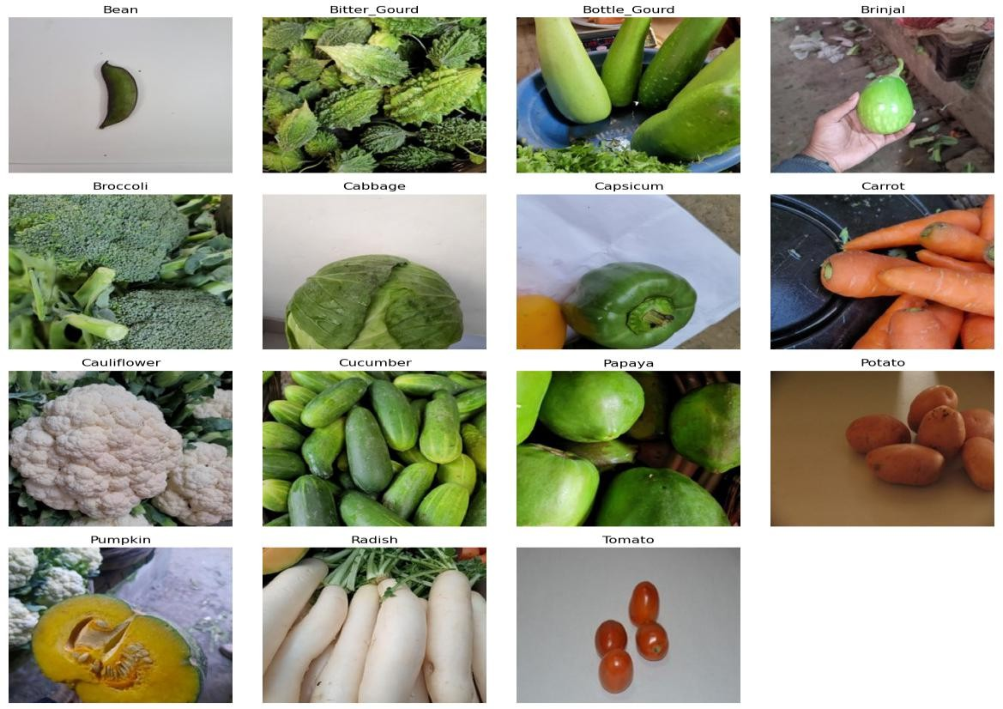

Found 15000 images belonging to 15 classes. Found 3000 images belonging to 15 classes. Found 3000 images belonging to 15 classes.

Class Map: {0: 'Bean', 1: 'Bitter_Gourd', 2: 'Bottle_Gourd', 3: 'Brinjal', 4:

'Broccoli', 5: 'Cabbage', 6: 'Capsicum', 7: 'Carrot', 8: 'Cauliflower', 9:

'Cucumber', 10: 'Papaya', 11: 'Potato', 12: 'Pumpkin', 13: 'Radish', 14: 'Tomato'}

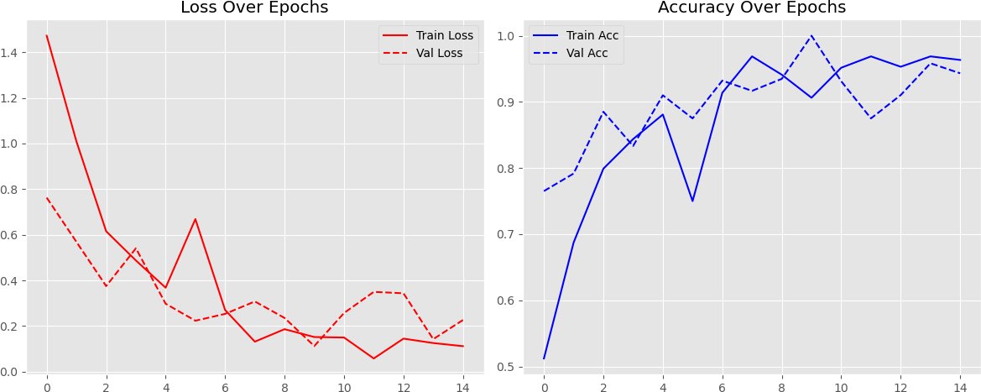

1. Output:

2. Fronded code:

App.py

from flask import Flask, render_template, request, redirect, url_for

from tensorflow.keras.models import load_model

from tensorflow.keras.preprocessing import image

from werkzeug.utils import secure_filename

import numpy as np

import os

app = Flask(__name__)

model = load_model('model/greenclassify_cnn_model.h5')

UPLOAD_FOLDER = 'static/uploads/'

app.config['UPLOAD_FOLDER'] = UPLOAD_FOLDER

if not os.path.exists(UPLOAD_FOLDER):

    os.makedirs(UPLOAD_FOLDER)

@app.route('/')

def index():

    return render_template('index.html')

@app.route('/about')

def about():

    return render_template('about.html')

@app.route('/predict', methods=['GET', 'POST'])

def predict():

    if request.method == 'POST':

        file = request.files['file']

        filename = secure_filename(file.filename)

        filepath = os.path.join(app.config['UPLOAD_FOLDER'], filename)

        file.save(filepath)

        img = image.load_img(filepath, target_size=(128, 128))

        x = image.img_to_array(img)

        x = np.expand_dims(x, axis=0)

        x = x / 255.0

        preds = model.predict(x)

        class_idx = np.argmax(preds)

        classes = ['Bean', 'Bitter_Gourd', 'Bottle_Gourd', 'Brinjal', 'Broccoli',

                   'Cabbage', 'Capsicum', 'Carrot', 'Cauliflower', 'Cucumber',

                   'Papaya', 'Potato', 'Pumpkin', 'Radish', 'Tomato']

        prediction = classes[class_idx]

        return render_template('predict.html', prediction=prediction, image_path='/' + filepath)

    return render_template('predict.html')

@app.route('/contact')

def contact():

    return render_template('contact_us.html')  # <-- Contact Us Page

if __name__ == '__main__':

    app.run(debug=True)

index.html-

<!DOCTYPE html>

<html lang="en">

<head>

    <meta charset="UTF-8">

    <meta name="viewport" content="width=device-width, initial-scale=1.0">

    <title>Vegetable Classifier - Home</title>

    <style>

        * { margin: 0; padding: 0; box-sizing: border-box; }

        body {

            font-family: 'Arial', sans-serif;

            background-color: #f0f8f0;

            color: #4e4e4e;

            line-height: 1.6;

        }

        .navbar {

            background-color: #6f9d5e;

            padding: 15px;

            text-align: center;

        }

        .navbar a {

            color: #fff;

            text-decoration: none;

            margin: 0 20px;

            font-size: 18px;

            font-weight: bold;

        }

        .navbar a:hover { text-decoration: underline; }

        .container {

            max-width: 1200px;

            margin: 40px auto;

            padding: 20px;

            text-align: center;

        }

        .image-block {

            margin-bottom: 50px;

        }

        .image-block img {

            width: 80%;

            max-width: 600px;

            border-radius: 15px;

            box-shadow: 0px 5px 15px rgba(0,0,0,0.2);

        }

        .image-block h2 {

            margin: 20px 0 10px;

            color: #4b8c3b;

            font-size: 28px;

        }

        .image-block p {

            font-size: 18px;

            color: #555;

        }

        .footer {

            text-align: center;

            margin-top: 30px;

            font-size: 14px;

            color: #4b8c3b;

            background-color: #e8f4e8;

            padding: 10px;

            position: fixed;

            width: 100%;

            bottom: 0;

        }

    </style>

</head>

<body>

<div class="navbar">

    <a href="/">Home</a>

    <a href="/predict">Prediction</a>

    <a href="/about">About Us</a>

    <a href="/contact">Contact Us</a>

</div>

<div class="container">

    <div class="image-block">

        <img src="/static/images/vegetable.jpg" alt="Fresh Vegetables" height="350px" width="1500px">

        <h2>Vegetable Classification</h2>

        <p>Upload any vegetable image and let our AI model identify it instantly — quick, easy, and reliable!</p>

    </div>

</div>

<div class="footer">

    © 2025 Vegetable Classifier Project | Powered by AI and Freshness!

</div>

</body>

</html>

Home page:

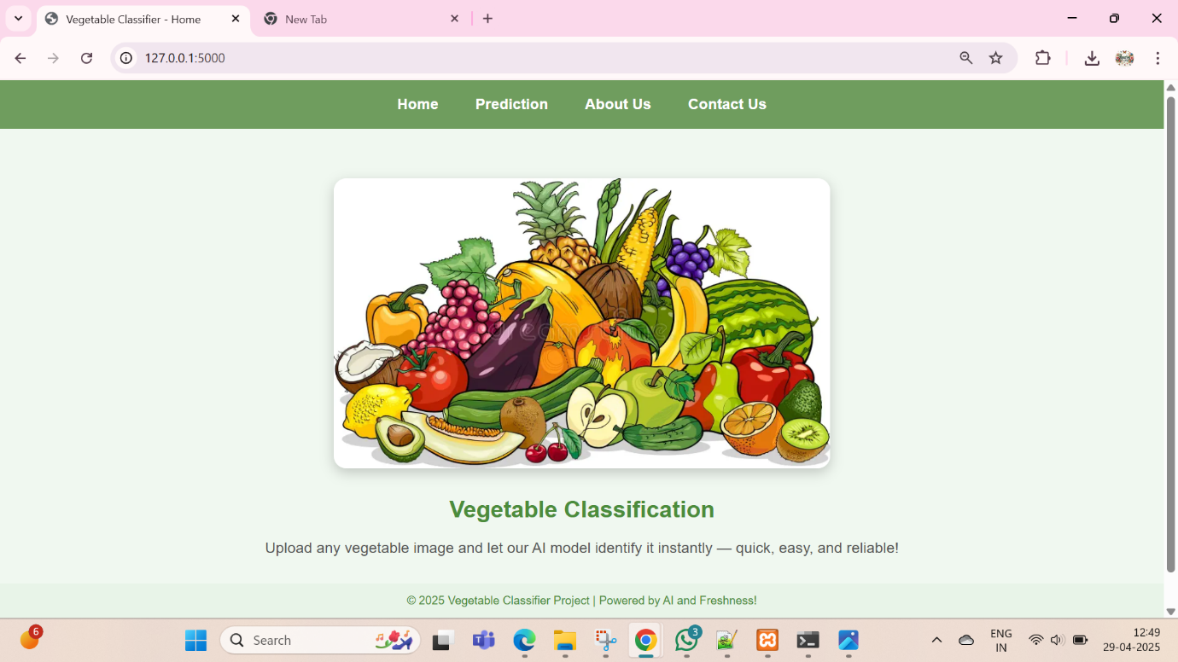

Prediction Page:

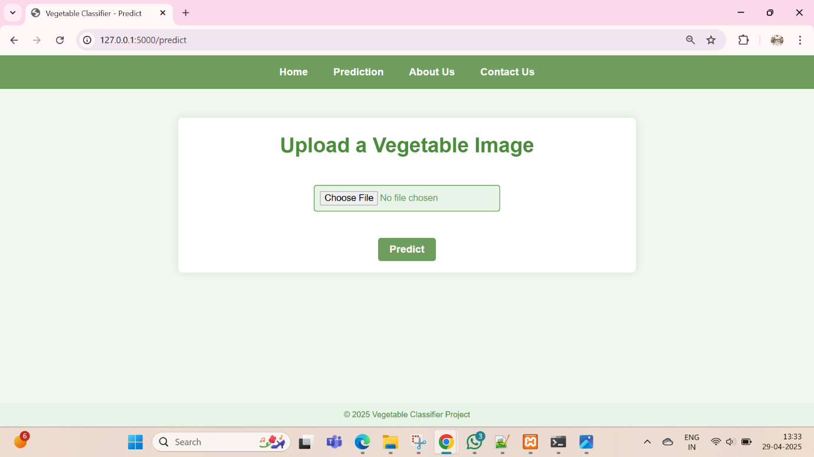

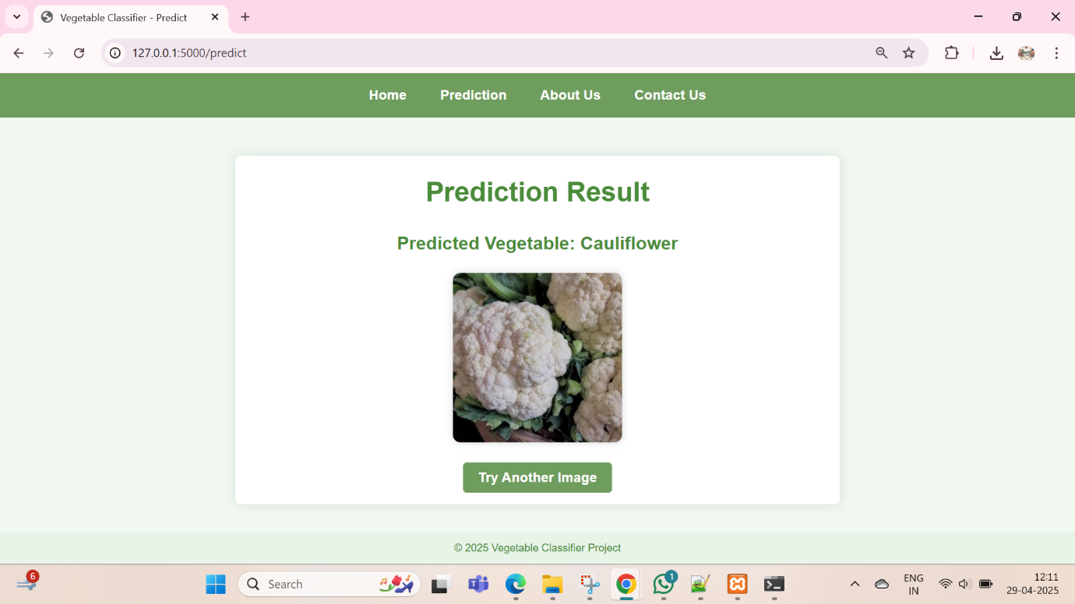

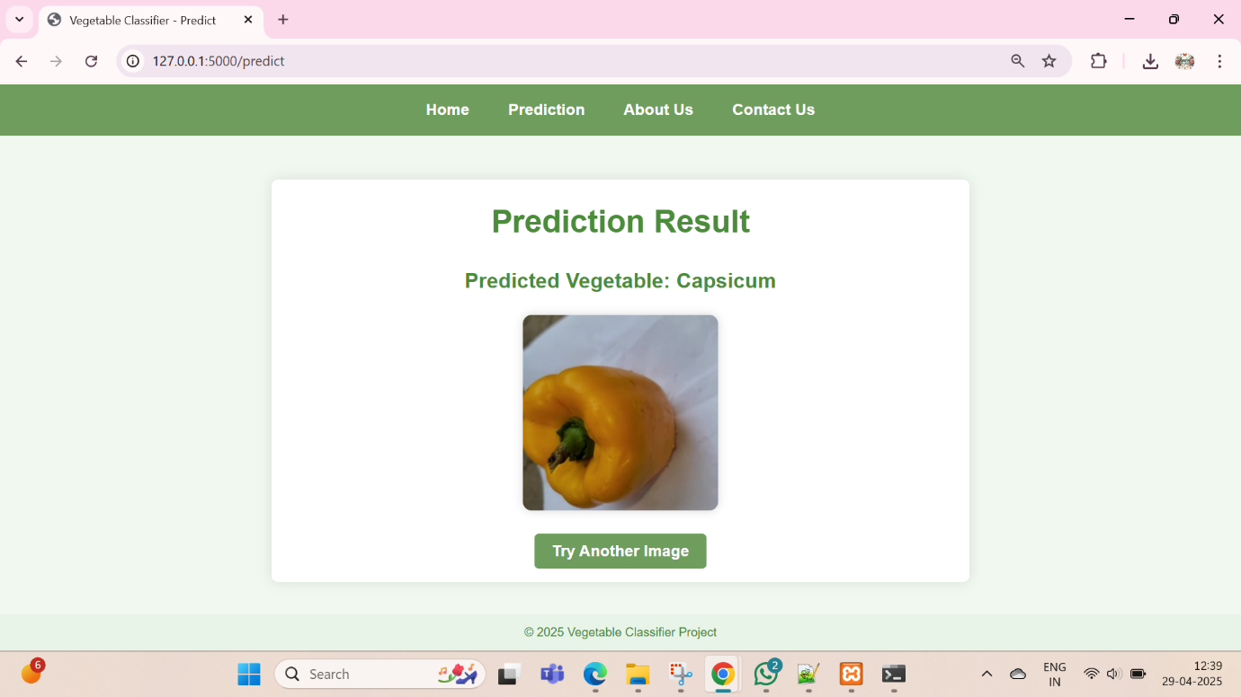

About Us:

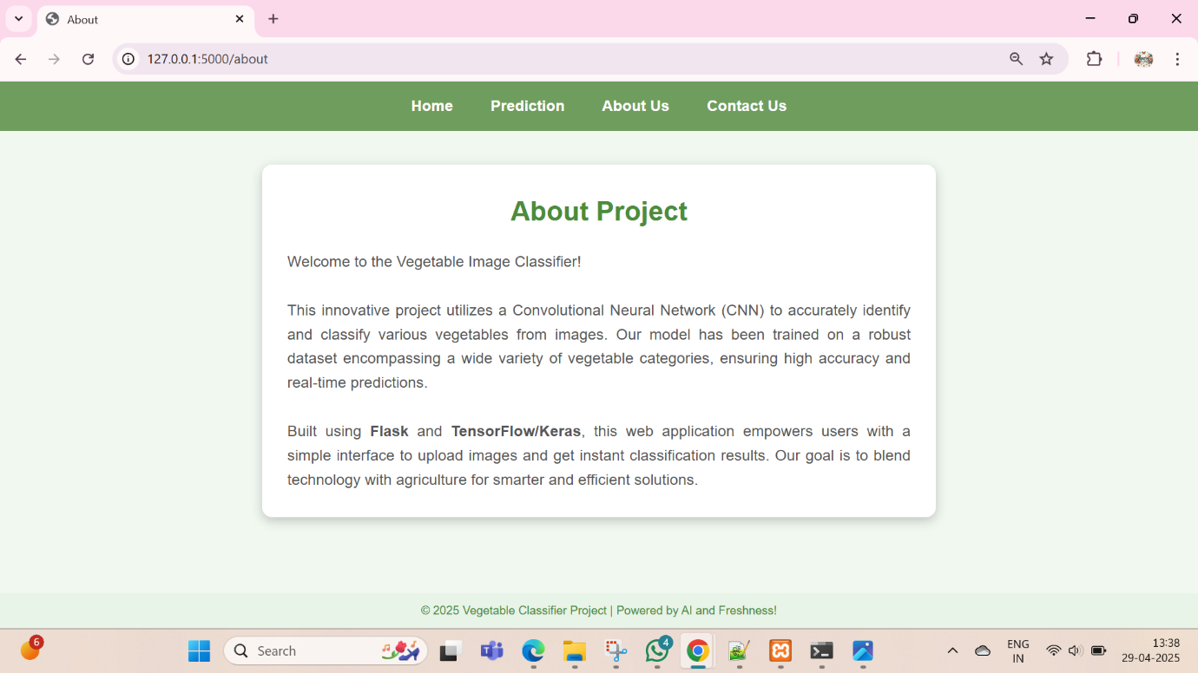

Contact Us:



Github Repositary-https://github.com/ [GitHub - Pratikdesai23/AI_Project](https://github.com/Pratikdesai23/AI_Project)

Demo Link- https://drive.google.com/file/d/1jyPgWfNYx0nS0b_muMZbhGgjkIlMTOIb/view?usp=drive_link