Winning Without the Ball
How Paris Saint-Germain Rebuilt Their Identity in the Champions League
A Comprehensive Analysis of PSG's 2024-25 and 2025-26 Champions League Campaigns
Pratik Kothari
May 2026

Abstract
Paris Saint-Germain finally got their hands on the Champions League trophy in 2024-25, the first in the club's history, and they did it the season after losing Kylian Mbappe, the player most people assumed the whole project was built around. That contradiction is what got me curious. A team that had spent a decade leaning on individual superstars suddenly won Europe playing as a collective, and then doubled down on that approach into 2025-26. This project digs into two seasons of Champions League match and player data to ask a simple question: what does this PSG side actually look like under the hood, and how has it changed?
Working entirely in R, I assembled match-level and player-level datasets covering both campaigns and ran a mix of descriptive analysis, finishing-efficiency comparisons, and k-means clustering to map out the squad's structure. Three findings stood out. First, the attacking load has genuinely spread across the squad rather than concentrating in one star. Second, PSG have become comfortable winning knockout ties with a minority of possession, leaning on efficiency rather than territorial dominance. Third, and most striking to me, the team presses as a unit with exactly one designated exception, and the data isolates that player cleanly. None of this is the final word given the sample sizes involved, but together it paints a coherent and, I think, genuinely interesting picture of a team in transition.

Introduction
There is a particular kind of football story that I find irresistible, and it is the one where a team is forced to reinvent itself and somehow comes out better. PSG in the summer of 2024 is exactly that story. Mbappe left for Real Madrid, and the consensus take was that a club which had organised itself around marquee names for years would struggle to replace that output. Instead, under Luis Enrique, they went and won the whole thing, completing a continental treble in the process and beating Inter 5-0 in the final, the largest winning margin in the history of a European Cup final.
What interested me was not the trophy itself but the manner of it. Watching the knockout rounds, this did not look like the PSG of old. The goals came from everywhere, the pressing was relentless, and in several of the biggest games they seemed perfectly happy to let the opponent have the ball. I wanted to know whether the numbers backed up that impression, or whether I was just pattern-matching to a narrative I liked. This report is my attempt to answer that honestly, using data rather than vibes.
I focused on two seasons: the 2024-25 title run and the 2025-26 campaign, which at the time of writing has reached the final. Comparing the two lets me separate what was a one-off from what has become a genuine, repeated identity. Throughout, I have tried to be upfront about where the data is thin and where a conclusion is more suggestive than proven, because a Champions League season is a small number of games and it is easy to over-read noise.

Data and Methods
All data was sourced from publicly available Champions League match and player statistics for both seasons, then cleaned and structured into tidy CSV files. The match-level data covers shooting, possession, and defensive actions per game; the player-level data covers attacking output, shooting, defensive contributions, and playing time. Per-90 metrics were computed where comparing players with different minutes, so that a rotation player is not unfairly compared against an ever-present starter on raw totals alone.
The analysis was carried out entirely in R, using the tidyverse for data manipulation and ggplot2 for visualisation. The clustering work used base R's k-means implementation with normalised inputs. I have deliberately kept the statistical machinery simple and transparent, because with samples this small the honest move is to favour interpretable descriptive methods over anything that pretends to more precision than the data can support.
Dataset | Level | Seasons | Key fields
Match shooting & possession | Team / match | 2025-26 | Shots, SoT%, possession, goals
Match defensive actions | Team / match | 2024-25 | Interceptions, tackles, fouls
Player profiles | Player | Both | Goals, assists, shots, defensive actions, minutes
Match results | Team / match | 2024-25 | Goals for/against, assists
Table 1. Overview of the datasets assembled for this project.

A Shift in Who Carries the Attack
The cleanest way into PSG's evolution is to ask who actually produces the goals and assists, and whether that has changed between the two seasons. The answer is yes, and quite dramatically. In 2024-25 the attack ran through Ousmane Dembele, who racked up fourteen goal contributions in the run to the title. By 2025-26 the focal point had shifted decisively to Khvicha Kvaratskhelia, who exploded to sixteen goal contributions, while Dembele's output dropped to nine, partly a function of reduced minutes.
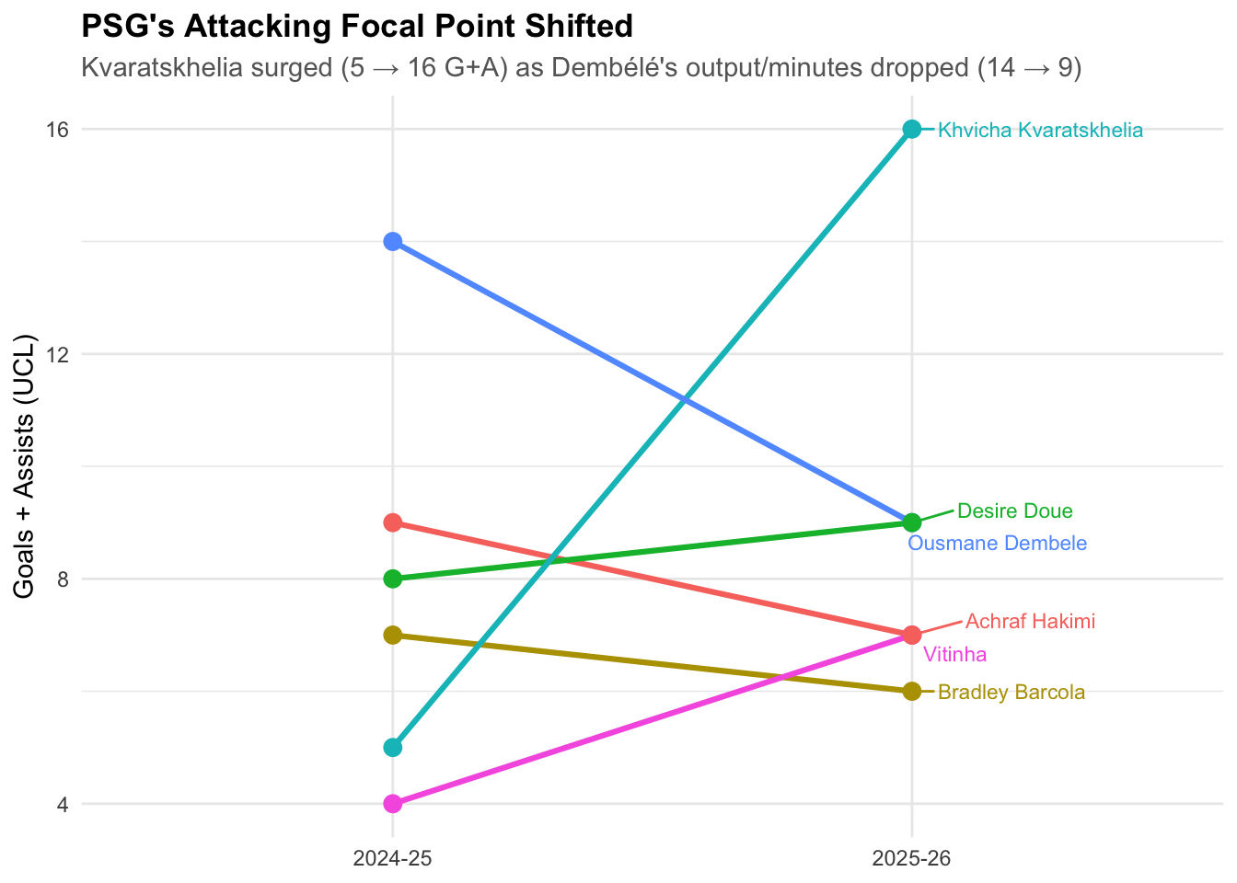
Figure 1. Goal contributions of key attackers across the two seasons. Kvaratskhelia's rise and Dembele's relative dip are the headline shift.
I do not read this as one player declining and another improving in isolation. It looks more like a team that is comfortable letting its primary threat rotate depending on form, fitness, and opponent. That flexibility is itself a kind of strength, and it is a long way from the days when a single departure could be framed as an existential problem.

The Attack Has Genuinely Spread Out
If the focal point can shift between seasons, the natural follow-up is whether the attack as a whole has become less dependent on any single player. To test this I plotted the cumulative share of total goal contributions against the number of players, ranked from most productive down. A curve that rises steeply means a few players carry everything; a flatter curve means the load is spread across the squad.
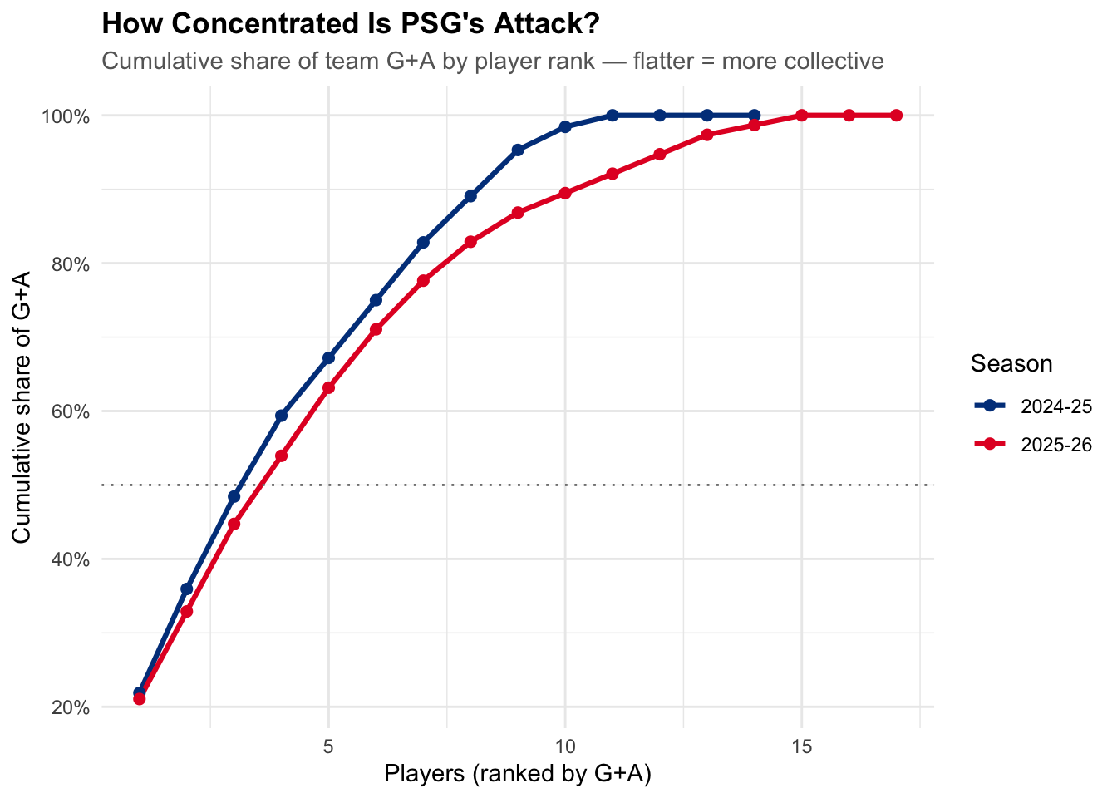
Figure 2. Cumulative share of team goal contributions by player rank. The lower 2025-26 line indicates a more collective attack.
The 2025-26 line sits consistently below the 2024-25 line, which means it takes more players to account for the same share of output. In plain terms, the attack got more collective. This is exactly the kind of subtle, structural change that is invisible if you only watch highlights but shows up clearly once you line the seasons up side by side. It is also the strongest statistical echo of the post-Mbappe identity that Luis Enrique has spoken about publicly.

Winning Without the Ball
The observation that started this whole project was the sense that PSG had stopped needing to dominate possession to win. My first instinct was to plot possession across the 2025-26 campaign and watch it fall through the knockout rounds. It does fall, but I want to be careful here, because possession dropping in later rounds is partly just a consequence of facing better teams. That on its own is not an insight, it is an expectation.
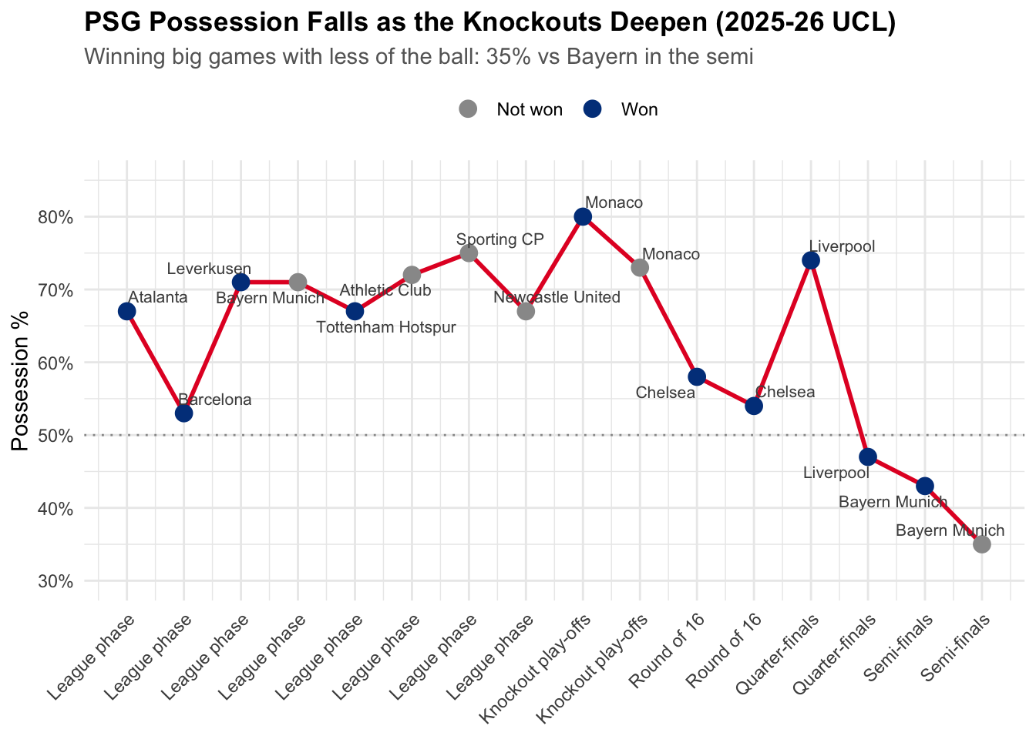
Figure 3. PSG possession by match in 2025-26. Possession dips in the deepest knockout ties, but the more meaningful story is what happens to results at those low-possession games.
The point only becomes interesting when you pair possession with the result. So the better chart, and the one I would actually stand behind, plots goal difference against possession for every match. If PSG were merely surviving low-possession games, you would expect their goal difference to sag when they had less of the ball. That is not what happens.
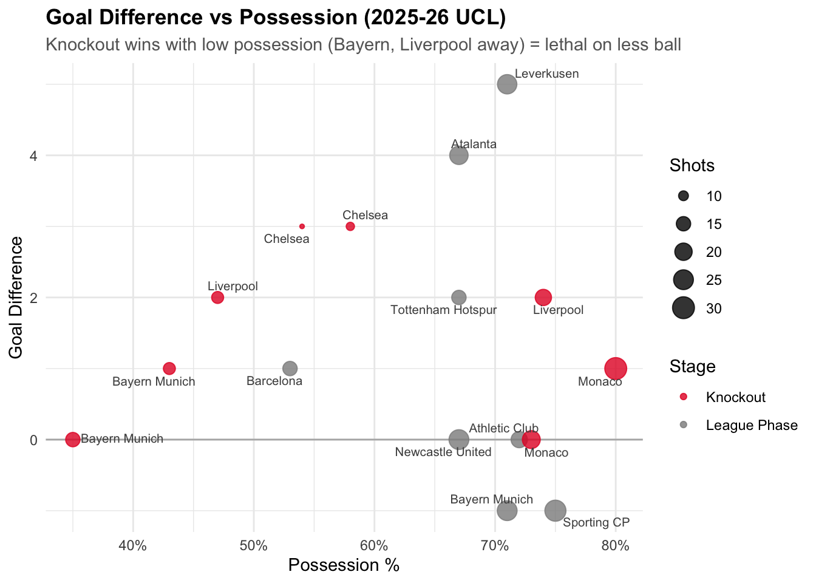
Figure 4. Goal difference versus possession in 2025-26. PSG post positive goal difference across the entire possession range, including the lowest-possession knockout ties against Bayern and Liverpool.
The knockout wins are scattered across the whole possession spectrum, from eighty percent against Monaco down to thirty-five percent away at Bayern, and almost all of them sit at or above a goal difference of zero. The honest framing is not that PSG are more lethal with less of the ball, because their biggest margins still come in high-possession league games against weaker sides. The accurate framing is that they have become effective at any possession level, which is a more flexible and arguably more dangerous trait than pure dominance.

Fewer Shots, Sharper Finishing
If a team can win with less of the ball, it has to be making the moments it does get count. The shooting data backs this up. In the knockout rounds PSG generally took fewer shots than in the league phase but put a higher proportion of them on target, and converted at a better rate.
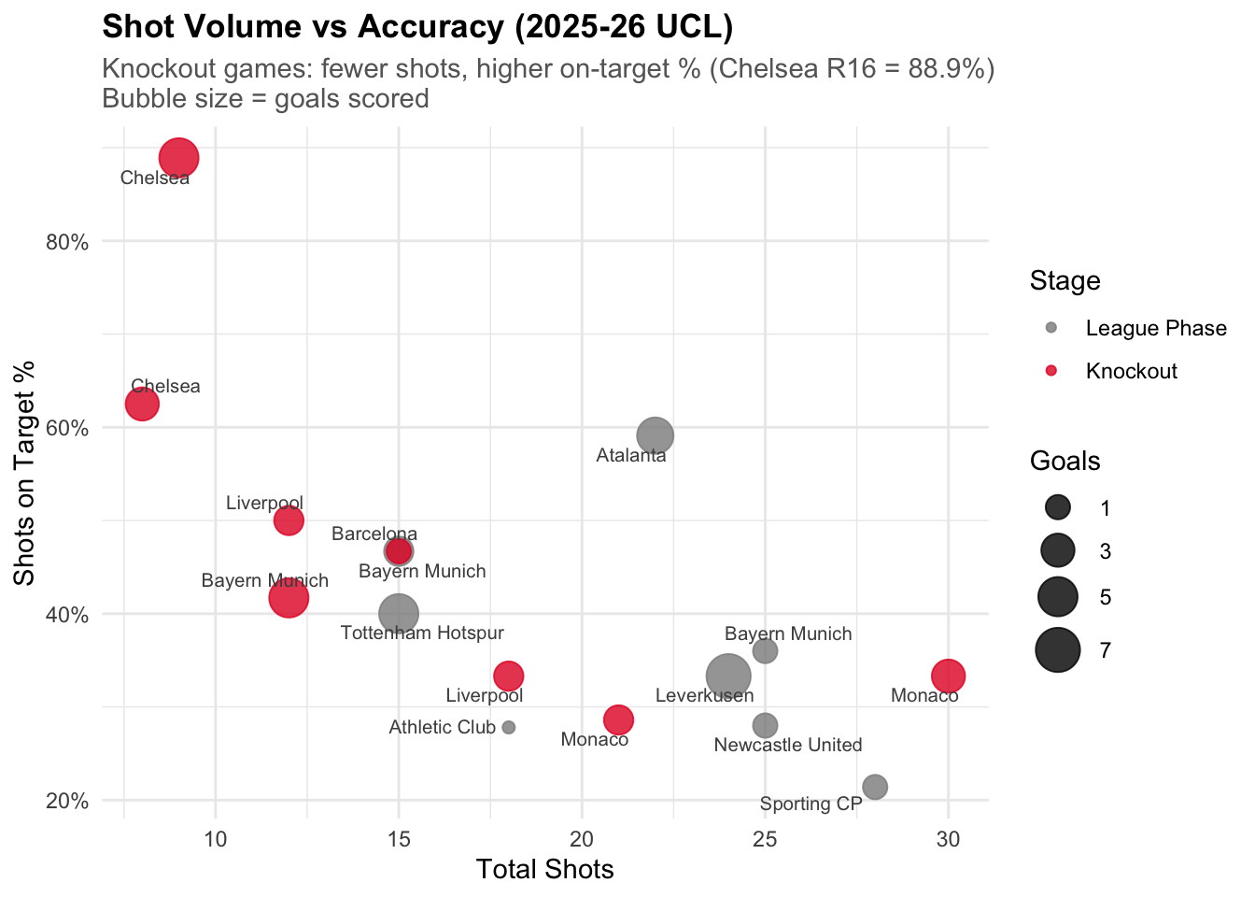
Figure 5. Shot volume against shots-on-target percentage, with bubble size showing goals. Knockout games trend toward fewer but sharper attempts.
The standout is the Chelsea round-of-sixteen tie, where PSG hit nearly ninety percent of their shots on target. I would not build a thesis on a single match like that, since it is an obvious small-sample spike, but the broader pattern of knockout efficiency is consistent enough to be worth noting. It fits the same story: a team that picks its moments rather than throwing everything at the wall.

The Press and the One Exception
Of everything I looked at, this is the finding I am most fond of, because it started as a hunch and the data sharpened it into something specific. The eye-test impression was that this PSG side presses aggressively as a unit. The question was whether that shows up in the numbers, and whether it is uniform across the team.
Using interceptions plus tackles won per ninety minutes as a rough ball-winning proxy, I plotted every regular player, grouped by position. The caveat here is important and I want to state it plainly: this data has no pitch coordinates, so it tells me who wins the ball, not where. A high count could mean pressing high or defending deep. But the pattern across players is still revealing.
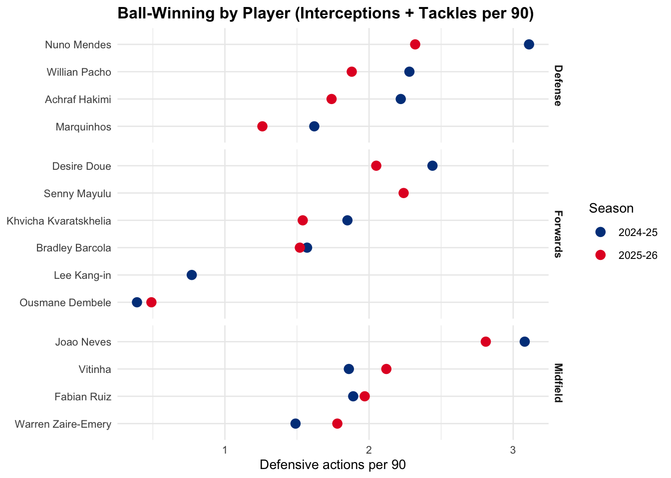
Figure 6. Ball-winning actions per 90 by player, split by position and season. Several forwards rank as high as defenders, but Dembele sits at the very bottom in both seasons.
Two things jump out. The forwards as a group do real defensive work, with players like Doue and Mayulu posting numbers comparable to some defenders, which is the fingerprint of a front line that presses. And then there is Dembele, sitting at the very bottom of the chart in both seasons, doing a fraction of the ball-winning of everyone around him. He is not pressing because the system does not ask him to. He is the released player, the one kept fresh to punish turnovers the rest of the team generates.

Mapping the Squad's Roles
To formalise that intuition, I ran a k-means clustering on the 2025-26 outfield players using their attacking output, shot volume, crossing, and defensive actions. After testing different numbers of clusters, four gave the most interpretable grouping. The result lines up beautifully with what the pressing chart hinted at.
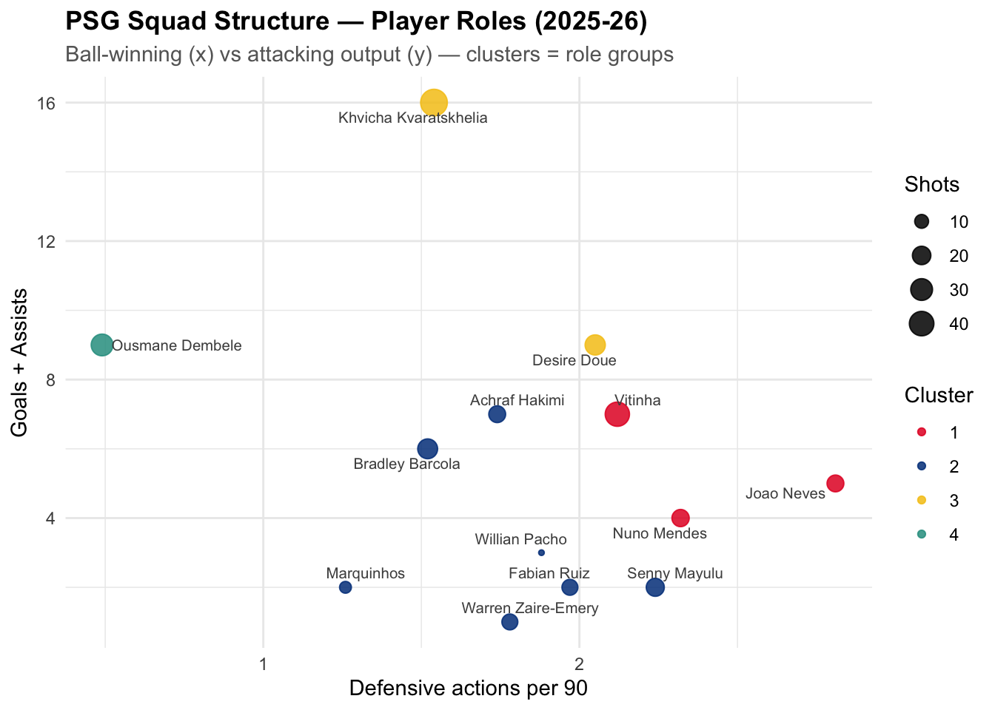
Figure 7. K-means player clusters for 2025-26, plotting ball-winning against attacking output. Dembele is isolated into a cluster of one.
The algorithm produced four groups: a pair of elite creators in Kvaratskhelia and Doue, a hard-working two-way engine of Vitinha, Joao Neves and Nuno Mendes who both win the ball and build play, a broad supporting cast, and finally a cluster containing exactly one player. Dembele's profile of high output and near-zero defensive work is so distinct that the model gives him his own category. I will be honest that a one-player cluster is more of a descriptive flourish than a robust statistical group, but as a way of showing how unique his role is, it could hardly be clearer.
Cluster | Players | Avg G+A | Avg shots | Def actions / 90
Elite creators | Kvaratskhelia, Doue | 12.5 | 37.0 | 1.79
Two-way engine | Vitinha, Neves, Mendes | 5.3 | 24.0 | 2.42
The released forward | Dembele | 9.0 | 30.0 | 0.49
Supporting cast | Hakimi, Barcola, +5 | 3.3 | 13.9 | 1.77
Table 2. Cluster averages. The contrast between the two-way engine (2.42 ball-winning actions per 90) and the released forward (0.49) captures PSG's structure in two numbers.

Player Fingerprints
Clustering tells you which players group together; radar profiles show you why. Normalising five dimensions across the squad and overlaying the key players makes their differing shapes obvious at a glance.
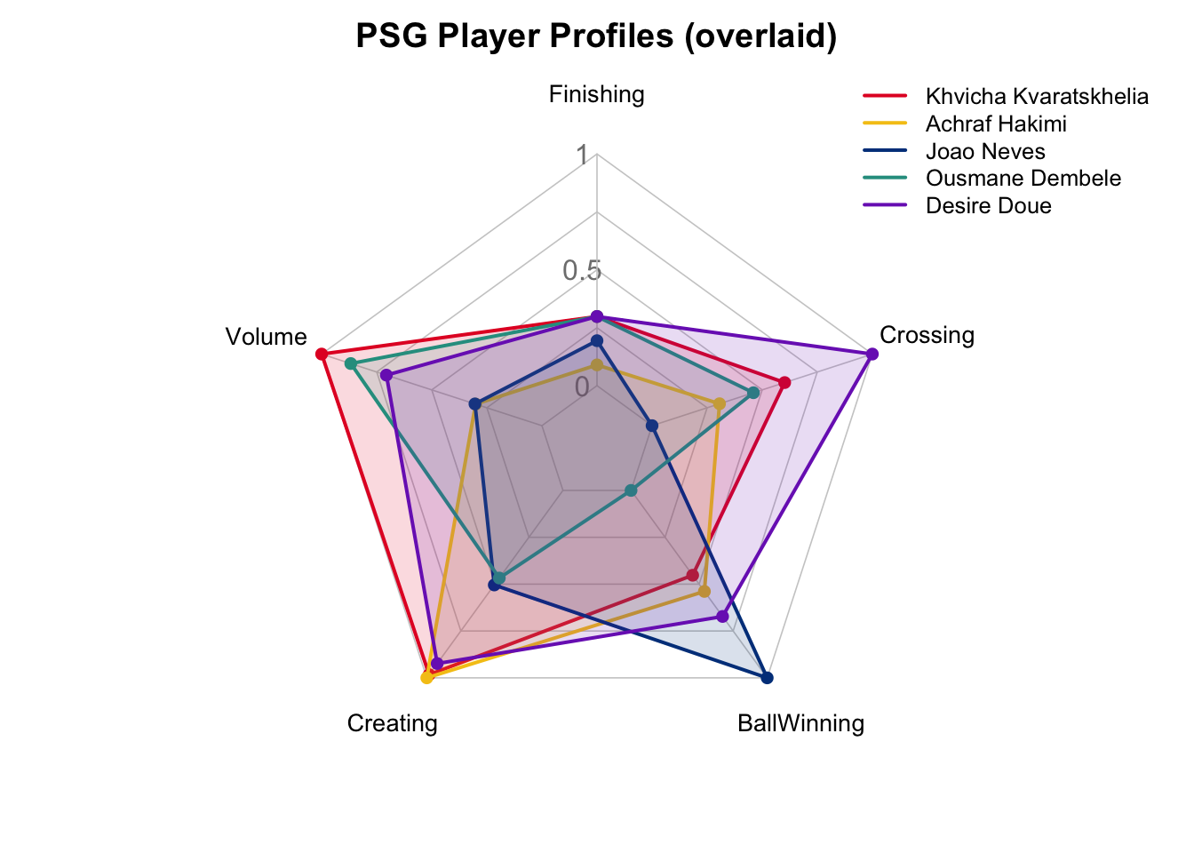
Figure 8. Normalised player profiles across five dimensions. Each axis is scaled relative to the squad, so the shapes show role, not absolute quality.
Neves spikes hard on ball-winning and little else, the perfect midfield enforcer shape. Hakimi leans toward creating and crossing, the modern attacking full-back. Kvaratskhelia stretches toward volume and creation. And Dembele's shape collapses inward on the defensive axis while extending on finishing, the visual twin of everything the clustering and pressing charts already told us. One note of caution worth repeating: these axes are normalised within this squad, so a full reach means most among these PSG players, not elite across Europe.

Home, Away, and the Limits of the Story
One hypothesis I wanted to test was whether PSG change their approach on the road. The match data tags every game as home or away, so this was straightforward to check, and the result is a nice example of the data complicating a tidy narrative rather than confirming it.
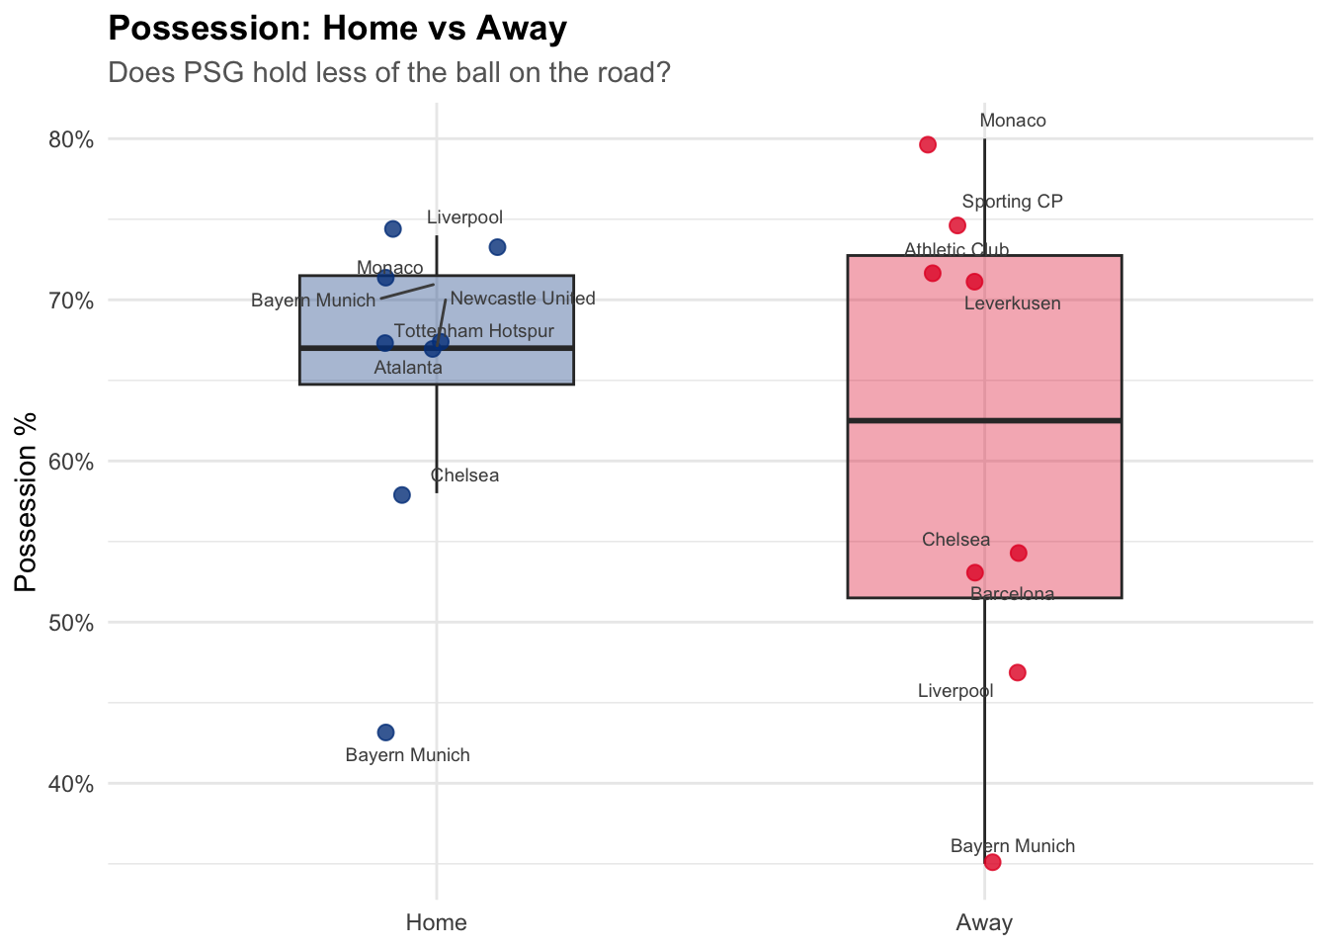
Figure 9. Possession home versus away in 2025-26. The away distribution is far wider, not simply lower.
PSG's home possession is tight and high, clustering in the high sixties to low seventies. Away from home, the picture is not lower so much as wildly more variable, from eighty percent at Monaco down to thirty-five percent at Bayern. When you look at which away games sit at the bottom, they are all the elite opponents: Bayern, Liverpool, Chelsea, Barcelona. And tellingly, the one home game where possession also collapsed was against Bayern as well.
So the real driver is not the venue at all, it is opponent quality. PSG cede the ball to strong teams whether home or away, and dominate weaker ones in either setting. I found this genuinely satisfying, because the original hunch was wrong in a useful way. The lesson, which I will carry into future analysis, is that venue is a tempting variable precisely because it is easy to measure, but it can mask the thing that is actually doing the work.

Limitations
I want to be candid about what this project cannot claim, because an analysis is only as trustworthy as its willingness to mark its own boundaries.
- Sample size is the big one. A Champions League campaign is on the order of fifteen or sixteen matches. Splitting that into home and away, or league phase and knockout, quickly leaves single-digit samples per bucket. The patterns here are real descriptions of what happened, but they are not statistically powered claims about what will happen.
- The defensive data lacks spatial context. Without pitch coordinates I can measure how often a player wins the ball but not where on the pitch, which is precisely the information needed to prove high pressing rather than deep defending. The pressing argument here rests on the distribution of ball-winning across players, which is suggestive but not conclusive.
- The team-level possession and defensive datasets do not cover the same season, which prevented a clean team-level link between pressing intensity and possession. The player-level data bridges some of this gap, but it is a compromise.
- Clusters with one or two members, like the Dembele cluster, are better understood as descriptions of distinct individuals than as statistically meaningful groups. I have tried to frame them that way throughout.
- Expected goals were not available in the assembled data, so finishing quality is approximated using goals per shot. This is a reasonable proxy but it lacks the shot-quality weighting that true xG provides.
None of these undermine the broad story, but they do set its ceiling. Everything here is best read as a well-supported portrait of two seasons, not as prediction.

Conclusion
When I started this, I half expected the data to deflate the romantic narrative of PSG reinventing themselves. Instead it mostly supported it, while sharpening the details in ways I did not anticipate. The attack has genuinely spread across the squad rather than leaning on one star. The team has learned to win in any game-state, comfortable with the ball or without it, picking its moments and finishing them. And underneath it all sits a clear structure: a hard-running, ball-winning spine that does the dirty work so that a small number of released attackers, Dembele chief among them, can do the damage.
What I take away, both as a fan and as someone learning this craft, is how much of a team's identity is legible in basic, publicly available numbers if you ask the right questions and stay honest about the limits. You do not need a proprietary tracking feed to see that this PSG side is built differently from its predecessors. You just need to line the seasons up, resist the obvious conclusions, and let the data correct you where your eye was wrong. That, more than any single chart, is what made this project worth doing.

