Semester | B.E. Semester VII – Computer Engineering
Subject | Scalable ML & BDA Lab
Subject In-charge | Prof. Shweta Jaiswar

Student Name | Pratik Pujari
Roll Number | 23102B0008
Grade and Subject
Teacher’s Signature

Experiment Number | 03
Experiment Title | Feature Engineering & Distributed ML using PySpark MLlib
Resources / Apparatus Required | Hardware: | Software:
Description | Develop a complete machine learning workflow using PySpark MLlib. Load a structured dataset, perform feature engineering by converting categorical attributes into numerical values using StringIndexer and OneHotEncoder, combine multiple features using VectorAssembler, normalize the data using StandardScaler, split the dataset into training and testing sets, train a Logistic Regression model, generate predictions, and evaluate the model using accuracy. This experiment demonstrates how feature engineering and distributed machine learning are integrated using PySpark MLlib.
Observation | - The Adult Census Income dataset contains both numerical and categorical attributes, making it suitable for demonstrating feature engineering techniques.  - Missing categorical values represented by '?' were identified and handled during data cleaning.  - Column names containing periods (.) were standardized by replacing them with underscores (_) to avoid conflicts with PySpark's nested field notation.  - StringIndexer successfully converted categorical variables into indexed numerical values.  - OneHotEncoder transformed indexed categorical features into sparse binary vectors suitable for machine learning algorithms.  - VectorAssembler combined numerical and encoded categorical features into a single feature vector required by Spark ML algorithms.  - StandardScaler normalized the feature vectors, ensuring that features with larger numeric ranges did not dominate the learning process.  - A Spark Pipeline successfully automated the complete preprocessing and model training workflow.  - The Logistic Regression model produced reliable predictions with good classification accuracy on the test dataset, demonstrating the effectiveness of the preprocessing pipeline.
Program | # !pip install pyspark -q  import kagglehub  import re  from pyspark.sql import SparkSession  from pyspark.sql.functions import col, trim, when  from pyspark.ml import Pipeline  from pyspark.ml.feature import (  StringIndexer,  OneHotEncoder,  VectorAssembler,  StandardScaler  )  from pyspark.ml.classification import LogisticRegression  from pyspark.ml.evaluation import MulticlassClassificationEvaluator  # ----------------------------------  # Download Dataset  # ----------------------------------  dataset_path = kagglehub.dataset_download("uciml/adult-census-income")  # ----------------------------------  # Create Spark Session  # ----------------------------------  spark = (  SparkSession.builder  .appName("Adult Census Income Classification")  .master("local[*]")  .getOrCreate()  )  # ----------------------------------  # Load Dataset  # ----------------------------------  df = spark.read.csv(  f"{dataset_path}/adult.csv",  header=True,  inferSchema=True  )  # ----------------------------------  # Rename Columns  # ----------------------------------  clean_columns = [  re.sub(r"[^a-zA-Z0-9_]", "_", c.lower())  for c in df.columns  ]  df = df.toDF(*clean_columns)  # ----------------------------------  # Data Cleaning  # ----------------------------------  string_columns = [  c for c, t in df.dtypes  if t == "string"  ]  for column in string_columns:  df = df.withColumn(  column,  when(trim(col(column)) == "?", None)  .otherwise(trim(col(column)))  )  df = df.dropna()  # ----------------------------------  # Feature Columns  # ----------------------------------  categorical_cols = [  "workclass",  "education",  "marital_status",  "occupation",  "relationship",  "race",  "sex",  "native_country"  ]  numerical_cols = [  "age",  "fnlwgt",  "education_num",  "capital_gain",  "capital_loss",  "hours_per_week"  ]  # ----------------------------------  # Pipeline Stages  # ----------------------------------  label_indexer = StringIndexer(  inputCol="income",  outputCol="label"  )  feature_indexers = [  StringIndexer(  inputCol=c,  outputCol=f"{c}_index",  handleInvalid="keep"  )  for c in categorical_cols  ]  encoder = OneHotEncoder(  inputCols=[f"{c}_index" for c in categorical_cols],  outputCols=[f"{c}_vec" for c in categorical_cols]  )  assembler = VectorAssembler(  inputCols=numerical_cols + [f"{c}_vec" for c in categorical_cols],  outputCol="features"  )  scaler = StandardScaler(  inputCol="features",  outputCol="scaled_features",  withMean=True,  withStd=True  )  lr = LogisticRegression(  featuresCol="scaled_features",  labelCol="label",  maxIter=100,  regParam=0.01  )  pipeline = Pipeline(  stages=[  label_indexer,  *feature_indexers,  encoder,  assembler,  scaler,  lr  ]  )  # ----------------------------------  # Train-Test Split  # ----------------------------------  train_df, test_df = df.randomSplit([0.8, 0.2], seed=42)  # ----------------------------------  # Train Pipeline  # ----------------------------------  pipeline_model = pipeline.fit(train_df)  # ----------------------------------  # Prediction  # ----------------------------------  predictions = pipeline_model.transform(test_df)  # ----------------------------------  # Evaluation  # ----------------------------------  accuracy_evaluator = MulticlassClassificationEvaluator(  labelCol="label",  predictionCol="prediction",  metricName="accuracy"  )  accuracy = accuracy_evaluator.evaluate(predictions)  precision = MulticlassClassificationEvaluator(  labelCol="label",  predictionCol="prediction",  metricName="weightedPrecision"  ).evaluate(predictions)  recall = MulticlassClassificationEvaluator(  labelCol="label",  predictionCol="prediction",  metricName="weightedRecall"  ).evaluate(predictions)  f1 = MulticlassClassificationEvaluator(  labelCol="label",  predictionCol="prediction",  metricName="f1"  ).evaluate(predictions)  print("=" * 50)  print("Model Evaluation")  print("=" * 50)  print(f"Accuracy : {accuracy:.4f}")  print(f"Precision: {precision:.4f}")  print(f"Recall : {recall:.4f}")  print(f"F1 Score : {f1:.4f}")  print("\nSample Predictions")  predictions.select(  "label",  "prediction",  "probability"  ).show(10, truncate=False)
Output | 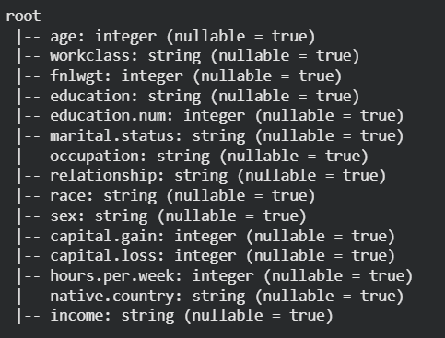  Schema  of the  CSV before  doing any  changes to  data  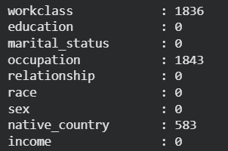  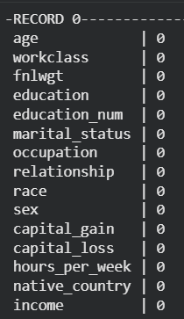  But colms are present with ? string  Here the dataset marked Null values with “?”  and not NULL or UNKNOWN strings  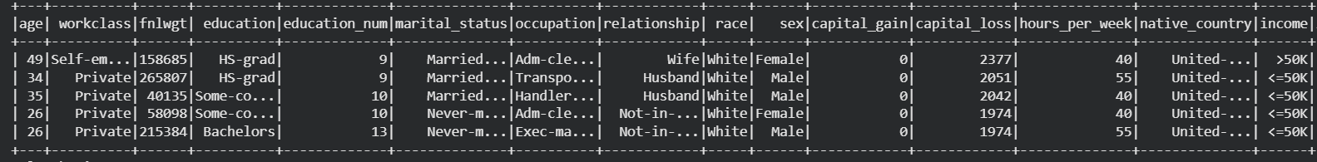  0 Null Values with Null keywords  Entire Dataset table shown above  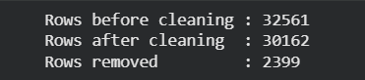  Rows after data cleaning stage    Dropping duplicate rows  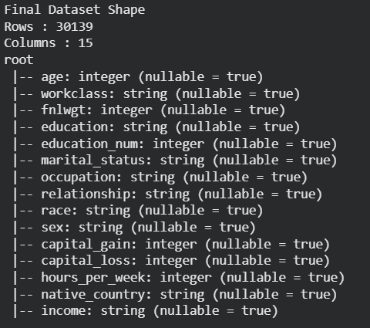  After completing data cleaning phase data frame schema    rows after cleaning in final df  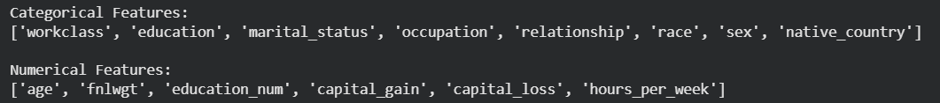  Categorical and Numerical Columns in Data Set  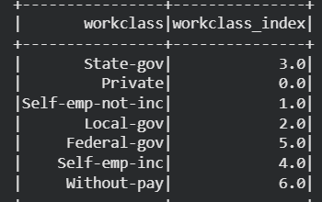  String Indexing sample for a single column “workclass”  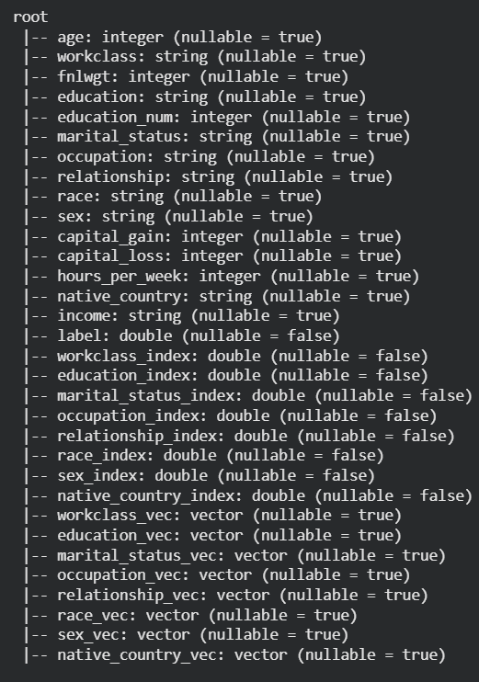  Now applying OHE on the string indexed columns  And the Schema after applying both steps  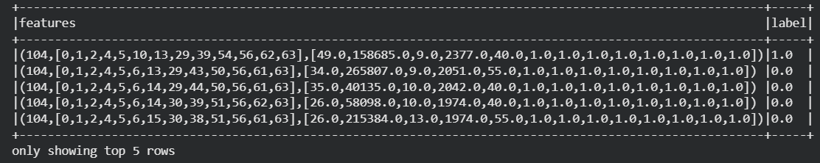  Vector Assembly output  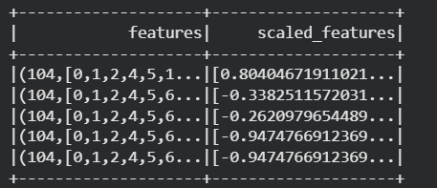  Standard Scaling those vectors  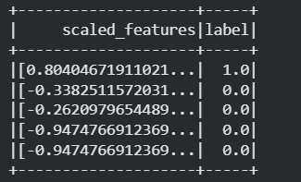  Final Data fame after scaling  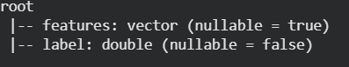  Final DF before training  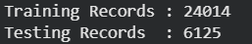  Record Spliting  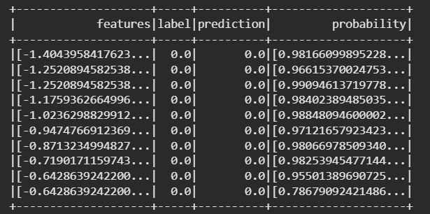  Predictions for the Data Set  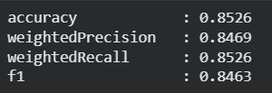  Accuracy and F1 Score  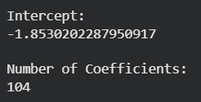  Coefficients of logistic model  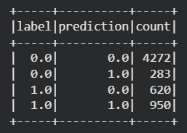  Some output metrices on the model
Conclusion: | A complete distributed machine learning workflow was successfully implemented using PySpark MLlib. The experiment demonstrated how feature engineering techniques such as StringIndexer, OneHotEncoder, VectorAssembler, and StandardScaler can be integrated into a unified Pipeline for efficient preprocessing and model training. Logistic Regression was trained on the processed dataset and evaluated using classification accuracy, producing satisfactory predictive performance. The experiment highlights the advantages of PySpark in building scalable machine learning applications capable of processing large datasets efficiently through distributed computing.

