**SUMMARY (29/05/2020)**

**Practical:-1 - how to create a new instance and key pair in AWS and checking different availability zones in Bombay.**

**Key pair - Login to console > Services > EC2> key pairs > create key pair >give name to your key>launch instance**

**Instance - Login to console > Services > EC2> >there are 7 steps for the instance>instances > launch instance> select OS > select instance type (RAM & CPU) > select network> add storage > configure security groups > add tags (labelling) > review and launch > launch**

**Images of the work which I have done:-**

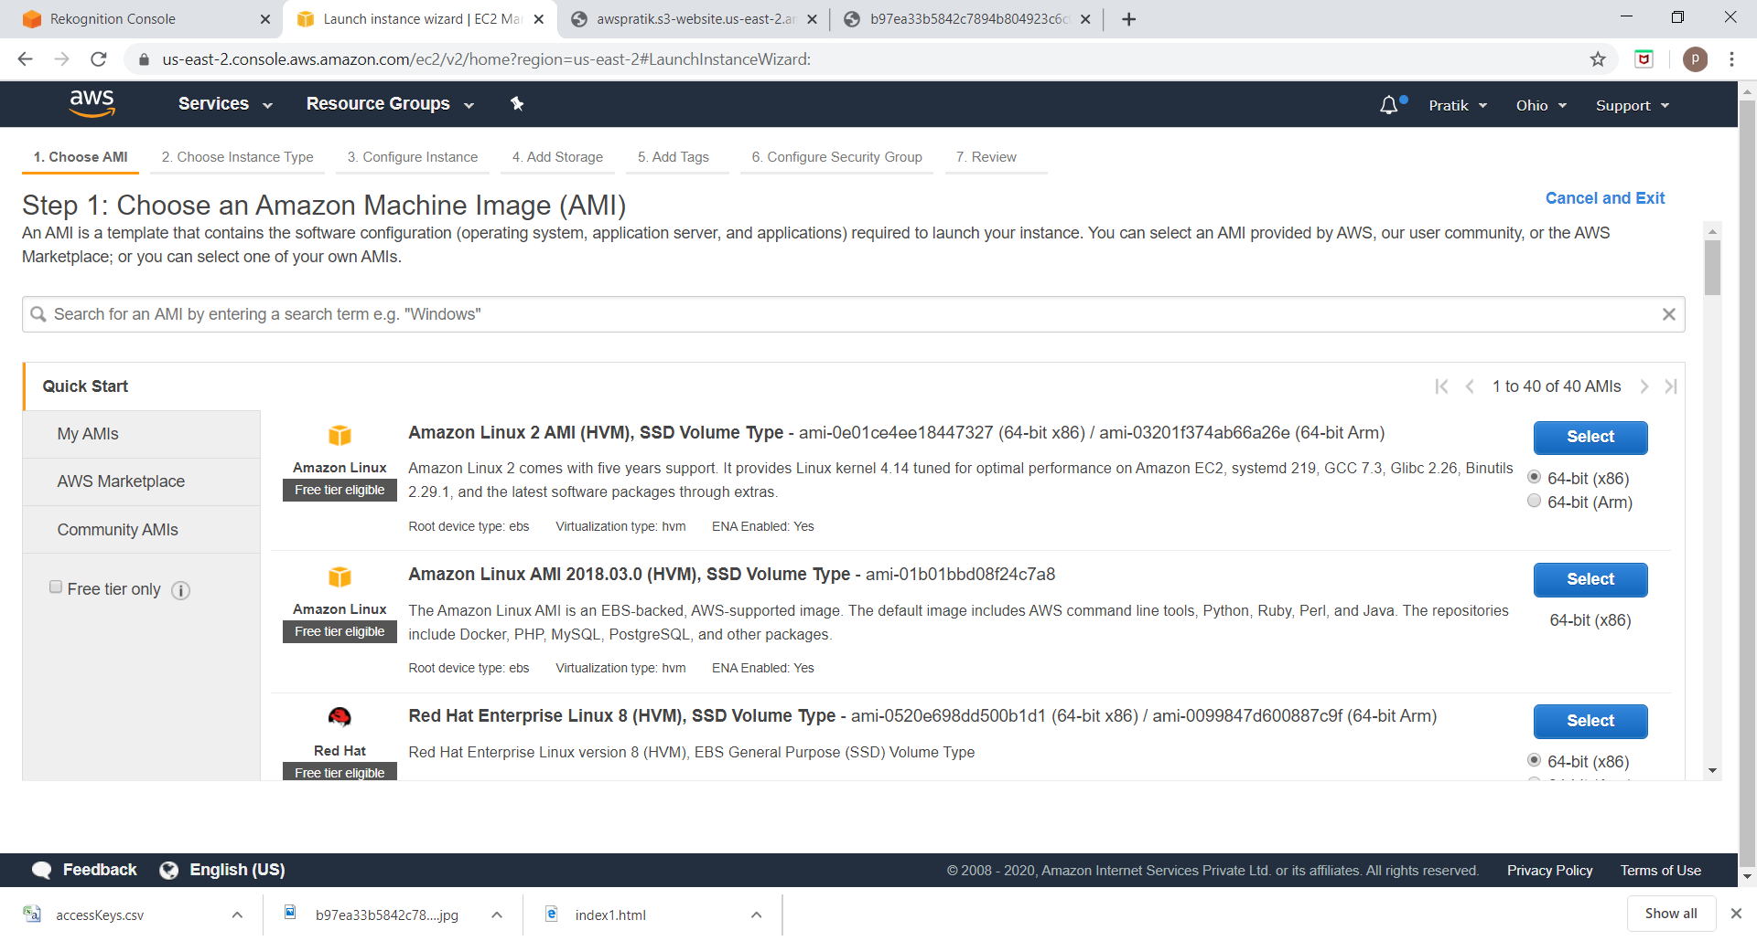

Fig1.step1

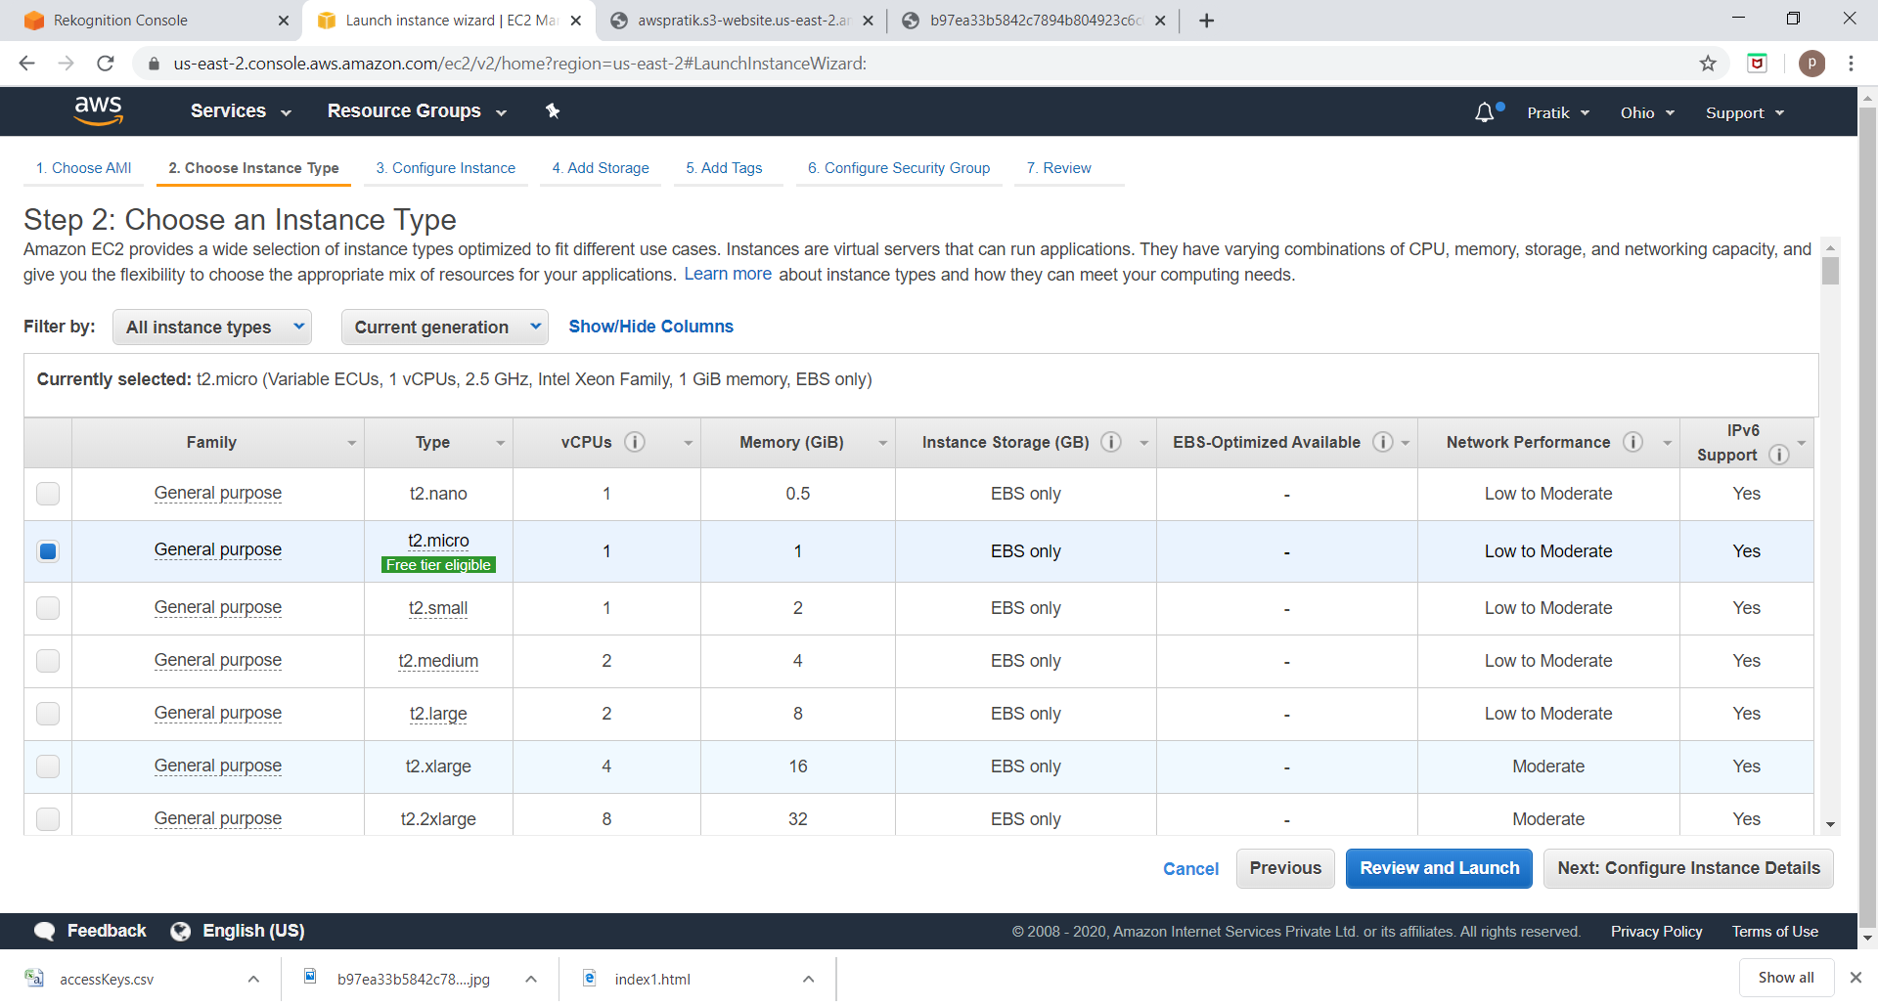

Fig2.step2

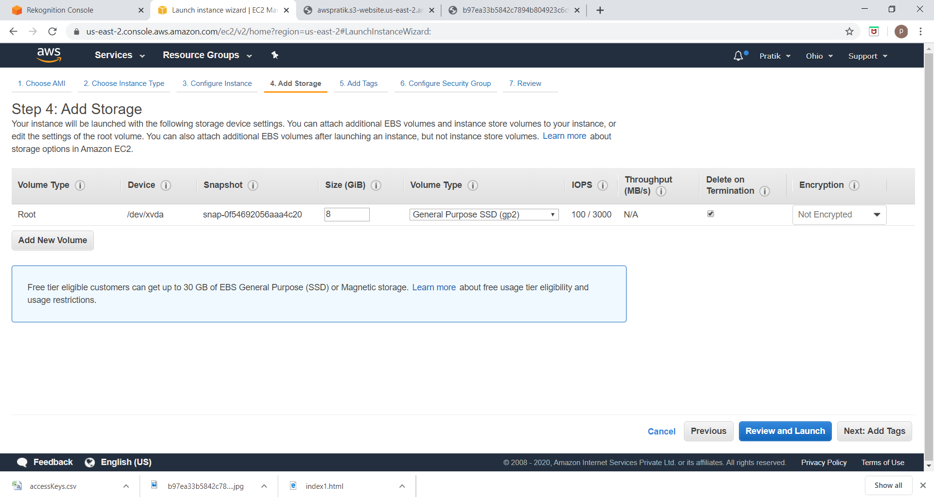

Fig3.step3

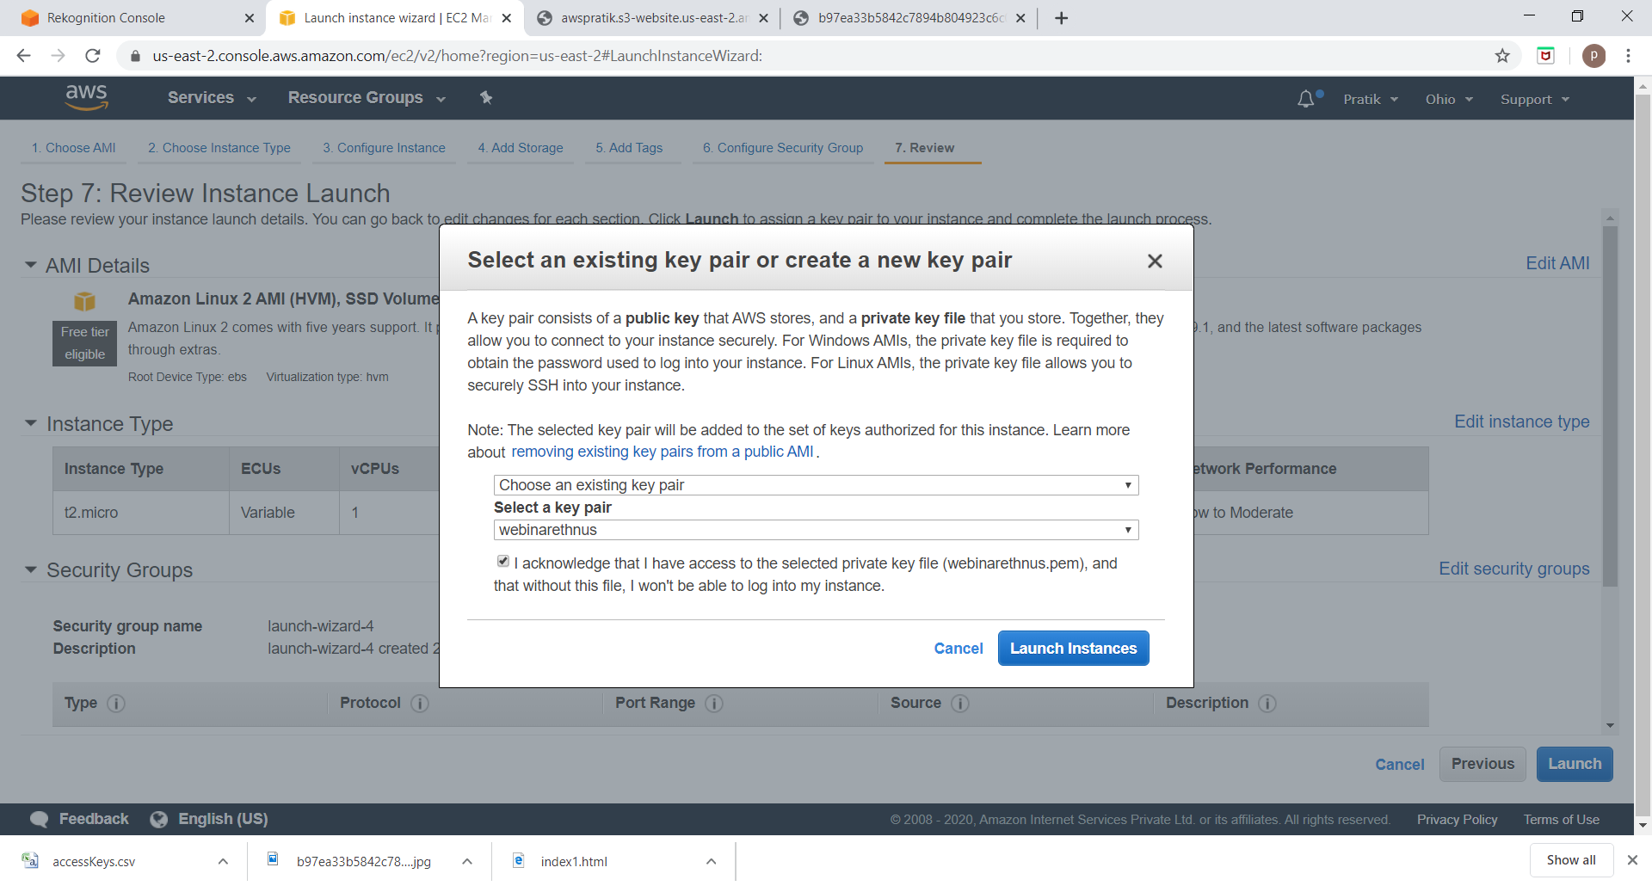

Fig4.step4

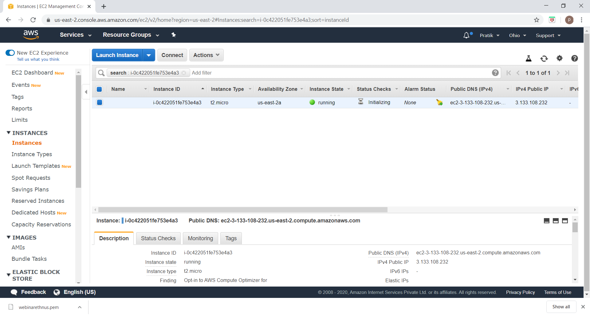

Fig5.step5

Pratik Kohad

1) Concepts:-Overview on Virtualization and multi-tenancy.

2) Overview on EC2,Subservice EBS,VPC.

3)The types of storage like object, file and block storage .Block storage as a service used in AWS as EBS (Elastic Block Storage) and in open stack as Cinder.

4)The concept of VPC that is Virtual Private Cloud.Learned about Tenant and landlords. The types of NAAS (Network As A Service)for AWS -->VPC and open stack -->Neutron.

5) For installing any of OS we require bootable DVD same here for AWS it uses AMI that is Amazon Mirror Image .