**SUMMARY(30/05/2020)**

**1.Overview on EC2 instances on Web UI.**

**2.Started with EC2 instances from CLI(i.e command line interface)**

**3. How to implement important commands in command prompt(windows)such as:(installed AWS CLI VERSION 2)**

**> aws ec2  help**

**> aws ec2  describe-instances**

**> aws ec2  describe-key-pairs**

**> aws ec2  describe-volumes**

**> aws ec2  start-instances  --instance-ids  i-071993b2d139e67a4**

**> aws ec2  stop-instances  --instance-ids  i-071993b2d139e67a4**

**> aws ec2 describe-images --owners amazon**

**> >aws ec2 describe-images --owners amazon  --query  "Images[0].[ImageId, Description, PlatformDetails]"**

**> aws ec2 describe-images --owners amazon  --query  "Images[*].[ImageId, Description, PlatformDetails]"**

**> aws ec2 describe-images  --image-ids  ami-0447a12f28fddb066**

**> aws ec2 describe-instance-types**

**> aws ec2 describe-instance-types --query "InstanceTypes[*].[InstanceType]"**

**> aws ec2 describe-instance-types --query "InstanceTypes[*].[InstanceType,MemoryInfo.SizeInMiB]"**

**> aws  ec2 describe-subnets --query "Subnets[0].[AvailabilityZone, SubnetId]"**

**> aws  ec2 describe-subnets --query "Subnets[*].[AvailabilityZone, SubnetId]"**

**> aws ec2  describe-key-pairs --query "KeyPairs[*].KeyName"**

**> aws ec2  describe-key-pairs --query "KeyPairs[*].[KeyName]"**

**>aws ec2 create-key-pair  --key-name mykey1**

**> aws ec2 create-key-pair  --key-name mykey4 --query "KeyMaterial" > mykey4.pem**

**> aws ec2 describe-security-groups --query "SecurityGroups[*].[GroupName, GroupId]"**

**> aws ec2 describe-security-groups --query "SecurityGroups[*].[GroupName, GroupId, Description]"**

**> aws ec2 describe-vpcs --query "Vpcs[*].VpcId"**

**> aws ec2 create-security-group --group-name MySecurityGroup --description "My security group" --vpc-id vpc-260c114e**

**> aws ec2 describe-security-groups --group-ids  sg-0de60e0111ed5da7f**

**>aws ec2 run-instances --security-group-ids  sg-0de60e0111ed5da7f --instance-type t2.micro --image-id  ami-0447a12f28fddb066 --key-name  mykey4 --subnet-id  subnet-884872e0 --count 1**

**> aws ec2 authorize-security-group-ingress --group-id sg-0de60e0111ed5da7f  --protocol tcp --port 22 --cidr 0.0.0.0/0**

**> aws ec2 describe-security-groups --group-ids  sg-0de60e0111ed5da7f**

**> aws ec2 describe-instances --query "Reservations[*].Instances[*].[InstanceId,PublicIpAddress,State.Name]"**

**> aws ec2 describe-instances --query "Reservations[*].Instances[*].[InstanceId,PublicIpAddress,State.Name,Tags[*].Value]"**

**4. 4.Using CLI we have done:-**

**---creation of keypair**

**---creation of muitiple instances**

**---checked keyname, and soon**

**IAM: IAM identity that you can create in your account that has specific permissions**

**5. We have learned various features of IAM which includes**

**--Shared access to your AWS account**

**--Secure access to AWS resources for applications that run on Amazon EC2**

**--power user access and administrative access where also done.**

**6.CLI Task was done successfully...**

Images:

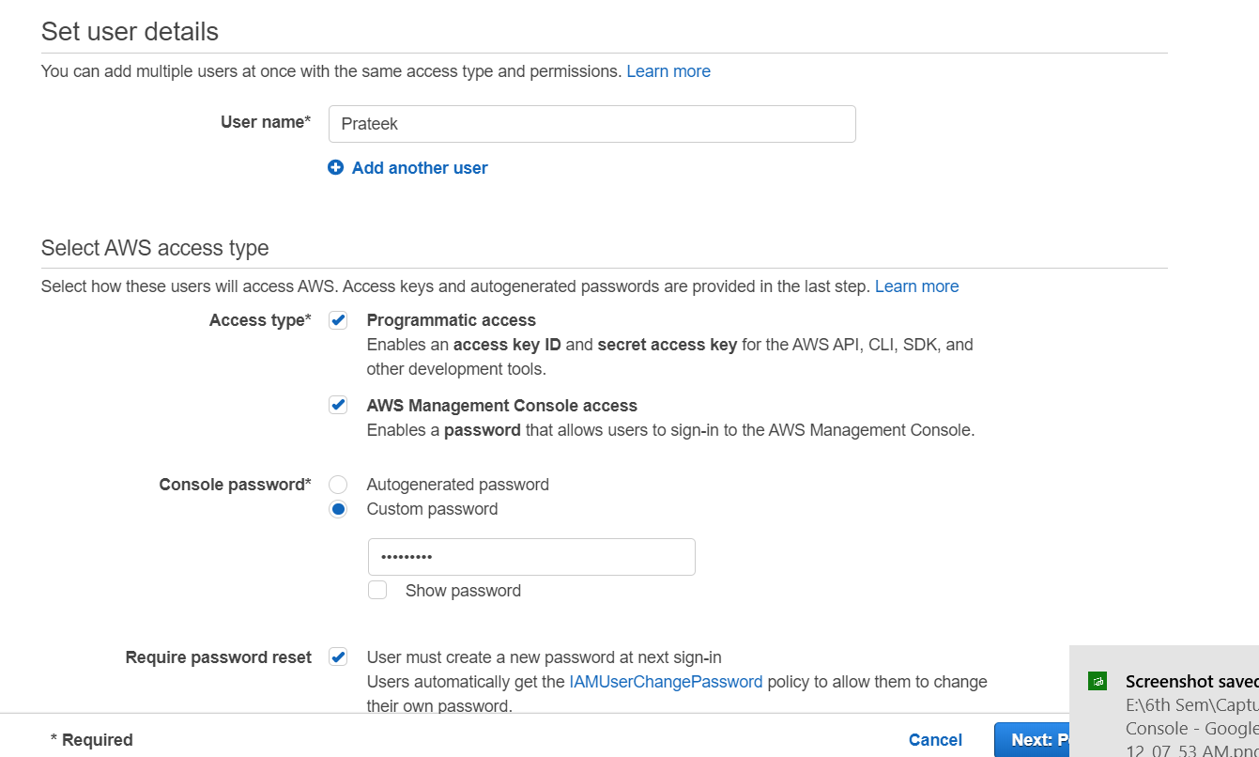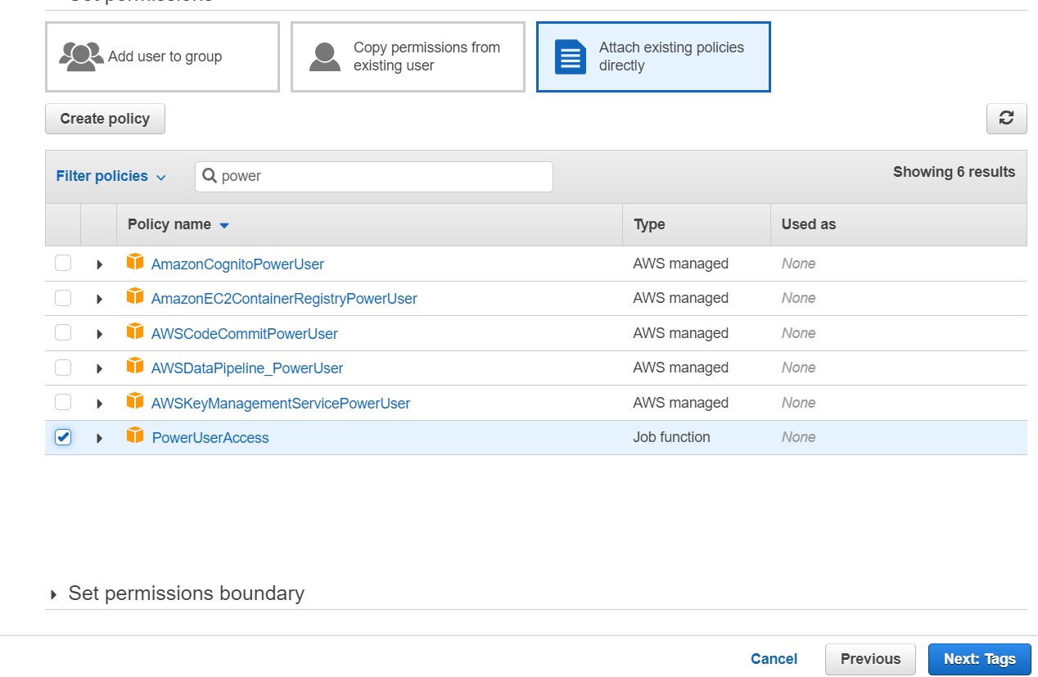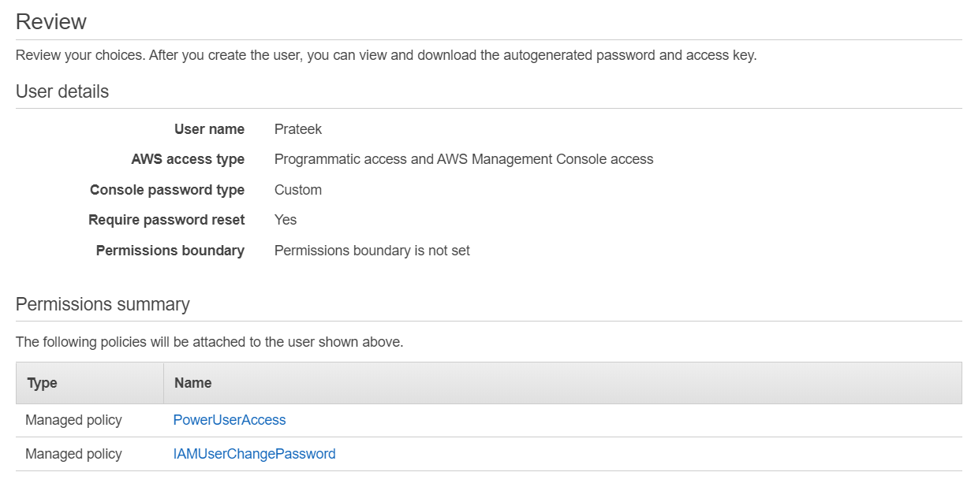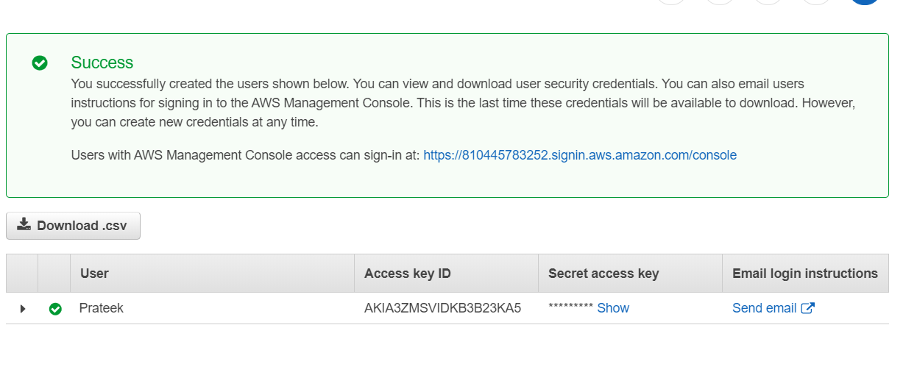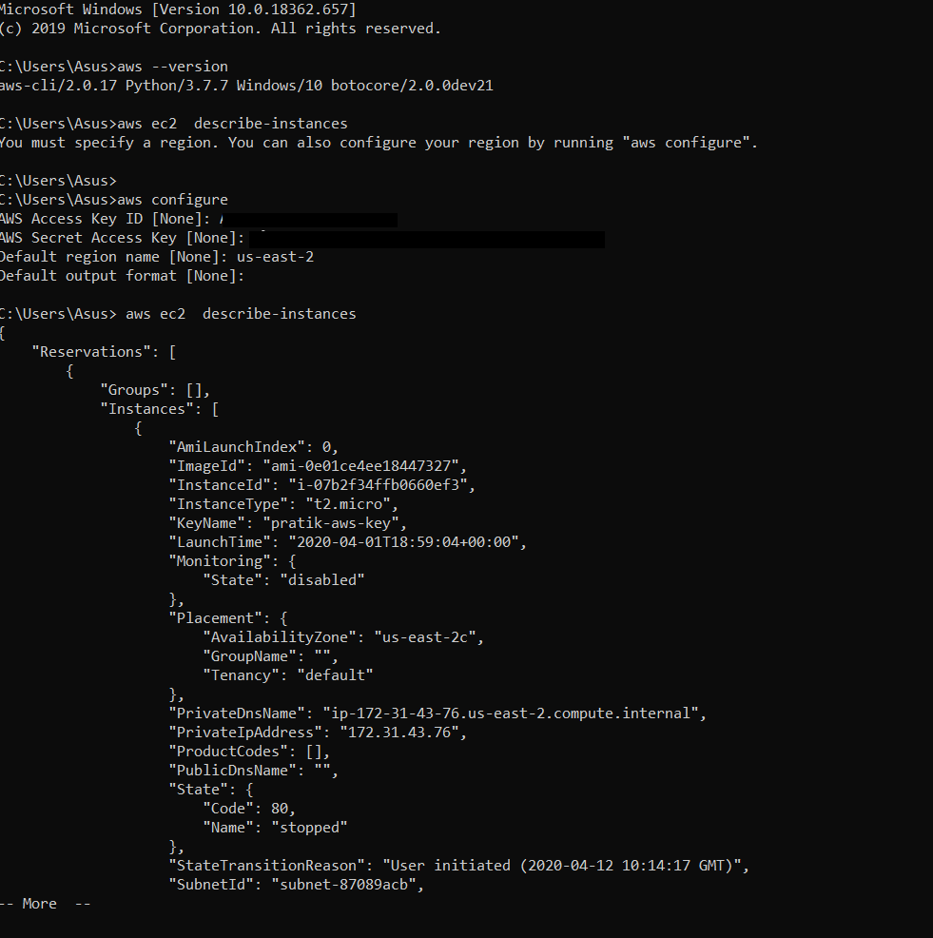

This are some basic cmd .I have given other commands in first and second screenshot.

Pratik Kohad