ARGUS DEFENSE CORE (ADC)
Team Understanding & Prototype Guide
AI-Orchestrated Multi-Agent Cyber Defense System
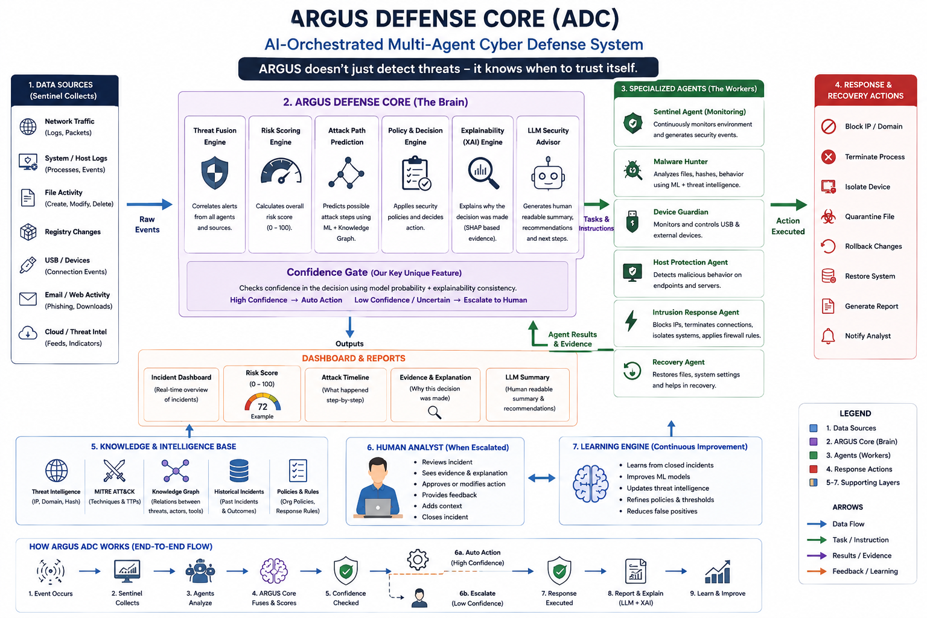

1. What is ARGUS Defense Core?
ARGUS Defense Core (ADC) is an AI-powered, multi-agent cybersecurity framework. It collects security events, sends relevant evidence to specialized agents, combines their findings, calculates threat risk, explains decisions, and selects an appropriate response.
The key safety idea is that ARGUS does not blindly trust an AI prediction. It checks the strength and consistency of evidence. High-confidence cases can proceed toward automated response; uncertain or conflicting cases are escalated to a human analyst.

2. The Problem We Are Solving
- Security environments generate huge numbers of events from networks, hosts, files, devices, email, and other sources.
- Different security tools often analyze different parts of an incident, making the complete attack story difficult to see.
- Analysts need a unified view of evidence, risk, explanation, and recommended response.
- Fully automatic response can be dangerous when the AI is uncertain.
- ARGUS aims to coordinate detection, evidence fusion, risk assessment, explanation, response, and human oversight.

3. Simple Example
A suspicious network event appears. Sentinel collects it. Relevant agents investigate it. ARGUS combines their findings and calculates a risk score. XAI explains the important evidence. The Confidence Gate checks whether the decision is trustworthy enough. High-confidence cases can trigger a controlled response; uncertain cases go to a human analyst.

4. End-to-End Flow
- Event occurs
- Sentinel collects and normalizes it
- Specialized agents investigate
- ARGUS fuses evidence and scores risk
- XAI explains the decision
- Confidence Gate checks trust
- Response or human escalation
- Report and explanation
- Outcome/feedback for improvement

5. Main Components

A. Sentinel Agent — The Eyes & Ears
Sentinel monitors the environment and produces structured security evidence.
- Network traffic/logs
- Processes and host events
- File activity
- Registry changes
- USB/external devices
- Email/web activity
- Cloud and threat-intelligence inputs

B. ARGUS Defense Core — The Brain
- Threat Fusion Engine — correlates evidence from agents and sources.
- Risk Scoring Engine — produces an overall risk score.
- Attack Path Prediction — reasons about possible next attack steps using available knowledge.
- Policy & Decision Engine — evaluates policies and chooses an appropriate response.
- Explainability/XAI Engine — explains why the model reached its conclusion.
- LLM Security Advisor — turns technical incident information into human-readable summaries and recommendations.

C. Specialized Agents — The Workers
Malware Hunter: Analyzes suspicious files, hashes, behavior, signatures, and malware indicators.
Device Guardian: Monitors external devices and applies device policies.
Host Protection Agent: Monitors endpoint integrity, processes, registry/startup behavior, and ransomware indicators.
Intrusion Response Agent: Supports containment actions such as blocking connections, isolating endpoints, or updating firewall rules.
Recovery Agent: Supports restoration and remediation, including rollback, health checks, and service recovery.

6. Confidence Gate — Our Key Research Direction
The Confidence Gate asks: “Is the evidence strong and consistent enough for ARGUS to trust its decision?”
- High confidence + strong supporting evidence → eligible for automated action.
- Low confidence, ambiguous prediction, or conflicting evidence → escalate to a human.
- The decision is accompanied by evidence and explanation rather than being a black-box action.
The thresholds must be experimentally validated. We should report precision, recall, F1, false positives, false negatives, escalation rate, and response latency rather than choosing thresholds only for a demonstration.

7. AI/ML Technologies
- XGBoost — supervised threat/risk classification.
- Isolation Forest — complementary anomaly detection.
- SHAP — feature-level explanations.
- LLM — human-readable incident summaries/recommendations.
- MITRE ATT&CK — threat-technique mapping.
- FastAPI — backend/API.
- React — dashboard.
- SQLite/PostgreSQL — prototype storage.

8. Datasets / Knowledge Sources
- CIC-IDS2017 or CSE-CIC-IDS2018 — network intrusion data.
- Edge-IIoTset — optional IoT/network extension.
- EMBER — optional malware static-feature dataset.
- MITRE ATT&CK STIX — structured adversary techniques and relationships.
- VirusTotal API — optional threat-intelligence/hash lookup, subject to access and API limits.
For the first prototype, start with one reliable pipeline rather than attempting to train every agent on every dataset.

9. Prototype Scope
- Sentinel ingestion for a limited set of security/network events.
- Threat Fusion + Risk Scoring pipeline.
- XGBoost baseline and Isolation Forest signal.
- SHAP explanation.
- Confidence Gate with validated thresholds.
- One or two operational agents for the first demonstration, such as Malware Hunter and Intrusion Response.
- MITRE ATT&CK lookup/mapping.
- LLM incident summary.
- Dashboard showing incident, risk, evidence, confidence, decision, and response.

10. Dashboard
- Incident list
- Risk score 0–100
- Threat classification
- Top contributing evidence/features
- SHAP explanation
- Confidence and gate result
- Automated action vs human escalation
- Agent findings
- MITRE ATT&CK mapping
- Response status
- LLM summary

11. Team Responsibilities
Frontend: Dashboard, incident views, risk visualization, evidence/XAI panels and decision trail.
Backend: FastAPI, event/incident schemas, orchestration, database, and interfaces to models/agents.
AIML 1: Preprocessing interface, XGBoost training, evaluation, model saving and prediction.
AIML 2: Anomaly detection, SHAP/XAI, Confidence Gate and threshold experiments.
Data Engineer: Dataset pipelines, cleaning, feature schemas, MITRE data, ETL and storage.

12. What We Should NOT Do Initially
- Do not build all six agents at enterprise scale immediately.
- Do not collect dozens of datasets before the first pipeline works.
- Do not claim production readiness without testing.
- Do not claim novelty merely because the system uses AI, agents, SHAP, or an LLM.
- Do not prioritize a beautiful dashboard over a reliable decision pipeline.
- Do not invent performance numbers; report actual experiments.

13. The Demo We Want
- A security event enters Sentinel.
- Agents investigate it.
- ARGUS fuses evidence and calculates risk.
- SHAP shows the important factors.
- Confidence Gate checks whether the decision is trustworthy.
- ARGUS performs a controlled simulated response or escalates to a human.
- The dashboard shows the complete decision trail and understandable report.

14. One-Minute Explanation for the Team
“ARGUS is like a cybersecurity control center with specialist investigators. Sentinel notices and collects suspicious activity. The agents investigate different parts of the incident. The ARGUS Core combines their findings and calculates danger. SHAP explains why the AI thinks it is dangerous. The Confidence Gate checks whether the evidence is strong enough to trust. If yes, ARGUS can trigger a controlled response; if not, it asks a human analyst to decide. The system records the outcome for future improvement.”

15. Research Questions
- Can multi-agent evidence improve threat decisions compared with a single detector?
- Can explainability help determine whether an automated decision should be trusted?
- Does confidence gating reduce unsafe automated actions while keeping response time acceptable?
- How should thresholds balance false positives, false negatives, and human escalations?
- How should ARGUS behave when agents disagree?

16. Important Positioning
ARGUS should be presented as a research prototype and experimental framework, not as a finished commercial cybersecurity product. Its research direction combines multi-agent evidence, explainability, and confidence-aware response. Claims of uniqueness must be supported by a literature review and experiments against appropriate baselines.

