**Assignmnet 4**

1. *Write a program in java to sort an ArrayList of string type in alphabetical order.*

**import** java.util.ArrayList;

**import** java.util.Scanner;

**public** **class** pro1 {

**public** **static** **void** main(String[] args) {

ArrayList<String> strList = **new** ArrayList<String>();

Scanner sc = **new** Scanner(System.**in**);

System.**out**.print("Enter no. of Names : ");

**int** size = sc.nextInt();

String []strArray = **new** String[size];

System.**out**.println("Enter "+size+" names : ");

**for**(String strTemp : strArray) {

strTemp = sc.next();

strList.add(strTemp);

}

System.**out**.println("Unsorted ArrayList : "+strList);

strList.sort(String::compareToIgnoreCase);

System.**out**.println("Sorted ArrayList : "+strList);

}

}

Output:

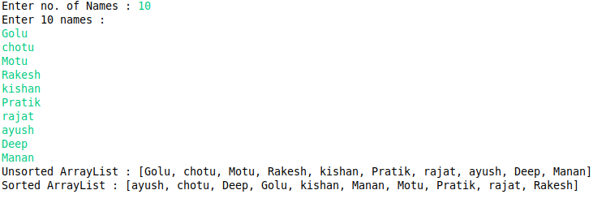

1. *Write a program in java to sort an ArrayList of string type in reverse alphabetical order i.e. in Descending Order.*

**import** java.util.ArrayList;

**import** java.util.Collections;

**import** java.util.Scanner;

**public** **class** pro2 {

**public** **static** **void** main(String[] args) {

ArrayList<String> strList = **new** ArrayList<String>();

Scanner sc = **new** Scanner(System.**in**);

System.**out**.print("Enter no. of Names : ");

**int** size = sc.nextInt();

String []strArray = **new** String[size];

System.**out**.println("Enter "+size+" names : ");

**for**(String strTemp : strArray) {

strTemp = sc.next();

strList.add(strTemp);

}

System.**out**.println("Unsorted ArrayList : "+strList);

strList.sort(String::compareToIgnoreCase);

System.**out**.println("Sorted ArrayList : "+strList);

Collections.reverse(strList);

System.**out**.println("Sorted Reverse ArrayList : "+strList);

}

}

Output:

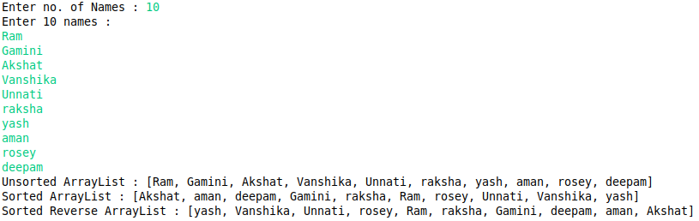

1. *Write a java program to add elements in an ArrayList using add() method.*

**import** java.util.ArrayList;

**public** **class** pro3 {

**public** **static** **void** main(String[] args) {

ArrayList list = **new** ArrayList();

list.add("I");

list.add("love");

list.add("Java");

list.add(100);

list.add(200);

list.add(list);

System.**out**.println("The Final ArrayList : ");

System.**out**.println(list);

}

}

Output:

pro3

1. *Write a java program to add elements in an ArrayList at a particular index.*

**import** java.util.ArrayList;

**public** **class** pro3 {

**public** **static** **void** main(String[] args) {

ArrayList list = **new** ArrayList();

list.add("I");

list.add(1, "love");

list.add(0, "Java");

list.add(2, 100);

list.add(3, 200);

list.add(1, list);

System.**out**.println("The Final ArrayList : ");

System.**out**.println(list);

}

}

Output:

pro4

1. *Write a java program to copy and add all the elements of a list to an ArrayList.*

**import** java.util.ArrayList;

**import** java.util.List;

**public** **class** pro5 {

**public** **static** **void** main(String[] args) {

List list = **new** ArrayList<>();

list.add("Hello !");

list.add("How");

list.add("Are");

list.add("you");

list.add(10);

list.add(20);

list.add(30);

ArrayList al = **new** ArrayList();

al.add("This");

al.add(45);

al.add("is");

al.add("Java");

System.**out**.println("The List : "+list);

System.**out**.println("The ArrayList (before) : "+al);

al.addAll(list);

System.**out**.println("The ArrayList (after) : "+al);

}

}

Output:

pro5

1. *Write a java program to get Sub List of an Array List.*

**import** java.util.ArrayList;

**import** java.util.List;

**public** **class** pro6 {

**public** **static** **void** main(String[] args) {

List list = **new** ArrayList<>();

list.add("Hello !");

list.add("How");

list.add("Are");

list.add("you");

list.add(10);

list.add(20);

list.add(30);

ArrayList al = **new** ArrayList();

al.add("This");

al.add(45);

al.add("is");

al.add("Java");

System.**out**.println("The List : "+list);

System.**out**.println("The ArrayList (before) : "+al);

al.addAll(list);

System.**out**.println("The ArrayList (after) : "+al);

List subList = **new** ArrayList();

subList = al.subList(3, 8);

System.**out**.println("The Sub List from index 3 to 8 : "+subList);

}

}

Output:

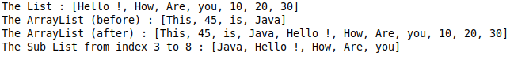

1. *Write java program to whether element is exists in the ArrayList.*

**import** java.util.ArrayList;

**import** java.util.List;

**public** **class** pro7 {

**public** **static** **void** main(String[] args) {

List list = **new** ArrayList<>();

list.add("Hello !");

list.add("How");

list.add("Are");

list.add("you");

list.add(10);

list.add(20);

list.add(30);

ArrayList al = **new** ArrayList();

al.add("This");

al.add(45);

al.add("is");

al.add("Java");

al.addAll(list);

System.**out**.println("The ArrayList : "+al);

System.**out**.println("The ArrayList contains 10 : "+al.contains(10));

System.**out**.println("The ArrayList contains 40 : "+al.contains(40));

System.**out**.println("The ArrayList contains Java : "+al.contains("Java"));

System.**out**.println("The ArrayList contains Hello : "+al.contains("Hello"));

System.**out**.println("The ArrayList contains 'Hello !' : "+al.contains("Hello !"));

System.**out**.println("The ArrayList contains Love : "+al.contains("Love"));

}

}

Output:

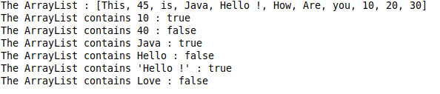

1. *Write java program to swap two elements in an ArrayList.*

**import** java.util.ArrayList;

**import** java.util.Collections;

**import** java.util.List;

**public** **class** pro8 {

**public** **static** **void** main(String[] args) {

List list = **new** ArrayList<>();

list.add("Hello !");

list.add("How");

list.add("Are");

list.add("you");

list.add(10);

list.add(20);

list.add(30);

ArrayList al = **new** ArrayList();

al.add("This");

al.add(45);

al.add("is");

al.add("Java");

al.addAll(list);

System.**out**.println("The ArrayList (before swappping): "+al);

Collections.swap(al, 0, 1);

Collections.swap(al, 4, 0);

Collections.swap(al, 4, 5);

Collections.swap(al, 5, 6);

Collections.swap(al, 6, 7);

System.**out**.println("The ArrayList (after swappping): "+al);

}

}

Output:

pro8

1. *Write java program to search elements in vector using index.*

**import** java.util.Vector;

**public** **class** Pro09 {

**public** **static** **void** main(String[] args) {

Vector<String> vec = **new** Vector<String>();

vec.add("Rakesh");

vec.add("Kamal");

vec.add("Prakash");

vec.add("Monti");

vec.add("Pooja");

vec.add("Rakesh");

vec.add("Ambika");

vec.add("Madhu");

vec.add("Keshav");

vec.add("Rakesh");

System.**out**.println("First occurence of Rakesh : "+vec.indexOf("Rakesh"));

System.**out**.println("First occurence of Madhu : "+vec.indexOf("Madhu"));

System.**out**.println("Last occurence of Rakesh : "+vec.lastIndexOf("Rakesh"));

System.**out**.println("First occurence of Rakesh after index 3: "+vec.indexOf("Rakesh",3));

System.**out**.println("Last occurence of Rakesh before 5: "+vec.lastIndexOf("Rakesh",5));

}

}

Output:

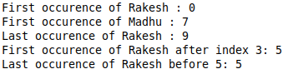

1. *Write a java program to copy elements of one vector to another and display elements of both the vectors.*

**import** java.util.Collections;

**import** java.util.Vector;

**public** **class** Pro10 {

**public** **static** **void** main(String[] args) {

Vector v1 = **new** Vector();

v1.add("One");

v1.add("Two");

v1.add("Three");

v1.add("Four");

Vector v2 = **new** Vector();

v2.add(1);

v2.add(2);

v2.add(3);

v2.add(4);

v2.add(5);

v2.add(6);

System.**out**.println("Vector v1 : "+v1);

System.**out**.println("Vector v2 (before copy): "+v2);

Collections.copy(v2, v1);

System.**out**.println("Vector v2 (after copy): "+v2);

}

}

Output:

Pro10

1. *Write java program to remove element from specified index in Vector.*

**import** java.util.Collections;

**import** java.util.Vector;

**public** **class** Pro11 {

**public** **static** **void** main(String[] args) {

Vector v1 = **new** Vector();

v1.add("One");

v1.add("Two");

v1.add("Three");

v1.add("Four");

v1.add(1);

v1.add(2);

v1.add(3);

v1.add(4);

v1.add(5);

v1.add(6);

System.**out**.println("Original Vector :"+v1);

v1.remove(6);

System.**out**.println("Removed index 6 :"+v1);

v1.removeElementAt(2);

System.**out**.println("Removed index 2 :"+v1);

}

}

Output:

Pro11

1. *Write a java program to concert vector to ArrayList.*

**import** java.util.ArrayList;

**import** java.util.Collections;

**import** java.util.Vector;

**public** **class** Pro12 {

**public** **static** **void** main(String[] args) {

Vector vector = **new** Vector();

vector.add("One");

vector.add("Two");

vector.add("Three");

vector.add("Four");

vector.add(1);

vector.add(2);

vector.add(3);

vector.add(4);

vector.add(5);

vector.add(6);

System.**out**.println("Vector :"+vector);

ArrayList al = **new** ArrayList(vector);

System.**out**.println("ArrayList :"+al);

}

}

Output;

Pro12

1. *Write a java program to sort vector using Collections.sort()*

**import** java.util.ArrayList;

**import** java.util.Collections;

**import** java.util.Vector;

**public** **class** Pro13 {

**public** **static** **void** main(String[] args) {

Vector vector = **new** Vector();

vector.add("One");

vector.add("Two");

vector.add("Three");

vector.add("Four");

vector.add("Five");

vector.add("Six");

vector.add("Seven");

vector.add("Eight");

vector.add("Nine");

vector.add("Ten");

System.**out**.println("Vector (before sort) :"+vector);

Collections.sort(vector);

System.**out**.println("Vector (before sort) :"+vector);

}

}

Output:

Pro13

1. *Write a java program to replace element in a vector.*

**import** java.util.ArrayList;

**import** java.util.Collections;

**import** java.util.Vector;

**public** **class** Pro14 {

**public** **static** **void** main(String[] args) {

Vector vector = **new** Vector();

vector.add("Zero");

vector.add("One");

vector.add("Two");

vector.add("Three");

vector.add("Four");

vector.add("Five");

vector.add("Six");

vector.add("Seven");

vector.add("Eight");

vector.add("Nine");

vector.add("Ten");

System.**out**.println("Vector (before replace) :"+vector);

vector.set(2, 2);

vector.set(4, "4");

vector.set(7, 8);

vector.set(10, "End");

System.**out**.println("Vector (after replace) :"+vector);

}

}

Output:

Pro14