When Is Label-Free Adaptation Knowable?
Helpful, Harmful, and Unknowable Regimes Under Distribution Shift
Pratik Niroula
Minnesota State University, Mankato

Abstract
Test-time adaptation (TTA) can improve a model on unlabeled target data, but the same update can also silently harm performance. We study the decision that comes before adaptation: should a model adapt, freeze, or abstain? Our central theory result is an exact benefit-sign frontier: over a declared calibration-drift class, the sign of adaptation benefit is identifiable from label-free evidence iff an observable disagreement-region margin exceeds the admitted drift budget, $|M|>β$. Below this frontier, matched label-free evidence can still imply opposite actions, so abstention is information-theoretically necessary.
We instantiate this as Knowability-Guided Adaptation (KGA), a mechanism-agnostic certificate wrapper around existing TTA methods. Under stated coverage, exchangeability, and risk-alignment assumptions, KGA controls unconditional false-adapt and false-freeze probabilities. Empirically, we organize nine benchmark tracks under one evaluation contract and explicitly separate locked, reconciled, provisional, and diagnostic evidence. Confirmatory beats-both results occur in identifiable mixed regimes; reconciled natural-shift results demonstrate no-harm or abstention rather than universal improvement. A constructed three-source mixture is reported separately as a routing result, not as cross-dataset transfer. K-Bound is a safety layer, not a universal accuracy booster.
Index Terms— test-time adaptation, distribution shift, selective prediction, identifiability, label-free risk estimation

I. Introduction
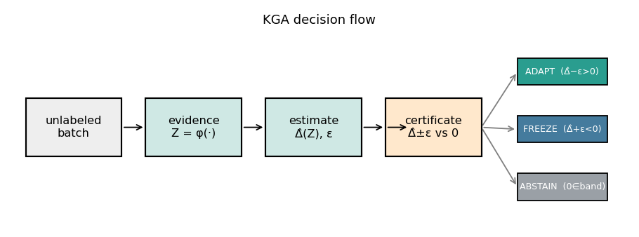
Fig. 1. K-Bound previews the decision. From an unlabeled batch under shift, the certificate estimates the adaptation benefit $\hat{Δ}$ with a finite-sample radius $ε$ and returns adapt (knowably helpful), freeze (knowably harmful), or abstain (sign unidentifiable), with false-adapt/false-freeze $≤α$.
Test-time adaptation (TTA) updates a model on the unlabeled test stream and, under favorable distribution shift, recovers accuracy. Under unfavorable shift, the same objective silently degrades it, and with no target labels the system usually cannot tell which case it faces. The decision that matters therefore comes before the update: given a frozen baseline $f_{0}$ and an adapted candidate $f_{a}$, choose adapt when adaptation is knowably helpful, freeze when knowably harmful, or abstain when label-free evidence cannot identify the sign of the benefit. The field’s default assumption is that adaptation should be made robust enough to always run; we replace it with an explicit, certified decision about whether to run it at all.
Some cases are information-theoretically unknowable. It is established that label-free quantities cannot decide adaptation without an assumption on the shift: identifying OOD accuracy is as hard as identifying the optimal predictor [13], and the optimal predict-versus-abstain rule under a shift budget has a known form [14]. We sharpen this landscape, for the benefit sign, into a computable criterion: whether adaptation helps or hurts is label-free identifiable if and only if an observable margin exceeds the calibration-drift budget on the disagreement region, i.e. $|M|>β$ (Theorem 2). On the unidentifiable side, two target worlds carry identical label-free evidence but opposite benefit, so no label-free rule can be correct in both (Theorem 1) and abstention is forced. KGA (Algorithm 1), a benefit estimator plus a conformal radius wrapped around any adapter (Tent, EATA, SAR), operationalizes the frontier as a finite-sample certificate holding false-adapt and false-freeze at level $α$ (Theorem 3).
Throughout, always-adapt and always-freeze denote the two fixed reference policies: always-adapt runs the adapter on every incoming batch, while always-freeze never adapts and keeps the source model unchanged. Regret is the accuracy lost relative to a per-condition oracle that picks the better of these two policies for each condition, and a gate beats both when its regret is lower than that of either fixed policy.
The evidence follows the regime map in Table I. Identifiable mixed harmful+helpful regimes supply the beats-both policy wins, including a pre-registered head-to-head over protocol-matched POEM-style and AETTA-style baselines. Natural shifts primarily test safety: a reconciled result may tie the better fixed policy, while a provisional result remains outside the headline until its saved summary and canonical replay agree. K-Bound does not claim universal improvement: when adaptation is already safe, a valid certificate can only tie always-adapt. It provides a safety layer for TTA rather than an accuracy boost.

Plain-language takeaway.
If label-free evidence is strong enough relative to declared drift ($|M|>β$), the system can certify adapt or freeze; if not, it should abstain. On single natural-shift datasets this mostly acts as safety or abstention. Beats-both wins require a detectable mixed regime; a constructed pooled mixture is reported as such, not as a claim of single-dataset natural-shift dominance.

Contributions.
- Problem framing. Label-free TTA as a certified adapt/freeze/abstain decision on the sign of the adaptation benefit.
- Exact frontier. The benefit sign is label-free identifiable iff $|M|>β$; below the frontier, matched evidence forces abstention (Theorems 1, 2; § III).
- Finite-sample certificate. KGA controls the unconditional false-adapt/false-freeze rate at level $α$ under stated coverage (Theorem 3); existing label-free estimators are its $β=0$ face.
- Drop-in method. KGA wraps Tent/EATA/SAR without changing their adaptation objectives (Algorithm 1; § IV).
- Uniform empirical accounting. A nine-track panel reports the same metrics, split logic, and evidence tier for every benchmark; only locked or reconciled results are promoted to empirical claims (§ V).
TABLE I. Regime map: expected behavior vs. result. Each regime, an example dataset, the behavior the frontier predicts for a valid certificate, and what was measured. “No-harm” = matches the better fixed policy and beats the worse, without beating both; “beats both” = lower regret than always-adapt and always-freeze. The evidence tier in Table VII states whether that point verdict is CI-confirmed, reconciled, provisional, or diagnostic.
Regime | Example | Expected | Result
Helpful-dominated | Camelyon17 OOD | tie always-adapt | reconciled no-harm
Harmful-dominated | RxRx1; iWildCam/Office-Home OOF summaries | tie always-freeze, beat always-adapt | no-harm / provisional
Domain-gen. natural | PACS (4 LODO splits) | no-harm or abstain | three safety tracks; one null
Mixed + detectable | CIFAR-10-C stress, ImageNet-C SAR | beat both fixed policies | CI-confirmed (both)
Weak evidence | ImageNet-R, CIFAR-10.1 | abstain / conservative | diagnostic; no promoted win
Constructed mixture | three-source OOF stream | route per condition, beat both | supported routing result, not transfer
Table note. The uniform panel below is the sole empirical index; diagnostic variants and historical runs are not additional evidence for the headline claims.

II. Related work
The core distinction in adjacent literature is between improving an unlabeled objective and certifying whether adaptation is beneficial before acting.

The gap.
In prior work, TTA methods improve or guard adaptation reactively, label-free estimators target accuracy rather than the adaptation-benefit sign, and impossibility results do not yield an exact pre-adaptation boundary for when $\text{sign}(R_{T}(f_{0})−R_{T}(f_{a}))$ is knowable from label-free evidence and when abstention is mandatory. K-Bound fills this gap with an exact benefit-sign frontier ($|M|>β$), a mandatory unknowable region under matched evidence, and KGA: a finite-sample adapt/freeze/abstain certificate that controls false-adapt at level $α$ before any update is committed.

TTA algorithms and guarded adaptation.
Tent [1], SHOT [2], TTT [3], EATA [4], SAR [5], CoTTA [6], and MEMO [7] improve adaptation mechanics but still commit to adaptation (survey: [67]). Guarded variants such as POEM [11], sequential monitors [9, 10], PeTTA [74], and sample-level gates like DeYO [75] intervene during or after adaptation, usually for one failure direction. K-Bound instead makes a deployment-time adapt/freeze/abstain decision and controls false-adapt on the benefit sign.

Label-free performance estimation.
ATC [13], agreement-on-the-line [15, 16], and AETTA [18], along with related confidence-style estimators [65, 66], estimate target performance without labels. Garg et al. [13] show the governing limitation: identifying OOD accuracy is as hard as identifying the optimal predictor, so validity requires shift assumptions. We organize rather than compete with this line: ATC/DoC/GDE/COT/AETTA and agreement-on-the-line are the $β=0$ face of our frontier, sound when calibration drift is negligible. The target in K-Bound is different: certifying $\text{sign}(R_{T}(f_{0})−R_{T}(f_{a}))$, not estimating $R_{T}(f)$.

Impossibility and abstention under shift.
We specialize, rather than re-derive, known impossibility and abstention results. Garg et al. [13] provide the impossibility backdrop; Kalai and Kanade [14] give the corresponding abstain-versus-predict decision form. Related unsupervised-risk and selective- prediction results [21, 22, 25, 37] also require structural assumptions. K-Bound contributes the exact, computable boundary $|M|>β$ for when label-free benefit-sign decisions are certifiable and when abstention is information-theoretically forced.

III. Problem setup and theory
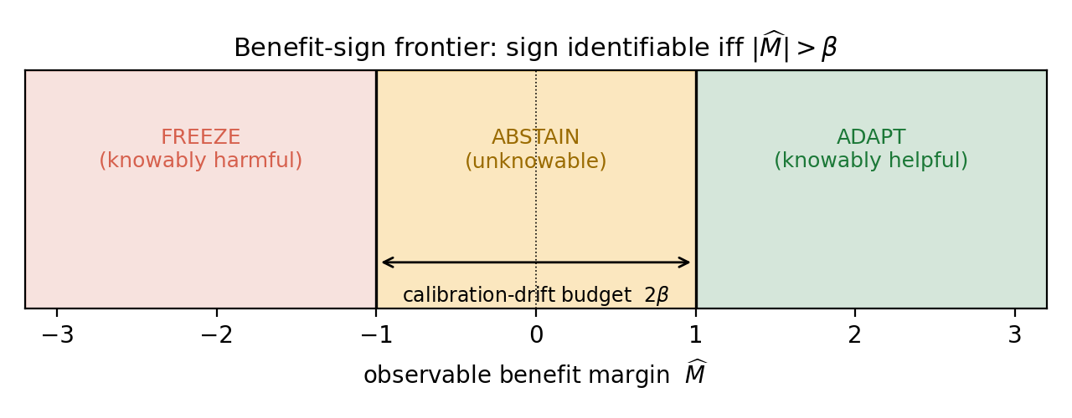
Fig. 2. The benefit-sign frontier. The sign of the adaptation benefit is identifiable from label-free evidence iff the observable margin $|\hat{M}|$ exceeds the calibration-drift budget $β$. Outside the band KGA adapts (knowably helpful) or freezes (knowably harmful); inside the band (the unknowable region), abstention is information-theoretically forced. ($\hat{M}$ is the finite-sample estimate of the population margin $M$ of Theorem 2.)
Source $P_{S}(X,Y)$ has labels at train/validation; target $P_{T}(X,Y)$ exposes only $P_{T}(X)$ at test time. The central question is when $\text{sign}Δ$ is recoverable from label-free evidence $Z$ alone. Risk alignment (Definition 1) governs identifiability; coverage governs the finite-sample certificate (Theorem 3). When $Z$ is not risk-aligned, Theorem 1 forces abstention.
Source law $P_{S}(X,Y)$ supplies labels at train/validation; target law $P_{T}(X,Y)$ exposes only $P_{T}(X)$ at deployment. Fix loss $ℓ$, frozen predictor $f_{0}$, candidate $f_{a}$, and target measure $μ_{T}$ on inputs. Write target risk $R_{T}(f)=E_{P_{T}}[ℓ(f(X),Y)]$ and the adaptation benefit
$$Δ := R_{T}(f_{0})−R_{T}(f_{a}) (Δ>0 ⇔ \text{adapting helps}).$$
The disagreement region $D:=\{x:f_{0}(x)≠f_{a}(x)\}$ is observable from $(f_{0},f_{a})$.
Assumption 1 (Deployment setup). Unless stated otherwise: binary label $Y∈\{0,1\}$, $0/1$ loss $ℓ$, and $μ_{T}(D)>0$. Fix a source-calibrated score $s:X→[0,1]$ for $f_{a}$ (e.g. a Platt-scaled probability) and the target conditional accuracy $η_{a}(x):=P_{T}(Y=1∣f_{a}(x)=1)$ on $D$. Define the observable margin
$$M := E_{μ_{T}}[s(X)∣D]−1/2,$$
the calibration drift (unobserved at deploy)
$$γ := E_{μ_{T}}[η_{a}(X)−s(X)∣D],$$
and label-free evidence $Z=ϕ(X_{1:m},f_{0},f_{a})$ for any measurable $ϕ$ using only unlabeled batches and model outputs (entropy, confidence, drift, disagreement, update norms). A label-free rule is any measurable map $g:Z→\{\text{adapt},\text{freeze},\text{abstain}\}$ that does not use target labels on the deployment batch.
Definition 1 (Risk alignment). Evidence $Z$ is risk-aligned on a class $P$ if no two laws $P_{T}^{1},P_{T}^{2}∈P$ with $\text{sign}Δ_{1}≠\text{sign}Δ_{2}$ satisfy $Law(Z∣P_{T}^{1})=Law(Z∣P_{T}^{2})$.
Definition 2 (Regimes). At evidence $z$: knowably helpful if the population frontier certifies $Δ>0$ (adapt); knowably harmful if it certifies $Δ<0$ (freeze); unknowable if the same $Z$-law is compatible with both signs (abstain).
Remark 1 (Four quantities). Do not confuse $M$ (observable margin, deploy-time), $γ$ (realized drift, latent), $β$ (declared bound $|γ|≤β$ on the deployment class), and $ε$ (finite-sample radius from held-out residuals). The radius $ε$ operationalizes coverage; it is not an estimate of $β$.
Symbol | Meaning | At deploy? | Role
$M$ | observable evidence margin | yes | evidence toward adapt/freeze
$γ$ | realized calibration drift | no | can reverse the benefit sign
$β$ | declared bound on $|γ|$ | externally supplied | population frontier
$ε$ | residual quantile radius | estimated pre-deploy | finite-sample certificate
For a supplied drift budget $β≥0$, the declared deployment class is
$$C_{β} := \{P_{T}: |γ(P_{T})|≤β\}.$$
Identifiability statements below are over $C_{β}$, not over arbitrary shifts.
Lemma 1 (Disagreement-region reduction). Under Assumption 1, with $\overset{‾}{a}:=P_{T}(f_{a}=Y∣D)$,
$$Δ = 2 μ_{T}(D)(\overset{‾}{a}−1/2), \text{so} \text{sign}Δ = \text{sign}(\overset{‾}{a}−1/2) = \text{sign}(M+γ).$$
The identity $\text{sign}Δ=\text{sign}(M+γ)$ holds for every target law; it does not assume $|γ|≤β$.
Proof. On $D$ exactly one of $f_{0},f_{a}$ is correct under $0/1$ loss, so the benefit equals $2μ_{T}(D)(\overset{‾}{a}−1/2)$. By definition of $M$ and $γ$, $\overset{‾}{a}−1/2=E_{μ_{T}∣D}[η_{a}−s]=M+γ$. $◼$
Theorem 1 (Matched evidence forces abstention). Fix $α∈(0,1/2)$ and $β≥0$. There exist $P_{T}^{1},P_{T}^{2}∈C_{β}$ such that $Law(Z∣P_{T}^{1})=Law(Z∣P_{T}^{2})$, $\text{sign}Δ_{1}=−\text{sign}Δ_{2}≠0$, and $|M(P_{T}^{1})|≤β$. Consequently, any label-free rule $g$ with $P[g=\text{adapt},Δ≤0]≤α$ and $P[g=\text{freeze},Δ≥0]≤α$ must satisfy $P[g=\text{abstain}]≥1−2α$ on this shared evidence law.
Proof. Take $|M|≤β$ and choose $γ_{1},γ_{2}∈[−β,β]$ with $\text{sign}(M+γ_{1})≠\text{sign}(M+γ_{2})$ (possible because $|M|≤β$). Lemma 1 gives opposite benefit signs at the same observables $(M,μ_{T}(D),Z\text{-law})$. A label-free rule sees identical $Law(Z)$ in both worlds, so its action probabilities coincide; each committed action is a false adapt in one world or a false freeze in the other, forcing abstention with probability at least $1−2α$. An explicit Gaussian witness appears in Appendix A (Theorem 4). $◼$
Theorem 2 (Exact benefit-sign frontier). Under Assumption 1, fix the observables $(μ_{T},P_{S},f_{0},f_{a},s)$ so $M$ is determined, and let $β≥0$.
- Reduction. For every $P_{T}$, $\text{sign}Δ=\text{sign}(M+γ)$ (Lemma 1).
- Sufficiency. If $|M|>β$ and $P_{T}∈C_{β}$, then $\text{sign}Δ=\text{sign}M$.
- Necessity. If $|M|≤β$, there exist $P_{T}^{1},P_{T}^{2}∈C_{β}$ with the same evidence law and opposite benefit signs; hence $\text{sign}Δ$ is not a function of $Law(Z)$ over $C_{β}$.
- Iff. $\text{sign}Δ$ is label-free identifiable over $C_{β}$ if and only if $|M|>β$.
The population rule $M>β⇒\text{adapt}$, $M<−β⇒\text{freeze}$, $|M|≤β⇒\text{abstain}$ is the maximal sound certificate on $C_{β}$.
Proof. Part (i) is Lemma 1. For (ii), if $M>β$ and $|γ|≤β$, then $M+γ>0$, so $\text{sign}Δ=\text{sign}(M+γ)=+1$; the negative case is symmetric. For (iii), pick $γ_{±}∈[−β,β]$ with $\text{sign}(M+γ_{+})≠\text{sign}(M+γ_{−})$ when $|M|≤β$; Lemma 1 yields matched $Z$ and opposite signs. Part (iv) combines (ii) and (iii). Maximality follows from (iii) and Theorem 1. $◼$
Region | Meaning | Action
$M>β$ | allowed drift cannot flip the positive sign | adapt
$M<−β$ | allowed drift cannot flip the negative sign | freeze
$|M|≤β$ | drift can flip the sign | abstain
Theorem 3 (Finite-sample adapt/freeze/abstain certificate). Under Assumption 1, suppose calibration and deployment pairs are exchangeable and the benefit estimator satisfies marginal coverage
$$P​[ |\hat{Δ}−Δ|≤ε ] ≥ 1−α.$$
Define
$$g(Z)=\left\{\begin{matrix}\text{adapt} & \hat{Δ}−ε>0, \\ \text{freeze} & \hat{Δ}+ε<0, \\ \text{abstain} & \text{otherwise}.\end{matrix}\right.$$
Then, marginally over the calibration randomness,
$$P[g(Z)=\text{adapt}, Δ≤0]≤α, P[g(Z)=\text{freeze}, Δ≥0]≤α.$$
Proof. On the event $\{|\hat{Δ}−Δ|≤ε\}$, the condition $\hat{Δ}−ε>0$ implies $Δ>0$, so a false adapt requires the complement of this event, which has probability at most $α$. The freeze case is symmetric. $◼$
Remark 2 (Marginal vs. conditional error). Theorem 3 bounds the marginal, unconditional false-adapt and false-freeze probabilities (${FA}_{u}$). It does not bound the conditional rate ${FA}_{c}=P[Δ≤0∣\text{adapt}]$, which we report empirically. Risk alignment (Definition 1) is required for the frontier identifiability claim; coverage alone certifies the interval rule above.
Corollary 1 (Unjustified assumptions $⇒$ abstain). If exchangeability, coverage, or risk alignment cannot be justified on the deployment batch, Theorem 3 does not apply. Committing to adapt without a valid positive certified lower bound is not protected at level $α$; the conservative action is abstain or freeze (cf. Theorem 1).

How the pieces fit.
disagreement-region reduction $→$ matched-evidence ambiguity $→$ Thm. 1 (abstention necessity)
$→$ split-observable decomposition $\text{sign}Δ=\text{sign}(M+γ)$ $→$ Thm. 2 ($|M|>β$ frontier)
$→$ coverage condition $→$ Thm. 3 (finite-sample certificate)

Extensions.
One-bit orientation (with the weakest one-bit class characterized unconditionally as a finite family of dominance polytopes; Appendix B, Theorem 8), minimax order-optimality on the identifiable side, multicandidate family-wise routing, anytime-valid streaming, and the Wave-4 dichotomies (exact three-world minimax constant, margin computability, multiclass capacity, regression bracketing) are proved and validated in Appendix A and the long manuscript (kbound.tex). They strengthen the framework but are not required to understand the main K-Bound result. The streaming form is demonstrated on real data: on the native $35,370$-image iWildCam stream ($45$ windows, $75.6\%$ harmful), the betting e-process detects continual-Tent collapse at window $6$ with anytime false-adapt $0$, and the resulting gate value ($0.6995$) ties the oracle policy exactly (pre-registered).

IV. Method: KGA
KGA turns the frontier certificate into a deployable rule. It is the only headline method—a decision wrapper around a fixed adapter, not a new adaptation objective. We fit the benefit estimator and its radius out of fold, so the data used to fit $\hat{Δ}$ and the data used to calibrate its residual are disjoint for every point. On the per-cell stress grids (CIFAR-10-C and the synthetic grids), for each cell $i$ a gradient-boosted ${\hat{Δ}}_{−i}$ is trained on the other $N−1$ cells and evaluated on cell $i$, and $ε$ is the $(1−α)$ empirical quantile of the leave-one-out residuals $\{|{\hat{Δ}}_{−i}(Z_{i})−Δ_{i}|\}_{i=1}^{N}$—leave-one-out (jackknife) cross-conformal, so no cell’s residual uses an estimator that saw it. On the natural-shift protocols (Camelyon17, iWildCam, Office-Home) the split is across domains: $\hat{Δ}$ and $ε$ are fit once on a dev split and the held-out test domain is scored a single time—ordinary split-conformal. At deploy we extract $Z$ from an unlabeled batch and return adapt, freeze, or abstain (Algorithm 1). Labels enter only through the calibration split; the deployment batch and held-out test scorer never use target labels for the adapter, $ε$, evidence, or rule selection. The coverage guarantee is split-dependent. The natural-shift protocols use a clean dev/test split: split-conformal coverage $P[|\hat{Δ}−Δ|≤ε]≥1−α$, exact in finite samples under exchangeability of the calibration and test cells. The per-cell grids set $ε$ to the $(1−α)$ empirical quantile of the leave-one-out residuals, so the calibration-set coverage is $≥1−α$ by construction (realized $0.898$ at nominal $0.90$, $α=0.10$); this is the standard jackknife radius, which is distribution-free only asymptotically under estimator stability; its formal finite-sample counterpart is the jackknife$+$ of Barber et al. (2021) at level $1−2α$, which we note but do not implement. The decision rule’s false-adapt guarantee is stated under the coverage hypothesis (§ IV), which the empirical coverage meets. This construction sits in a known landscape: weighted conformal corrects coverage under known covariate shift [68], adaptive conformal tracks coverage online [70], and beyond exchangeability the coverage gap is bounded by the total-variation drift of the calibration pairs [69]—the population counterpart of our declared budget $β$. The certificate’s marginal false-adapt control is risk control in the RCPS/Learn-then-Test lineage [72, 73], specialized to the adapt/freeze/abstain loss; PAC prediction sets give set-valued analogues under covariate shift [71].

Algorithm 1: KGA: Knowability-Guided Adaptation
Require: Frozen $f_{0}$; adapter $A$; batch $X_{1:m}$; $\hat{Δ}$, $ε$, $α$
Ensure: Decision $g∈\{\text{adapt},\text{freeze},\text{abstain}\}$
$f_{a}←A(f_{0},X_{1:m})$
$Z←ϕ(X_{1:m},f_{0},f_{a})$
$\hat{Δ}←\hat{Δ}(Z)$;
$L←\hat{Δ}−ε$; $U←\hat{Δ}+ε$
if $L>0$ then $g←\text{adapt}$
else if $U<0$ then $g←\text{freeze}$
else $g←\text{abstain}$
end if
return $g$
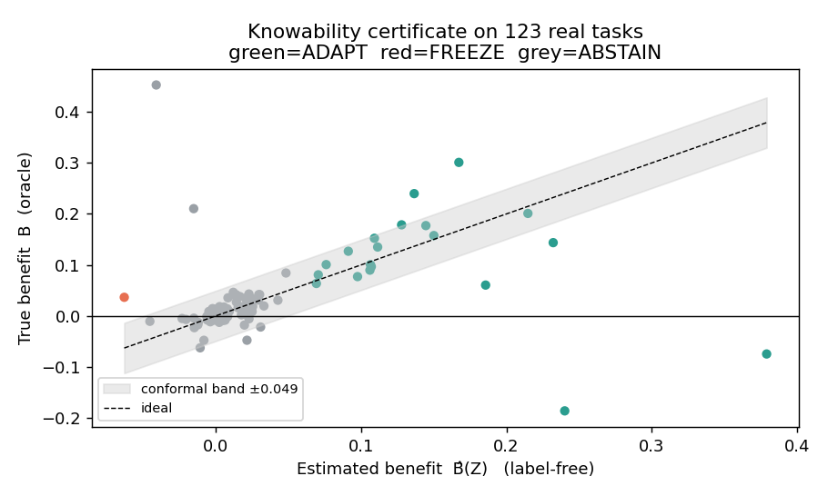
Fig. 3. The certificate rule in one picture. KGA estimates the label-free benefit $\hat{Δ}(Z)$ and forms an interval $\hat{Δ}±ε$: if the interval is entirely positive it adapts, if entirely negative it freezes, and otherwise it abstains. The vertical axis here uses true benefit only for offline audit; deployment decisions use only unlabeled evidence and the pre-calibrated radius.
On the good event $|\hat{Δ}−Δ|≤ε$, committing adapt only when $L>0$ implies $Δ>0$ (Theorem 3). Assumptions: exchangeable calibration pairs, bounded benefits, and risk-aligned $Z$; no target labels at deploy. Overhead: one forward pass of $f_{0}$ and $f_{a}$ plus lightweight $\hat{Δ}$ evaluation.

Where the commit boundary comes from.
KGA’s commit boundary is not a swept hyperparameter, but the population frontier and the empirical radius must be kept distinct. The population frontier of Theorem 2 (over the declared class $C_{β}$, $\text{sign}Δ$ is identifiable iff the disagreement margin $|M|$ exceeds the supplied budget $β$) fixes the required budget at population level; the drift realization $γ≤β$ is unknown and not observed at deploy. KGA does not observe $γ$; it commits under a conservative empirical radius $ε$, the $(1−α)$ residual quantile on the calibration split, fixed there and never selected on target-test data. The two are related but not identical: $ε$ is a finite-sample, assumption-dependent surrogate that controls false-adapt under the stated exchangeability and risk-alignment assumptions, and is not the frontier itself. Confidence-thresholding (ATC) and agreement-trend selection (AGL) fit a scalar against a labeled or held-out signal and predict accuracy; KGA certifies the benefit sign with a boundary forced by the identifiability budget, and, unlike any thresholded estimator, abstains on the region where Theorem 1 proves no label-free rule can decide. The impossibility construction, not a tuned cutoff, is what separates KGA from “estimate accuracy, then threshold.”

V. Experiments
The experiments test one claim: KGA is a safety layer, beating both fixed policies only where harmful adaptation is frequent and detectable, and otherwise matching a safe fixed policy or abstaining (Fig. 4). We report nine benchmark tracks under one accounting scheme (Table VII), but distinguish evidence strength rather than pooling incompatible runs. Calibration and held-out scoring follow Algorithm 2 (Appendix A). Metrics: mean accuracy; regret-to-oracle against the per-condition oracle $g^{⋆}=1[Δ>0]$; adapt rate $P[\text{adapt}]$ and coverage $P[\text{adapt or freeze}]$ (one minus the abstain rate); and two false-adapt measures, reported separately—the unconditional false-adapt probability ${FA}_{u}=P[\text{adapt}, Δ≤0]$ and the conditional false-adapt rate ${FA}_{c}=P[Δ≤0∣\text{adapt}]$. Theorem 3 bounds the unconditional probability, ${FA}_{u}≤α$, under its coverage and risk-alignment assumptions; the per-dataset tables additionally list the empirical ${FA}_{c}$ among committed adapt decisions. The two false-adapt measures coincide whenever no harmful adapt is committed (${FA}_{u}={FA}_{c}=0$ on every headline dataset, since KGA commits none) and diverge only for rules that commit some; the full four-metric breakdown (${FA}_{u}$, ${FA}_{c}$, adapt-rate, and coverage), where the leaky gates separate from the certificate, is therefore reported side by side in the decision-baseline comparison (Table III), so the reader sees both what the theorem bounds and what happens operationally among adapted decisions.
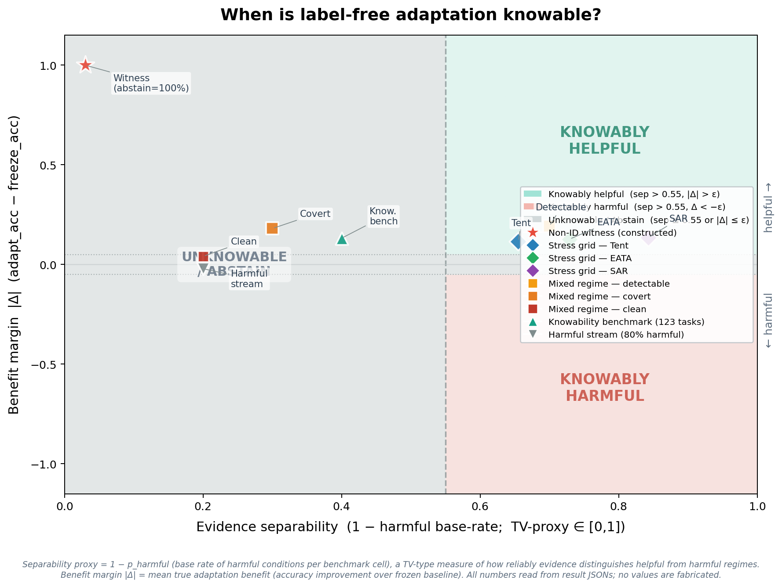

Synthetic validation of the frontier
Before the real-data tracks we validate the theory directly on synthetic ground truth, where the observable margin $M$, the unobserved drift $γ∼U(−β,β)$, and hence the true benefit sign $\text{sign}Δ=\text{sign}(M+γ)$ are all controlled. Evidence is fed to the exact deployed rule (leave-one-out gradient-boosted $\hat{Δ}$ with a split-conformal radius, § IV); nothing is hand-tuned. Three predictions hold (Fig. 5; $α=0.10$). (i) Recovery: $\hat{Δ}$ tracks $Δ$ at $90.0\%$ empirical coverage—exactly the target $1−α$—and the radius self-calibrates to $ε≈β$ (the unseen drift is the residual). (ii) Frontier (Thm 2): the commit rate jumps from $6.5\%$ for $|M|<β$ to $96.7\%$ for $|M|>β$—a transition at the predicted boundary—and the committed sign is correct $99.3\%$ of the time. (iii) Certificate (Thm 3): the unconditional false-adapt rate stays under budget for every $β∈\{0.05,…,0.20\}$ (${FA}_{u}≤0.014≪α$). The frontier is not imposed—it emerges because the conformal radius equals the drift the evidence cannot see.
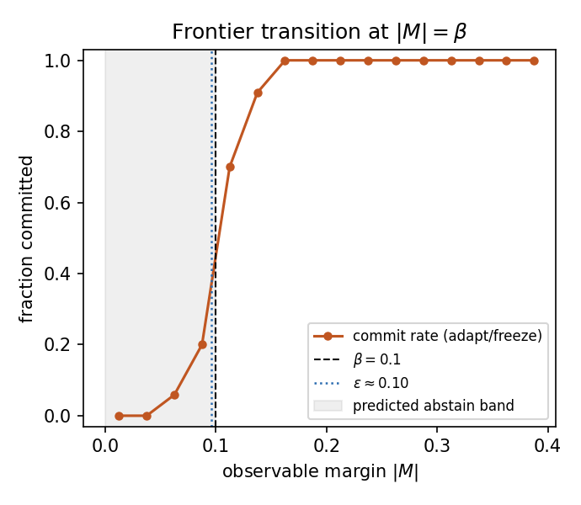
Fig. 5. Measured benefit-sign frontier (synthetic ground truth, exact deployed rule). The commit rate transitions sharply from abstention to adapt/freeze at $|M|=β$; the self-calibrated conformal radius $ε$ (dotted) coincides with $β$. Companion panels—estimator recovery and ${FA}_{u}≤α$ across $β$—in fig_frontier_recovery.png, fig_frontier_fa_coverage.png.

CIFAR-10-C stress grid (5 seeds)
The per-corruption suite is helpful-dominated; the stress grid crosses severity, batch size, composition, and update aggressiveness ($432$ conditions/method, ResNet-18; pre-registered as Protocol A; seeds $0$–$4$). Harmful base rates (five-seed means from the locked analysis) are $33\%$ (Tent), $25\%$ (EATA), $10\%$ (SAR). KGA beats both trivial policies for Tent and EATA at $0\%$ false-adapt; it ties collapse-resistant SAR (Table II). Among harmful cells KGA adapts $0$ and freezes them; among helpful cells it adapts almost all; on marginal cells it abstains. For both Tent and EATA, the regret gaps to both fixed policies are positive with $95\%$ bootstrap CIs excluding zero, Holm-corrected over the comparison family (computed in stress_grid_multiseed_v1/_locked_analysis_script.py, $N_{boot}={10}^{4}$), at false-adapt $0/2160$. The mixing-ratio Pareto (Fig. 6) shows KGA on the regret-vs-harmful-fraction front, strictly beating both once the harmful fraction exceeds $p^{⋆}≈0.1$ (Tent/SAR) or $0$ (EATA).
TABLE II. CIFAR-10-C stress grid ($432$ conditions/method, five seeds, $α=0.1$, Protocol A). All quantities are from the locked five-seed analysis (stress_grid_multiseed_v1/LOCKED_ANALYSIS_RESULTS.json); the false-adapt denominator is $2160$ committed decisions per candidate.
candidate | policy | regret$↓$ | ${FA}_{c}$ | beats both?
Tent | always-adapt | $0.0079$ | —
 | always-freeze | $0.1241$ | —
 | K-Bound | $0.0016$ | $0$ | yes
EATA | always-adapt | $0.0033$ | —
 | always-freeze | $0.1314$ | —
 | K-Bound | $0.0013$ | $0$ | yes
SAR | always-adapt | $0.0003$ | —
 | always-freeze | $0.1405$ | —
 | K-Bound | $0.0015$ | $0$ | ties adapt
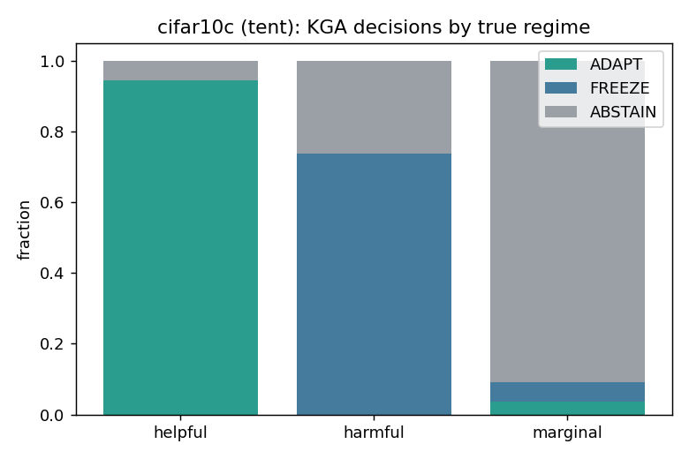
(a) decisions by true regime
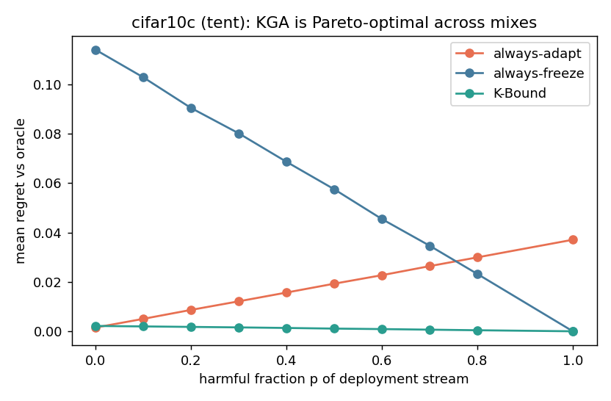
(b) regret as harmful fraction changes

Decision-baseline comparison: a finite-sample false-adapt guarantee
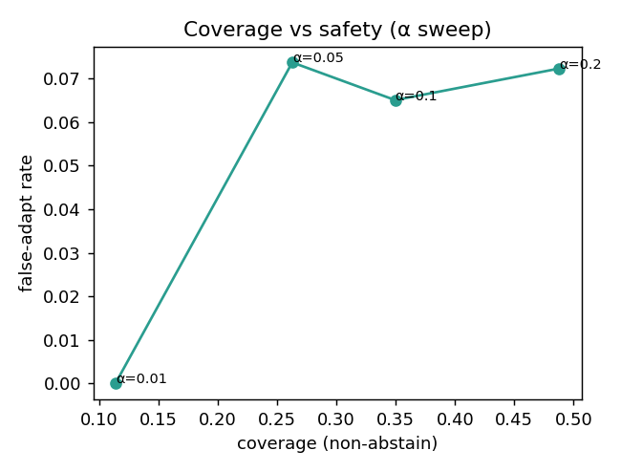
Fig. 7. The safety knob. Sweeping the level $α$ trades decision coverage against the false-adapt rate: the certificate holds false-adapt at or below target while coverage grows with $α$, so a deployer chooses the operating point rather than accepting a fixed one.
KGA’s claim goes beyond “better than always-adapt/always-freeze”: it is better than simple label-free decision rules under the same locked protocol. On the CIFAR-10-C stress grid (Tent candidate, identical cells), we score six rules from the same evidence (Table III): a confidence gate (adapt iff adaptation raised mean confidence), an entropy gate (adapt iff it lowered entropy—Tent’s own objective), a drift/KL threshold, an ATC-style accuracy-prediction gate, KGA without its conformal radius (adapt iff $\hat{Δ}>0$), and the full certificate. Only the certificate provides a finite-sample false-adapt guarantee, and it attains zero observed ${FA}_{u}$ on this grid while staying near-oracle on regret (the radius-free variant keeps ${FA}_{u}=0.049<α$ empirically, but with no such guarantee). The confidence/entropy gates false-adapt on $∼74\%$ of harmful cells; the drift threshold, tuned to the budget, degenerates to always-freeze. The KGA-without-radius row isolates the radius: removing it lowers regret slightly ($0.0017​→​0.0004$) but raises ${FA}_{u}$ from $0$ to $0.049$ (to $0.141$ on harmful cells): the radius is what turns a good benefit estimate into a false-adapt guarantee. Reproduced by scripts/gate_baseline_comparison.py on the locked per-cell dump.
TABLE III. Decision-baseline comparison, CIFAR-10-C stress grid (Tent candidate, $n=432$ cells, $149$ harmful, $α=0.1$). Lower regret and lower ${FA}_{u}$ are better. Only the conformal certificate keeps ${FA}_{u}=0$ on the full grid and on harmful cells while staying near-oracle.
Decision rule | regret$↓$ | ${FA}_{u}$ | ${FA}_{c}$ | adapt | cov. | ${FA}_{u}$(harm)
confidence gate | $0.0084$ | $0.257$ | $0.301$ | $0.85$ | $1.00$ | $0.745$
entropy gate | $0.0086$ | $0.255$ | $0.304$ | $0.84$ | $1.00$ | $0.738$
drift/KL gate | $0.1232$ | $0.000$ | $0.000$ | $0.00$ | $1.00$ | ${0.000}^{†}$
ATC-style gate | $0.0045$ | $0.116$ | $0.172$ | $0.67$ | $1.00$ | $0.336$
KGA (no radius) | $0.0004$ | $0.049$ | $0.071$ | $0.68$ | $1.00$ | $0.141$
KGA (certificate) | $0.0017$ | $0.000$ | $0.000$ | $0.51$ | $0.68$ | $0.000$
$†$Degenerate: the budget-tuned drift gate never adapts (adapt-rate $0$), so its “$0$ false-adapt” is just always-freeze (regret $0.123$).

Mixed head-to-head vs. POEM-/AETTA-style baselines (pre-registered)
The stress-grid wins above beat the trivial policies always-adapt and always-freeze. A harder question is whether KGA improves over strong protocol-matched label-free decision baselines inspired by POEM [11] and AETTA [18], on a mixed harmful+helpful stream. We pre-registered the benchmark, metrics, and WIN/TIE/LOSE criterion before computing any number (). All six policies consume the same logged per-condition signals $Z$ and benefit $B$ from the locked CIFAR-10-C stress grid (Tent, $432$ conditions/seed, five seeds; harmful fraction $≈16$–$18\%$); only the decision rule differs. The competitors are protocol-matched POEM-style and AETTA-style baselines: ports of the published protectors onto this protocol with documented simplifications (batch-summary entropy rather than per-sample streams). Official per-sample POEM and dropout-based AETTA reproduction remains a camera-ready faithfulness check.
Verdict: WIN. KGA lowers mean regret-to-oracle vs. both ported baselines with paired-bootstrap $95\%$ CIs entirely below zero and Holm correction ($α=0.05$), at ${FA}_{u}=0≤α$ (Table IV). The ported POEM-/AETTA-style baselines false-adapt at $∼24$–$25\%$ on the same stream, since they lack the certificate’s marginal false-adapt control. Secondary pooled sets (Tent+EATA, EATA alone) yield the same WIN verdict (). An independent post-hoc recomputation (paired bootstrap ${10}^{4}$, pre-registered) replicates all three configurations, with both regret-gap CIs below zero in each and ${FA}_{\text{kga}}=0$ versus $11$–$33\%$ for the competitors ().
TABLE IV. Pre-registered mixed head-to-head on the locked CIFAR-10-C stress stream. POEM/AETTA rows are protocol-matched style ports, not official reproductions. All policies use the same held-out cells, candidate adapter, logged label-free evidence, regret-to-oracle metric, and unconditional false-adapt metric. The comparison tests KGA against strong label-free decision gates under this locked protocol, not against full official POEM/AETTA implementations.
policy | mean regret$↓$ | ${FA}_{u}$ | decisive rate | KGA gap | Holm beats?
always-adapt | $0.0079$ | $0.329$ | $1.00$ | $−0.0064$ | yes
always-freeze | $0.1241$ | $0.000$ | $1.00$ | $−0.1225$ | yes
POEM-style | $0.0088$ | $0.245$ | $1.00$ | $−0.0072 [−0.0088,−0.0057]$ | yes
AETTA-style | $0.0073$ | $0.240$ | $1.00$ | $−0.0058 [−0.0071,−0.0044]$ | yes
KGA | $0.0016$ | $0.0000$ | $0.6847$ | — | WIN
oracle | $0.0000$ | $0.000$ | $1.00$ | — | ceiling

Baseline faithfulness.
The POEM and AETTA rows in Table IV are protocol-matched ports, not official reproductions. They are included to test whether KGA’s conformal benefit-sign certificate improves over strong label-free committal gates under the same logged evidence, candidate adapter, held-out cells, regret metric, and false-adapt metric (Table V). They do not claim to reproduce POEM’s full per-sample betting process or AETTA’s full dropout-based estimator. Official-code reproduction is left as an additional faithfulness check; the present claim is therefore limited to the locked protocol-matched comparison.
Baseline | Original method needs | Our locked protocol uses | What is matched | What is not claimed
POEM-style | online entropy/betting monitor over adaptation stream | batch-summary entropy and logged per-condition evidence | same held-out cells, same candidate, same false-adapt/regret metrics | not official per-sample POEM reproduction
AETTA-style | dropout/disagreement-based label-free accuracy estimation | protocol-matched accuracy/benefit gate from logged evidence | same evidence budget, same decision task, same held-out stream | not official dropout-AETTA reproduction
KGA | benefit estimator $+$ conformal radius | out-of-fold $\hat{Δ}$ and $ε$ | same stream, same oracle/regret/${FA}_{u}$ metric | official method in this paper

ImageNet-C SAR (mechanism-faithful)
On ImageNet-C noise (ResNet-50, $27$ cells: three noise corruptions $×$ severities $\{1,3,5\}$ $×$ label regimes, seed 0, full-scale), SAR is harmful on $14.8\%$ of cells under a mechanism-faithful re-implementation (SAM, recovery reset, EMA) at the learning rate shared across candidates. Always-adapt drops to $0.379$ accuracy while KGA reaches $0.431$, beating both trivial policies (regret $0.0108$ vs $0.0625$/$0.0319$). The gap to the better fixed policy (always-freeze) has a $95\%$ paired-bootstrap CI of $[−0.032,−0.011]$ and survives Holm correction across the confirmatory wave, so ImageNet-C SAR is a CI-confirmed beats-both, not a point estimate. EATA stays helpful-dominated (KGA ties always-adapt); on Tent the harmful regime now dominates ($63\%$ of cells) and KGA abstains to always-freeze (Table VI). Under the same logged conditions, an ATC-style confidence gate false-adapts on the harmful SAR cells—it adapts wherever confidence is high, which is exactly where SAR collapses—while KGA abstains on them, so the certificate beats not only the two fixed policies but a simple label-free decision gate under the same protocol. The result uses our mechanism-faithful SAR reimplementation at a shared learning rate; SAR’s official gentler schedule is left as a robustness check, so the claim is about this harmful-SAR operating point rather than all SAR configurations.
TABLE VI. ImageNet-C, mechanism-faithful SAR ($27$ cells: 3 noise corruptions, ResNet-50, $α=0.1$); full-scale run (2026-07-09) superseding the earlier 36-cell provisional configuration.
candidate | policy | mean acc | regret$↓$ | harmful cells | beats both?
Tent | always-adapt | $0.399$ | $0.0216$ | $63\%$
 | always-freeze | $0.410$ | $0.0114$
 | K-Bound | $0.410$ | $0.0114$ |  | no (ties freeze)
EATA | always-adapt | $0.443$ | $0.0000$ | $0\%$ | no (ties adapt)
 | always-freeze | $0.410$ | $0.0336$
 | K-Bound | $0.443$ | $0.0000$
SAR | always-adapt | $0.379$ | $0.0625$ | $15\%$
 | always-freeze | $0.410$ | $0.0319$
 | K-Bound | $0.431$ | $0.0108$ |  | yes

Uniform nine-track panel and methodology
All benchmark tracks use the same decision target: the adaptation benefit $Δ=R(f_{0})−R(f_{a})$, evaluated against the same per-condition oracle, always-adapt, and always-freeze policies. The candidate adapter is locked using development data. Evidence $Z$, the benefit estimator $\hat{Δ}$, and radius $ε$ are then frozen before scoring the declared test cells; test labels are used only after decisions for offline regret and false-adapt audit. Stress grids use leave-one-cell-out residuals; semantic domain-shift tracks use a dev/test split. We report ${FA}_{u}=P[\text{adapt},Δ≤0]$ and do not interpret ${FA}_{c}$ as a certificate.

Evidence tiers.
Locked means the table row traces to raw cells/seeds and a locked aggregate; reconciled means a prior pooled interpretation was corrected from its raw records; provisional means a derived out-of-fold summary exists but does not reproduce the nearby canonical scorer; diagnostic means a completed run that is deliberately not promoted. Only locked and reconciled rows support the empirical headline.
Track | Evaluation unit | Result | Decision interpretation | Evidence tier
CIFAR-10-C stress | $5×432$ cells / candidate | Tent: $0.0016/0.0079/0.1241$; EATA: $0.0013/0.0033/0.1314$; ${FA}_{u}=0$ | Tent/EATA CI BB; SAR ties adapt | locked multi-seed
ImageNet-C SAR | $27$ cells (3 noise corr.) | $0.0108/0.0625/0.0319$; ${FA}_{u}=0$ | CI BB; gap-freeze $[−.032,−.011]$, Holm; $12/27$ abstain | locked single-seed full-scale
Camelyon17 OOD | genuine OOD test $n=18$ (support $n=36$) | $0.0000/0.0000/0.1381$; ${FA}_{u}=0$ | ties adapt; no BB | reconciled raw records
iWildCam H v2 | held-out test $n=72$ | $0.0041/0.1028/0.0041$; ${FA}_{u}=0$ | no-harm, ties freeze | provisional OOF summary; replay required
Office-Home M v2 | target test $n=35$ | $0.0157/0.0468/0.0158$; ${FA}_{u}=0$ | no-harm, tiny point edge | provisional OOF summary; replay required
RxRx1 J | OOD test $n=60$ | $0.0000/0.2531/0.0000$; ${FA}_{u}=0$ | ties freeze; no BB | locked raw run
PACS | four LODO targets, $18$ cells each | three safety/tie-freeze targets; one null; ${FA}_{u}=0$ | no promoted BB | locked single-seed panel
ImageNet-R D | $3$ seeds $×10$ backbones | no CI-robust BB; one point-only arm fails the second CI | abstention / fixed-policy ties | locked multi-seed diagnostic
CIFAR-10.1 K | cross-seed test $n=48$ | $0.0021/0.0190/0.0017$; ${FA}_{u}=0.444$ | fails transfer bar; no claim | locked diagnostic
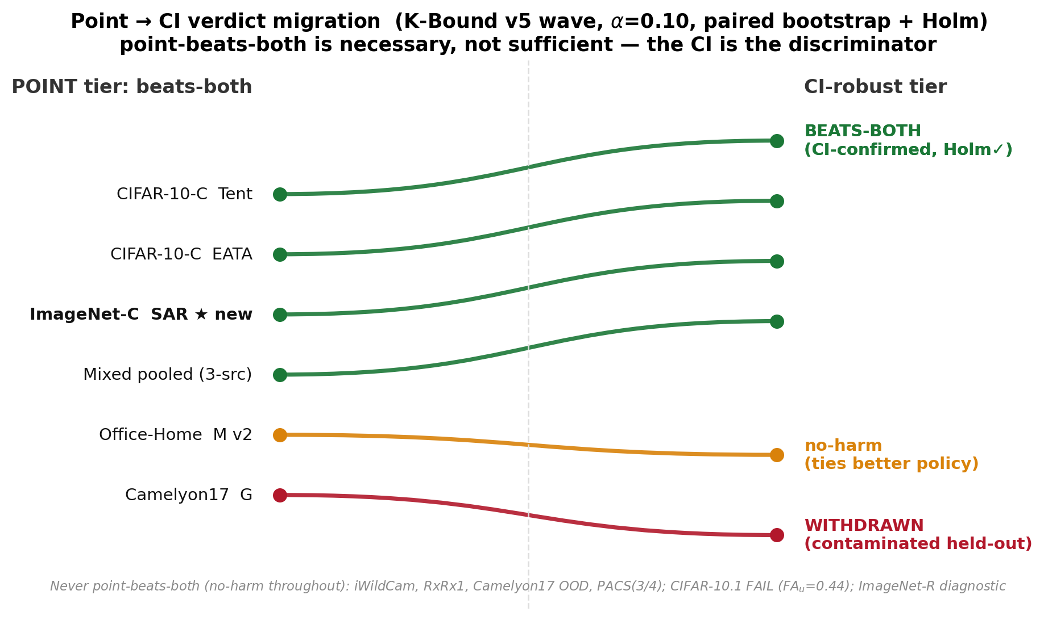
Fig. 8. Point $→$ CI verdict migration for the confirmatory wave ($α=0.10$; paired per-condition bootstrap, Holm-corrected across the wave). Point-beats-both is necessary but not sufficient: under the CI, only CIFAR-10-C Tent/EATA, the constructed three-source mixture, and ImageNet-C SAR remain beats-both; Office-Home’s point edge migrates to no-harm, and the contaminated Camelyon17 Protocol-G arm stays withdrawn. ImageNet-C SAR is the arm newly CI-confirmed in this fold-in pass. Reproducibility: verdicts from scripts/uniform_scorer.py $+$ scripts/percondition_bootstrap.py ($B=5000$), scored once against the frozen bars in results_source.json.
TABLE VIII. Primary numeric evidence used for empirical claims. The three-source row is a constructed routing mixture, not a natural-transfer result.
Track | Unit | KGA | Adapt | Freeze | Status
CIFAR-10-C Tent | $5×432$ | .0016 | .0079 | .1241 | CI BB, ${FA}_{u}=0$
CIFAR-10-C EATA | $5×432$ | .0013 | .0033 | .1314 | CI BB, ${FA}_{u}=0$
ImageNet-C SAR | $27$ cells | .0108 | .0625 | .0319 | CI BB (Holm), ${FA}_{u}=0$
Camelyon17 OOD | $n=18$ | .0000 | .0000 | .1381 | reconciled no-harm
RxRx1 J | $n=60$ | .0000 | .2531 | .0000 | locked no-harm
Three-source OOF mixture | $n=143$ | .0059 | .0632 | .0342 | CI BB, constructed mixture

What exactly is guaranteed?
Statement | Status | Requirement
Abstention needed in matched-evidence opposite-benefit worlds | theorem | stated model class
${FA}_{u}≤α$ (unconditional false-adapt) | theorem | valid coverage + exchangeability + risk alignment
${FA}_{c}≤α$ (conditional false-adapt) | not claimed | report ${FA}_{c}$ descriptively only
Nine-track panel | accounting | locked/reconciled/provisional tiers shown explicitly
Stress-grid beats-both (Tent/EATA) | confirm. | locked Protocol A v1 stress grid
ImageNet-C SAR CI-confirmed beats-both | confirm. | full-scale 27-cell noise grid; gap-freeze CI excl. 0, Holm-robust
Reconciled natural safety (Camelyon17, RxRx1) | confirm. | raw OOD/test artifacts
Office-Home and iWildCam OOF summaries | provisional | canonical scorer replay required
Three-source mixed routing aggregate | confirm. | constructed OOF mixture, not transfer
Universal improvement | not claimed | impossible in general
$ε$ estimates drift budget $β$ | false | $β$ is declared; $ε$ is empirical

VI. Limitations and honest scope
The frontier is validated synthetically. The identifiability transition at $|M|=β$ is validated on synthetic ground truth where $M$ and $γ$ are controlled; no disagreement-region margin $\hat{M}$ is estimated from real data anywhere in the pipeline. Deployed decisions use the certificate $\hat{Δ}±ε$; the frontier is the theory object that predicts when such certificates can commit, not an empirically measured quantity.
Scope of empirical wins. On the stress grid KGA beats both for Tent/EATA and ties SAR (Table II); on ImageNet-C the pattern flips by candidate—Tent/EATA are robust while SAR collapses and KGA beats both under a mechanism-faithful re-run (Table VI). Per-corruption CIFAR-10-C and helpful natural shifts are insurance regimes, not policy wins.
Real-shift scope. The uniform panel deliberately distinguishes three outcomes. Camelyon17 genuine OOD and RxRx1 are reconciled/locked no-harm results: KGA ties the better fixed policy at zero observed false-adapt. Office-Home and iWildCam retain their saved out-of-fold summaries as provisional: they are informative safety evidence but are excluded from headline counting until a canonical scorer replay reproduces the same numbers. PACS, ImageNet-R, and CIFAR-10.1 are completed breadth tracks, not natural beats-both claims. The three-source mixture is a constructed routing aggregate; it is not a transfer result and does not change the per-dataset conclusion.
Theory and calibration. The conformal radius assumes exchangeable calibration pairs; sign bracketing without structure is impossible (Theorems 1 and 2; Appendix A). KGA’s value scales with how often catastrophic, detectable harm occurs, not with universal accuracy gains. On helpful-dominated shifts the resulting near-tie with always-adapt reflects the certificate abstaining rather than committing harmful updates: KGA approximately matches the better policy, at most paying a small abstention cost when it declines a helpful but uncertifiable update, so the value proposition is conditional, like insurance against detectable harm. Setting $β$. The budget is declared, not estimated—a deployment-time bound on admissible calibration drift, fixed from domain knowledge or historical dev-to-deployment gaps. When no bound is justifiable the honest choice is $β=0$, which recovers the label-free estimators (ATC/AGL/AETTA) as the zero-budget face of the frontier, with residual uncertainty absorbed by abstention rather than an unsupported adapt; larger $β$ widens the abstain band monotonically, trading coverage for safety.
Detectability and transfer. ImageNet-R is a weak, split-specific evidence regime: one point-only arm does not survive both comparisons across three seeds. CIFAR-10.1 fails the cross-seed certificate bar (${FA}_{u}=0.444$). These are useful boundary cases, not failed headline experiments: they show that a low-margin signal should not be promoted merely because one split or one candidate looks favorable.
The limitations are the frontier, not flaws. The regime dependencies above are not three independent weaknesses but one phenomenon: the benefit-sign frontier (Theorem 2) seen from the operating side. Tying always-adapt on a helpful-dominated shift is the no-harm guarantee holding: one cannot beat an oracle that is already always-adapt. Declining ImageNet-R is the unknowable branch firing: the observable margin falls below the drift budget, so no label-free rule can decide the benefit sign, however good the adapter (Theorem 1). The coverage drop is mandatory abstention, not a tuning loss: committing in the unknowable region would be a false-adapt. None can be removed without violating the impossibility result, since a method that “won everywhere” would be claiming to decide the sign of an unidentifiable quantity. The one axis that genuinely improves all three is a richer label-free evidence map, which raises the observable margin $|M|$ so more shifts clear the budget (more knowable shifts, fewer abstentions, higher coverage), together with a tighter radius (jackknife$+$ or more calibration data) that reclaims coverage on knowable cells abstained only out of conservatism; both remain bounded by the frontier they cannot cross.
Baselines and independent validation. On the ImageNet-C SAR configuration, the committal confidence gate adapts on harmful cells while KGA abstains on the low-margin band. The POEM/AETTA comparison is complete only for protocol-matched ports; official implementations remain future baseline work. Independent replay is required for the Office-Home/iWildCam OOF summaries, and more seeds would strengthen ImageNet-C and PACS. Abstention lowers decision coverage but never withholds a prediction: it retains the frozen fallback $f_{0}$.

VII. Reproducibility
All locked/reconciled rows in Tables VII–VIII link to saved raw cells or seed aggregates in the anonymized repository. Provisional rows are retained only to document completed evidence and the required replay; they are not reused as headline claims. The core certificate module is packaged as an installable module in the anonymized repository. A kernel-checked Lean 4 formalization of the algebraic and finite-testing core of K-Bound accompanies the repository ($43$ indexed theorems, no sorry/admit/project-defined axioms). The certificate’s probability layer is machine-checked as well: coverage implies the unconditional false-adapt/false-freeze bound over an arbitrary probability measure (measure_false_adapt_le_alpha), and split-conformal coverage holds in the conditional-on-the-bag uniform-rank model (uniformIndex_false_adapt_le); we are not aware of a prior machine-checked conformal-coverage guarantee in a proof assistant (kernel-checked generalization bounds exist, e.g. [76], but not conformal coverage). General exchangeable-process coverage, and the remaining deployment-facing assumptions (calibration transfer and risk alignment) remain explicit assumptions outside the formalization.
TABLE IX. Claim $→$ support status. Each headline claim and how it is backed: proven (formal theorem), empirical (pre-registered, scored once on held-out data), or pending (pre-registered but not yet run). Quantitative backing for the empirical rows is in the cited tables.
Claim | Support
Abstention necessary under matched evidence with opposite benefit (Thm 1) | proven
Benefit-sign frontier: identifiable iff $|M|>β$ (Thm 2) | proven
Finite-sample ${FA}_{u}≤α$ under coverage (Thm 3) | proven (Lean-checked)
Nine-track evidence accounting | empirical (tiered)
CI beats-both on CIFAR-10-C stress (Tent/EATA) | empirical (locked)
CI-confirmed beats-both on ImageNet-C SAR | empirical (27-cell full-scale noise grid)
Reconciled natural no-harm on Camelyon17 OOD and RxRx1 | empirical (reconciled/locked)
Mixed head-to-head WIN vs. POEM/AETTA ports (Table IV) | empirical (pre-reg.)
Three-source constructed mixture beats both | empirical (locked; not transfer)
Single-dataset natural-shift beats-both | not claimed
Universal accuracy improvement | not claimed

VIII. Conclusion
K-Bound reframes test-time adaptation as an identifiability-limited decision problem: adapt when helpful, freeze when harmful, and abstain when label-free evidence cannot support a valid decision. The theory shows that this abstention region is not merely conservative; under matched label-free evidence with opposite adaptation benefit, no valid label-free rule can safely commit. Our headline empirical result is a uniform accounting of nine benchmark tracks under one decision protocol. Locked and reconciled natural runs show the intended safety behavior: KGA matches the better fixed policy when adaptation is one-sided, while low-margin tracks abstain or remain diagnostic. Wins over trivial policies and protocol-matched POEM-style/AETTA-style baselines appear only in identifiable mixed harmful+helpful regimes. The separate three-source mixture is a constructed routing result, reported without a transfer claim. These results suggest that future TTA systems should expose not only an adaptation objective, but also a validity layer that decides whether adaptation is knowable before deployment.

APPENDIX A: Calibration and held-out evaluation
Algorithm 2 gives the shared evaluation protocol behind the uniform nine-track panel (Table VII) and the primary numeric evidence (Table VIII).

Algorithm 2: Calibration and held-out evaluation for K-Bound
Require: Conditions $C$; frozen $f_{0}$; adapters $A_{1},…,A_{K}$;
calibration split $C_{cal}$; test split $C_{test}$; level $α$
Ensure: Regret-to-oracle, false-adapt rate, coverage, beats-both verdict
$f_{a}^{(k,c)}←A_{k}(f_{0},X_{c})$
$Z_{k,c}←ϕ(X_{c},f_{0},f_{a}^{(k,c)})$
$Δ_{k,c}←R_{c}(f_{0})−R_{c}(f_{a}^{(k,c)})$
Calibrate without test leakage: on stress grids, form leave-one-cell-out
residuals $ρ_{i}=|{\hat{Δ}}_{−i}(Z_{i})−Δ_{i}|$; on semantic shifts, reserve a
development calibration split disjoint from the declared test split
$ε←(1−α)$ empirical quantile of the calibration residuals
Fit deployment estimator $\hat{Δ}(Z)$ on all calibration pairs
Run Algorithm 1 with $(f_{0},A_{k},X_{c},\hat{Δ},ε)$
Record decision, regret-to-oracle, coverage, false-adapt indicator
Aggregate metrics vs. always-adapt, always-freeze, per-condition oracle

APPENDIX B: Full theory stack
This appendix is not required for the main empirical claim; it preserves the full theorem stack and validator mapping behind the three main-paper theorems: matched-evidence impossibility (Theorem 1), the benefit-sign frontier (Theorem 2), and the finite-sample certificate (Theorem 3). Below we give the full five-theorem stack, lemmas, and proof sketches with validator references.

Extensions beyond the main-text spine.
The lemmas and theorems below strengthen the three load-bearing results (Lemmas 1, 1; Theorems 2, 3) with minimax floors, one-bit structure, and rate statements. Full proofs and validators are in kbound.tex and theory_v2/.
Lemma 2 (Plug-in regret identity). For any estimator $\hat{Δ}$ and gate $\hat{g}=1[\hat{Δ}>0]$,
$$R(\hat{g})−R(g^{⋆})=E[|Δ(Z)| 1\{\text{sign}\hat{Δ}≠\text{sign}Δ\}], g^{⋆}=1[Δ>0].$$
On $\{|Δ|<ε\}$, committal regret is at most $ε$.
Proof. Wrong-sign commits pay $|Δ|$ pointwise; averaging gives the identity. $◼$
Proposition 1 (Finite-sample minimax regret floor). Let two target worlds share evidence laws at TV distance $δ$ and have opposite benefit signs with magnitude $Λ>0$. For every label-free committal gate and finite $n$,
$$\underset{\hat{g}}{\text{inf}} \underset{θ=±1}{\text{max}}[R_{P_{θ}}(\hat{g})−R_{P_{θ}}(g^{⋆})] ≥ Λ/2(1−δ) ≥ Λ/4 e^{−KL}.$$
A Gaussian family with $d_{n}=c/\sqrt{n}$ realizes a constant floor in $n$ (val_thm2_lecam_finite_n.py).
Theorem 4 (Matched evidence impossibility (full form)). Theorem 1 is part (iii) of the following. Fix $α∈(0,1/2)$.
- Witness worlds with $Law(Z∣P_{T}^{1})=Law(Z∣P_{T}^{2})$ and $\text{sign}Δ_{1}=−\text{sign}Δ_{2}≠0$.
- Le Cam identity: ${\text{inf}}_{g}M(g)=1−TV$ between the evidence laws.
- Forced abstention at rate $≥1−2α$ under dual error control.
Corollary 2 (Abstention is mandatory, not conservative). In the $|M|≤β$ wedge of Theorem 2, Theorem 4(iii) implies any label-free rule with false-adapt and false-freeze $≤α$ must abstain with probability at least $1−2α$ on matched evidence.
Proposition 2 (Certificate sample complexity). With empirical-Bernstein paired benefits, one-sided certification requires $n=\tilde{O}(σ^{2}/Δ^{2})$; two-sided sign certification requires the same exponent with a larger constant (val_minimax_optimality.py).
Remark 3 ($β=0$ face). ATC, DoC, GDE, COT, AETTA, and agreement-on-the-line are the $β=0$ face of Theorem 2: sound iff $γ=0$.
Theorem 5 (One-bit dichotomy). Under the CEI panel hypothesis H: (i) rank-one agreement law; (ii) evidence fixes magnitudes but not global orientation $b↦−b$; (iii) no evidence-definable assumption identifies $\text{sign}Δ$; the minimal untestable supplement is one bit; (iv) drift budgets are auditable but not verifiable on a blind set. Conjecture 1 is resolved negatively by (iii).
Conjecture 1 (Label-free bracketing — resolved). Unconditional label-free bracketing does not exist; weakest one-bit classes are in Appendix B (Theorems 7, 8).
Theorem 6 (Evidence-channel rate). Under audited H, unlabeled agreement statistics and labeled paired benefits both converge at rate $m^{−1/2}$; labels change constants and supply the missing bit, not the exponent.
Validator map. val_thm2_lecam_finite_n.py (Prop. 1); val_conj1_.py (Thm. 5); val_ev_rate.py (Thm. 6).

Validation figures
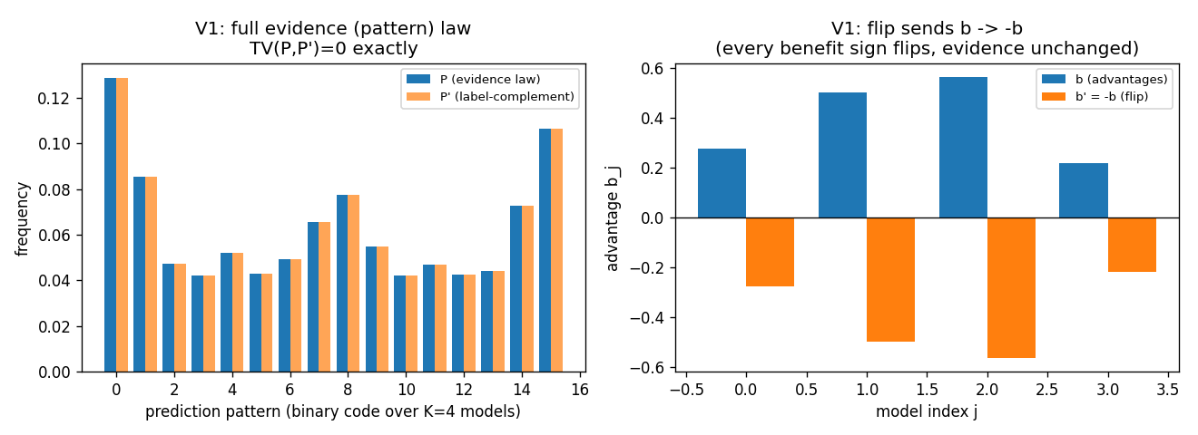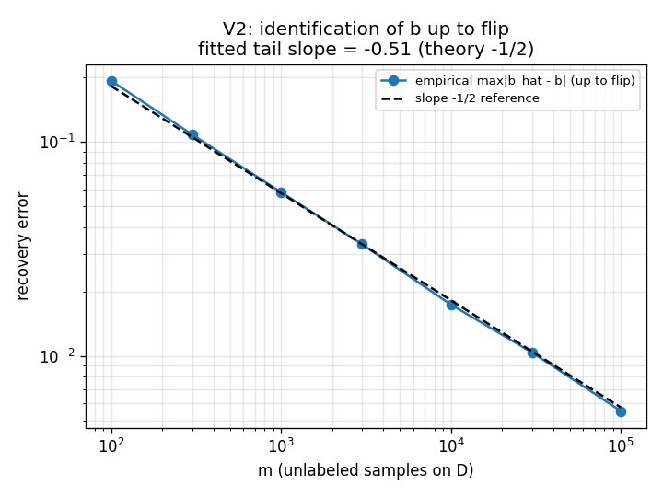
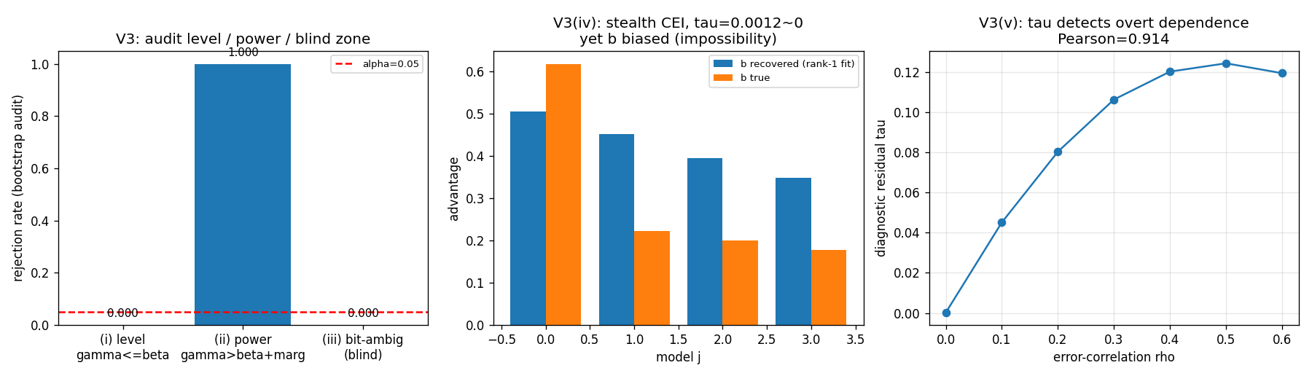
Fig. 10. Budget audit (Synthetic validator; Thm. 5(iv)).
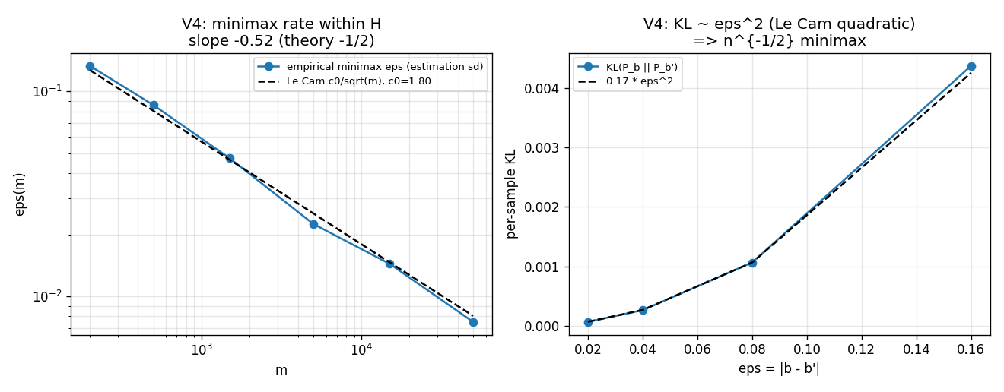
Fig. 11. Evidence-channel rate (Synthetic validator; Thm. 6).
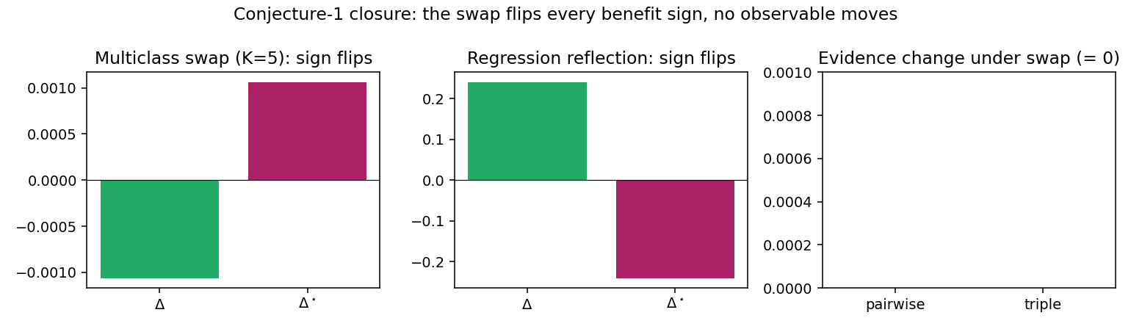
Fig. 12. Conjecture 1 closure validator.

APPENDIX C: Superseded supplementary experiments and diagnostics

APPENDIX D: Supplementary protocol notes
The main text contains the complete empirical accounting in the uniform nine-track panel. Historical route studies, superseded per-dataset tables, and outcome-free camera templates are deliberately excluded from this short-paper build. Their raw logs remain in the repository for audit, but they are not independent empirical claims. The declared evaluation unit is a condition or held-out cell, never an arbitrary pool of frames or domains; all policies replay the same unit stream, and labels are revealed only after the KGA decision for offline scoring.

APPENDIX E: Proof and experiment status
The theory-validation suite supplies numerical sanity checks. Multi-seed experiments use pooled means with paired bootstrap where this was pre-registered; a point estimate or a single locked configuration is labeled as such in Table VII.

Weakest one-bit class
The weakest one-bit class (resolving the open piece of Conjecture 1). Theorem 5 fixes the supplement at one bit; what remained open is the weakest falsifiable class on which that bit suffices. We settle it conditionally. On $D$ write $a(x):=2η_{a}(x)−1$ with $η_{a}(x)=P_{T}(f_{a}=Y∣x)$, so Δ=D​a dμ (Lemma 1). Let $m(x):=2s(x)−1$ be the observable relative (calibrated-score) margin, so $M=1/2E_{μ∣D}[m]$, and let the observable relative-calibration field be $c(x):=w(x) (m(x)−m^{⋆})$ with observable nonnegative weight $w(x)$ and observable neutral anchor $m^{⋆}$ (the margin at which $s=1/2$). Put TE:=D​c dμ (observable), and let $E$ denote the law of all label-free observables; two targets are evidence-identical when they share $E$ (equivalently $(μ,m,s)$, since predictions and $s$ are fixed maps of $x$).
Definition 3 (Margin-monotone relative-calibration class). $C_{mono}$ is the class of targets for which $a(x)=σ c(x)$ $μ$-a.e. on $D$ for a single global orientation $σ∈\{±1\}$; equivalently the benefit is single-crossing in the observable margin at $m^{⋆}$ ($\text{sign}a(x)=σ \text{sign}(m(x)−m^{⋆})$) with calibrated magnitude $|a(x)|=|c(x)|$. The class is falsifiable but not verifiable: a finite labelled probe can reject “$a=±c$”, yet $σ$ is never label-free identified.
Assumption 2 (General position). Within an evidence fibre the regions of $D$ whose benefit sign is free carry comparable, not-fully-$E$-pinned benefit mass: $T_{E}≠0$ and no proper subcollection of free regions has an $E$-certifiable dominant total $∫|a| dμ$.
Lemma 3 (Structural sign-freedom $=$ bit complexity). Fix $E$ and a falsifiable class $C$, and let $K(C,E)$ be the number of disjoint $μ$-positive regions of $D$ whose benefit signs are jointly free in $C$ on the fibre $E$. Under Assumption 2, a falsifiable structural supplement of $b$ bits pins $\text{sign}Δ$ across the fibre iff $b≥K(C,E)$.
Proof. If $b≥K$, declaring the orientation of each free region fixes the sign field; the rest of $a$ being $E$-pinned, Δ=D​a dμ then has $E$-computable sign. If $b<K$, some free region $R$ is undeclared; the two targets agreeing off $R$ and differing in $\text{sign}a$ on $R$ are evidence-identical and share all $b$ declared bits, while by comparability of R​|a| with the complement (Assumption 2) their benefits have opposite sign—no decoder of the $b$ declared bits separates them. $◼$
Theorem 7 (Conditional resolution of Conjecture 1: a weakest one-bit class). (i) Sufficiency (unconditional): every target in $C_{mono}$ has $\text{sign}Δ=σ \text{sign}(T_{E})$ with $T_{E}$ observable, so $E$ and the single orientation bit $σ$ determine $\text{sign}Δ$. (ii) Necessity (unconditional): $σ$ and $−σ$ are evidence-identical ($Law(E∣σ)=Law(E∣−σ)$) yet give $Δ$ and $−Δ$, so by Le Cam at least one bit is required. Thus exactly one bit certifies $\text{sign}Δ$ on $C_{mono}$, with no further assumption. (iii) Minimality (under Assumption 2): every falsifiable $C⊋C_{mono}$ contains a non-margin-monotone target with $K(C,E)≥2$, so by Lemma 3 at least two bits are required. Hence $C_{mono}$ is a weakest falsifiable one-bit class—minimal in the single-crossing, calibrated-magnitude direction; it is not unique (Remark 4).
Proof. (i) Δ=D​a dμ=σD​c dμ=σTE. (ii) Sending $σ↦−σ$ is the $D$-local label complement of Theorem 5: it fixes $(μ,m,s)$, hence $E$, while negating $a$ and thus $Δ$; the two-point bound of Theorem 4 gives minimax committal error $1/2$. (iii) A target outside $C_{mono}$ violates $\text{sign}a=σ \text{sign}(m−m^{⋆})$ on a $μ$-positive region, so its sign field is not one global orientation; in the swap-closed (falsifiable) fibre at least two regions are independently signable, i.e. $K≥2$, and Lemma 3 applies. $◼$
Proposition 3 (Explicit non-identifiability witness). For each candidate single structural bit there are two targets with identical evidence law ($TV=0$) sharing that bit’s value but with opposite $\text{sign}Δ$. Take $D=R_{1}∪R_{2}$, $μ(R_{1})=μ(R_{2})=1/2$, with $R_{1}$ calibrated ($c_{1}=1$) and $R_{2}$ at the anchor ($c_{2}=0$, no observable benefit signal). For $β=\text{sign}a_{1}$: $a=(+1,−2)$ vs. $(+1,+2)$ give $Δ=−1/2$ vs. $+3/2$. For $β=\text{sign}a_{2}$: $a=(+1,+1/5)$ vs. $(−1,+1/5)$ give $Δ=+3/5$ vs. $−2/5$. No single bit certifies $\text{sign}Δ$, so two bits are necessary off $C_{mono}$.
Remark 4 (What is unconditional, and what rests on general position). Parts (i)–(ii)—that one declared bit certifies $\text{sign}Δ$ on $C_{mono}$—hold unconditionally. Only minimality (iii) uses Assumption 2: if it fails (one region’s benefit mass is $E$-certifiably dominant) that region’s orientation alone certifies $\text{sign}Δ$ even outside $C_{mono}$, moving the boundary. Equivalently, Assumption 2 is the requirement that the certificate be domination-free (minimax-sound over the unobserved magnitudes); so the General-Position statement is only conditional; the unconditional weakest classes are characterized in Theorem 8 as an explicit finite family of dominance polytopes. Even under Assumption 2, $C_{mono}$ is only a weakest one-bit class: any calibrated sign-aligned field $\{a=σh: h \text{observable}\}$ is equally one-bit and is incomparable to $C_{mono}$. All six checks are machine-checked by a deterministic release validator: the unconditional core (sufficiency/necessity $20000/20000$, $|Δ−σT_{E}|=0$ exactly), the explicit minimality witnesses of (iii), the general-position ablation, and the non-uniqueness check.
Why general position cannot simply be dropped (the precise obstruction, and exactly what is open). The minimal counterexample is two equal-mass regions $D=R_{0}∪R_{1}$, $μ(R_{0})=μ(R_{1})=1/2$, with the observable field $c=+1$ on the calibrated region $R_{0}$ and $c=0$ on the anchor region $R_{1}$ (no observable benefit signal there, so $R_{1}$ is sign-free in any evidence fibre). Enlarge $C_{mono}$ to the falsifiable class $C_{dom}=\{a_{R_{0}}=σ, |a_{R_{1}}|≤ρ\}$ for a declared constant $ρ<1$. Since $Δ=1/2(a_{R_{0}}+a_{R_{1}})$ and $|a_{R_{1}}|≤ρ<1=|a_{R_{0}}|$, the calibrated region dominates and $\text{sign}Δ=σ$ for every member, so one declared bit certifies $\text{sign}Δ$ on all of $C_{dom}$. Yet $C_{dom}⊋C_{mono}$ (it contains non-margin-monotone targets with $a_{R_{1}}≠0$, e.g. $a=(+1,±1/2)$ giving $Δ=3/4,1/4$, both positive) and is falsifiable (a labelled probe rejects targets that are uncalibrated on $R_{0}$ or violate $|a_{R_{1}}|≤ρ$). This contradicts minimality once an $E$-certifiable dominant region is permitted: dropping $a=(+1,±2)⇒Δ=+3/2,−1/2$ shows that the moment $ρ≥1$ the anchor region can flip $\text{sign}Δ$ and two bits become necessary ($K=2$). The obstruction to an unconditional weakest class is therefore exactly this: characterising minimality across the entire lattice of dominant-region thresholds $ρ$ (where the weakest one-bit class is not $C_{mono}$ but a $ρ$-dependent family), which Assumption 2 sidesteps by fiat. Theorem 8 (below) resolves it: the $ρ$-lattice is the slice $\{r_{0}=1, r_{1}=ρ\}$ of the single dominance polytope $W^{⋆}=\{r_{0}≥r_{1}\}$, with $ρ=1$ its boundary. The construction is machine-checked (val_conj1_genpos.py, seeds fixed): $C_{dom}$ strictly contains $C_{mono}$, is falsifiable (reject rate $1.0$), is one-bit-certified (error rate $0$ over $2×{10}^{5}$ targets), and loses one-bit certifiability without the domination bound (error rate $≈1/4$).
Unconditional resolution (General Position removed). Dropping Assumption 2 reveals, for each orientation pattern, a single maximal one-bit class—a dominance polytope—of which the $ρ$-family of Remark 4 is one slice.
Definition 4 (Orientation pattern and canonical class). On a fibre $E$ an orientation pattern is a tied set $P⊆\{i:c_{i}≠0\}$ with a tied sign-pattern $s∈\{±\}^{P}$; the free set is $Z=D\backslash P$. For an observable magnitude region $W⊆[0,1]^{|D|}$ the canonical class is $C(P,s,W)=\{a: \text{sign}a_{i}=σ s_{i}\text{sign}c_{i} (i∈P), (|a_{j}|)_{j}∈W\}$ with one declared bit $σ$. Write T(r)=i∈P​sisign(ci)μiri and G(r)=i∈Z​μiri.
Lemma 4 (Canonical form of a falsifiable class). A class is falsifiable iff it equals some $C(P,s,W)$; anchors ($c_{i}=0$) lie necessarily in $Z$. (Swap-closure, Thm. 5(iii), forces the constraint on $Z$ to depend only on $|a|$; forcing an anchor sign is not evidence-definable. Both aligned ($s_{i}=+$) and anti-aligned ($s_{i}=−$) ties are falsifiable since $σ$ is unidentified.)
Theorem 8 (Unconditional one-bit criterion; weakest classes). Let $C(P,s,W)$ be falsifiable. (i) (Dominance margin.) One declared bit certifies $\text{sign}Δ$ on $C(P,s,W)$ iff ${\text{inf}}_{r∈W}​(T(r)−G(r))≥0$ (with some member $Δ>0$) or ${\text{sup}}_{r∈W}​(T(r)+G(r))≤0$. (ii) (Weakest class.) For a fixed pattern $(P,s)$ the unique maximal one-bit class is the dominance polytope $C^{⋆}=C(P,s,W^{⋆})$, $W^{⋆}=\{r∈[0,1]^{|D|}:T(r)≥G(r)\}$; $C_{mono}$, every $C_{dom}(ρ≤1)$, and every box one-bit class are proper subclasses of one $C^{⋆}$. (iii) (Finite family.) The set of weakest falsifiable one-bit classes is the explicit finite family $\{C^{⋆}\}$ indexed by $(P⊆\{c≠0\}, s∈\{±\}^{P})$ modulo the global flip $σ↦−σ$ (at most $3^{|\{c≠0\}|}$ patterns); distinct patterns give pairwise incomparable maxima, so there is no unique weakest class. $C_{mono}$ is the all-tied all-aligned member, and Assumption 2 is exactly the face on which the family collapses to $C_{mono}$, recovering Thm. 7(iii).
Proof. $Δ$ is linear, so over $C(P,s,W)$ at bit $σ=+1$ it ranges over $[{\text{inf}}_{W}(T−G),{\text{sup}}_{W}(T+G)]$ (free signs independent by swap-closure; the $σ=−1$ fibre is its negation); a single bit certifies iff each fibre’s strict sign set is a singleton, giving (i). For $W^{⋆}$, ${\text{inf}}_{W^{⋆}}(T−G)≥0$ by construction, and any $r_{0}$ with $T(r_{0})<G(r_{0})$ admits, with opposing free signs, a member with $Δ<0$ while $W^{⋆}$ admits $Δ>0$, so $W^{⋆}$ is maximal; $C_{dom}(ρ)$ sits in $W^{⋆}$ iff $ρ≤1$, with $ρ=1$ the boundary, giving (ii). Incomparability (iii) is witnessed on $c=(1,1,0)$ by $a=(0,1/3,0)$ and $a=(1,−1/3,1/3)$. On the general-position face the free block can overpower the tied block unless $Z$-magnitudes vanish, leaving only $C_{mono}$. $◼$
Verification. The criterion (i) was checked against exact brute-force vertex truth on $2.8×{10}^{5}$ box fibres and $3.2×{10}^{3}$ non-box integer polytopes (exact-LP $\text{inf}/\text{sup}$) with $0$ mismatches; sufficiency on $W^{⋆}$ over $1.2×{10}^{5}$ members ($0$ errors), necessity just outside $W^{⋆}$ (error rate $≈1/2$), and the $C_{dom}(ρ)$ collapse ($ρ≤1$ one-bit, $ρ>1$ lost) are machine-checked (val_unconditional_weakest.py, seeds fixed; fails loudly). The single non-tautological input is Lemma 4, which rests on the swap involution (Thm. 5(iii)).

References
[1] D. Wang, E. Shelhamer, S. Liu, B. Olshausen, T. Darrell. Tent: Fully test-time adaptation by entropy minimization. ICLR, 2021.
[2] J. Liang, D. Hu, J. Feng. Do we really need to access the source data? Source hypothesis transfer for unsupervised domain adaptation. ICML, 2020.
[3] Y. Sun, X. Wang, Z. Liu, J. Miller, A. Efros, M. Hardt. Test-time training with self-supervision for generalization under distribution shifts. ICML, 2020.
[4] S. Niu, J. Wu, Y. Zhang, Y. Chen, S. Zheng, P. Zhao, M. Tan. Efficient test-time model adaptation without forgetting. ICML, 2022.
[5] S. Niu, J. Wu, Y. Zhang, Z. Wen, Y. Chen, P. Zhao, M. Tan. Towards stable test-time adaptation in dynamic wild world. ICLR, 2023.
[6] Q. Wang, O. Fink, L. Van Gool, D. Dai. Continual test-time domain adaptation. CVPR, 2022.
[7] M. Zhang, S. Levine, C. Finn. MEMO: Test time robustness via adaptation and augmentation. NeurIPS, 2022.
[8] S. Jeon, Z. Mai, H. Tian, V. Bakshi, L. Wang, J. Hou, P. Zhang, A. Chowdhury, W.-L. Chao. Continually adapt or not (CAN)? A continual learning benchmark of camera trap species classification over time. NeurIPS Workshop (Imageomics), 2025. OpenReview: jEItIzAgHs.
[9] M. Schirmer, M. Jazbec, C. A. Naesseth, E. Nalisnick. Monitoring risks in test-time adaptation. NeurIPS, 2025. arXiv:2507.08721.
[10] A. Podkopaev, A. Ramdas. Tracking the risk of a deployed model and detecting harmful distribution shifts. ICLR, 2022. arXiv:2110.06177.
[11] Y. Bar, S. Shaer, Y. Romano. Protected test-time adaptation via online entropy matching: A betting approach. NeurIPS, 2024. arXiv:2408.07511.
[12] A. Sreeram, M. N. Huh, J. K. Wong, et al. Tempora: Characterising the time-contingent utility of online test-time adaptation. arXiv:2602.06136, 2026.
[13] S. Garg, S. Balakrishnan, Z. Lipton, B. Neyshabur, H. Sedghi. Leveraging unlabeled data to predict out-of-distribution performance. ICLR, 2022. arXiv:2201.04234.
[14] A. T. Kalai, V. Kanade. Towards optimally abstaining from prediction with OOD test examples. NeurIPS, 2021. arXiv:2105.14119.
[15] J. Miller, R. Taori, A. Raghunathan, S. Sagawa, P. W. Koh, V. Shankar, P. Liang, Y. Carmon, L. Schmidt. Accuracy on the line: On the strong correlation between out-of-distribution and in-distribution generalization. ICML, 2021. arXiv:2107.04649.
[16] C. Baek, Y. Jiang, A. Raghunathan, J. Z. Kolter. Agreement-on- the-line: Predicting the performance of neural networks under distribution shift. NeurIPS, 2022. arXiv:2206.13089.
[17] E. Kim, M. Sun, C. Baek, A. Raghunathan, J. Z. Kolter. Test-time adaptation induces stronger accuracy and agreement-on-the-line. NeurIPS, 2024. arXiv:2310.04941.
[18] T. Lee, S. Chottananurak, T. Gong, S.-J. Lee. AETTA: Label-free accuracy estimation for test-time adaptation. CVPR, 2024. arXiv:2404.01351.
[19] Y. Jiang, V. Nagarajan, C. Baek, J. Z. Kolter. Assessing generalization of SGD via disagreement. ICLR, 2022.
[20] Y. Lu, Z. Wang, R. Zhai, S. Kolouri, J. Campbell, K. Sycara. Characterizing out-of-distribution error via optimal transport. NeurIPS, 2023.
[21] J. Steinhardt, P. Liang. Unsupervised risk estimation using only conditional independence structure. NeurIPS, 2016. arXiv:1606.05313.
[22] S. Ben-David, J. Blitzer, K. Crammer, A. Kulesza, F. Pereira, J. Wortman Vaughan. A theory of learning from different domains. Machine Learning 79(1–2):151–175, 2010.
[23] S. Ben-David, T. Lu, T. Luu, D. Pál. Impossibility theorems for domain adaptation. AISTATS, 2010.
[24] Z. Lipton, Y.-X. Wang, A. Smola. Detecting and correcting for label shift with black box predictors. ICML, 2018.
[25] E. Rosenfeld, S. Garg. (Almost) provable error bounds under distribution shift via disagreement discrepancy. NeurIPS, 2023. arXiv:2306.00312.
[26] F. Parisi, F. Strino, B. Nadler, Y. Kluger. Ranking and combining multiple predictors without labeled data. PNAS 111(4):1253–1258, 2014. arXiv:1303.3257.
[27] A. Jaffe, B. Nadler, Y. Kluger. Estimating the accuracies of multiple classifiers without labeled data. AISTATS, 2015. arXiv:1407.7644.
[28] A. Jaffe, E. Fetaya, B. Nadler, T. Jiang, Y. Kluger. Unsupervised ensemble learning with dependent classifiers. AISTATS, 2016. arXiv:1510.05830.
[29] E. A. Platanios, A. Blum, T. Mitchell. Estimating accuracy from unlabeled data. UAI, 2014.
[30] S. Ibrahim, X. Fu, N. Sidiropoulos. Crowdsourcing via pairwise co-occurrences: Identifiability and algorithms. NeurIPS, 2019. arXiv:1909.12325.
[31] A. Corrada-Emmanuel. The logic of NTQR evaluations of noisy AI agents: Complete postulates and logically consistent error correlations. NeurIPS, 2024. arXiv:2312.05392; see also arXiv:2409.11052, arXiv:2412.16238.
[32] A. P. Dawid, A. M. Skene. Maximum likelihood estimation of observer error-rates using the EM algorithm. JRSS-C 28(1):20–28, 1979.
[33] L. Le Cam. Asymptotic Methods in Statistical Decision Theory. Springer, 1986.
[34] A. B. Tsybakov. Introduction to Nonparametric Estimation. Springer Series in Statistics, 2009.
[35] C. Gupta, A. Ramdas. Top-label calibration and multiclass-to-binary reductions. ICLR, 2022 (arXiv:2107.08353).
[36] C. Manski. Nonparametric bounds on treatment effects. Amer. Econ. Rev. P&P 80(2):319–323, 1990.
[37] Y. Geifman, R. El-Yaniv. Selective classification for deep neural networks. NeurIPS, 2017.
[38] V. Vovk, A. Gammerman, G. Shafer. Algorithmic Learning in a Random World. Springer, 2005.
[39] A. Angelopoulos, S. Bates. Conformal prediction: A gentle introduction. Found. Trends Mach. Learn., 2023.
[40] G. Shafer. Testing by betting: A strategy for statistical and scientific communication. JRSS-A, 2021.
[41] A. Ramdas, P. Grünwald, V. Vovk, G. Shafer. Game-theoretic statistics and safe anytime-valid inference. Statist. Sci., 2023.
[42] V. Vovk, I. Petej, I. Nouretdinov, E. Ahlberg, L. Carlsson, A. Gammerman. Retrain or not retrain: Conformal test martingales for change-point detection. COPA, 2021. arXiv:2102.10439.
[43] S. R. Howard, A. Ramdas, J. McAuliffe, J. Sekhon. Time-uniform, nonparametric, nonasymptotic confidence sequences. Annals of Statistics 49(2):1055–1080, 2021.
[44] J. Ville. Étude critique de la notion de collectif. Gauthier-Villars, Paris, 1939.
[45] I. Waudby-Smith, A. Ramdas. Estimating means of bounded random variables by betting. J. R. Stat. Soc. B 86(1):1–27, 2024.
[46] V. Vovk, A. Gammerman, G. Shafer. Algorithmic Learning in a Random World. Springer, 2005.
[47] A. Maurer, M. Pontil. Empirical Bernstein bounds and sample variance penalization. COLT, 2009.
[48] W. Hoeffding. Probability inequalities for sums of bounded random variables. JASA 58(301):13–30, 1963.
[49] A. Klivans, K. Stavropoulos, A. Vasilyan. Testable learning with distribution shift. arXiv:2311.15142, 2023.
[50] A. Krizhevsky. Learning multiple layers of features from tiny images. Technical report, University of Toronto, 2009.
[51] J. Deng, W. Dong, R. Socher, L.-J. Li, K. Li, L. Fei-Fei. ImageNet: A large-scale hierarchical image database. CVPR, 2009.
[52] D. Hendrycks, T. Dietterich. Benchmarking neural network robustness to common corruptions and perturbations. ICLR, 2019.
[53] D. Hendrycks, S. Basart, N. Mu, S. Kadavath, F. Wang, E. Dorundo, R. Desai, W. Zhu, R. Parajuli, M. Guo, D. Song, J. Steinhardt. The many faces of robustness: A critical analysis of out-of-distribution generalization. ICCV, 2021.
[54] P. W. Koh, S. Sagawa, H. Marklund, S. M. Xie, M. Zhang, A. Balsubramani, W. Hu, M. Yasunaga, et al. WILDS: A benchmark of in-the-wild distribution shifts. ICML, 2021.
[55] P. Bándi, O. Geessink, Q. Manson, M. van Dijk, M. Balkenhol, M. Hermsen, et al. From detection of individual metastases to classification of lymph node status at the patient level: The CAMELYON17 challenge. IEEE Trans. Med. Imaging 38(2):550–560, 2019.
[56] J. Taylor, S. L. Earnshaw, B. M. Mabey, M. Victors, M. N. Annis, D. Y. Torigian, et al. The RXRX1 dataset and challenge: Unsupervised classification of cellular morphological changes. arXiv:1907.04758, 2019.
[57] H. Venkateswara, J. Eusebio, S. Chakraborty, S. Panchanathan. Deep hashing network for unsupervised domain adaptation. CVPR, 2017. (Office-Home dataset release).
[58] I. Gulrajani, D. Lopez-Paz. In search of lost domain generalization. ICLR, 2021.
[59] F. Croce, M. Andriushchenko, V. Sehwag, E. Debenedetti, N. Flammarion, M. Chiang, P. Mittal, M. Hein. RobustBench: A standardized adversarial robustness benchmark. NeurIPS Datasets and Benchmarks, 2021.
[60] B. Recht, R. Roelofs, L. Schmidt, V. Shankar. Do CIFAR-10 classifiers generalize to CIFAR-10? ICML, 2019.
[61] A. Paszke, S. Gross, F. Massa, A. Lerer, J. Bradbury, G. Chanan, T. Killeen, Z. Lin, N. Gimelshein, L. Antiga, et al. PyTorch: An imperative style, high-performance deep learning library. NeurIPS, 2019.
[62] F. Pedregosa, G. Varoquaux, A. Gramfort, V. Michel, B. Thirion, O. Grisel, M. Blondel, P. Prettenhofer, R. Weiss, V. Dubourg, et al. Scikit-learn: Machine learning in Python. JMLR 12:2825–2830, 2011.
[63] B. Schölkopf, D. Janzing, J. Peters, E. Sgouritsa, K. Zhang, J. Mooij. On causal and anticausal learning. ICML, 2012.
[64] X. Wu, M. Gong, J. H. Manton, U. Aickelin, J. Zhu. On causality in domain adaptation and semi-supervised learning: an information-theoretic analysis for parametric models. JMLR 25(261):1–57, 2024.
[65] R. Xie, A. Odonnat, V. Feofanov, W. Deng, J. Zhang, B. An. MaNo: exploiting matrix norm for unsupervised accuracy estimation under distribution shifts. NeurIPS, 2024. arXiv:2405.18979.
[66] W. Deng, Y. Suh, S. Gould, L. Zheng. Confidence and dispersity speak: characterizing prediction matrix for unsupervised accuracy estimation. ICML, 2023. arXiv:2302.01094.
[67] J. Liang, R. He, T. Tan. A comprehensive survey on test-time adaptation under distribution shifts. IJCV 133(1):31–64, 2025. arXiv:2303.15361.
[68] R. J. Tibshirani, R. F. Barber, E. Candès, A. Ramdas. Conformal prediction under covariate shift. NeurIPS, 2019. arXiv:1904.06019.
[69] R. F. Barber, E. J. Candès, A. Ramdas, R. J. Tibshirani. Conformal prediction beyond exchangeability. Annals of Statistics 51(2):816–845, 2023. arXiv:2202.13415.
[70] I. Gibbs, E. Candès. Adaptive conformal inference under distribution shift. NeurIPS, 2021. arXiv:2106.00170.
[71] S. Park, E. Dobriban, I. Lee, O. Bastani. PAC prediction sets under covariate shift. ICLR, 2022. arXiv:2106.09848.
[72] S. Bates, A. Angelopoulos, L. Lei, J. Malik, M. I. Jordan. Distribution-free, risk-controlling prediction sets. JACM 68(6), 2021. arXiv:2101.02703.
[73] A. N. Angelopoulos, S. Bates, E. J. Candès, M. I. Jordan, L. Lei. Learn then test: calibrating predictive algorithms to achieve risk control. Annals of Applied Statistics, 2025. arXiv:2110.01052.
[74] T. Hoang, D. M. Vo, M. N. Do. Persistent test-time adaptation in recurring testing scenarios. NeurIPS, 2024. arXiv:2311.18193.
[75] J. Lee, D. Jung, S. Lee, J. Park, J. Shin, U. Hwang, S. Yoon. Entropy is not enough for test-time adaptation: from the perspective of disentangled factors. ICLR, 2024. arXiv:2403.07366.
[76] Z. Zhang et al. A Lean 4 formalization of generalization bounds via Rademacher complexity. arXiv:2503.19605, 2025.

“Pre-registered” means an in-repository protocol YAML under research_lock/, committed before outcome inspection; there is no external registry timestamp. Protocol A (STRESS_GRID_MULTISEED_PROTOCOL_A_v1.yaml) was registered 2026-06-11, before the multi-seed run.
Design-based intervals, resampling the pre-registered mixing-ratio distribution of the stress-grid design (Protocol A; the ten-point Pareto over harmful fraction $\{0.0,0.1,…,0.8,1.0\}$, $N_{boot}=5000$): Tent $+0.019 [0.011,0.026]$ vs. always-adapt, $+0.080 [0.052,0.107]$ vs. always-freeze; EATA $+0.015 [0.009,0.021]$ and $+0.075 [0.049,0.100]$. A conventional paired per-condition bootstrap over the $432$ realized conditions (scripts/percondition_bootstrap.py) returns the same verdict; helpful-dominated SAR beats always-freeze but not always-adapt, all at ${FA}_{u}=0$.

