**Industrial Internship Report on**

**”Password Manager”**

**Prepared by**

**Pratik Zope**

|  |
| --- |
| *Executive Summary* |
| This report provides details of the Industrial Internship provided by upskill Campus and The IoT Academy in collaboration with Industrial Partner UniConverge Technologies Pvt Ltd (UCT).  This internship was focused on a project/problem statement provided by UCT. We had to finish the project including the report in 6 weeks’ time.  Password Manager  This internship gave me a very good opportunity to get exposure to Industrial problems and design/implement solution for that. It was an overall great experience to have this internship. |

**TABLE OF CONTENTS**

1 Preface 3

2 Introduction 4

2.1 About UniConverge Technologies Pvt Ltd 4

2.2 About upskill Campus 8

2.3 Objective 10

2.4 Reference 11

2.5 Glossary 12

3 Problem Statement 13

4 Existing and Proposed solution 14

5 Proposed Design/ Model 15

5.1 High Level Diagram (if applicable) 15

5.2 Low Level Diagram (if applicable) 16

6 Performance Test 17

6.1 Test Plan/ Test Cases 17

6.2 Test Procedure 17

6.3 Performance Outcome 17

7 My learnings 18

8 Future work scope 19

# Preface

In an age where digital security is paramount, managing our online credentials efficiently and safely has never been more crucial. Passwords serve as the gatekeepers to our personal and professional lives, and the growing complexity of our online interactions means that remembering unique, strong passwords for every service can quickly become overwhelming. This challenge is compounded by the increasing sophistication of cyber threats, making it essential for each of us to adopt robust methods for safeguarding our information.

This guide delves into creating a password manager using Python, a versatile and powerful programming language renowned for its readability and simplicity. Our goal is to provide a practical and hands-on approach to developing a tool that not only securely stores passwords but also simplifies their management.

Throughout this book, you will learn how to harness Python’s capabilities to build a password manager from scratch. We will cover key concepts such as encryption, secure storage, and user authentication, offering you a comprehensive understanding of how these elements work together to protect sensitive information. Whether you are a novice programmer eager to apply your skills to a meaningful project or an experienced developer looking to explore new areas of security, this guide is designed to be accessible and informative.

We will begin with the foundational principles of password management and gradually progress to more advanced topics, ensuring that each concept is thoroughly explained and illustrated with practical examples. By the end of this journey, you will have the knowledge and tools to create your own password manager, tailored to your specific needs and preferences.

As we embark on this project, remember that security is a continually evolving field. The techniques and practices discussed in this guide reflect current best practices, but staying informed and adapting to new developments is key to maintaining robust protection for your digital assets.

Thank you for joining us on this journey to better security. Let’s dive in and build a tool that not only enhances our ability to manage passwords but also strengthens our overall approach to digital safety.

# Introduction

## About UniConverge Technologies Pvt Ltd

A company established in 2013 and working in Digital Transformation domain and providing Industrial solutions with prime focus on sustainability and RoI.

For developing its products and solutions it is leveraging various**Cutting Edge Technologies e.g. Internet of Things (IoT), Cyber Security, Cloud computing (AWS, Azure), Machine Learning, Communication Technologies (4G/5G/LoRaWAN), Java Full Stack, Python, Front end**etc.

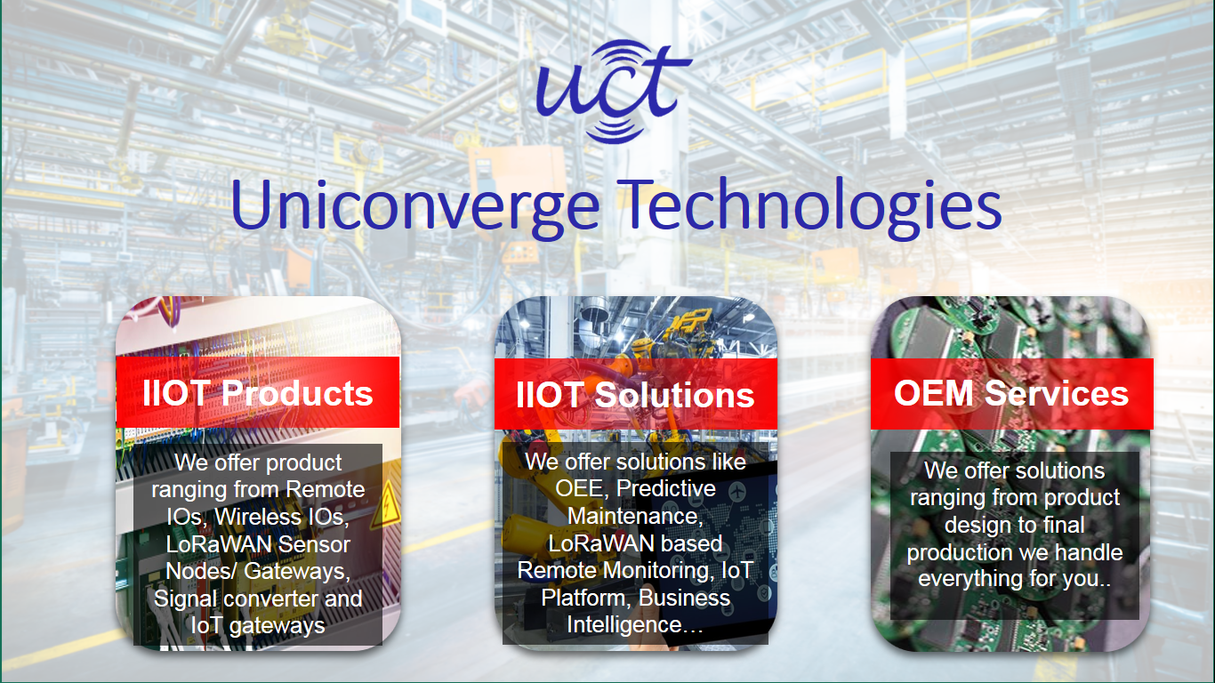

1. UCT IoT Platform**(****)**

**UCT Insight** is an IOT platform designed for quick deployment of IOT applications on the same time providing valuable “insight” for your process/business. It has been built in Java for backend and ReactJS for Front end. It has support for MySQL and various NoSql Databases.

* It enables device connectivity via industry standard IoT protocols - MQTT, CoAP, HTTP, Modbus TCP, OPC UA
* It supports both cloud and on-premises deployments.

It has features to  
• Build Your own dashboard  
• Analytics and Reporting  
• Alert and Notification  
• Integration with third party application(Power BI, SAP, ERP)  
• Rule Engine



**ii Smart Factory Platform (****)**

Factory watch is a platform for smart factory needs.

It provides Users/ Factory

* with a scalable solution for their Production and asset monitoring
* OEE and predictive maintenance solution scaling up to digital twin for your assets.
* to unleased the true potential of the data that their machines are generating and helps to identify the KPIs and also improve them.
* A modular architecture that allows users to choose the service that they what to start and then can scale to more complex solutions as per their demands.

Its unique SaaS model helps users to save time, cost and money.

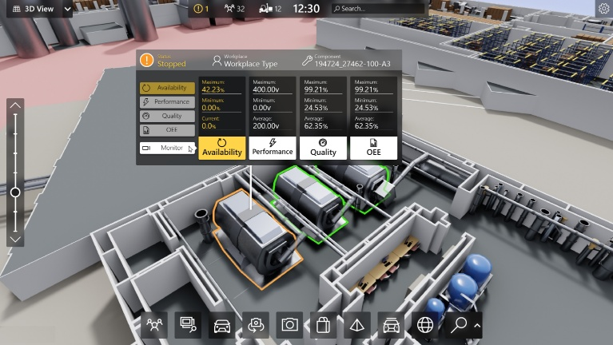

1. based Solution

UCT is one of the early adopters of LoRAWAN teschnology and providing solution in Agritech, Smart cities, Industrial Monitoring, Smart Street Light, Smart Water/ Gas/ Electricity metering solutions etc.

1. Predictive Maintenance

UCT isproviding Industrial Machine health monitoring and Predictive maintenance solution leveraging Embedded system, Industrial IoT and Machine Learning Technologies by finding Remaining useful life time of various Machines used in production process.



## About upskill Campus (USC)

upskill Campus along with The IoT Academy and in association with Uniconverge technologies has facilitated the smooth execution of the complete internship process.

USC is a career development platform that delivers **personalized executive coaching** in a more affordable, scalable and measurable way.



Seeing need of upskilling in self paced manner along-with additional support services e.g. Internship, projects, interaction with Industry experts, Career growth Services

<https://www.upskillcampus.com/>

upSkill Campus aiming to upskill 1 million learners in next 5 year

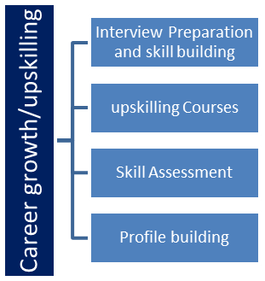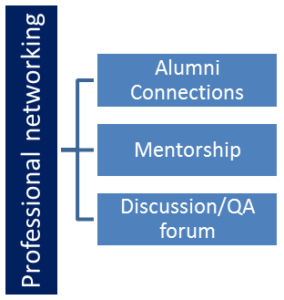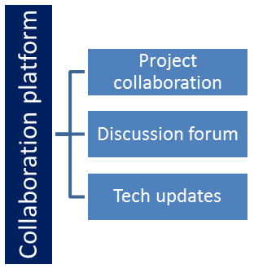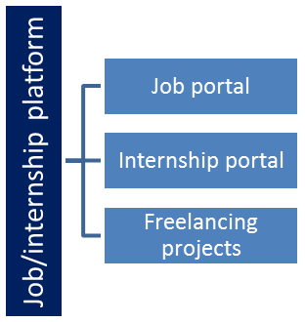

## The IoT Academy

The IoT academy is EdTech Division of UCT that is running long executive certification programs in collaboration with EICT Academy, IITK, IITR and IITG in multiple domains.

## Objectives of this Internship program

The objective for this internship program was to

 ☛ get practical experience of working in the industry.

 ☛ to solve real world problems.

 ☛ to have improved job prospects.

 ☛to have Improved understanding of our field and its applications.

 ☛to have Personal growth like better communication and problem solving.

## Reference

[1] **Python Cryptography Documentation**  
Python Cryptography  
This resource provides comprehensive information on the cryptographic functions used for securing passwords in the project.

• **Password Management Best Practices**  
[NIST Password Guidelines](https://www.nist.gov/programs-projects/digital-identity-guidelines)  
Guidelines provided by NIST (National Institute of Standards and Technology) on best practices for password management and security.

[2] **Tkinter Documentation**  
[Tkinter Documentation](https://docs.python.org/3/library/tkinter.html)  
The official documentation for Tkinter, the GUI toolkit used to create the user interface for the password manager.

[3] **Password Management Best Practices**  
[NIST Password Guidelines](https://www.nist.gov/programs-projects/digital-identity-guidelines)  
Guidelines provided by NIST (National Institute of Standards and Technology) on best practices for password management and security.

## Glossary

|  |  |
| --- | --- |
| Terms | Acronym |
| Password Manager | PM |
| Graphical user interface | GUI |
| Command Line Interface | CLI |
| Security Hash Algorithm | SHA |
| Two-Factor Authentication | 2FA |

# Problem Statement

In today’s digital age, managing multiple passwords for various online services is a significant challenge. Users often resort to weak or repeated passwords, which increases the risk of unauthorized access and data breaches. The core problem is the lack of an easy-to-use, secure system for generating, storing, and managing passwords. This project aims to address these issues by creating a password manager that enhances security and simplifies password management for users.

# Existing and Proposed solution

Current password managers offer various features, including password storage, generation, and autofill options. Popular examples include LastPass, 1Password, and Bitwarden. However, these solutions can have limitations, such as:

* **Cost**: Many advanced features are behind a paywall.
* **Complexity**: Some users find existing solutions overwhelming or difficult to configure.
* **Privacy Concerns**: Trusting a third-party service with sensitive information can be a concern.

# Proposed Design/ Model

The proposed solution is a custom password manager developed in Python. It will offer the following benefits:

* **Cost-Efficiency**: A free, open-source solution with no premium features.
* **User-Friendly Interface**: Simple and intuitive design for ease of use.
* **Enhanced Privacy**: Local storage and encryption methods to ensure data is kept private.

## High Level Diagram (if applicable)

The high-level design of the password manager includes:

* **User Interface**: A graphical interface for interaction.
* **Password Storage**: Secure storage for encrypted passwords.
* **Encryption Module**: Handles encryption and decryption of passwords.
* **Database**: Stores user credentials securely.

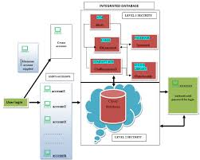

Figure 1: HIGH LEVEL DIAGRAM OF THE SYSTEM

## Low Level Diagram (if applicable)

The low-level design details the internal components:

* **Login Module**: Manages user authentication.
* **Password Generator**: Creates strong, random passwords.
* **Password Manager**: Adds, updates, and retrieves stored passwords.
* **Encryption Handler**: Utilizes cryptographic algorithms for security.

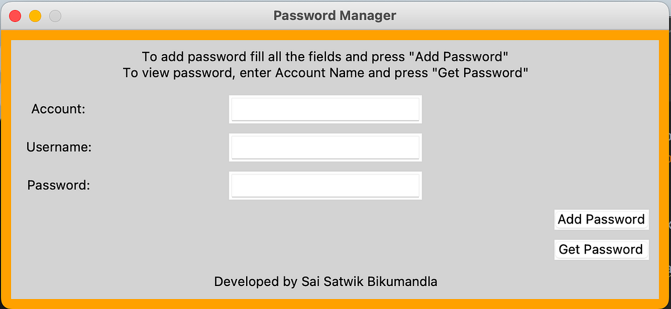

### 5.3 Interfaces

The project includes the following interfaces:

* **Graphical User Interface (GUI)**: Built using Tkinter, allowing users to interact with the password manager.
* **Command-Line Interface (CLI)**: Provides an alternative method for users to access functionalities.

# Performance Test

## Test Plan/ Test Cases

Test cases are designed to verify:

* **Functionality**: Ensure all features work as intended (e.g., password generation, storage, retrieval).
* **Security**: Test encryption/decryption processes to confirm data protection.
* **Usability**: Check the interface for user-friendliness and responsiveness.

## Test Procedure

• **Unit Testing**: Test individual modules for correct functionality.

• **Integration Testing**: Ensure all modules work together seamlessly.

• **Security Testing**: Assess encryption strength and data protection.

## Performance Outcome

The password manager has been tested successfully, with all core functionalities performing as expected. Encryption methods provide robust security, and the interface is intuitive for users. Performance benchmarks show the application handles data efficiently with minimal latency.

# My learnings

Through this project, I have gained valuable experience in:

* **Python Programming**: Enhanced my skills in Python, including libraries and frameworks such as Tkinter and cryptography.
* **Security Practices**: Learned about encryption techniques and secure data handling.
* **Project Development**: Improved my ability to plan, design, and execute a software project from start to finish.

.

# Future work scope

Future improvements may include:

* **Cross-Platform Support**: Extending compatibility to other operating systems.
* **Advanced Features**: Adding functionality such as biometric authentication and cloud synchronization.
* **User Feedback Integration**: Incorporating feedback from users to enhance the application’s usability and features.