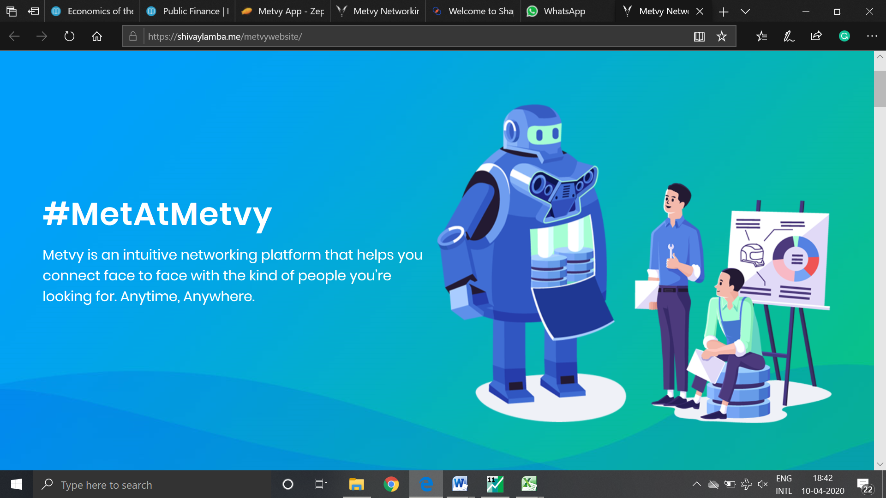

**First thing should be to get people to download metvy.**

**So, in place of the yellow square we should add:**

**Meet at Metvy**

Connect with people around you

Build your network on Metvy

**Sign up for free> (link to playstore)**

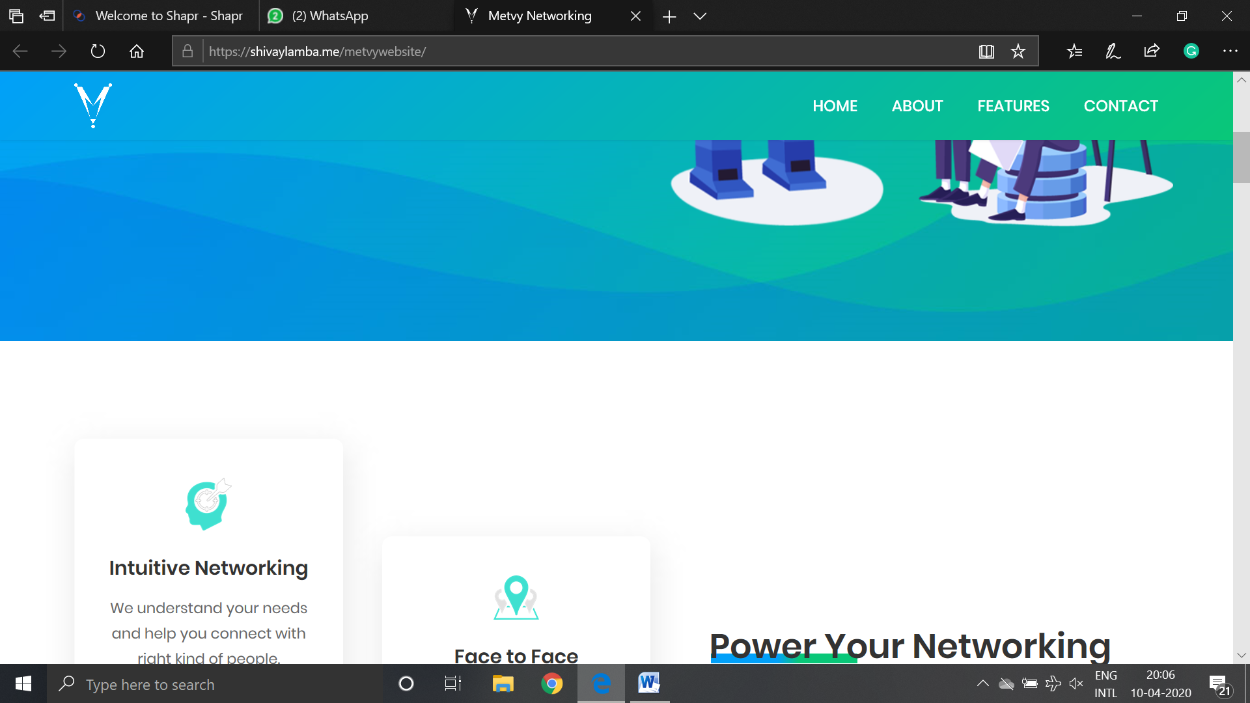

**Here we can have the intro:**

**#MetAtMetvy**

Metvy is an intuitive hyper-local networking platform which leverages Artificial Intelligence to help you connect and network with others around you.

**Also, add the short video around here.**

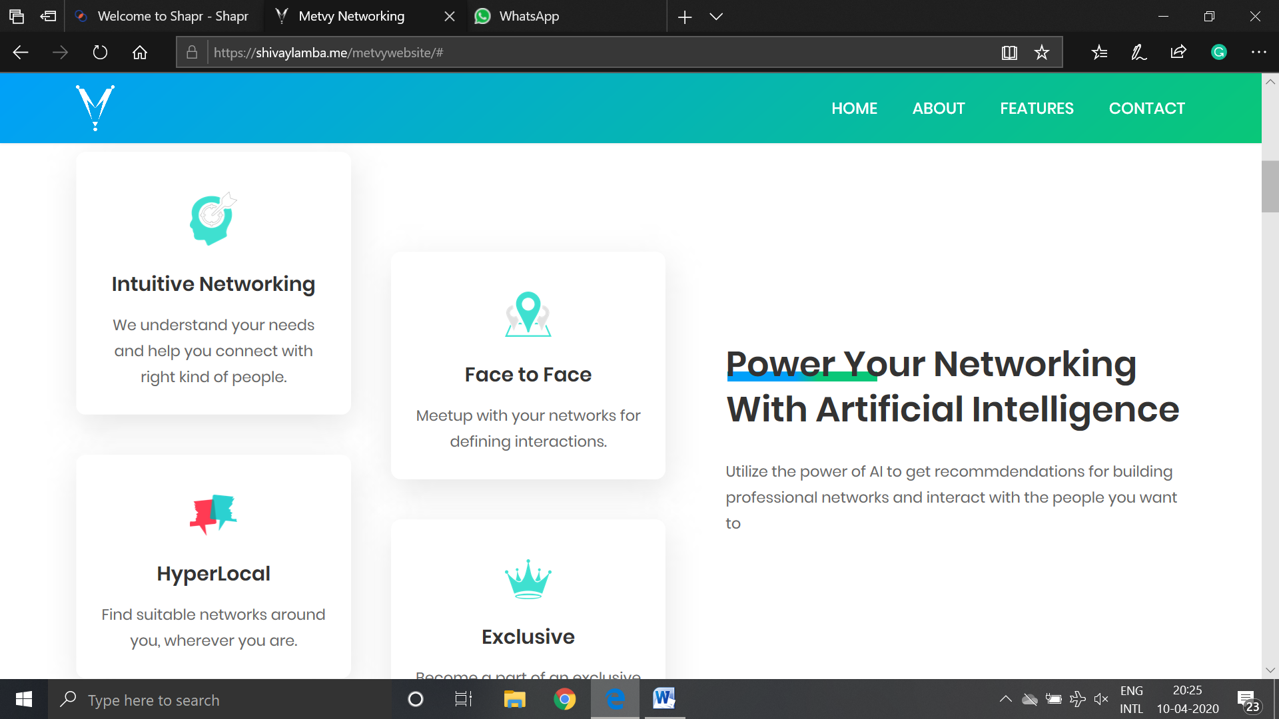

**AI powered HyperLocal networking**

On Metvy, find interest based opportunities, global mentors, live projects, make a difference.

**Intuitive Networking:** We analyse your needs and connect you with people who share mutual interest

**Face to Face:** We need to remove this

**HyperLocal:** Find suitable networks around you, wherever you are

**Map Based:** Connect in real life.

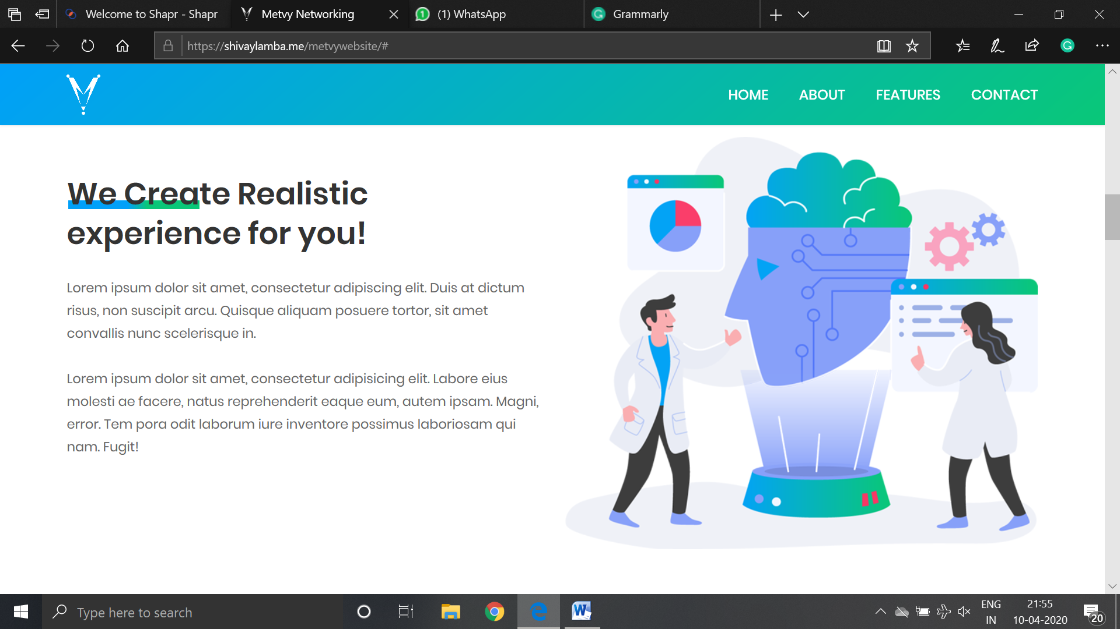

**DO NOT NEED THIS**

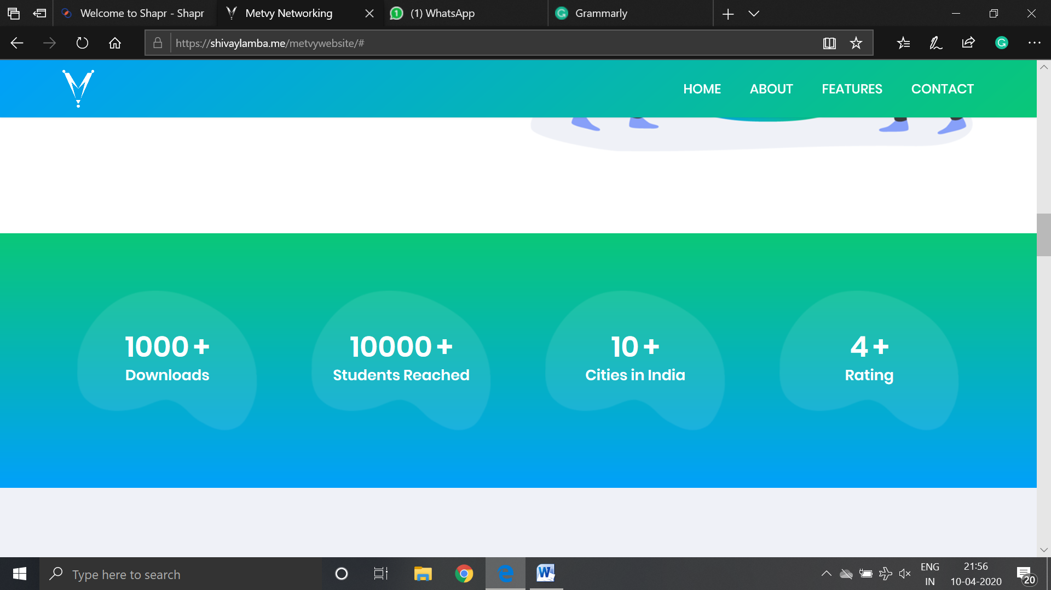

**COOL**

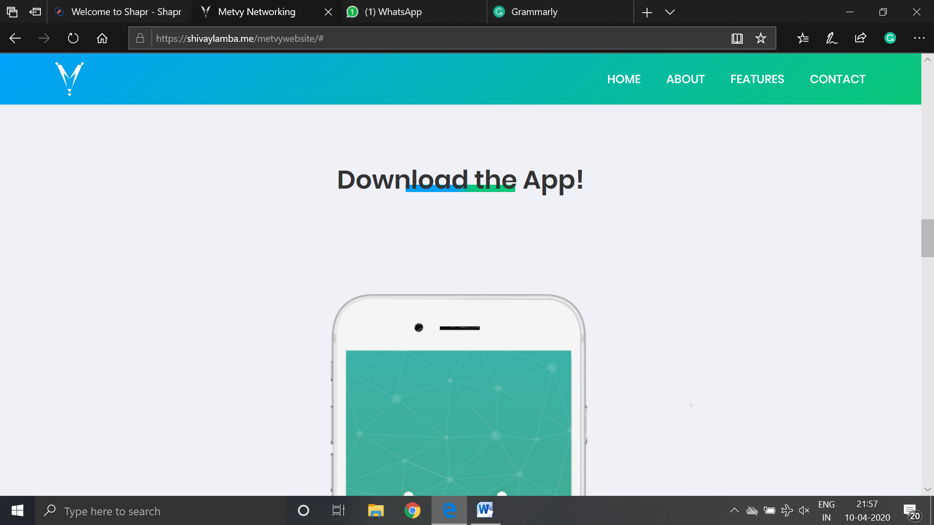

**COOL**

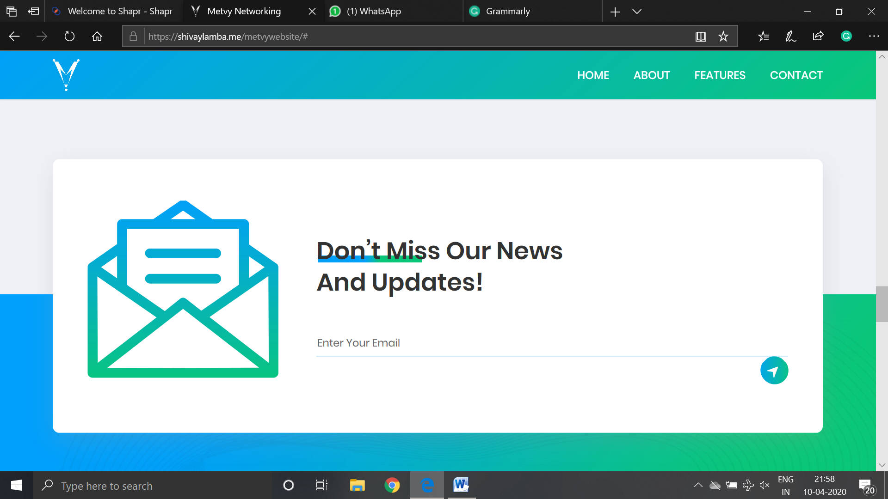

**COOL**

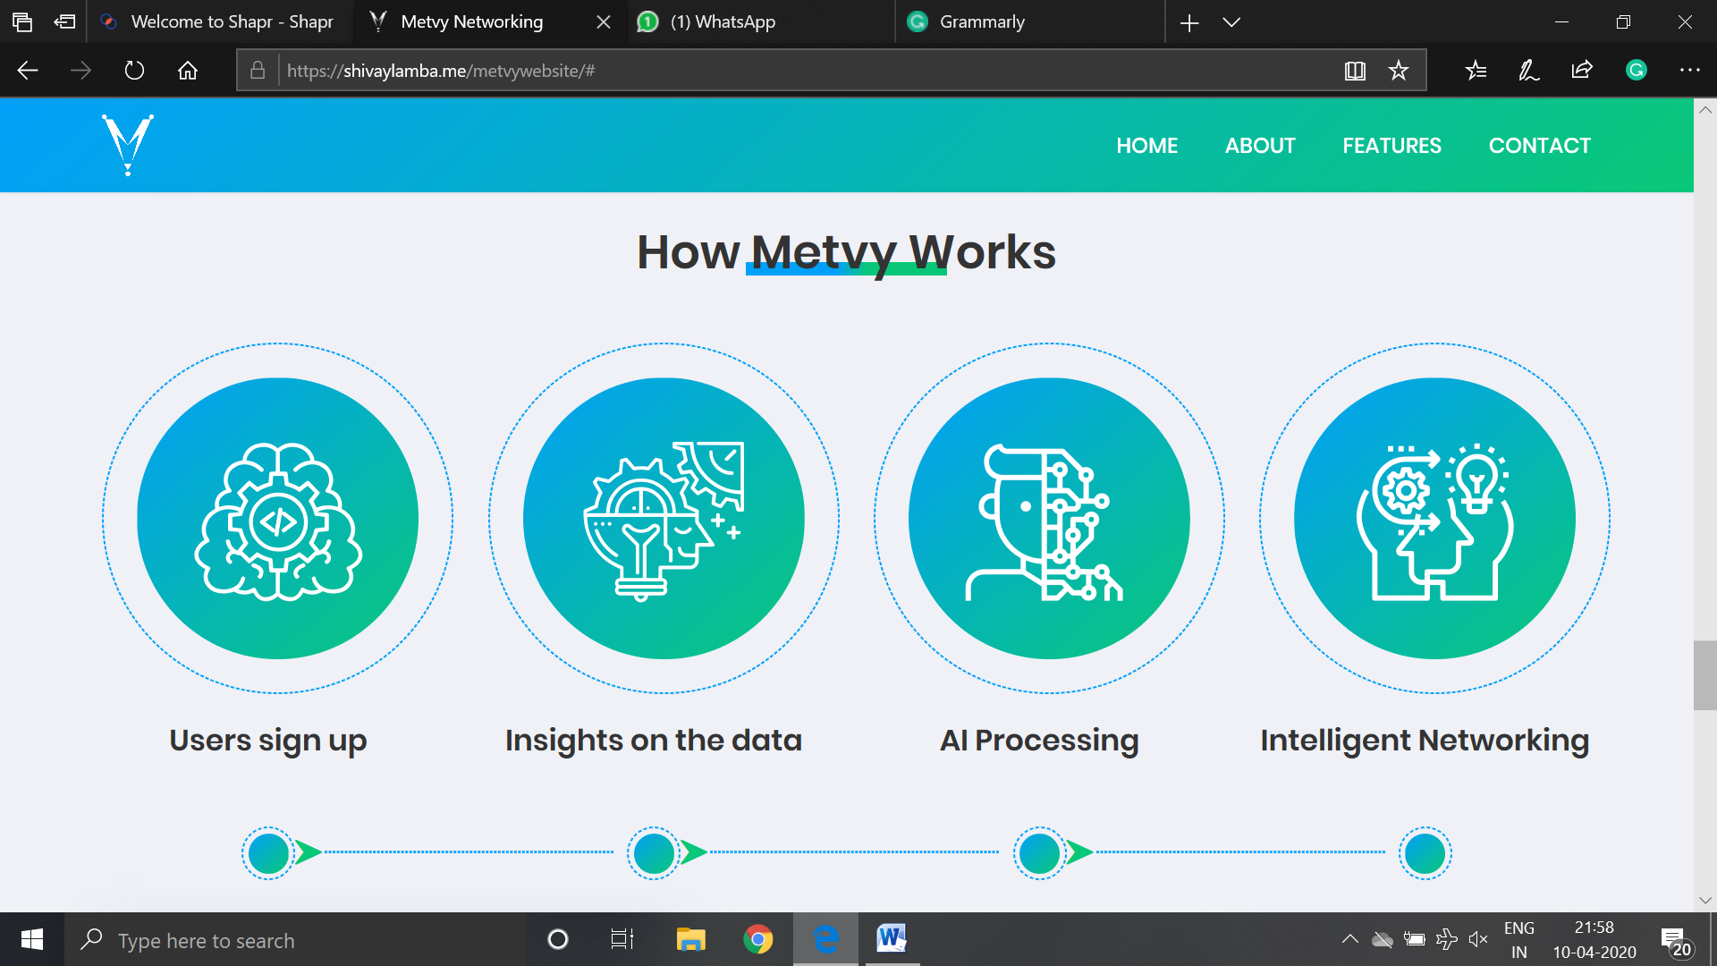

Users Sign-Up Insights on the Data Intuitive Networking

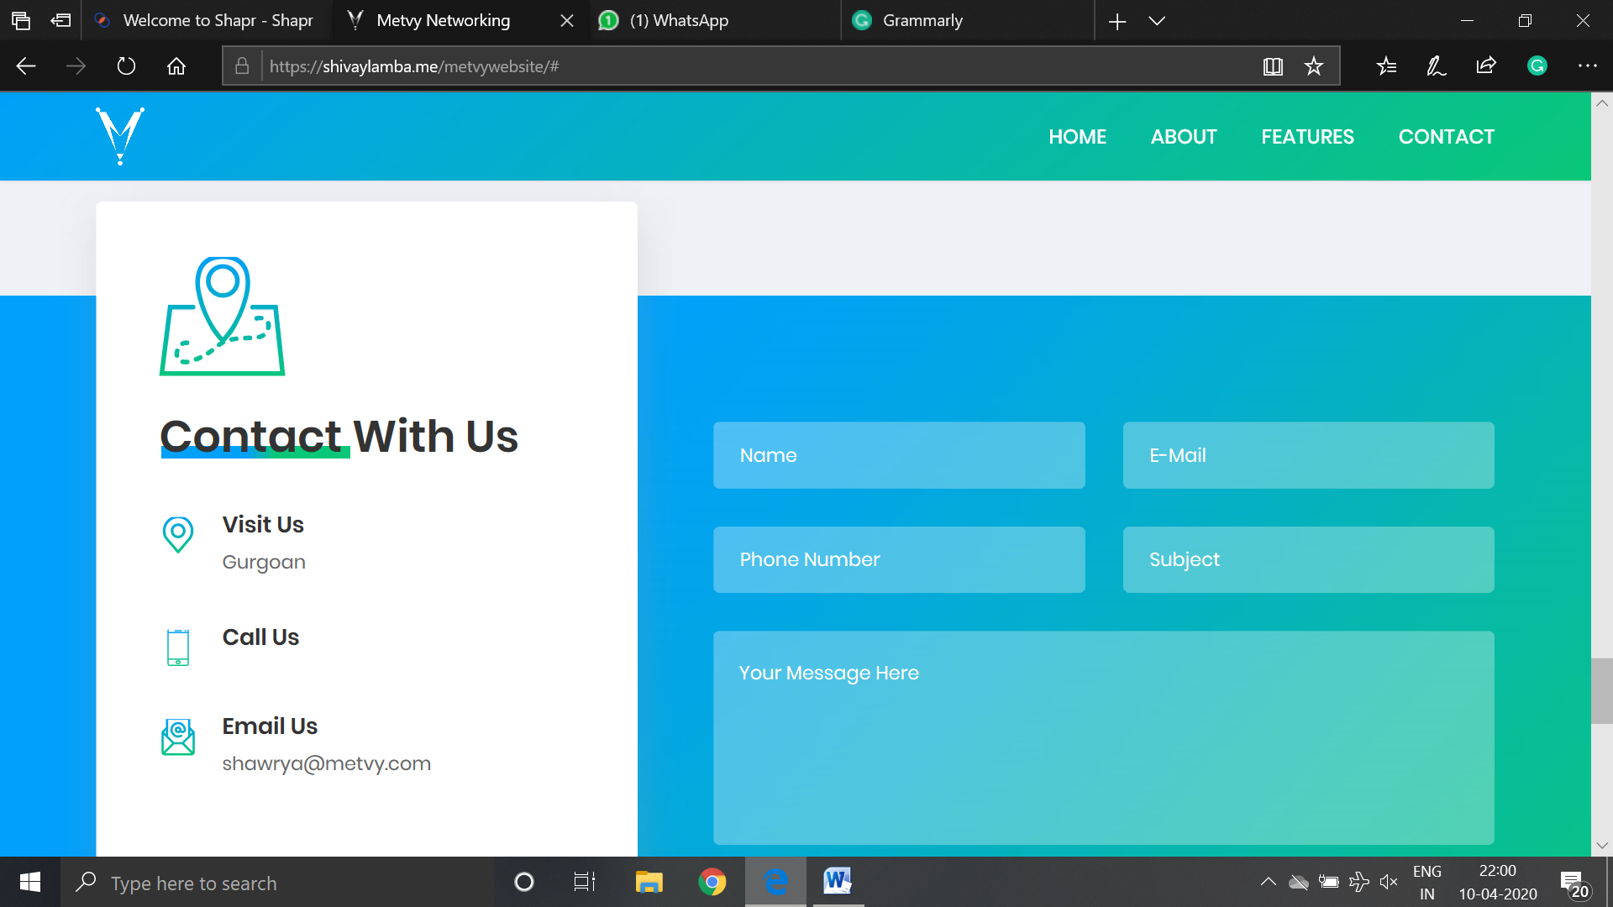

Contact Us

**Add a number**

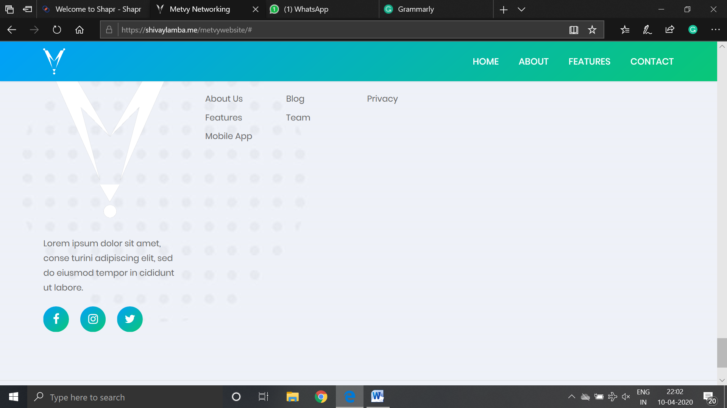

**REMOVE**

**TEAM:**

*Shawrya Mehrotra, CEO & Founder*

*Rajan Luthra, Co-Founder*

*Shivay Lamba, Head of Product*

**Add photos**