**Everything You Need to Know About Shark Attacks as Told by Graphs**

* **By MEGHAN KENEALLY**
* **JAN DIEHM**

Jun 15, 2015

ABC News

This article appeared in ABC news after two teens were injured by shark attacks in North Carolina in June 2015.

The authors represented data collected by Florida Museum of Natural History using graphics to present the shark attack trends and Geographics to put the 2015 attacks in perspective.

The first graphic conveyed the message that surface activity poses more risk (people who use some kind of flotation device on the surface of water have been the most frequently attacked individuals in recent years).

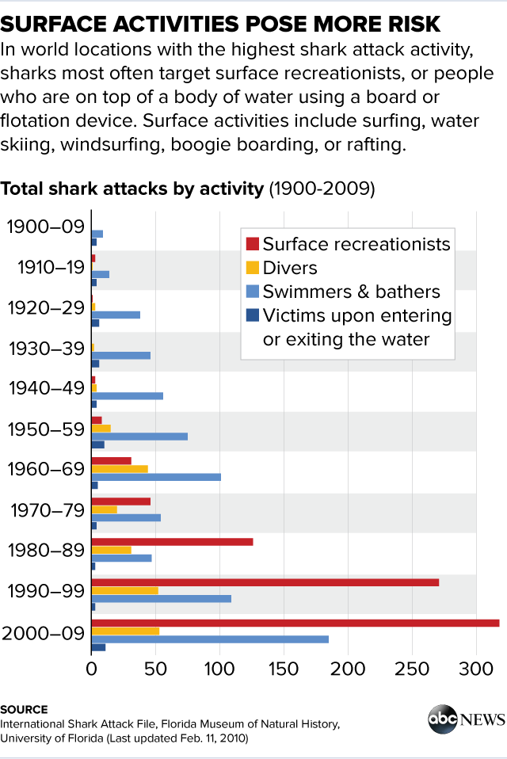

The graphic is well depicted with titles, legend and source citation. The recreationists’ attacks being so high, this simple bar plot seem to convey the message well. It seems very obvious that before flotation devices became mainstream in recent years, most attacks tended to be on swimmers and bathers (as objects get spotted by sharks gets easier so are the attacks).

Shark attacks averaged around 70 per year from 2005-2014 with a total of 701 of which 59 or 8.4% were fetal attacks. While the graph is well presented, usage of very different colors for both types of attacks could have conveyed the message even better.

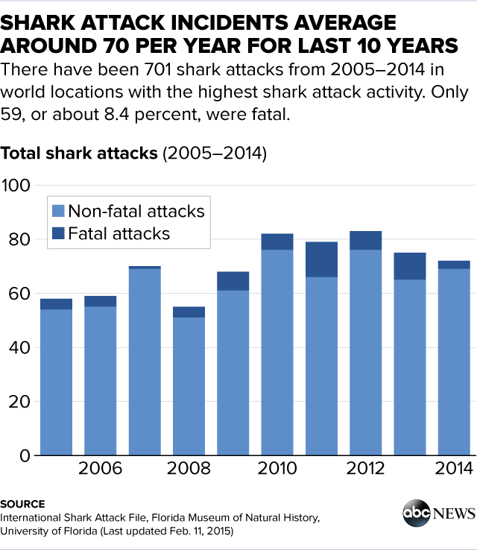

Next graph tried to convey number of injuries and fatalities that each species of shark was responsible for – from which researchers determined that vast majority were three types (white sharks, followed by tiger sharks and then bull sharks). The data collected is from 1580-2014.

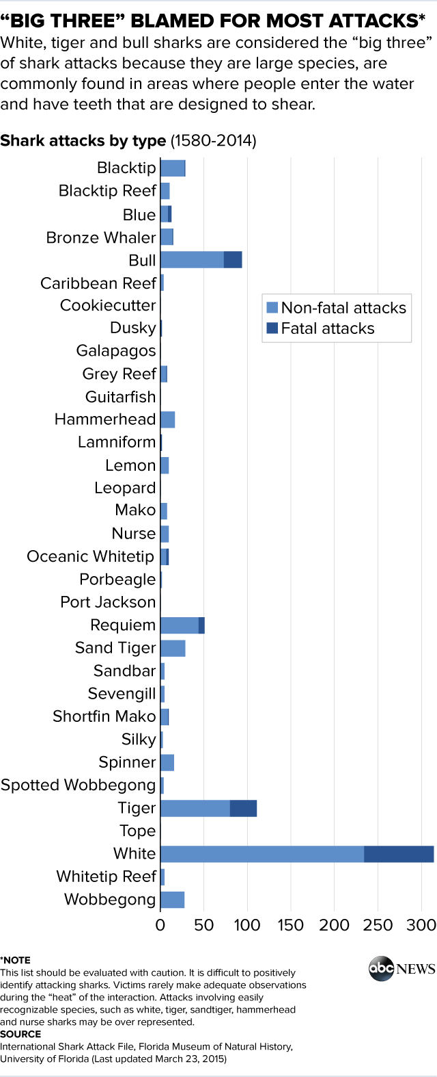

There are few thoughts about this graph that ran in my mind.

* What is the motive behind presenting this information here?
* Why can’t the data be for the same years as the other two graphs? – is it just presented because it is available?
* This data is very subjective, but glad to see the note beneath the graph
* The graph can be presented better, like a pareto chart so the top three show up at the top

Next two graphics presented the counts of attacks on different geographies and their trends:

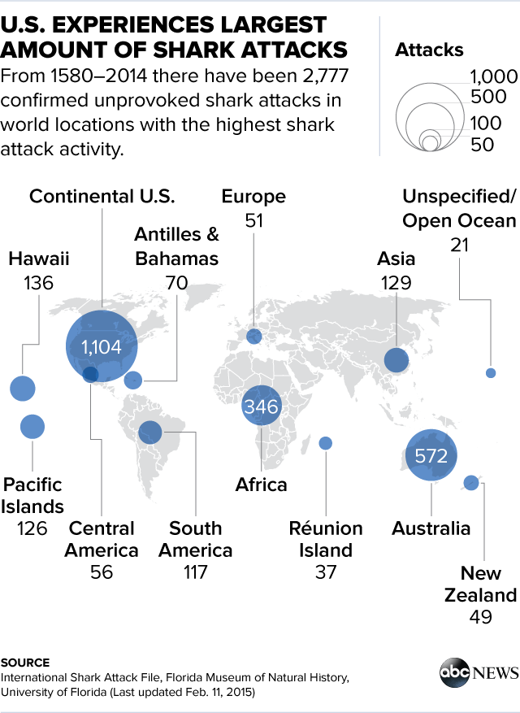

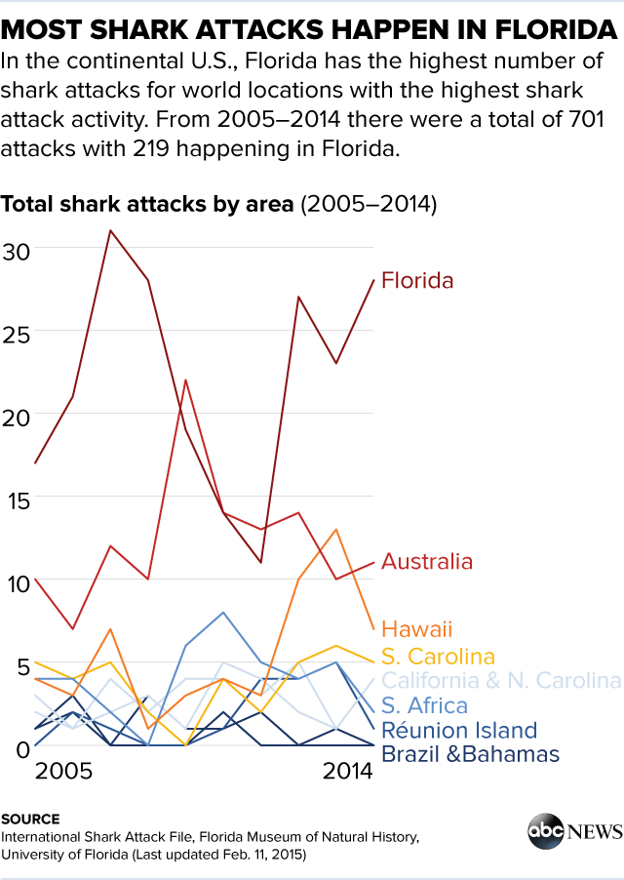

While the graphics depicted the intended messages well, the number of years from one graph to the other vastly differed. In the last graphic, better colors should have been used to distinguish the lower count locations. Other thing I thought missing is the proportions of all these categories for which we may not have data. Florida being famous for beach destinations, the results do not seem to surprise.

While the counts being so drastically high, these simple graphs seemed to convey the intended messages very well otherwise more intensive statistics would be required.

References:

<http://abcnews.go.com/US/shark-attacks-told-graphs/story?id=31779076>

<https://www.floridamuseum.ufl.edu/fish/isaf/home>