**Binomial, Poisson and Hypergeometric Distributions**

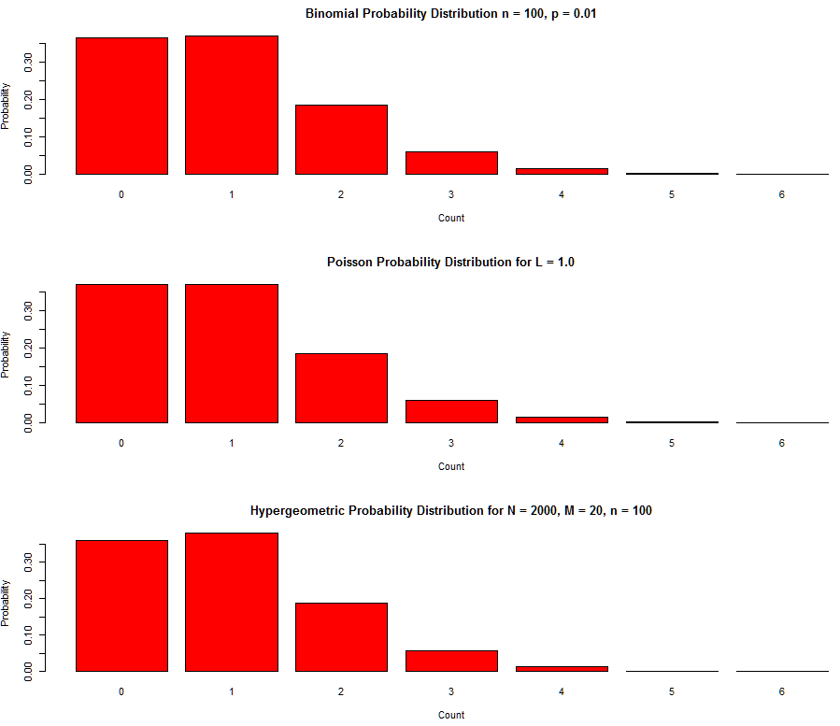

**Under certain conditions, the three distributions are similar.**

1. **Binomial and Poisson: Small p and n >= 100 with the mean of the Poisson distribution = np <= 10.**
2. **Binomial and Hypergeometric: M/N = p, N >= 20n and M = Np. (M = white balls, N = black balls, n = number of balls drawn)**
3. **Poisson and Hypergeometric: Combination of 1) and 2) n(M/N) <= 10, n >= 100, N >= 20n and M = Np.**

**x <- c(0, 1, 2, 3, 4, 5, 6)  
dbinom(x, 100, 0.01, log = FALSE)  
dpois(x, 1.0, log = FALSE)  
dhyper(x, 20, 2000, 100, log = FALSE)**