**Project Members:**

Pratiksha Gaikwad

Siddhi Baravkar

**Tasks completed:**

Pratiksha Gaikwad

1. Discussion for ideas and implementation methods.
2. Logic for overall code flow.
3. Implemented logic for the SEND command.
4. Implemented logic for the SHUTDOWN command.

Siddhi Baravkar

1. Discussion for ideas and implementation methods.
2. Code setup for Multithreading.
3. Environment testing to fit code from P1 for multithreading.
4. Implemented the logic for the WHO command.

**Steps to run the program:**

1. Download the tar file pratiksha_g_siddhi_b_p1.tar
2. Unzip the tar - **$ tar -xvf pratiksha_g_siddhi_b_p1.tar**
3. Compile the MultiThreadServer.java and Client.java - **$ Make**
4. Run the Server program - **$ java MultiThreadServer.java**
5. Run multiple clients - **$java Client.java 127.0.0.1**

**Sample outputs:**

1. As per previously implemented commands LOGIN, MSGGET, MSGSTORE, LOGOUT, QUIT below are outputs.

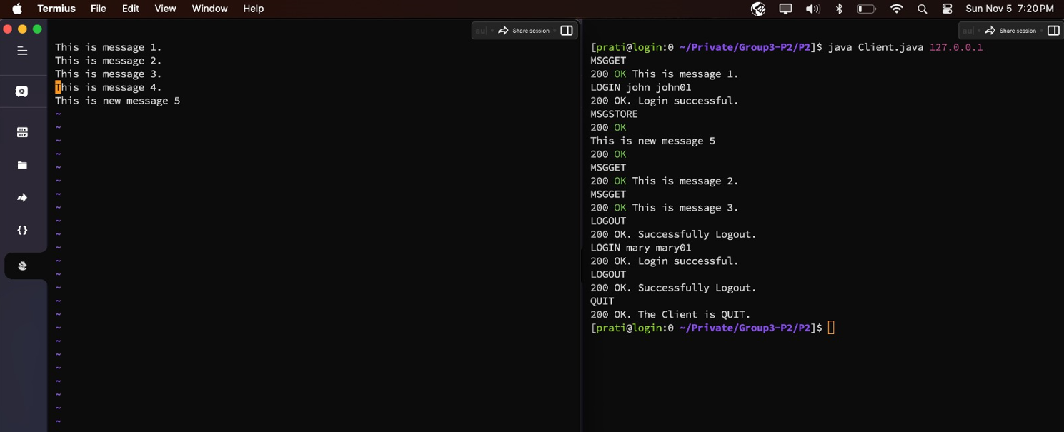

1. Output for WHO:

root, david, and mary are logged in. WHO command is sent from root. It shows all logged in users.

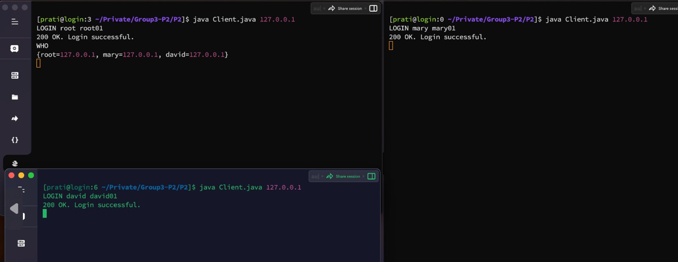

Now Mary is logged out and WHO command is sent from David it shows 2 active users root and david.

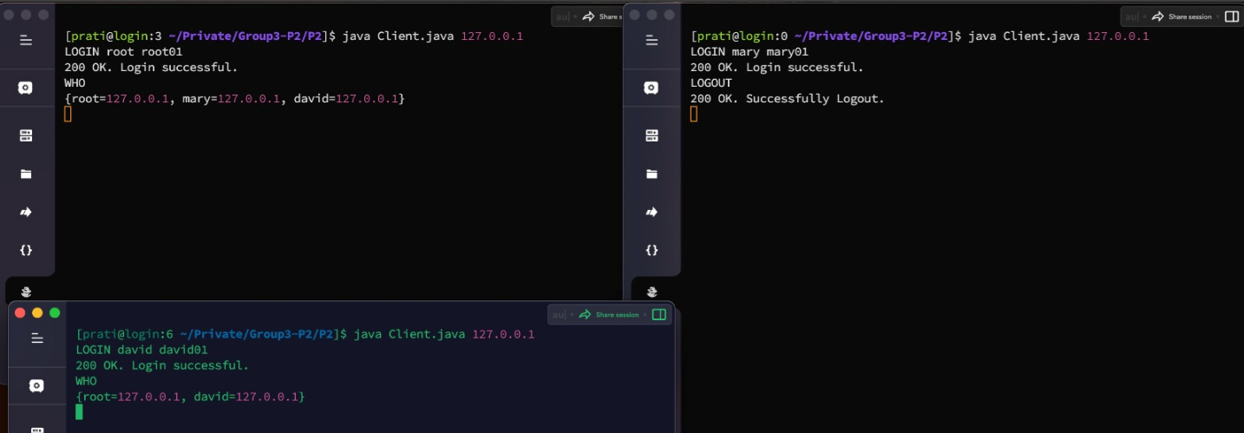

1. Output for SEND:

SEND command is sent from root to david. It shows the desired output.

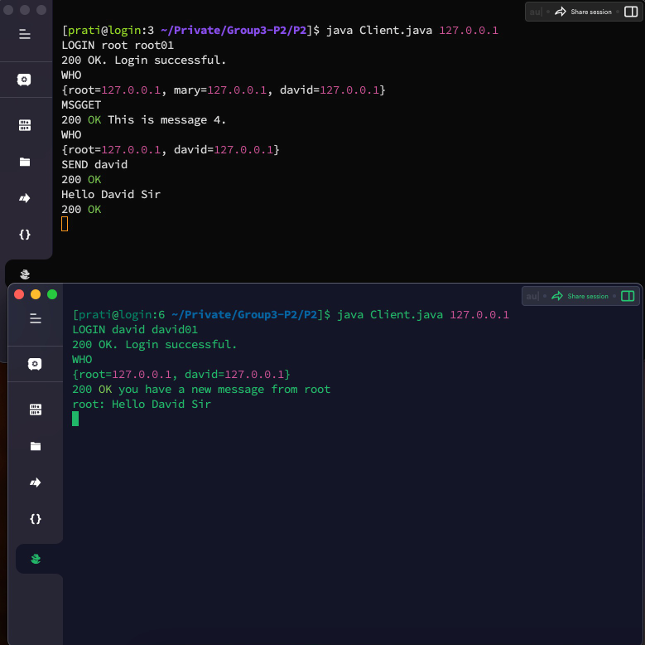

1. Output for SHUTDOWN

Shutdown acts as a broadcast command here after sending SHUTDOWN from root, all servers are SHUTDOWN.

