**In all scripts use appropriate constants and add comments .**

1. Write a php script to take two command line inputs a number and a string.

a. If the string length is greater than number then print "String size is more".

b. If the string length is smaller than number then print "String size is less".

c. If they are equal print "Jackpot"

2. Write a php script to take two command line inputs a string and a character.

a. Search the character in the string and print its position.

3. Write a php script to split input string into individual characters and arrange them in ascending order.

4. Write a php script to count the number of words in a file.

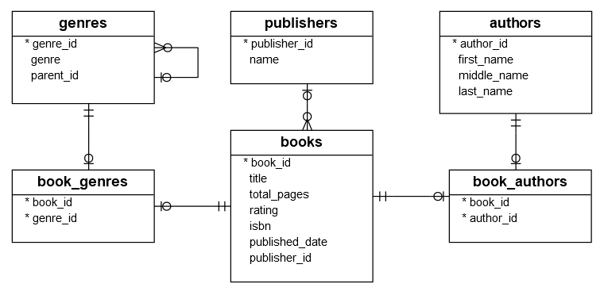5. Create tables as below for book publishing database. Give appropriate indexes.

a. Enter some dummy values about 20 records for books.

b. Write a php script to read the details for books,author name, genre and publisher name details and enter in a csv file with appropriate headers.

6. Write a php script to read data from the csv and enter data in mysql table.

You can create a csv with minimum 7 fields containing mixture of string and numeric records.

Create table in mysql. And push the data through script.