#include <GL/glut.h>
#include <math.h>

double parr[8];
bool showPolygon = false; // A flag to control whether to show the polygon

void init() {
glClearColor(0, 0, 0, 1);
gluOrtho2D(-600, 600, -600, 600); // Increased the visible range

// Polygon Default (Rectangle)
parr[0] = 100; // x1
parr[1] = 100; // y1
parr[2] = 300; // x2
parr[3] = 100;
parr[4] = 300; // x3
parr[5] = 300;
parr[6] = 100; // x4
parr[7] = 300;
}

void polygon() {
glColor3f(0, 1, 0); // Set polygon color to green
glBegin(GL_LINE_LOOP);
glVertex2f(parr[0], parr[1]);
glVertex2f(parr[2], parr[3]);
glVertex2f(parr[4], parr[5]);
glVertex2f(parr[6], parr[7]);
glEnd();
glFlush(); // Ensure rendering is done
}

void drawCoordinates() {
glClear(GL_COLOR_BUFFER_BIT); // Clear the screen

glColor3f(1, 1, 1); // Set axis color to white
glBegin(GL_LINES);
glVertex2f(-600, 0); glVertex2f(600, 0); // X-axis
glVertex2f(0, 600); glVertex2f(0, -600); // Y-axis
glEnd();

// Draw the polygon only if showPolygon is true
if (showPolygon) {
polygon(); // Draw the polygon when the flag is true
}

glFlush(); // Render the axes and polygon to screen
}

// Reflection across the X-axis
void reflectionX() {
for (int i = 1; i < 8; i += 2) {
parr[i] = -parr[i]; // Reflect Y-coordinate
}
glutPostRedisplay(); // Request a redraw
}

// Reflection across the Y-axis
void reflectionY() {
for (int i = 0; i < 8; i += 2) {
parr[i] = -parr[i]; // Reflect X-coordinate
}
glutPostRedisplay(); // Request a redraw
}

// Translation
void translate2d() {
int x = 100, y = 100;
for (int i = 0; i < 8; i += 2) {
parr[i] = parr[i] + x; // Translate X
parr[i + 1] = parr[i + 1] + y; // Translate Y
}
glutPostRedisplay(); // Request a redraw
}

// Rotation about an arbitrary point (cx, cy)
void rotation() {
double angle = 45, rad, x, y;
double cx = 100, cy = 100; // The arbitrary point (center of rotation)

rad = 3.141 * (angle / 180); // Convert angle to radians

// Apply the rotation for each vertex
for (int i = 0; i < 8; i += 2) {
// Step 1: Translate the point so that (cx, cy) becomes the origin
x = parr[i] - cx;
y = parr[i + 1] - cy;

// Step 2: Apply the rotation around the origin (0, 0)
double newX = x * cos(rad) - y * sin(rad);
double newY = x * sin(rad) + y * cos(rad);

// Step 3: Translate back by adding (cx, cy)
parr[i] = newX + cx;
parr[i + 1] = newY + cy;
}
glutPostRedisplay(); // Request a redraw
}

// Scaling
void scaling2d() {
double x = 0.5, y = 0.5; // Scaling factors
for (int i = 0; i < 8; i += 2) {
parr[i] = parr[i] * x; // Scale X-coordinate
parr[i + 1] = parr[i + 1] * y; // Scale Y-coordinate
}
glutPostRedisplay(); // Request a redraw
}

void menu(int ch) {
switch(ch) {
case 1:
showPolygon = true; // Set flag to true to display polygon
glutPostRedisplay(); // Request a redraw
break;
case 2: translate2d(); break;
case 3: scaling2d(); break;
case 4: rotation(); break;
case 5: reflectionX(); break; // Reflection option (X-axis only)
case 6: reflectionY(); break; // Reflection option (Y-axis only)
}
}

int main(int argc, char** argv) {
glutInit(&argc, argv);
glutInitWindowSize(500, 500);
glutCreateWindow("2D Transformation");
init();
glutDisplayFunc(drawCoordinates);

glutCreateMenu(menu);
glutAddMenuEntry("1 Display Polygon", 1);
glutAddMenuEntry("2 Translate", 2);
glutAddMenuEntry("3 Scaling", 3);
glutAddMenuEntry("4 Rotation", 4);
glutAddMenuEntry("5 Reflection Across X-axis", 5); // Reflection option for X-axis only
glutAddMenuEntry("6 Reflection Across Y-axis", 6); // Reflection option for Y-axis
glutAttachMenu(GLUT_RIGHT_BUTTON);

glutMainLoop();
return 0;
}

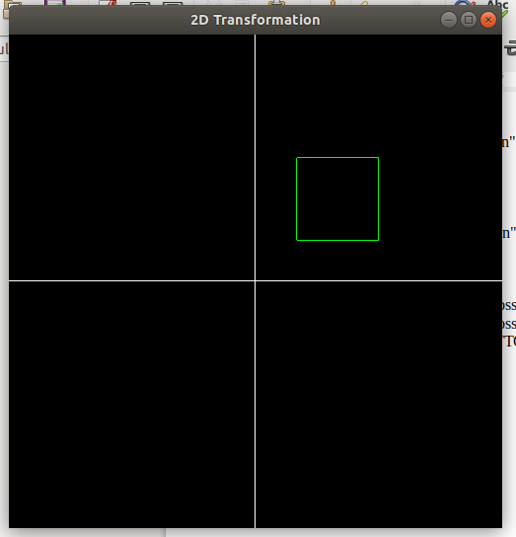
OUTPUT:-
1.Display Polygon:

2. Translation

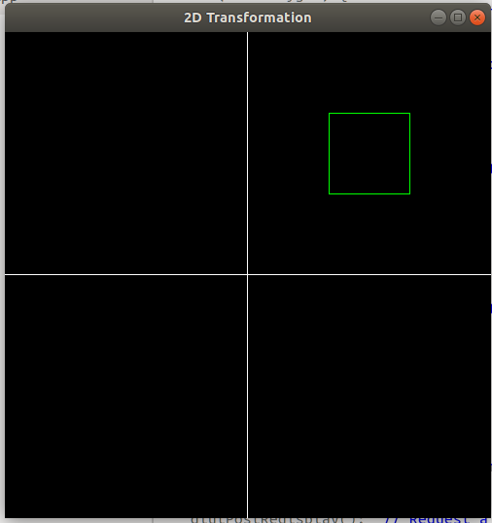

3.Scalling:
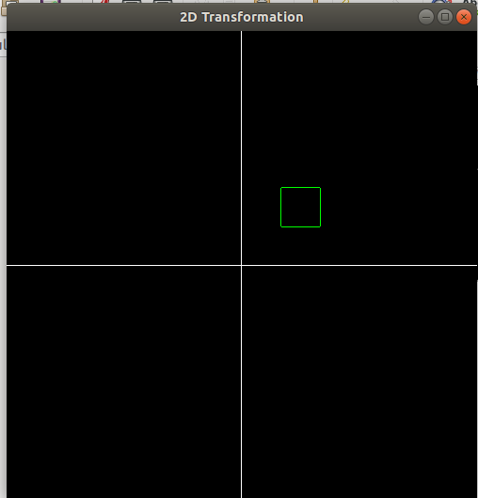

4.Rotation:

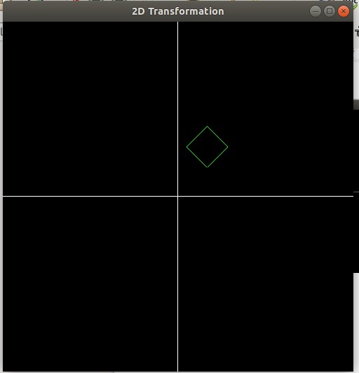

Reflecion Across X-Axis
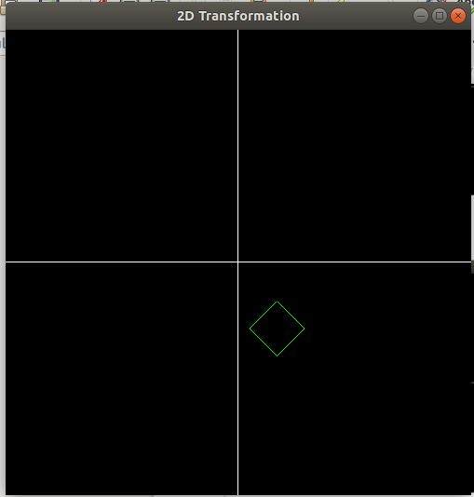

Reflecion Across Y-Axis
