ECR

ECR-[Elastic Container Registry]

* We store Docker image inside this for future use.
* this is like our repository.
* It allows developers to store, share, and deploy container images, and integrates with other AWS services to createan ecosystem for managing containerized applications.

Search 'amazon ecr public gallery' on google-->

Steps-->

-Launch Linux Instance

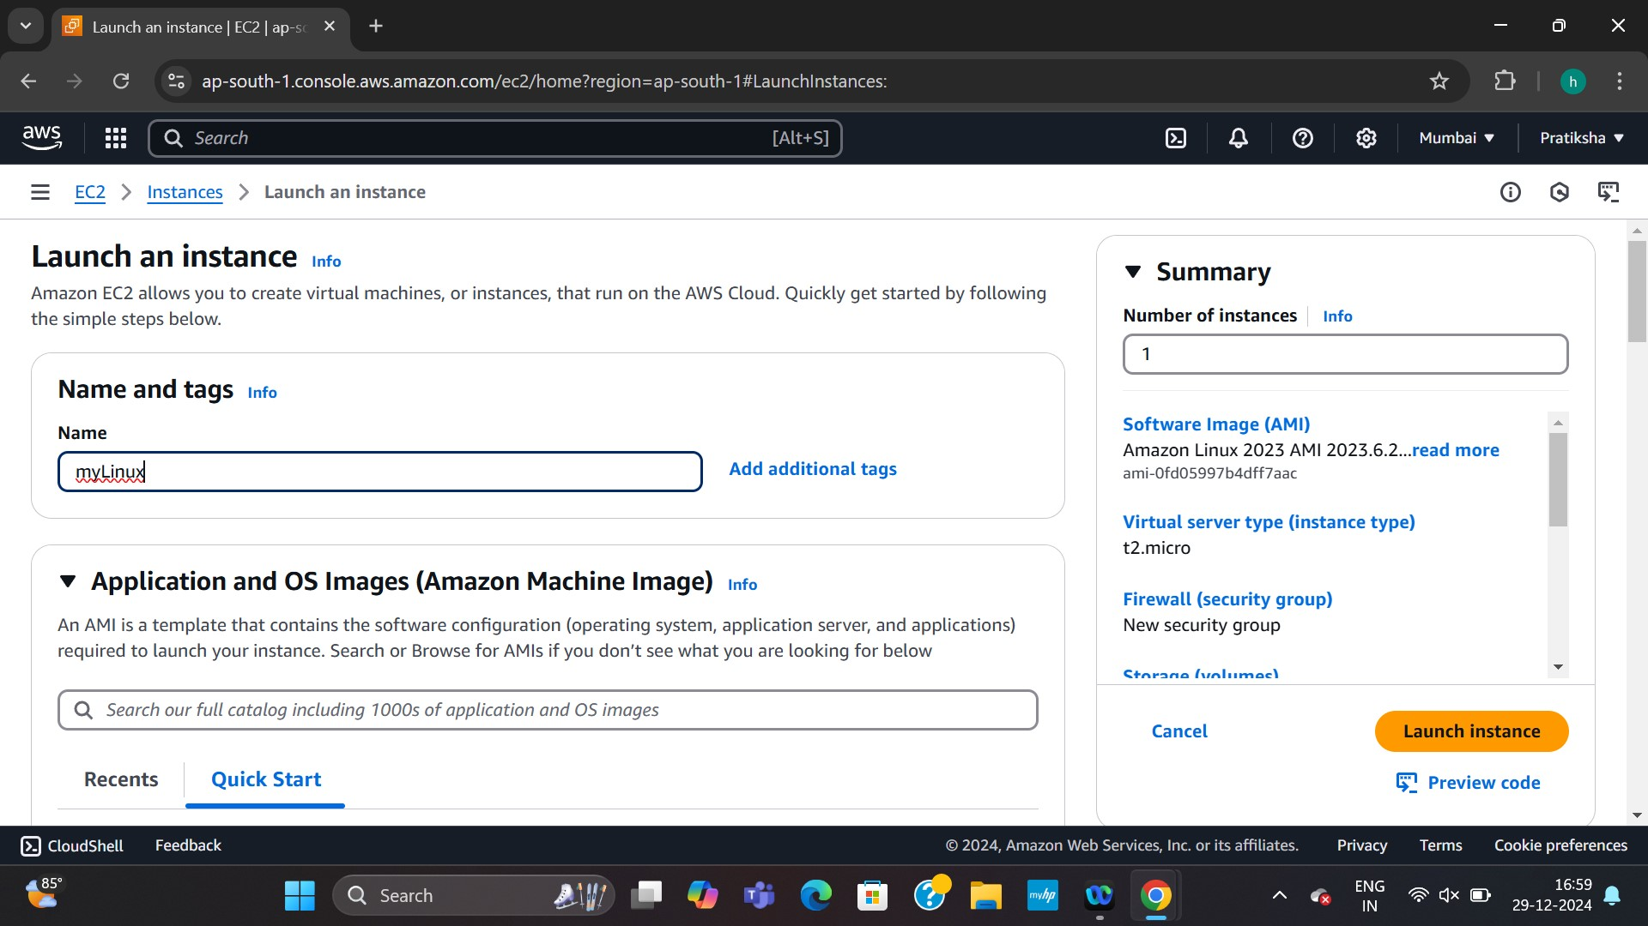

--> Search ECR

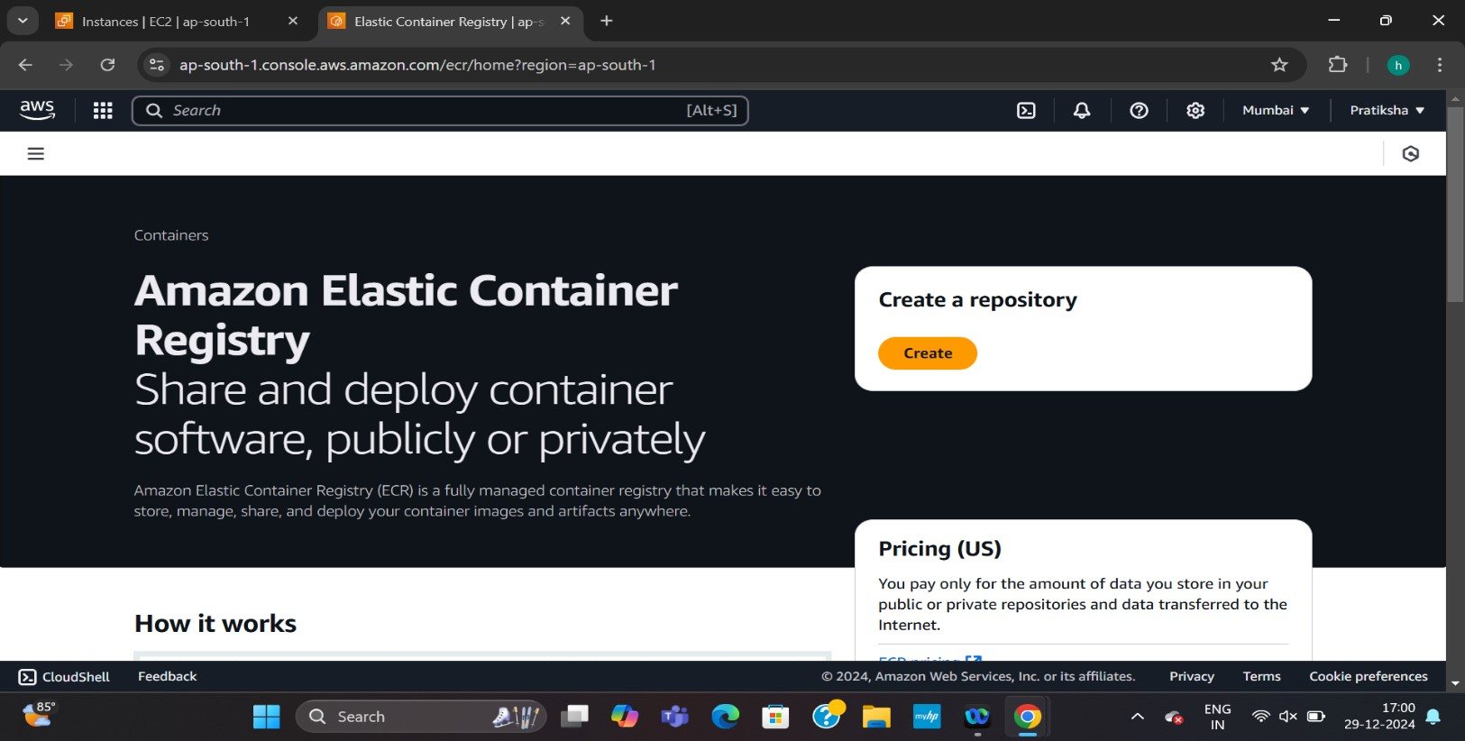

--> create a private Repo--> provide name--> create repo.

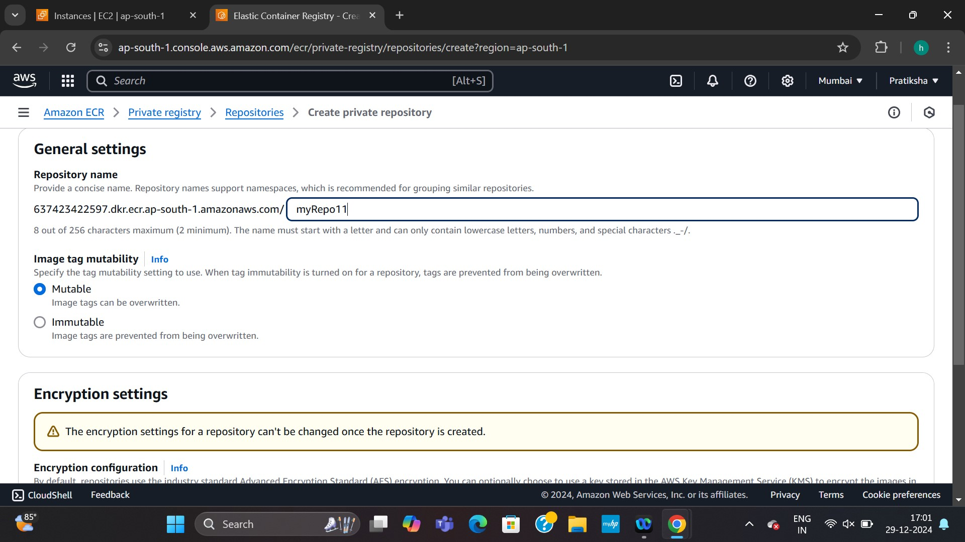

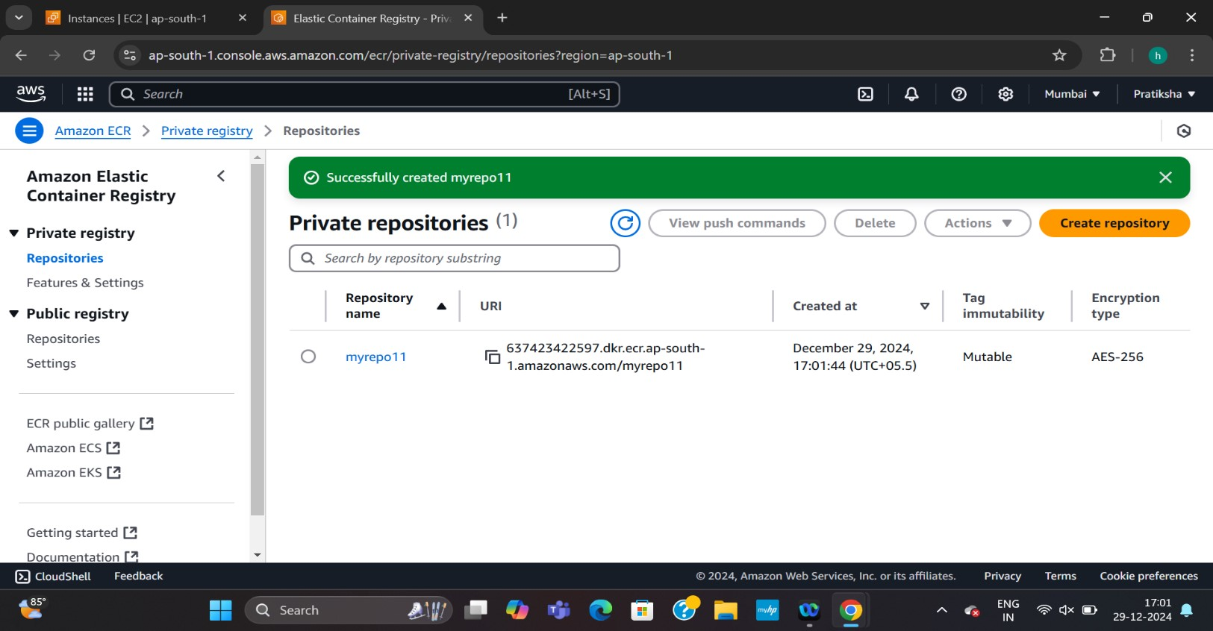

--> connect

Instance SSH client

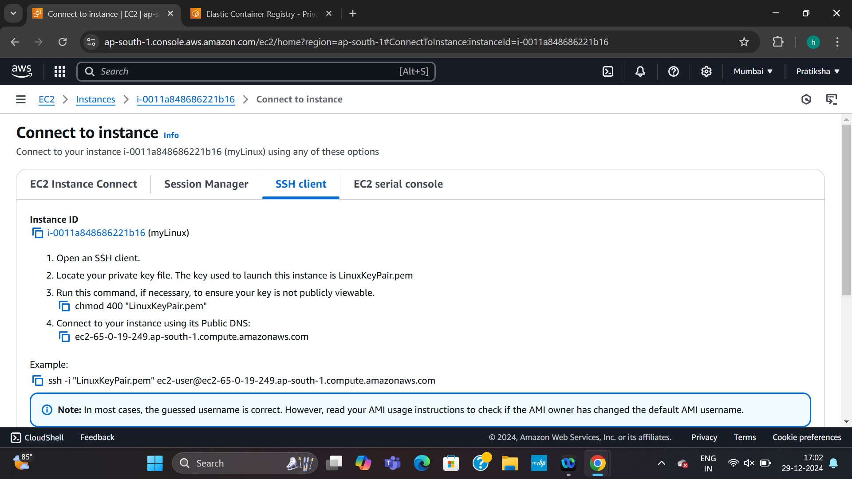

sudo su

yum update -y

yum install docker -y

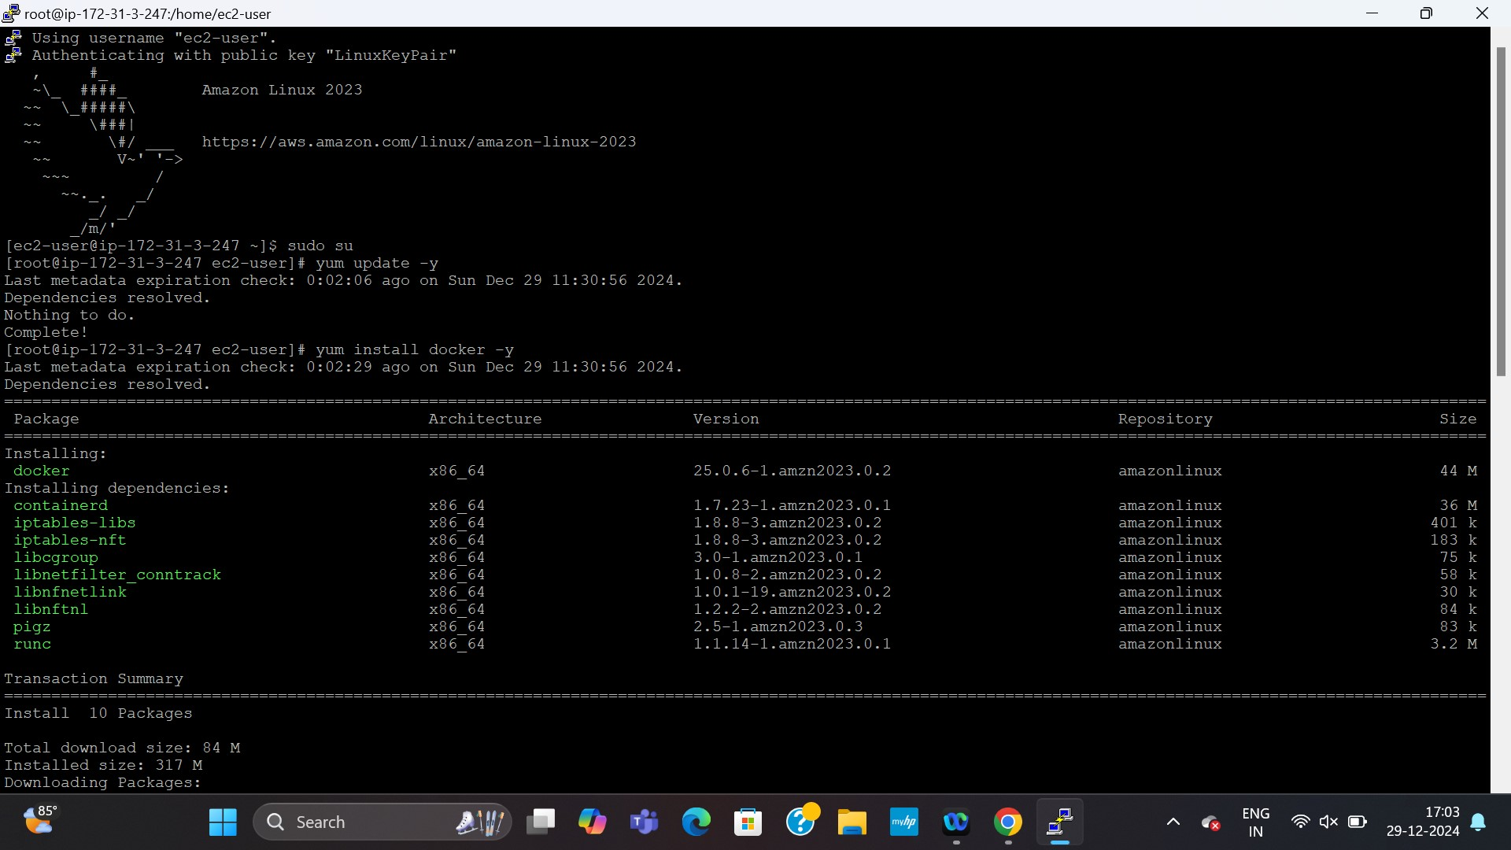

Service docker start

vi Dockerfile

FROM ubuntu

RUN apt update -y

RUN apt-get install apache2 -y

COPY index.html /var/www/html

EXPOSE 80

CMD ["apachectl", "-D", "FOREGROUND"]

--> create index.html also

--> docker build -t img1:v1 .

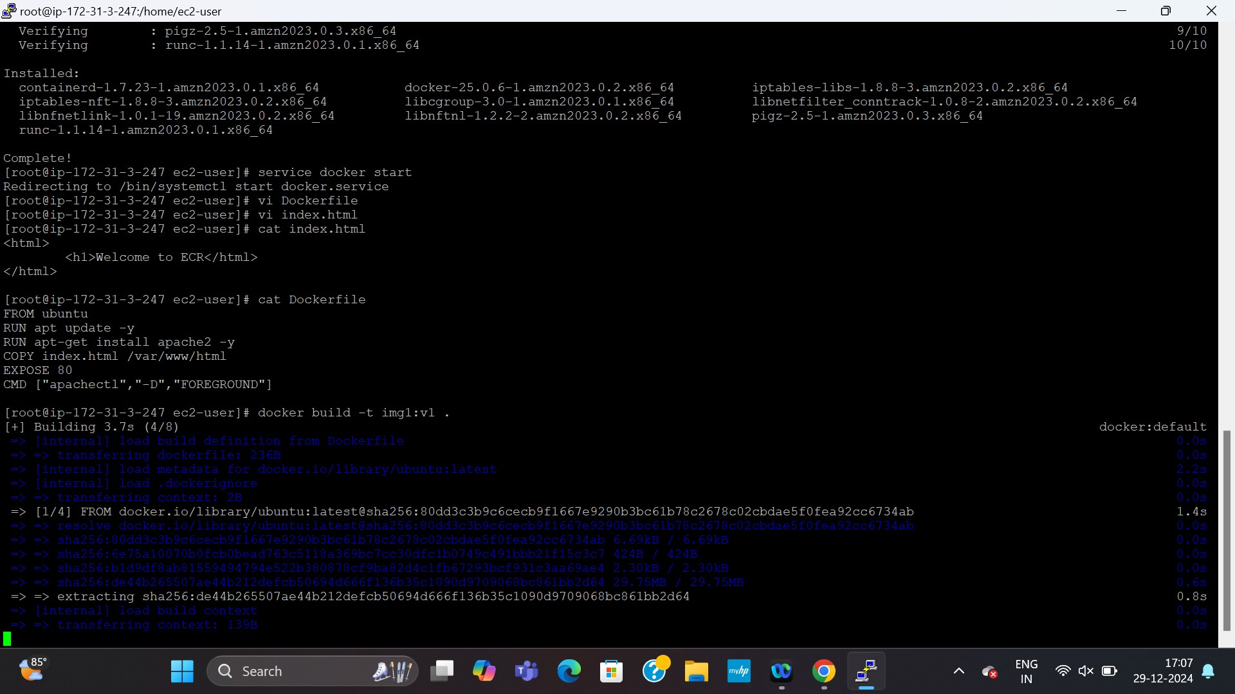

--> docker images

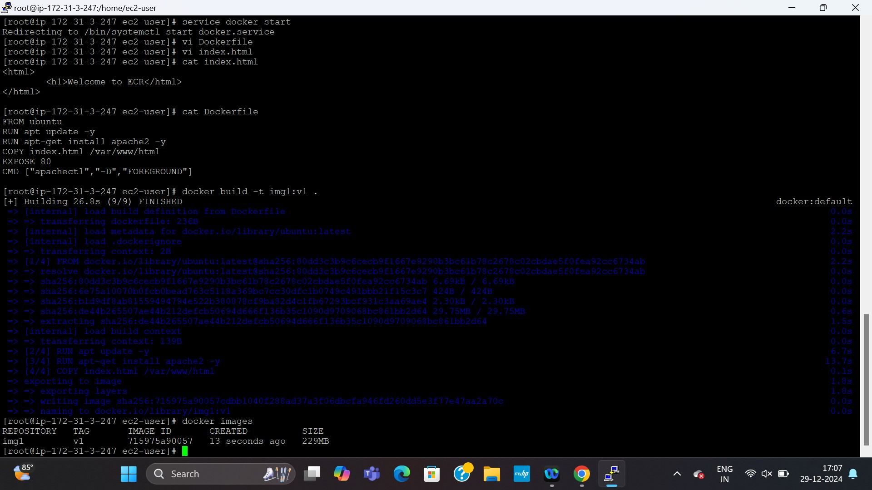

--> aws configure

--> paste access key --> enter --> paste secrete access key --> enter --> enter --> enter-->

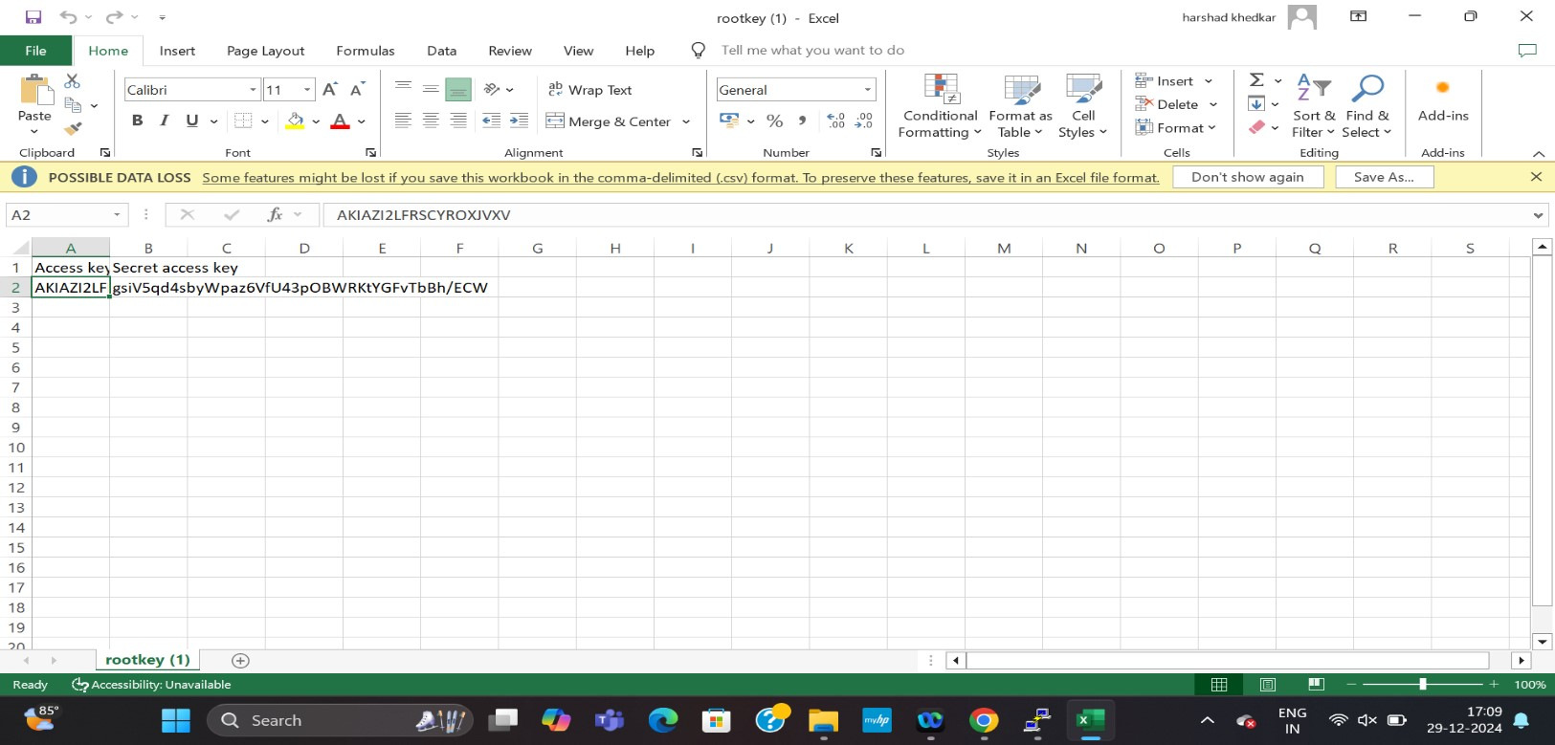

--> go to ecr repo--> view push commands--> copy first command and paste as it is in the putty-->

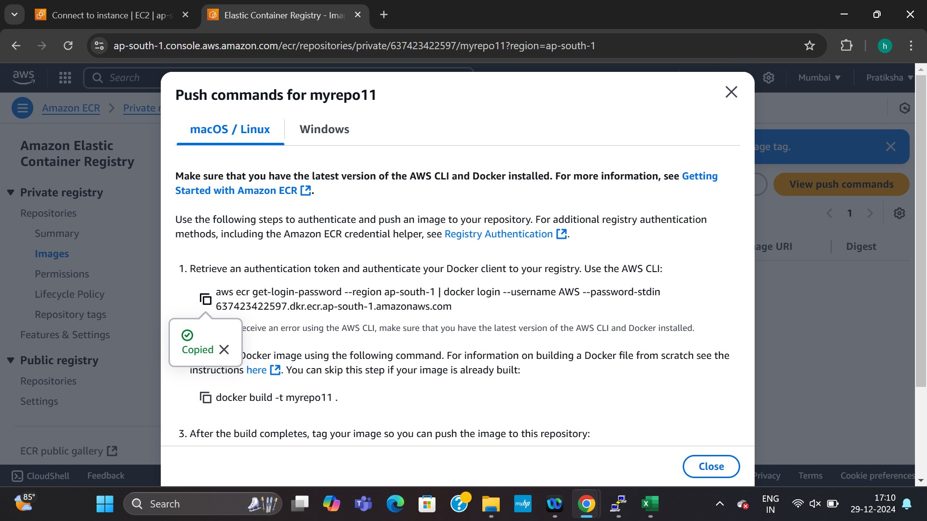

--> skip second command--> edit third and fourth command and paste it in putty (Edit image name and tag name only)

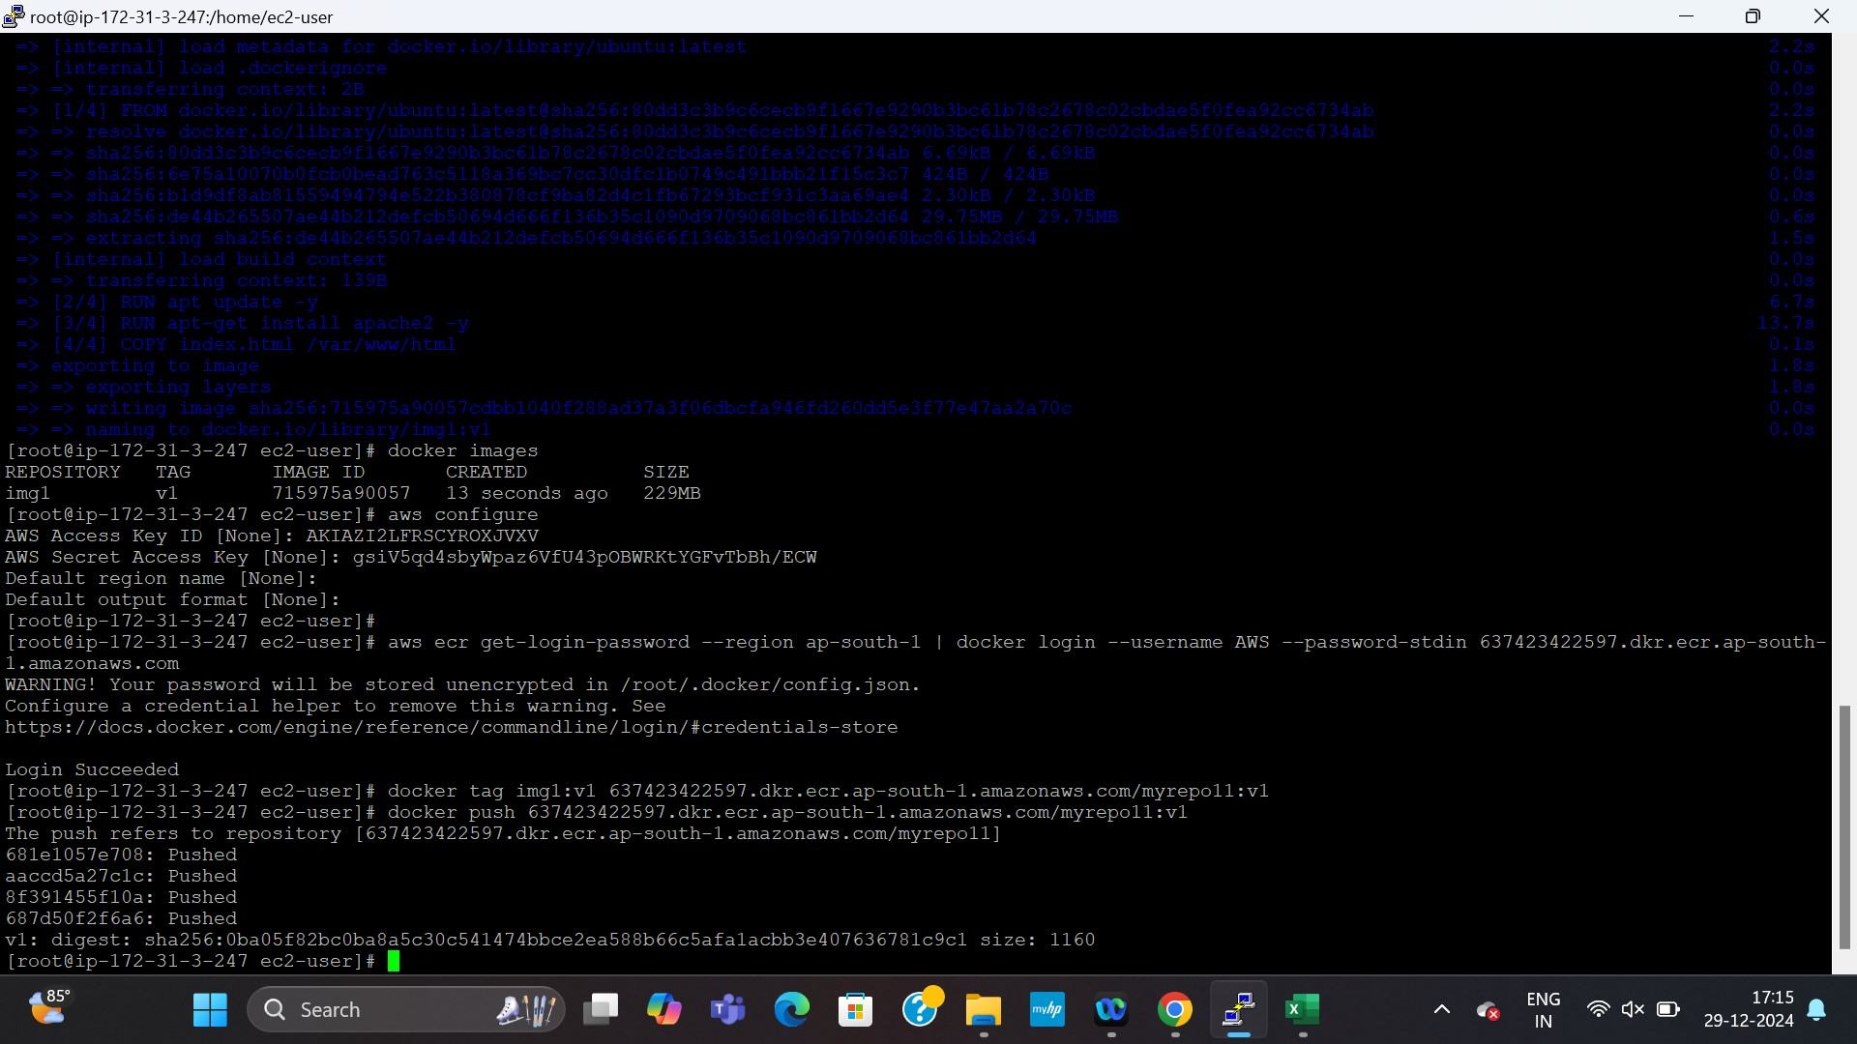

Img:

