MentorAI – Data Analytics-Based Mentor Allocation and Psychometric Compatibility System
A Big Data Analytics (BDA) Mini Project Report
Submitted in partial fulfillment of the requirements of the
University Of Mumbai
For the Degree of
Fourth Year Sem VII of Computer Engineering
Submitted By
Aditya Yadav (72)
Pratiksha Zodge (74)
Under The Guidance Of
Prof. Vaishali Yeole

Dept. Of Computer Engineering,
Smt. Indira Gandhi College Of Engineering
Affiliated to University of Mumbai (2026-2027)

CERTIFICATE
This is to certify that the Project Report entitled “MentorAI – Data Analytics Based Mentor Allocation and Psychometric Compatibility System” is a Bonafide work of Aditya Yadav (72), Pratiksha Zodge (74) submitted to the University of Mumbai in partial fulfillment of the requirements for the award of the degree of “Fourth Year Sem VII of Computer Engineering” in the subject of Big Data Analytics.
………………………………
Prof. Vaishali Yeole
(Internal Guide)

INDEX / TABLE OF CONTENTS
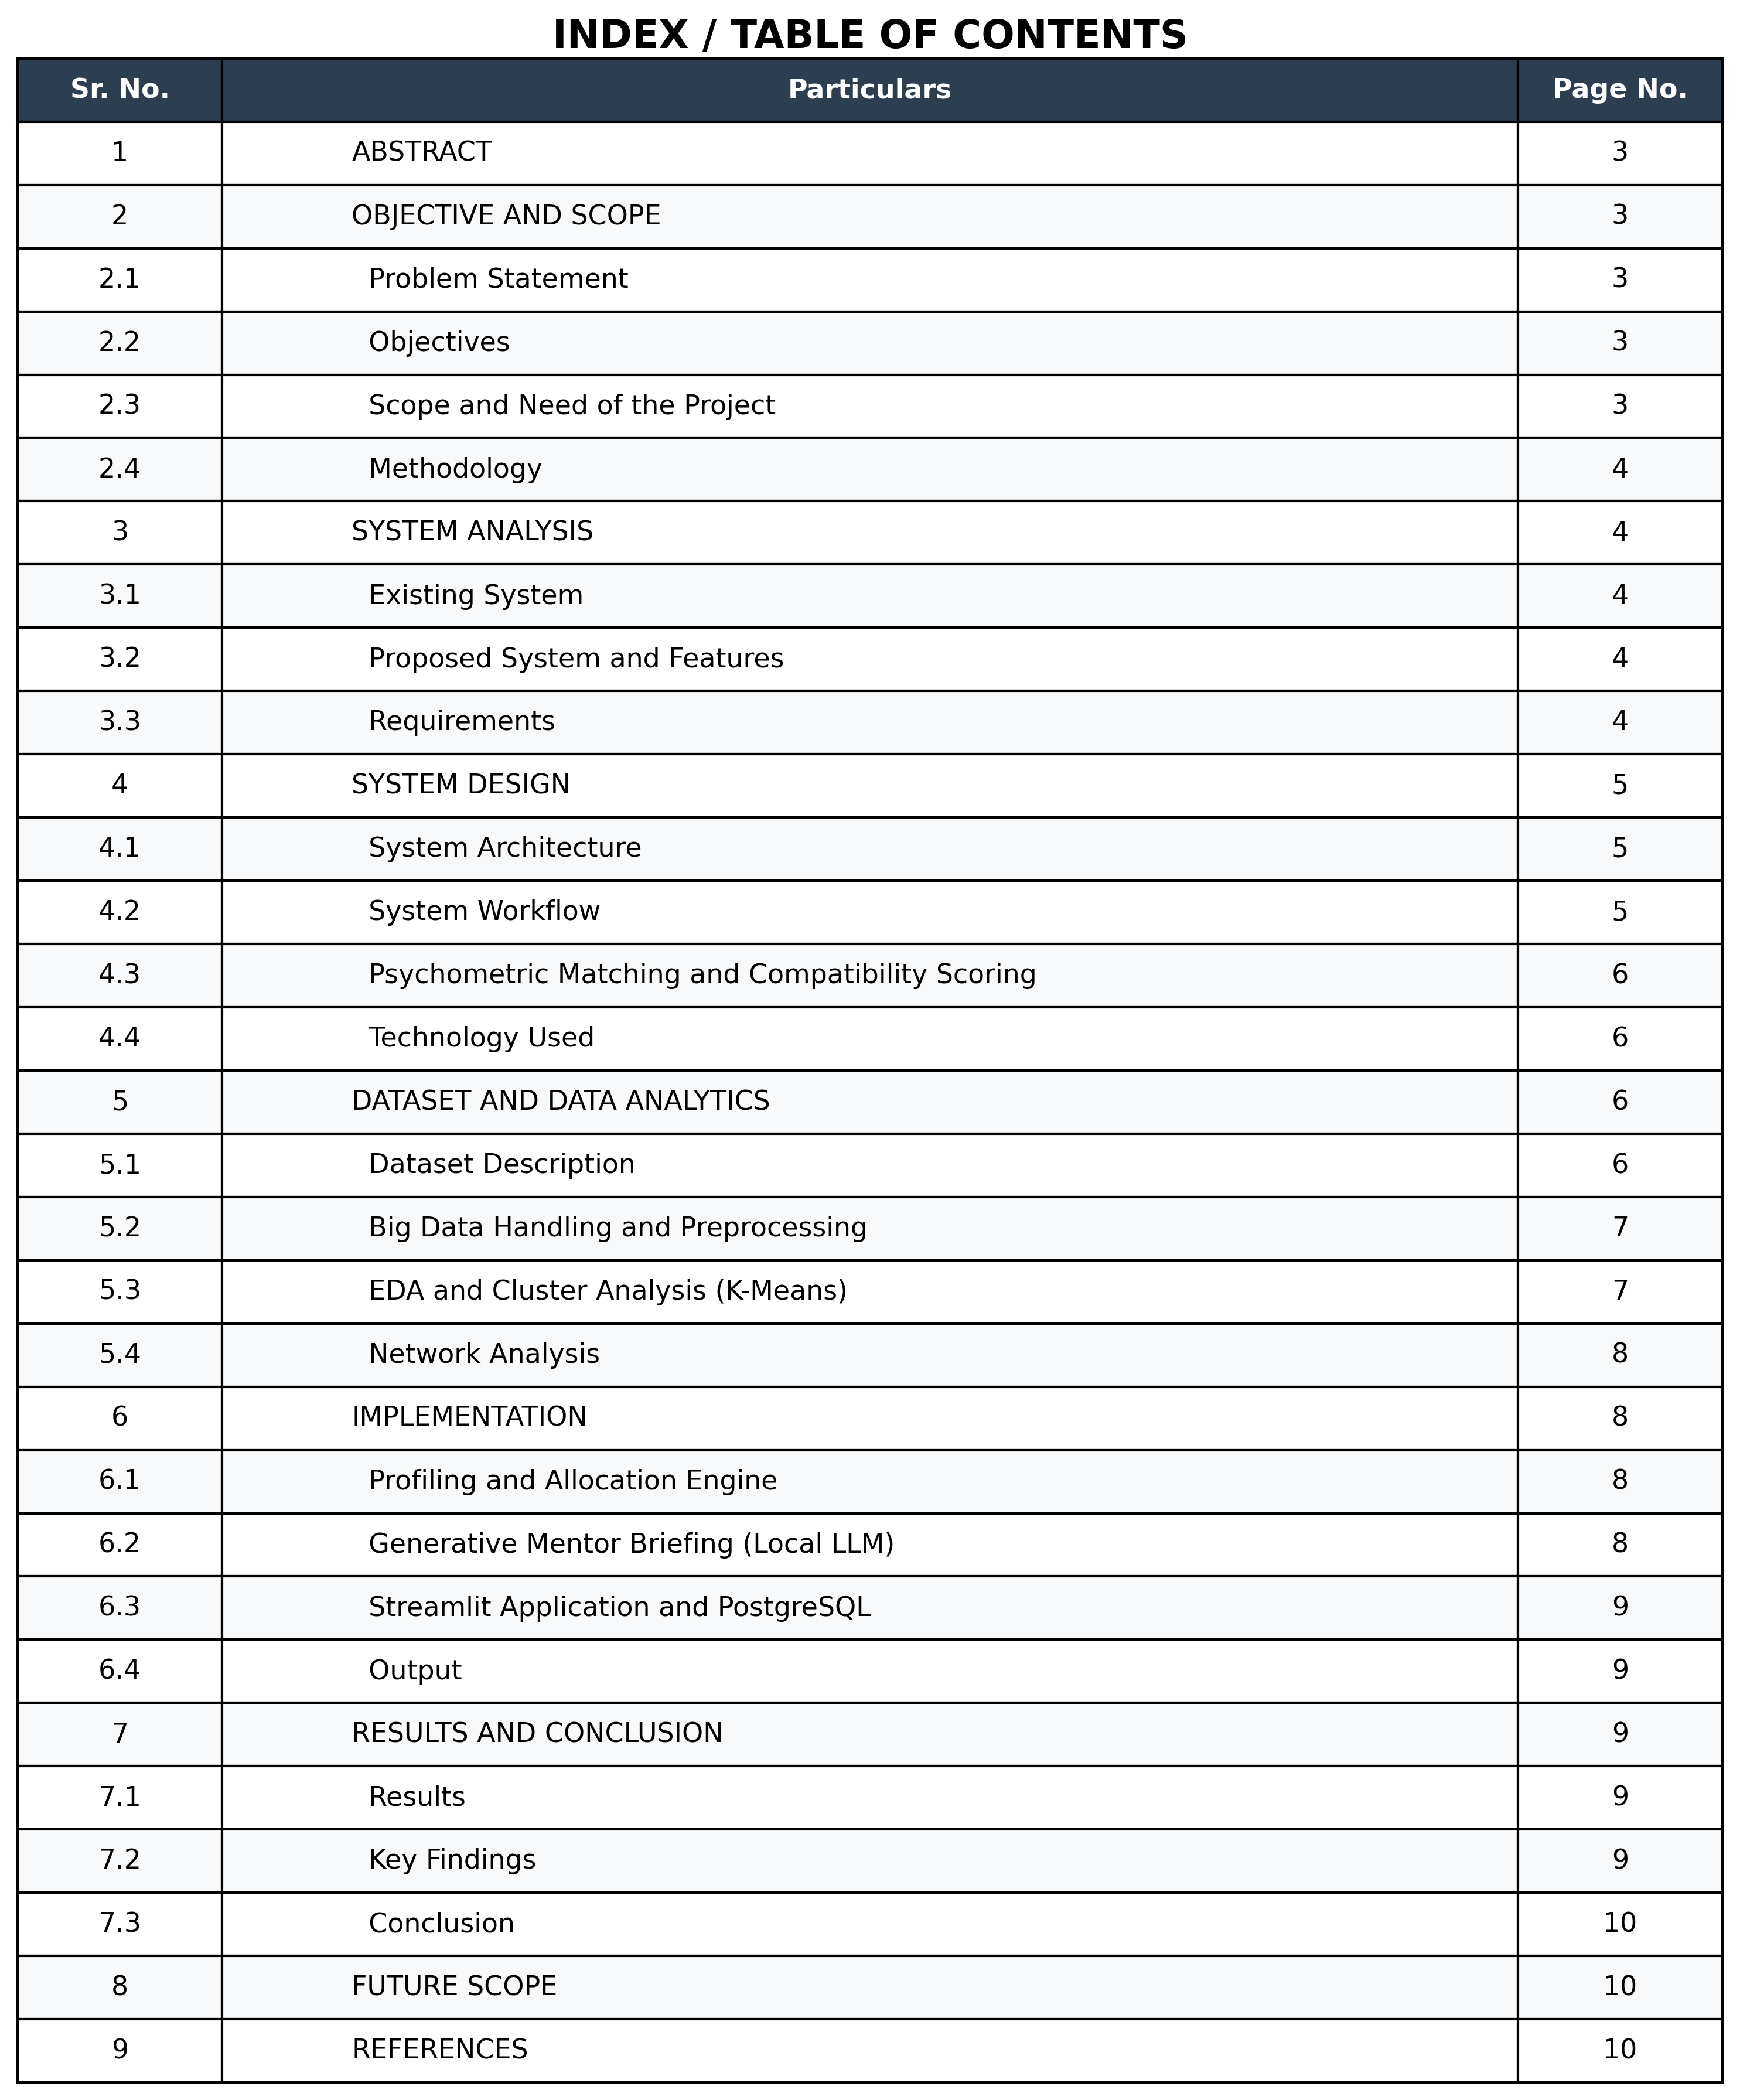
1. ABSTRACT
Assigning students to project groups and faculty mentors is often random, biased, or based purely on grades, ignoring team dynamics. This leads to dysfunctional teams, communication breakdowns and weak project outcomes.
MentorAI is a data-driven allocation system built on a large public psychometric dataset: the Kaggle Big Five Personality Test dataset (data-final.csv, about 400 MB, roughly one million responses to the 50-item IPIP Big-Five questionnaire). The data is processed with a chunked pandas pipeline that removes null, incomplete and duplicate-IP records, reverse-scores negatively keyed items and normalizes the results to OCEAN domain scores (0–100): Openness, Conscientiousness, Extraversion, Agreeableness and Neuroticism. The Elbow method and Silhouette scores show that the personality space has between k = 3 and k = 5 natural archetypes. In the live platform, K-Means is dynamic: a UI slider lets the professor vary k from 2 to 6.
A Euclidean-distance (nearest-neighbour style) engine pairs student groups with mentors using domain alignment, mentor capacity and trait-distance. The cohort is also modelled as a similarity graph (edge when distance < 1.5) and shown as a physics-based “Neural Web”. After pairing, a local LLM (Ollama, Llama 3.2) writes a coaching briefing for the mentor with a compatibility score, so no student data leaves the institution’s servers.
The stack is Python, pandas, NumPy, scikit-learn, NetworkX, PyVis, Plotly, Streamlit, PostgreSQL and Ollama. The prototype was evaluated on 17 student groups (56 students) and 8 mentors. It is an academic prototype: data is processed on a single machine (no Spark or Hadoop), and production use would need validated instruments, outcome tracking, access control and fairness auditing.

2. OBJECTIVE AND SCOPE

2.1 Problem Statement
Project-group and mentor allocation is usually manual or based on heuristics such as GPA, roll number or timestamp. This verifies academic standing but not interpersonal compatibility between group members, or between a group and its assigned faculty mentor. If a volatile personality mix or a mismatched advising style is assigned, the result is often a dysfunctional team, a free-rider dynamic or a stalled project, usually discovered only at midterm or final evaluation when remediation is no longer practical.
Therefore, a data-driven allocation mechanism is required that can score every student and mentor on a validated personality model, cluster participants into behavioural archetypes, pair groups with mentors who are genuinely compatible with them, and proactively brief the mentor on how best to manage the relationship before the first meeting takes place.

2.2 Objectives
• To acquire, clean and analyse the Kaggle Big Five dataset (~400 MB) using a chunked, vectorized pandas pipeline (null/zero/duplicate removal, reverse-scoring, 0–100 normalization).
• To perform EDA and choose the number of archetypes using the Elbow method and Silhouette scores.
• To profile students and mentors on the OCEAN model and cluster them with K-Means (adjustable k).
• To build a constrained allocation engine using Euclidean trait-distance, domain overlap and mentor capacity, with a 0–100 compatibility score.
• To perform network analysis with a similarity graph and a force-directed “Neural Web”.
• To generate privacy-preserving mentor briefings with a local LLM (Ollama / Llama 3.2) and deliver everything through a Streamlit dashboard backed by PostgreSQL.

2.3 Scope and Need of the Project
The scope covers dataset preprocessing and EDA, OCEAN profiling of students (as groups) and mentors, K-Means clustering, constrained allocation, network analysis, LLM briefings, Plotly 3-D visualization, and PostgreSQL persistence, evaluated on 17 groups (56 students) and 8 mentors. The project reduces dependence on random or GPA-only allocation, gives an auditable quantitative basis for pairings, surfaces friction points before the relationship begins, gives faculty actionable tips without manual interviews, and keeps sensitive psychometric data on local infrastructure.

2.4 Methodology
The methodology has two phases. In the offline analytics phase, the raw dataset is read in chunks, cleaned, reverse-scored and normalized; Elbow and Silhouette analysis then identify the natural number of archetypes (k = 3 to 5). In the live platform phase, groups and mentors complete the OCEAN questionnaire, participants are clustered (k from the UI slider), mentors are filtered by domain and capacity, and the pairing with minimum Euclidean trait-distance is selected. A similarity graph is built for network analysis, and the local LLM generates the score and briefing.
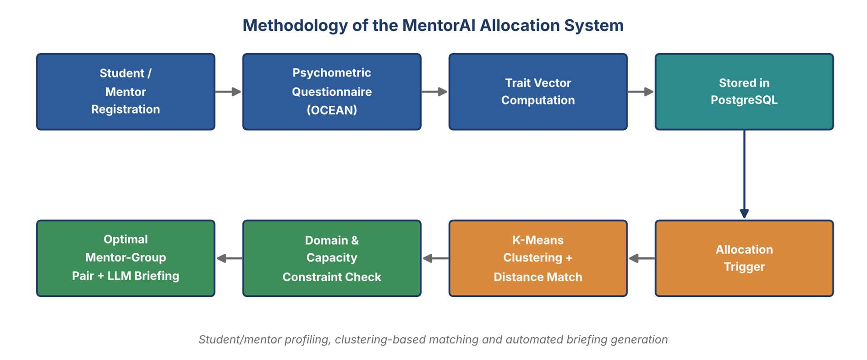
Figure 2.1: Methodology of the MentorAI Allocation System
3. SYSTEM ANALYSIS

3.1 Existing System
Departments usually assign groups and mentors manually or by alphabetical order, roll number, timestamp or GPA, with the mentor chosen only by subject expertise. Its limitations are:
• Random or GPA-only grouping pairs volatile personality mixes and ignores mentor advising style.
• Conflicts are found only at midterm or final evaluation, and there is no auditable basis for a given pairing.
• Faculty receive no advance briefing, and large psychometric datasets are not used.
3.2 Proposed System
The proposed system, MentorAI, replaces manual/random allocation with a psychometric, ML-driven matching engine. Every student group and mentor completes an OCEAN questionnaire. K-Means clustering groups participants into behavioural archetypes, and a constrained optimization step pairs each group with the mentor who best satisfies domain overlap, remaining mentor capacity and minimum trait-distance. A local LLM then generates a proactive coaching briefing for the mentor.
The system provides:
- Psychometric (OCEAN) profiling for students and mentors.
- Unsupervised K-Means clustering of behavioural archetypes.
- Domain-aware, capacity-constrained allocation optimization.
- A quantitative compatibility score for every pairing.
- Local, privacy-preserving LLM-based mentor coaching briefings.
- Streamlit web interface for the full registration-to-allocation workflow.
- PostgreSQL database integration.
- Interactive 3-D cluster visualization and a physics-based relationship graph.
3.2 System Features
The major features of the system are:
1. Psychometric Profiling
Students and mentors are scored on the Big-Five (OCEAN) traits via a structured onboarding questionnaire.
2. Domain Tagging
Each mentor and project group records its subject domain(s), e.g. Machine Learning, Fintech, Gaming, Healthcare.
3. K-Means Clustering
Unsupervised clustering groups all participants into behavioural archetypes for visualization and matching.
4. Multi-Variable Allocation
The matching engine evaluates domain overlap, mentor capacity and trait-distance together before confirming a pairing.
5. Compatibility Scoring
Every confirmed pairing receives a quantitative score (e.g., 67/100) summarizing fit.
6. Generative Mentor Briefing
A local LLM (Ollama/Llama 3.2) produces a structured coaching report highlighting dynamics, friction points and actionable tips.
7. 3-D Cluster Visualization
Plotly renders mentors and students across three trait axes to reveal natural groupings.
8. Neural Web Graph
A NetworkX/PyVis force-directed graph visualizes relational affinities and “super-team” groupings.
9. Directory & Registration
Streamlit pages for mentor registration, student group creation and a searchable directory.
10. Relational Persistence
PostgreSQL stores profiles, trait scores, allocations and system logs.
3.4 Requirements
Hardware Requirements
- Computer/Laptop
- Minimum 8 GB RAM recommended (16 GB recommended for local LLM inference)
- Multi-core CPU; GPU optional (used to accelerate local LLM inference where available)
- Sufficient storage for the PostgreSQL database and the local Llama 3.2 model weights
- Internet connection only for initial package/model installation (runtime is fully local)
Software Requirements
- Windows/Linux/macOS
- Python 3.10+
- Streamlit (web UI framework)
- scikit-learn (K-Means clustering)
- Pandas and NumPy (data processing)
- NetworkX and PyVis (graph modeling and visualization)
- Plotly (3-D data visualization)
- Ollama with the Llama 3.2 model (local LLM inference)
- PostgreSQL and psycopg2-binary (relational database and connector)
- Modern web browser
- VS Code or equivalent IDE
4. SYSTEM DESIGN

4.1 System Architecture
The architecture is layered: Data Layer (Kaggle dataset, pandas) → Client Layer (Streamlit) → Logic & ML Layer (Pandas/NumPy, K-Means, Euclidean matching) → Inference Layer (Ollama/Llama 3.2) → Visualization Layer (Plotly, NetworkX/PyVis) → Storage Layer (PostgreSQL). The Data Layer cleans and scores the dataset and informs the choice of k; the Logic & ML Layer produces clusters and allocations; the Inference Layer writes the briefings.
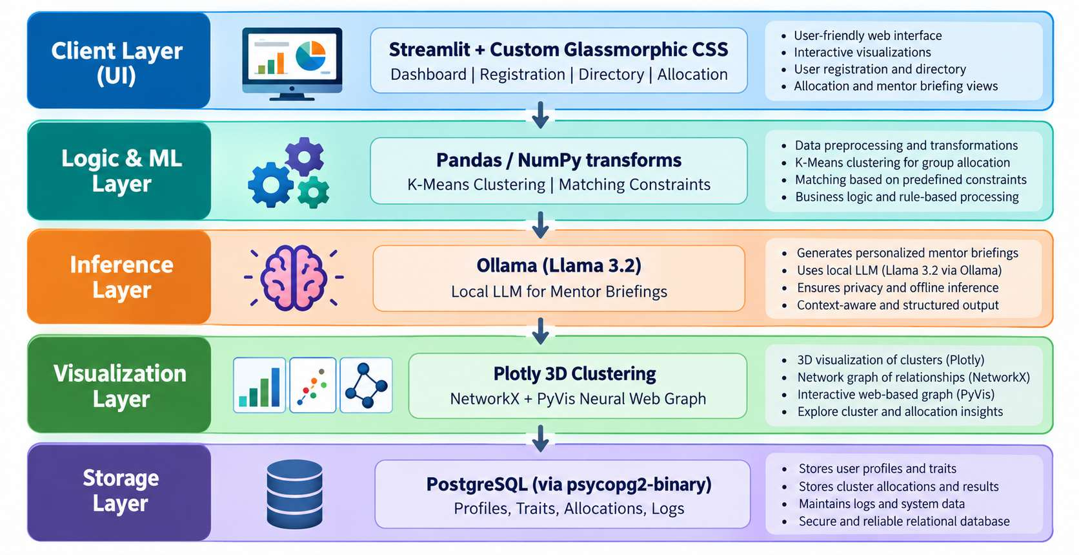
Figure 4.1: System Architecture

4.2 System Workflow
The complete workflow of the system is:
1. Groups and mentors register with domain and capacity information.
2. Each participant completes the OCEAN psychometric questionnaire; a 5-D trait vector is computed and stored in PostgreSQL.
3. An administrator triggers allocation; K-Means clusters participants (k from the slider).
4. Mentors are filtered by capacity and domain; Euclidean distance selects the best fit.
5. A compatibility score is computed and the local LLM generates the mentor briefing.
6. The similarity graph is built, results are saved to PostgreSQL and shown on the dashboard.
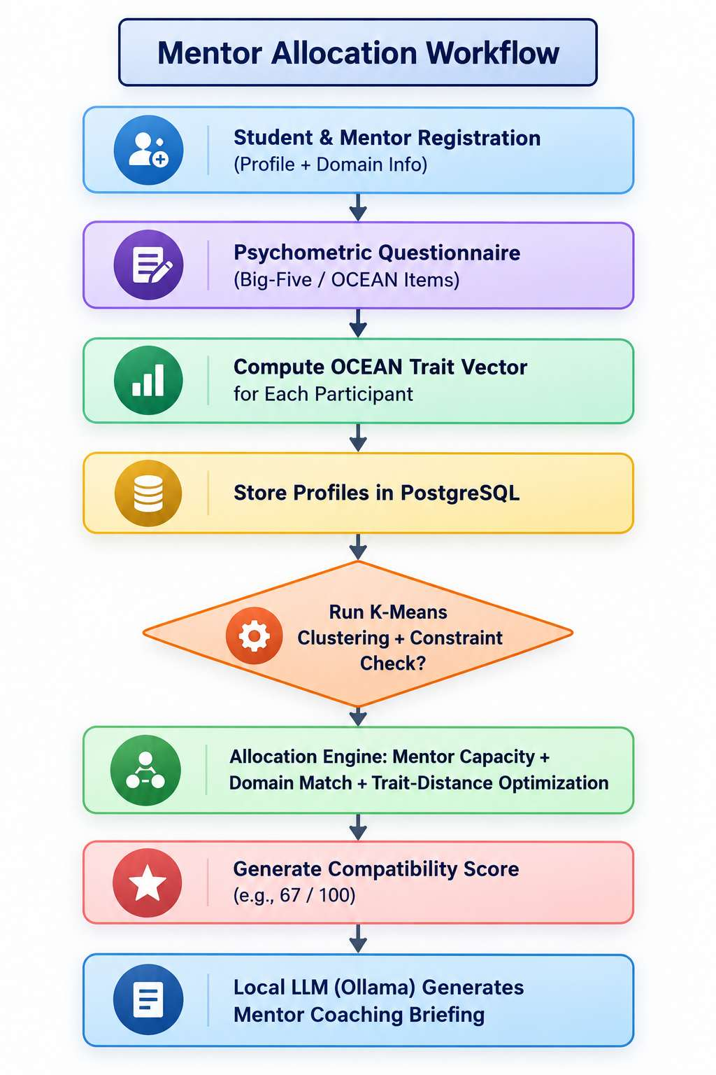
Figure 4.2: Mentor Allocation Workflow

4.3 Psychometric Matching and Compatibility Scoring
Every group and mentor is a 5-dimensional OCEAN vector. The distance between a group’s aggregate vector x and a mentor’s baseline vector y is the Euclidean distance: d(x, y) = √ Σ(x_i − y_i)²
Let d_min be the smallest distance among mentors who pass the hard constraints (remaining capacity and domain overlap). The compatibility score is:
S = 100 × (1 − d_min / d_max)
where d_max is the maximum possible trait-distance across the OCEAN space (approx 8.94). Higher S means closer compatibility.

5. DATASET AND DATA ANALYTICS

5.1 Dataset Description
The analytics foundation is the Big Five Personality Test dataset (data-final.csv) from Kaggle, collected through an online IPIP Big-Five questionnaire. At about 400 MB it is too large to load comfortably in one pass on a standard laptop, so it is treated as a big-data workload. It contains roughly one million responses to 50 items on a 1–5 scale, 10 per OCEAN trait.

5.2 Big Data Handling and Preprocessing
The ~400 MB file was read in chunks with pandas (chunksize) and all transformations were vectorized pandas/NumPy operations rather than row loops. The steps include:
• Missing data and duplicates: dropped rows with nulls, incomplete tests (items answered 0) and duplicate IP addresses.
• Reverse-scoring: negatively keyed items were reversed (score → 6 − score) so higher always means more of the trait.
• Aggregation and normalization: the ten items per trait were aggregated and linearly rescaled from 1–5 to standardized 0–100 domain scores.
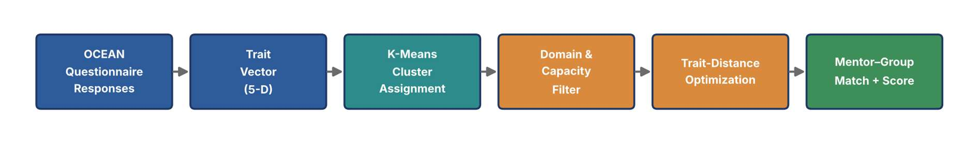
Figure 5.1: Data Analytics Pipeline for the OCEAN Dataset

5.3 EDA and Cluster Analysis (K-Means)
K-Means (scikit-learn) is used for unsupervised archetype discovery from the 5-D scores alone. The Elbow method (WCSS) and Silhouette scores showed that the natural number of archetypes lies between k = 3 and k = 5. Because MentorAI is a live platform, k is passed from a UI slider into the model, so the professor can toggle k between 2 and 6 and view macro or micro archetypes in real time.
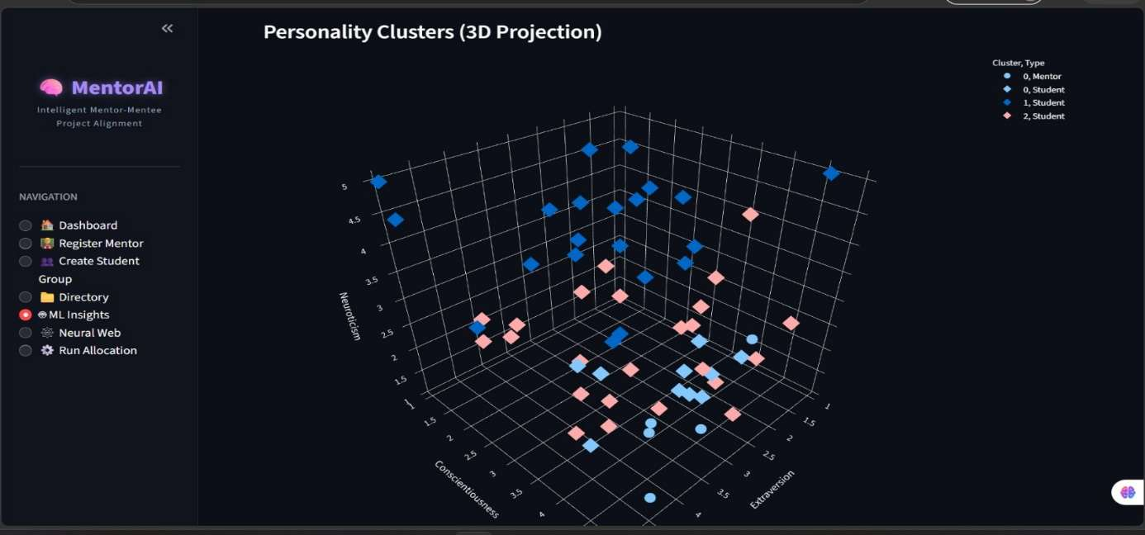
Figure 5.2: 3-D Personality Clusters
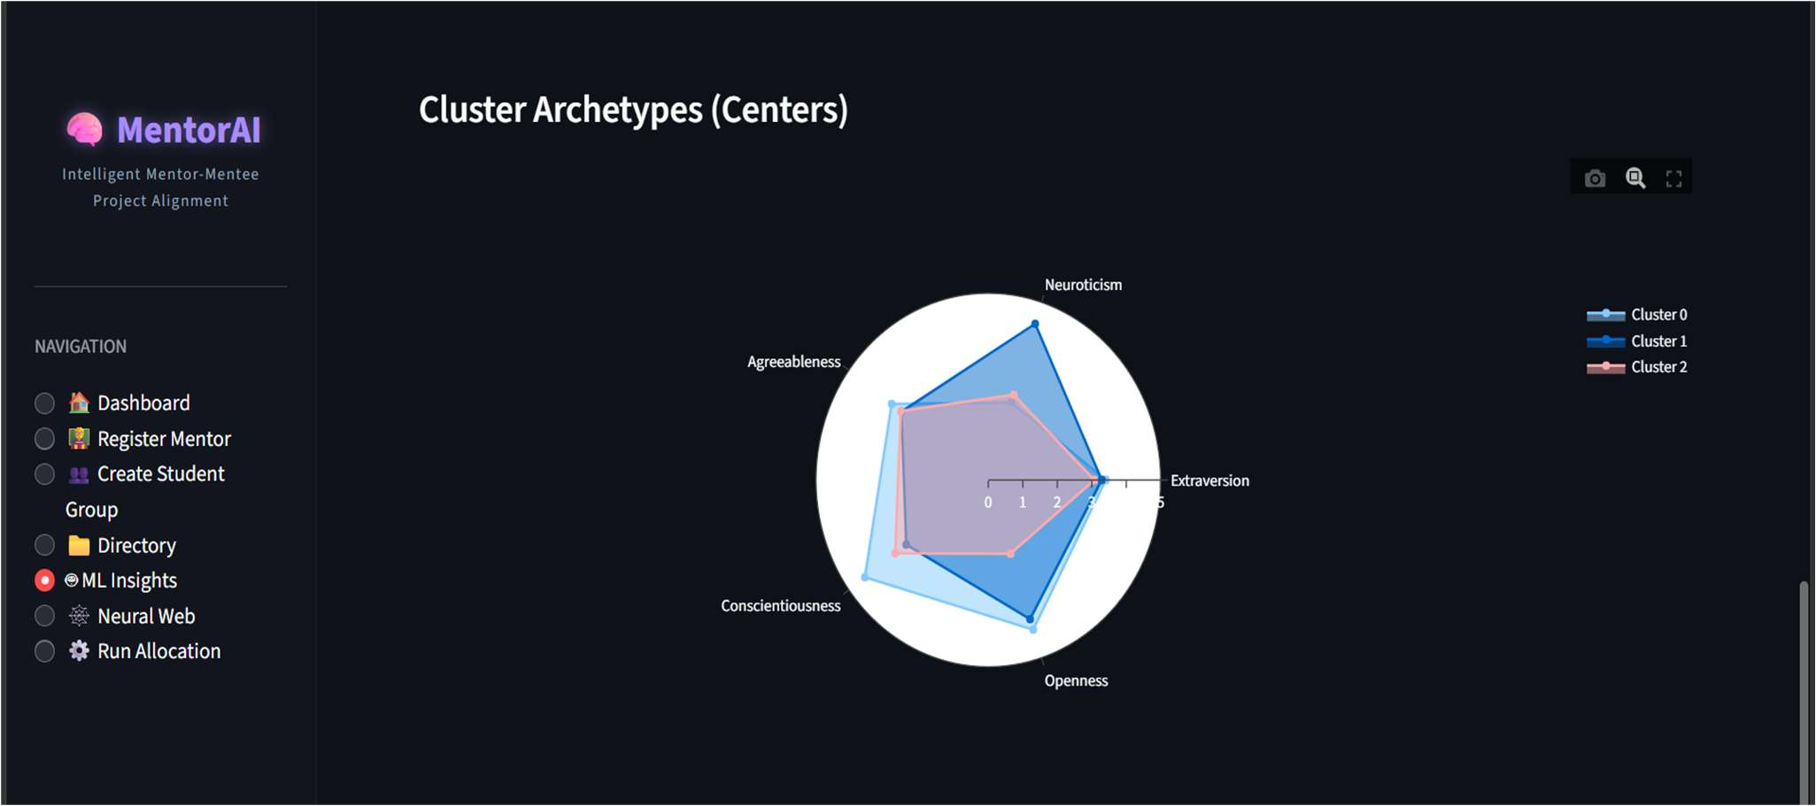
Figure 5.3: Cluster Archetype Centres

5.4 Network Analysis
The cohort is also analysed as a network built with NetworkX. Each participant is a node, and an edge is drawn when the Euclidean distance between two users in the 5-D space is below a strict threshold (e.g., 1.5). On the seeded population, the graph has 64 nodes (8 mentors, 56 students) and 36 compatibility edges, giving a density of ~1.8% and an average degree of about 1.1, so the graph is sparse and links only genuinely similar participants.
Instead of computing Louvain communities or betweenness centrality, the graph is rendered with a physics-based gravity simulation (PyVis forceAtlas2Based solver): highly connected nodes are pulled together, so visual communities and “Super-Teams” emerge naturally.
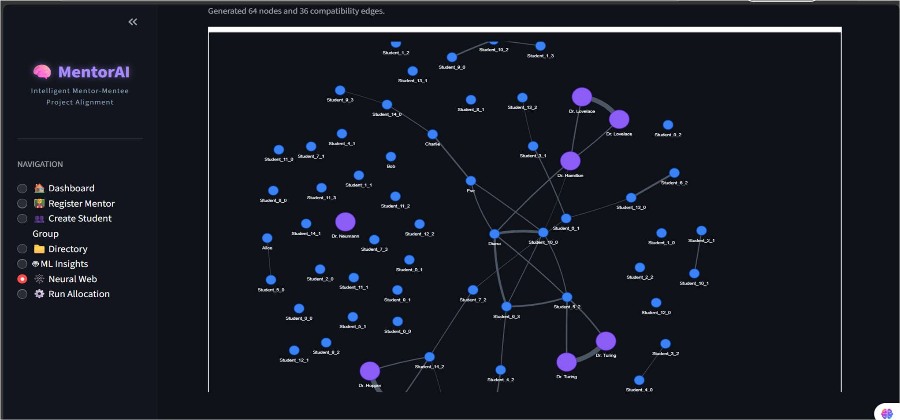
Figure 5.4: Neural Web Similarity Graph
6. IMPLEMENTATION

6.1 Profiling and Allocation Engine
Every participant is recorded with an advising/working persona including Domain Expertise (Machine Learning, Fintech, etc.) and Advising Traits quantified across OCEAN. The allocation engine balances Hard Constraints (mentor bandwidth limits and domain alignment) and Soft Optimization (minimizing interpersonal friction by matching the group's composite psychometric scores against the mentor's behavioural baseline using trait-distance).

6.2 Generative Mentor Briefing (Local LLM)
When matching completes, an inference pipeline runs locally via Ollama. The input context includes the mentor trait-score vector, student project topic, and group OCEAN aggregates. The inference output is a compatibility score (e.g., 67/100), an assessment of mentor-group dynamics, and concrete management directives. Because inference runs on a local Ollama instance hosting Llama 3.2, no sensitive psychometric data is transmitted to an external cloud API.

6.3 Streamlit Web Application & PostgreSQL
The Streamlit layer provides the browser-based dashboard. The UI follows a dark, glassmorphic design. It provides a live dashboard, mentor/student registration, a searchable directory, ML Insights (3-D clustering), Neural Web (relationship graph), and a one-click allocation trigger.
PostgreSQL is selected for structured relational records (profiles, trait scores, allocations). The backend uses psycopg2-binary.

6.4 Output
The final system provides the following outputs:
• Live dashboard with registered-mentor, student-group and total-student counts.
• 3-D K-Means cluster plot and Archetype radar charts.
• Compatibility score (e.g., 67/100) for every confirmed allocation.
• AI-generated mentor briefing with dynamics assessment.
• Neural Web relationship graph.
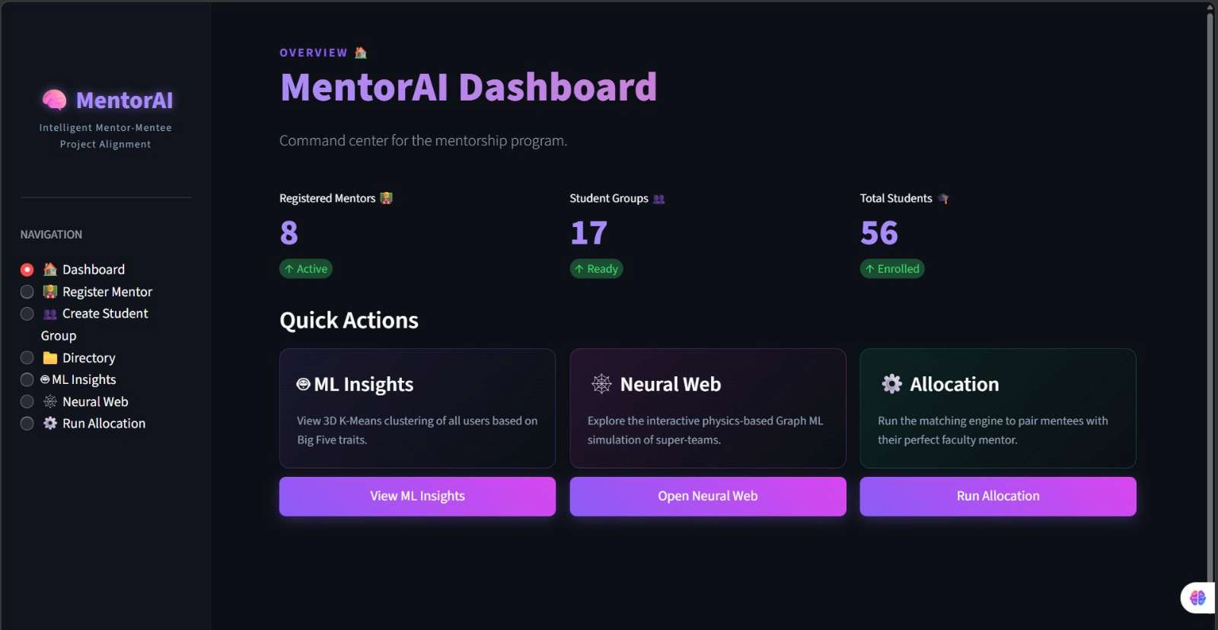
Figure 6.1: MentorAI Dashboard
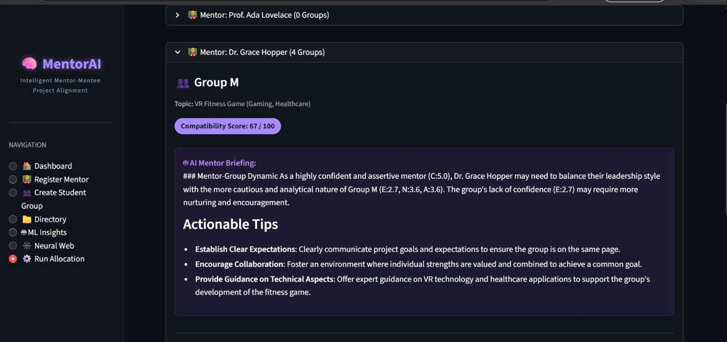
Figure 6.2: AI-Generated Mentor Briefing and Compatibility Score
7. RESULTS AND CONCLUSION

7.1 Results
The prototype was evaluated on 17 student groups (56 students) and 8 mentors. The ~400 MB Kaggle dataset was successfully loaded, reverse-scored, and normalized on local hardware using chunked processing. Clustering successfully isolated mentors and student cohorts into distinct groups. Network analysis generated 64 nodes and 36 edges (threshold 1.5). Allocation completed in milliseconds, and Llama 3.2 inference completed in under 3 seconds per allocation.

7.2 Key Findings
• A ~400 MB dataset can be cleaned and scored on one machine using chunked pandas and vectorized operations, without a distributed framework.
• Reverse-scoring and normalization are essential; otherwise the traits are not comparable for distance-based methods.
• The OCEAN space supports about three to five archetypes.
• Hard constraints must be applied before distance optimization.
• A strict similarity threshold gives a sparse, readable network that highlights genuinely similar participants.
• Local LLM inference (sub-3 seconds) shows privacy-preserving generative AI is highly practical.

7.3 Conclusion
MentorAI demonstrates how data preprocessing, unsupervised learning, network analysis and a privacy-preserving local LLM can form an end-to-end academic project allocation workflow. The system scores students and mentors on the Big-Five (OCEAN) personality model, clusters participants into behavioural archetypes, optimizes mentor-group pairings under capacity and domain constraints, and generates a proactive coaching briefing for every confirmed pairing.

8. FUTURE SCOPE
• Distributed processing: move preprocessing and clustering to Spark or Dask for multi-institution datasets, with streaming ingestion of new submissions.
• Advanced network analytics: implement formal Louvain communities and betweenness/degree centrality on the similarity graph.
• Supervised success forecasting: train a Random Forest classifier on historical outcomes to predict project risk at allocation time.
• Audio-based profiling and RAG: infer OCEAN indicators from speech samples, and let faculty upload briefs and rubrics for milestone-specific LLM guidance.
• Fairness auditing and longitudinal tracking: audit the algorithm for bias and compare predicted compatibility with real project outcomes.

9. REFERENCES
1. Big Five Personality Test (data-final.csv), Kaggle dataset – https://www.kaggle.com/datasets/tunguz/big-five-personality-test
2. Open Psychometrics – Raw Data (IPIP Big-Five responses) – https://openpsychometrics.org/_rawdata/
3. Python, pandas, NumPy, scikit-learn, NetworkX, PyVis, Plotly and Streamlit documentation.
4. PostgreSQL and psycopg2 documentation.
5. Ollama and Meta AI Llama 3 model card.
6. Costa, P. T., & McCrae, R. R. – NEO-PI-R and NEO-FFI Professional Manual, Psychological Assessment Resources, 1992.
7. Goldberg, L. R. – The Structure of Phenotypic Personality Traits, American Psychologist, 48(1), 26–34, 1993.
8. MacQueen, J. – Some Methods for Classification and Analysis of Multivariate Observations, 5th Berkeley Symposium, 1967.
9. Rousseeuw, P. J. – Silhouettes: A Graphical Aid to the Interpretation and Validation of Cluster Analysis, J. Computational and Applied Mathematics, 20, 53–65, 1987.
10. Jacomy, M., Venturini, T., Heymann, S., & Bastian, M. – ForceAtlas2, a Continuous Graph Layout Algorithm for Handy Network Visualization, PLoS ONE, 9(6), e98679, 2014.

