PROJECT ON SQL QUERIES

Dataset – Olympic cities Analysis

**Purpose**

The dataset aims to provide comprehensive information about Olympic Games events and the countries participating in them. Researchers, analysts, and sports enthusiasts can use this dataset to analyse trends, performance, and geographical distribution of Olympic Games over time. It can also be used for data visualization, statistical analysis, and predictive modelling related to the Olympics.

**Introduction**

The Olympic Data table provides information about various aspects of Olympic Games events, including details such as the location, year, season, total medals awarded, number of committees involved, number of disciplines and events, and the countries participating. Each row represents a specific Olympic event.

The Country Data table provides information about countries participating in the Olympics, including their names, continents, and geographical coordinates. Each row represents a distinct country.

In PostgreSQL

Step-1- CREATE TABLE

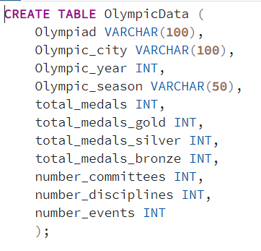

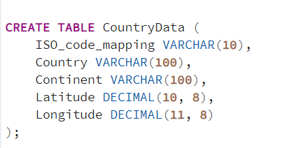

STEP 2- INSERT VALUES

STEP 3- COPY PATH AND GET REMAINING DATA

STEP 4 – PERFORM QUERIES

**QUE - Get the Olympic year, season, and country along with the total number of medals won in the Winter Olympics**

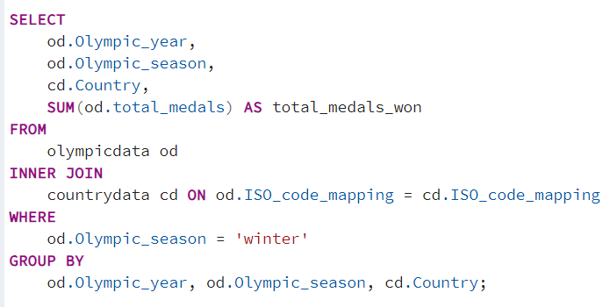QUERY-1

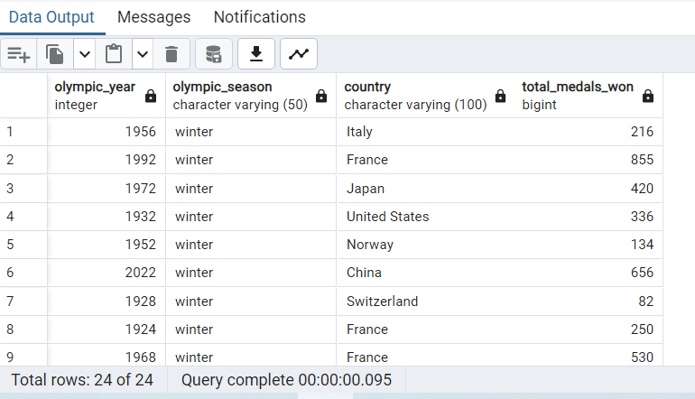OUTPUT

QUERY-2

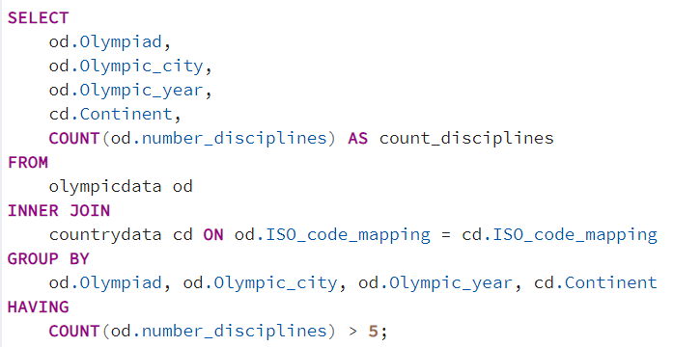**QUE- Get the Olympiad, Olympic city, Olympic year, continent, and the count of disciplines for each entry where the count of disciplines is greater than 5**

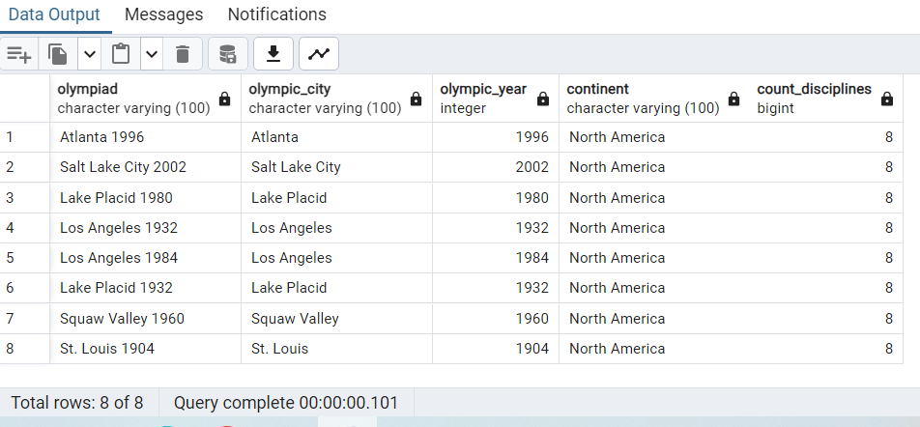OUTPUT

QUERY-3

**QUE- Get query retrieves distinct countries that participated in the Olympics held in 2020 by referencing the country data table and filter by ISO code mappings from the Olympic data table.**

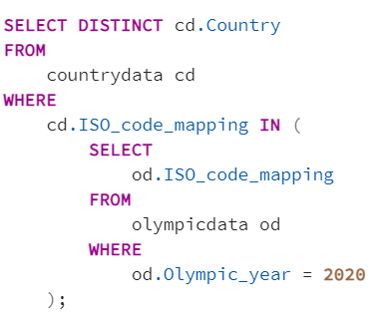

OUTPUT

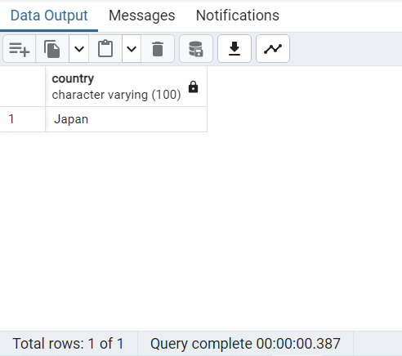

QUERY-4

**QUE- Get the number of events hosted in each city and the continent they belong to.**

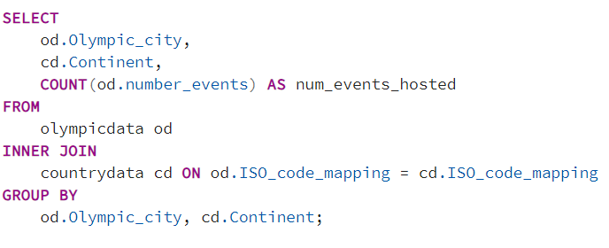

OUTPUT

