**Goibibo:** The service enables travellers to book their hotel stay and travel on flights, trains, buses, and cars. Goibibo prides itself on providing the widest travel choices possible while delivering a fast, trusted user experience across search, booking, payment, settlement, and refunds.

**1st Section**

HOMEPAGE

HEADER section Includes logo booking option at one place e.g flight, hotels, trains, cabs ,bus

Login/signup

Offer at same div

**2nd Section**

Flight booking interface with big box with radio button location list, calendar, filter options

Recent search for help

big Search button

1. Flight booking interface div at top
2. Filter option -price, time, airlines, preferred airports
3. Multiple result according selected one
4. Booking details about flight ticket interface
5. Traveller details box
6. COUPONS
7. Payment gateway QR, credit card, Debit Card, UPI, wallet Razor pay,

**3rd Section**

Running Adds/sponsored section

**4th Section**

Offer For You

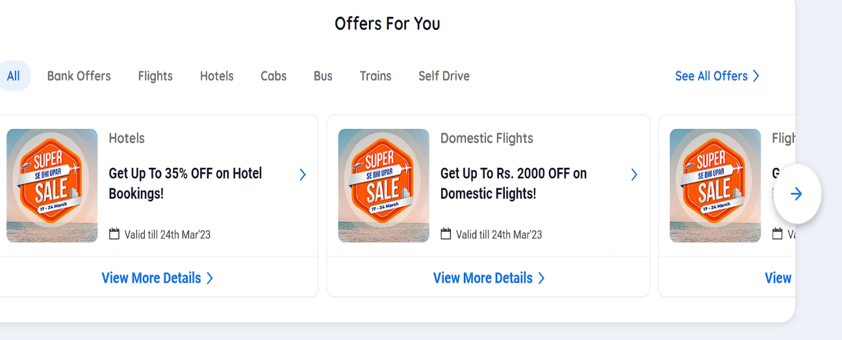Big box includes multiple offer box/div with redirect or page

Another New Box with discount suggestion on available flights/hotels contain multiple similar div with diff information

**5th Section**

Includes information contain

1. FLIGHTS
2. HOTELS
3. TRAINS
4. BUSE
5. CABS

**6th Section**

Included Direct link to specific Contain

e.g.

our product

about us

Travel Essentials

More Links

**7th Section**

Footer

Contact

Available at (application)

payment gateway option logo

copyright