Assignment no: 3
Problem Statement: Implement C++/Java/Python program to create a base class called shape. Use this class to store two double type values that could be used to compute the area of figures. Derive two specific classes called function get_data() to initialize base class data members and another member function display_area() to compute and display the area of figures. Make classes to suit their requirements. Using these three classes, design a program that will accept dimension of a triangle or a rectangle interactively, and display the area. Remember the two values given as input will be treated as lengths of two sides in the case of rectangles, and as base and height in the case of triangles, and used as follows:
Area of rectangle= x*y Area of triangle =1/2*x*y
Aim of Assignment : To implement concept of Inheritance, virtual class and function.
Description : In this assignment we designed three classes. In that shape is base class and triangle and rectangle are derived classes from base class that is the shape. In shape class we declare two variables which required to calculate area of triangle and rectangle. In triangle class we accept base and height using getdata()and calculate the area of triangle and display the area of triangle in display().In rectangle class we accept length and width using accept()and calculate the area of rectangle and display the area of rectangle using display().

OOP Concept used :
C++ Inheritance
- In C++, inheritance is a process in which one object acquires all the properties and behaviors of its parent object automatically. In such way, you can reuse, extend or modify the attributes and behaviors which are defined in other class.
- In C++, the class which inherits the members of another class is called derived class and the class whose members are inherited is called base class. The derived class is the specialized class for the base class.
- Code reusability: Now you can reuse the members of your parent class. So, there is no need to define the member again. So less code is required in the class.
- C++ supports five types of inheritance:
- Single inheritance
- Multiple inheritance
- Hierarchical inheritance
- Multilevel inheritance
- Hybrid inheritance

Single Inheritance
Single inheritance is defined as the inheritance in which a derived class is inherited
from the only one base class.


Multilevel Inheritance
Multilevel inheritance is a process of deriving a class from another derived class.


Multiple Inheritance
Multiple inheritance is the process of deriving a new class that inherits the attributes from two or more classes.
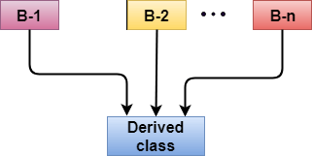

Hybrid Inheritance
Hybrid inheritance is a combination of more than one type of inheritance.
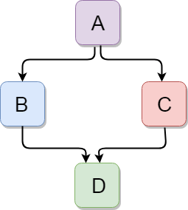

Hierarchical Inheritance

Hierarchical inheritance is defined as the process of deriving more than one class from a base class.
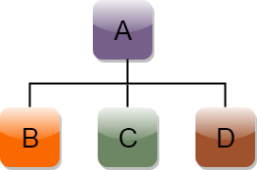

- virtual function: virtual function a member function which is declared within a base class and is re-defined(Overriden) by a derived class. When you refer to a derived class object using a pointer or a reference to the base class, you can call a virtual function for that object and execute the derived class’s version of the function.
- Virtual functions ensure that the correct function is called for an object, regardless of the type of reference (or pointer) used for function call.
- They are mainly used to achieve Runtime polymorphism
- Functions are declared with a virtual keyword in base class.
- The resolving of function call is done at Run-time.
Rules for Virtual Functions
- Virtual functions cannot be static and also cannot be a friend function of another class.
- Virtual functions should be accessed using pointer or reference of base class type to achieve run time polymorphism.
- The prototype of virtual functions should be same in base as well as derived class.
- They are always defined in base class and overridden in derived class. It is not mandatory for derived class to override (or re-define the virtual function), in that case base class version of function is used.
- A class may have virtual destructor but it cannot have a virtual constructor.
Compile-time(early binding) VS run-time(late binding) behavior of Virtual Functions.
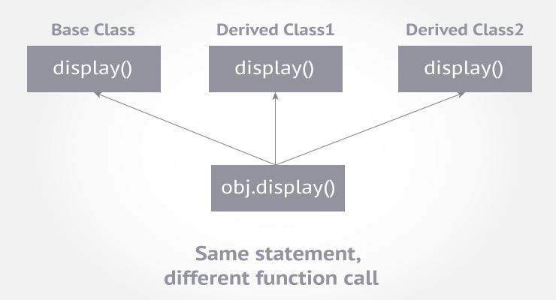
The goal of object-oriented programming is to divide a complex problem into small sets. This helps understand and work with problem in an efficient way.

Pure Virtual Function
- A virtual function is not used for performing any task. It only serves as a placeholder.
- When the function has no definition, such function is known as "do-nothing" function.
- The "do-nothing" function is known as a pure virtual function. A pure virtual function is a function declared in the base class that has no definition relative to the base class.
- A class containing the pure virtual function cannot be used to declare the objects of its own, such classes are known as abstract base classes.
- The main objective of the base class is to provide the traits to the derived classes and to create the base pointer used for achieving the runtime polymorphism.
Pure virtual function can be defined as: virtual void display() = 0;

output :
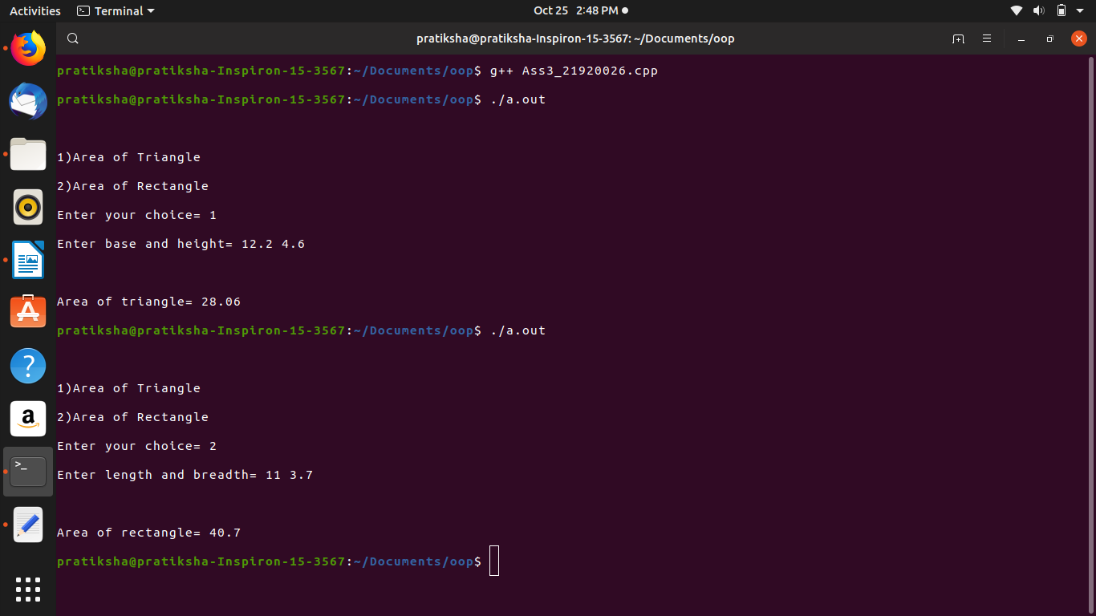

Conclusion: Thus, we successfully implement program that will accept dimension of a triangle or a rectangle interactively, and display the area using inheritance and vertual function.

