Assignment No : 4
Problem Statement : Write a function template and class template selection Sort. Write a program that inputs, sorts and outputs an integer array and a float array.
Aim of Assignment : To implement function template and class template in program for generic data sorting.
Description :

Generics in C++
- Generics is the idea to allow type (Integer, String, … etc and user-defined types) to be a parameter to methods, classes and interfaces. For example, classes like an array, map, etc, which can be used using generics very efficiently. We can use them for any type.
- The method of Generic Programming is implemented to increase the efficiency of the code. Generic Programming enables the programmer to write a general algorithm which will work with all data types. It eliminates the need to create different algorithms if the data type is an integer, string or a character.
- The advantages of Generic Programming are Code Reusability, Avoid Function Overloading ,Once written it can be used for multiple times and cases.
- Generics can be implemented in C++ using Templates. Template is a simple and yet very powerful tool in C++. The simple idea is to pass data type as a parameter so that we don’t need to write the same code for different data types. For example, a software company may need sort() for different data types. Rather than writing and maintaining the multiple codes, we can write one sort() and pass data type as a parameter.
- Templates in C++
A template is a simple and yet very powerful tool in C++. The simple idea is to pass data type as a parameter so that we don’t need to write the same code for different data types. For example, a software company may need sort() for different data types. Rather than writing and maintaining the multiple codes, we can write one sort() and pass data type as a parameter.
- C++ adds two new keywords to support templates: ‘template’ and ‘typename’. The second keyword can always be replaced by keyword ‘class’.
- How templates work ?
Templates are expanded at compiler time. This is like macros. The difference is, compiler doe type checking before template expansion. The idea is imple, source code contains only function/class, but compi ed code may contain multiple copies of same function/class.
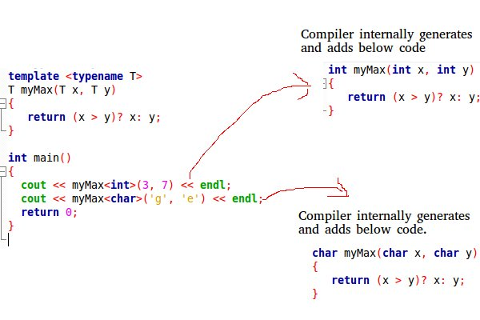
OOP Concept used :
- Function Templates
We write a generic function that can be used for different data types. Examples of function templates are sort(), max(), min(), printArray().
- Class Templates
Like function templates, class templates are useful when a class defines something that is independent of the data type. Can be useful for classes like LinkedList, BinaryTree, Stack, Queue, Array, etc.
Conclusion : Thus, we successfully implement program for function template and class templete.

Outout :
