Assignment No : 5
Problem Statement : Create User defined exception to check the following conditions and throw the exception if the criterion does not meet.
a.User stays in Pune / Mumbai / Bangalore / Chennai b. User has 4-wheeler City, Vehicle from the user and check for the conditions mentioned above. If any of the condition not met then throw the exception. If user does not enter proper input throw the exception.
Aim of Assignment : To implement user define exception in above problem statament.

Description :
Exception Handling
- An exception is a problem that arises during the execution of a program. A C++ exception is a response to an exceptional circumstance that arises while a program is running, such as an attempt to divide by zero.
- Exceptions provide a way to transfer control from one part of a program to another. C++ exception handling is built upon three keywords: try, catch, and throw.
- throw − A program throws an exception when a problem shows up. This is done using a throw keyword.
- catch − A program catches an exception with an exception handler at the place in a program where you want to handle the problem. The catch keyword indicates the catching of an exception.
- try − A try block identifies a block of code for which particular exceptions will be activated. It's followed by one or more catch blocks.
- Assuming a block will raise an exception, a method catches an exception using a combination of the try and catch keywords. A try/catch block is placed around the code that might generate an exception. Code within a try/catch block is referred to as protected code, and the syntax for using try/catch as follows −
try
{
// protected code
}
catch( ExceptionName e1 )
{
// catch block
}
catch( ExceptionName e2 )
{
// catch block
}
catch( ExceptionName eN )
{
// catch block
}
- We can list down multiple catch statements to catch different type of exceptions in case your try block raises more than one exception in different situations.

Throwing Exceptions
- Exceptions can be thrown anywhere within a code block using throw statement. The operand of the throw statement determines a type for the exception and can be any expression and the type of the result of the expression determines the type of exception thrown.
- FoAllowing is an example of throwing an exception when dividing by zero condition occurs −
double division(int a, int b) {
if( b == 0 ) {
throw "Division by zero condition!";
}
return (a/b);
}

Catching Exceptions
- The catch block following the try block catches any exception. You can specify what type of exception you want to catch and this is determined by the exception declaration that appears in parentheses following the keyword catch.
Try { // protected code }
catch( ExceptionName e ) { // code to handle ExceptionName exception }
- Above code will catch an exception of ExceptionName type. If you want to specify that a catch block should handle any type of exception that is thrown in a try block, you must put an ellipsis, ..., between the parentheses enclosing the exception declaration as follows −
try {
// protected code
} catch(...) {
// code to handle any exception
}

OOP Concept used :
Standard Exceptions in c++
C++ provides a list of standard exceptions defined in <exception> which we can use in our programs. These are arranged in a parent-child class hierarchy shown below −

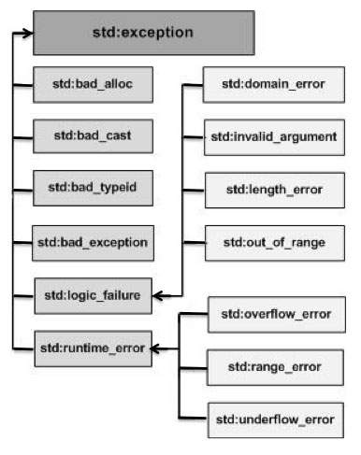

Conclusion : Thus, we successfully studied user define exception also perform program for same.

Output :
