Assignment No : 6
Problem Statement: Create a class template to represent a generic vector. Include following member functions:
i. To create the vector.
ii. To modify the value of a given element
iii. To multiply by a scalar value
iv. To display the vector in the form (10,20,30,…)
Aim of Assignment : To implement lass template to represent a generic vector.
Description :

Vectors
Vectors are same as dynamic arrays with the ability to resize itself automatically when an element is inserted or deleted, with their storage being handled automatically by the container. Vector elements are placed in contiguous storage so that they can be accessed and traversed using iterators. In vectors, data is inserted at the end. Inserting at the end takes differential time, as sometimes there may be a need of extending the array. Removing the last element takes only constant time because no resizing happens. Inserting and erasing at the beginning or in the middle is linear in time.

Difference between vector and array
An array follows static approach, means its size cannot be changed during run time while vector implements dynamic array means it automatically resizes itself when appending elements.

OOP Concept used :
functions associated with the vector are:

Function | Description
at() | It provides a reference to an element.
back() | It gives a reference to the last element.
front() | It gives a reference to the first element.
swap() | It exchanges the elements between two vectors.
push_back() | It adds a new element at the end.
pop_back() | It removes a last element from the vector.
empty() | It determines whether the vector is empty or not.
insert() | It inserts new element at the specified position.
erase() | It deletes the specified element.
resize() | It modifies the size of the vector.
clear() | It removes all the elements from the vector.
size() | It determines a number of elements in the vector.
capacity() | It determines the current capacity of the vector.
assign() | It assigns new values to the vector.
operator=() | It assigns new values to the vector container.
operator[]() | It access a specified element.
end() | It refers to the past-lats-element in the vector.
emplace() | It inserts a new element just before the position pos.
emplace_back() | It inserts a new element at the end.
rend() | It points the element preceding the first element of the vector.
rbegin() | It points the last element of the vector.
begin() | It points the first element of the vector.
max_size() | It determines the maximum size that vector can hold.
cend() | It refers to the past-last-element in the vector.
cbegin() | It refers to the first element of the vector.
crbegin() | It refers to the last character of the vector.
crend() | It refers to the element preceding the first element of the vector.
data() | It writes the data of the vector into an array.
shrink_to_fit() | It reduces the capacity and makes it equal to the size of the vector.

push_back function
push_back() is used for inserting an element at the end of the vector. If the type of object passed as parameter in the push_back() is not same as that of the vector or is not interconvertible an exception is thrown.
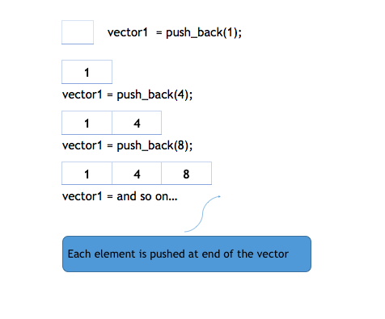

insert function
insert(itr, element) method inserts the element in vector before the position pointed by iterator itr.
The following illustration will show how insert works :
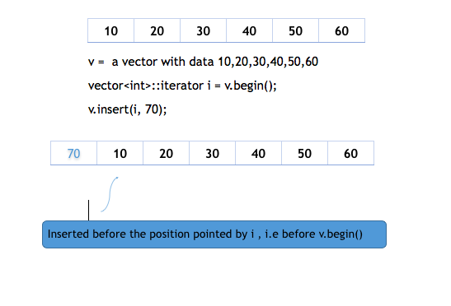
pop_back function
pop_back() is used to remove the last element from the vector. It reduces the size of the vector by one.
Below is an example:
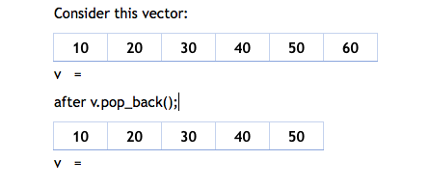

erase function
erase(itr_pos) removes the element pointed by the iterator itr_pos. erase method can also be overloaded with an extra iterator specifying the end point of the range to be removed, i.e erase(itr_start, itr_end).

Conclusion: Thus, we successfully implement a class represents the class template to represent a generic vector.

Output:
