|  |  |  |  |  |  |  |  |  |  |  |  |  |  |  |  |
| --- | --- | --- | --- | --- | --- | --- | --- | --- | --- | --- | --- | --- | --- | --- | --- |
| ***A SYNOPSIS ON***  ***“End-to-End Relational Database Management System.”***  ***BACHELOR OF ENGINEERING***  *In*  *Instrumentation and Control Engineering*   |  |  |  | | --- | --- | --- | | ***Name*** | ***GR. No*** | ***Roll No.*** | | ***Manas Dani*** |  | ***34*** | | ***Pritesh Chaudhari*** |  |  | | ***Payal Deshmukh*** |  |  | | ***Pratiksha Kale*** |  |  | |

**AIM/ OBJECTIVE:**

To provide an interactive user-interface (website) hosted on cloud platform:

1. To generate Student Details for TNP activities for companies
2. To generate Data Insights, Data Reports about Students and Companies.
3. To provide an ease of updating database.

**INTRODUCTION:**

Companies visit campuses to hire students. They require specific details from Students such as-

* 1. Name
  2. CGPAs
  3. Email IDs
  4. Roll Number etc.

But what student has to do is, he/she has to fill these details every time a company plans a visit on campus.

This is tedious both for Students and TNP coordinators to maintain different files, require a lot of Manual efforts. In this scenario we come handy and aim to provide an automation-Solution to this approach.

**What do we propose?**

**Product - 1**

* + 1. TNP should roll-out a Google form with only one field - i.e. Unique Registration Number

(E2Kxxx,I2Kxxx,C2Kxx)

* + 1. We will provide an interactive website for Admins/TNP coordinators, where they can just upload this csv file and can select columns/details from website checkbox.
    2. We will Parse this file of interested students and get those required details from our database.
    3. We will attach the fetched details to CSV file and mail it to designated person's email id.
    4. All this will happen in SINGLE CLICK and within a Blink of an EYE.

**Product - 2**

* + 1. An Interactive User Interface for CRUD Operations.
    2. Where a TNP coordinator can update/create data points within website itself.
    3. E.g. If a new students registration shall be done, our website will have an option to enter details of the students and insert it into database.

**Product - 3**

* + 1. Our website will also have SEE REPORTS sections.
    2. Where everyone can see what the current situation of Placements in PICT is.
    3. How many students registered? How many of them are placed?
    4. All inside Charts format.
    5. We will also have a section called GET JDs of Previous Companies, where will show JD of companies

That student is interested in.

**BLOCK DIAGRAM:**

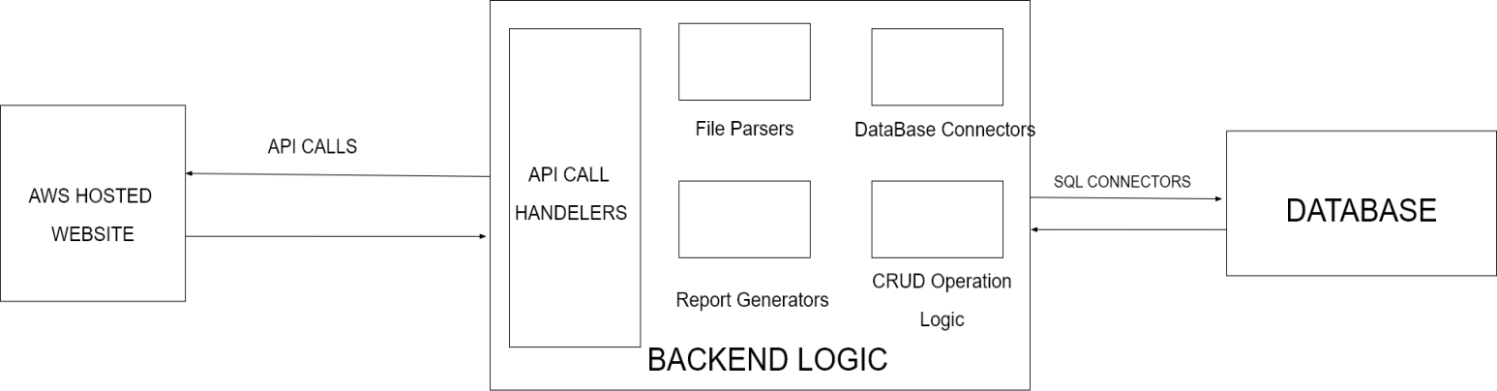

**TECHNICAL DETAILS:**

1. Tech Stack:
   1. Python, Django/Flask
   2. APIs
   3. React, HTML, CSS
   4. AWS
   5. MySQL
   6. Jenkins, GitHub.

1. The code versioning will be managed end-to-end with [GitHub](https://github.com/Aaditya-git/relationalDBManagementSystem)
2. The code will be deployed using Jenkins, GitHub Webhooks to Cloud.
3. Now Frontend, Backend and database code will be completely isolated to avoid security vulnerabilities.
4. Frontend-Backend communications will be done using APIs.

**INNOVATION AND USEFULNESS:**

1. Our project will help students as well as TnP coordinators by saving their time.
2. It would help to manage the placement activity in a easier way.
3. The data reports and insights are now single click away.
4. This will provide ease of maintenance of student data and will avoid extra manual efforts.

***CONCLUSION:***

**What is the Value addition?**

* 1. A complete end-to-end fully automated project is delivered, which will save students’ and TnP coordinators’ time and will provide ease.
  2. The data reports and insights are now single click away.
  3. This will provide ease of maintenance of student data and will avoid extra manual efforts.

***FUTURE SCOPE:***

* 1. To Run ML models to predict chances of Student getting into a company.
  2. To provide Login and Password for students to upload their data.
  3. Do Image Recognition to validate mark sheets automatically.
  4. To provide company details and average criteria to qualify for students.
  5. To provide interview experience for particular company.

***REFERENCES:***

[*https://youtu.be/3vsC05rxZ8c*](https://youtu.be/3vsC05rxZ8c) : Link for SQL python connector video [*https://youtu.be/rHux0gMZ3Eg*](https://youtu.be/rHux0gMZ3Eg) *:* Link for python django for framework [*https://youtu.be/KoNWlnx6E1I*](https://youtu.be/KoNWlnx6E1I) : Link for AWS CodeDeploy i.e. website hosting.

[*https://youtu.be/ACI8EDbaXzo*](https://youtu.be/ACI8EDbaXzo) : Link for frontend backend integration.