App (Java)
|
| -- (Binder call via AIDL or Service)
↓
Android Framework (Java)
|
| -- (JNI call)
↓
Native Libraries (C/C++)
|
| -- (Call HAL Interface)
↓
HAL Module (C/C++)
|
| -- (Driver Call)
↓
Linux Kernel
📱 1. Application Layer (Java/Kotlin)

✅ What it includes:
- Apps developed by users and OEMs (Settings, Camera, WhatsApp, etc.)
- Built using Android SDK (Java/Kotlin).

🧩 Key Components:
- Activity – UI screen (e.g., MainActivity).
- Service – Background task (e.g., music playing).
- BroadcastReceiver – Receives system-wide events.
- ContentProvider – Shares data between apps.
- UI – XML layouts, Jetpack Compose, Views.

🔧 Tools/Language:
- Java / Kotlin
- Android Studio
- XML (for UI)

⚙️ 2. Android Framework (Java)

✅ What it includes:
- System APIs used by apps to interact with device features (camera, sensors, audio).
- Manages resources, services, permissions, and user interface.

🧩 Key Services:
Framework Class | Function
ActivityManagerService | Manages activity lifecycle.
PackageManagerService | Handles app install/uninstall.
WindowManagerService | Controls window layout.
AudioManager, CameraManager | Control audio & camera APIs.

🔧 Language:
- Java
- Kotlin (newer APIs use it too)

🔗 3. Binder IPC (Inter-Process Communication)

✅ What it includes:
- Mechanism that allows Android components (in different processes) to communicate efficiently.
- Used extensively between Framework and Native system services.

🧩 Key Components:
Component | Description
Binder | Kernel-level driver used for IPC.
AIDL | Interface definition for services.
ServiceManager | Central registry of binder services.
IBinder | Base interface for all binder services.

🔧 Language:
- Java ↔ C++ communication
- JNI bridges Java code to native binder stubs

⚙️ 4. Native Services Layer (C/C++)

✅ What it includes:
- Core system services implemented in C++.
- These services handle the real work delegated from the framework (via Binder).

🧩 Examples:
Native Service | Description
SurfaceFlinger | Handles rendering graphics to screen.
MediaServer | Controls audio/video playback and capture.
CameraService | Accesses and manages camera hardware.
AudioFlinger | Mixes and manages audio streams.

🔧 Language:
- C++
- Interacts with HAL or drivers directly

🧩 5. HAL (Hardware Abstraction Layer - C/C++)

✅ What it includes:
- Standardized interface between Android OS and hardware.
- Makes hardware implementation independent from higher layers.

🧩 Examples:
HAL Module | Description
audio.primary.default.so | HAL for audio operations.
camera.default.so | HAL for camera access.
sensors.default.so | HAL for accelerometer, gyroscope, etc.

🛠️ HAL Types:
- Pre-Oreo: Custom C headers and .so files.
- HIDL HAL (Android 8+) – Interface in .hal file, implemented in C++.
- AIDL HAL (Android 11+) – More modern, faster development.

🔧 Language:
- C / C++

🧱 6. Linux Kernel (C)

✅ What it includes:
- Manages all hardware and core system resources (memory, processes, power, etc.).
- Contains drivers for device components.

🧩 Drivers in Kernel:
Driver | Function
binder | Android’s IPC driver.
ashmem | Shared memory driver.
pmem | Physical memory allocator.
camera, audio, touch | Hardware drivers.

🔧 Language:
- Pure C
- Kernel modules are loaded based on device tree and HAL use.

🔄 Full Stack Flow Example: Taking a Picture
markdown
CopyEdit
1. App Calls Camera API (Java/Kotlin)
↓
2. Android Framework forwards request via CameraManager → Binder
↓
3. Native CameraService (C++) handles the request
↓
4. Camera HAL (C/C++) issues commands to hardware
↓
5. Kernel driver controls actual camera hardware and returns image buffer

🗂 Summary Table
Layer | Language | Role
App Layer | Java/Kotlin | UI and user logic
Android Framework | Java | Exposes APIs, handles services
Binder IPC | Java/C++ | Cross-layer communication
Native Services | C++ | Real implementation of services
HAL | C/C++ | Abstracts hardware differences
Linux Kernel | C | Talks to physical hardware
JNI stands for Java Native Interface.
It is a programming interface that allows Java/Kotlin code to call native (C/C++) code, and vice versa.

Layer-by-Layer Communication

1. App (Java/Kotlin) ⟶ Android Framework (Java)
✅ Mechanism: AIDL (Binder IPC)
- Apps call system services like CameraManager, AudioManager, MediaCodec, etc.
- These are implemented using AIDL or bound services, which use Binder IPC under the hood.
📦 Example:
java
CopyEdit
IMediaPlayerService.aidl ← Exposes service to apps

2. Android Framework (Java) ⟶ Native Libraries (C/C++)
✅ Mechanism: JNI (Java Native Interface)
- The framework uses JNI to call into native C/C++ libraries (libmedia, libcameraservice, libbinder, etc.).
📦 Example:
java
CopyEdit
MediaPlayer.java → native_setup() → JNI → C++ MediaPlayer

3. Native Libraries (C/C++) ⟶ HAL (C/C++)
✅ Mechanism: Function calls or HIDL/AIDL (for system/vendor separation)
There are two scenarios here:

A. For internal/native HAL components:
- Native libraries directly link to HAL .so files.
- Example: AudioFlinger calling audio.primary.default.so

B. For vendor HAL modules (post Treble, Android 8+):
- Communication is via:
  - HIDL (Android 8–10)
  - AIDL HAL (Android 11+ preferred)
- This ensures framework–vendor separation.
📦 Example:
swift
CopyEdit
frameworks/av/services/camera/libcameraservice/
↔ HIDL: android.hardware.camera.device@3.4

4. HAL (C/C++) ⟶ Linux Kernel (C)
✅ Mechanism: Direct system calls or IOCTLs
- The HAL calls Linux kernel drivers directly using:
  - open(), ioctl(), mmap(), read(), write()
📦 Example:
- Camera HAL uses ioctl() to send commands to /dev/video0 via V4L2 driver.

✅ Summary Table
Communication Layer | Mechanism Used | Technology
App → Framework | Binder IPC | AIDL
Framework → Native Libraries | Java ↔ C++ Bridge | JNI
Native Libraries → HAL | Direct call or Binder IPC | HIDL / AIDL (new)
HAL → Linux Kernel Drivers | System calls | ioctl, mmap, etc
App (Java/Kotlin)
|
| 1. MediaCodec.configure(… "video/avc", ENCODER …)
| 2. MediaCodec.start()
↓
Android Framework (Java)
|
| -- JNI call into native layer
↓
Codec2 SFPlugin (JNI ↔ C++)
|
| -- Uses Codec2 Client API
↓
Codec2 Core (C++)
|
| -- Queries component store (e.g., C2PlatformComponentStore)
| -- Selects appropriate encoder
↓
Codec2 Component:
→ Software Encoding:
frameworks/av/media/codec2/components/C2SoftAvcEnc.cpp
(e.g., using x264 or libavcodec via C++ wrapper)
→ OR
→ Hardware Encoding:
frameworks/av/media/codec2/hidl/ or aidl/
→ IPC to vendor HAL
→ hardware/vendor/*/media/… HAL implementation
↓
HAL Layer (C/C++)
|
| -- Translates requests to V4L2 or custom kernel interface
↓
Linux Kernel
|
| -- Uses driver (e.g., /dev/videoX)
| -- Performs hardware-accelerated H.264 (AVC) encoding

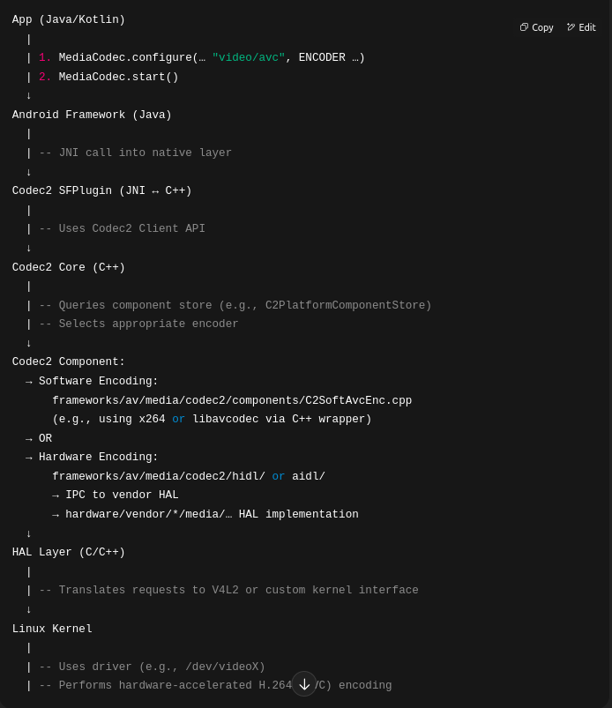

Refreshed Architecture Stack with Codec2
java
CopyEdit
[ App (Java/Kotlin) ]
⬇️
[ Android Framework (Java) ]
↳ Media APIs (e.g., MediaCodec)
⬇️
[ Native Services (C++) ]
↳ MediaServer
↳ Codec2 SFPlugin ↔ Codec2 Core
⬇️
[ Codec2 Layer (C++) ]
↳ Codec2 components (Software or HAL-backed)
↳ Codec2 HIDL/AIDL (for hardware codecs)
⬇️
[ HAL (C/C++) ]
↳ Codec2 HIDL/AIDL HAL Implementation (for hardware codecs only)
⬇️
[ Hardware Drivers (Linux Kernel) ]
↳ Video encoder/decoder drivers (e.g., via V4L2 or custom vendor drivers)

✅ So where does Codec2 reside?

📍 Codec2 spans these two layers:

1. ✅ Part of Native Services (C++)
- Codec2 is mostly implemented in native C++.
- It resides within the media server space (in the native part of Android).
- Integrates tightly with MediaCodec Java APIs via the sfplugin.
Relevant AOSP folders:
bash
CopyEdit
frameworks/av/media/codec2/ ← Core Codec2 framework
frameworks/av/media/codec2/components ← Software encoders/decoders
frameworks/av/media/codec2/sfplugin ← Integrates with Java MediaCodec API

2. ✅ May extend into HAL layer (for hardware codecs)
- When using hardware acceleration, Codec2 can interact with the Codec2 HAL, defined via HIDL (Android 8-10) or AIDL (Android 11+).
- This bridges into vendor HAL implementations, typically under:
bash
CopyEdit
hardware/google/media/ ← Reference HALs
hardware/vendor_name/media/ ← Vendor-specific HALs
- These HALs then talk to kernel drivers (e.g., V4L2 on Linux).

💡 Quick Summary Table
Layer | Codec2 Role
App (Java) | Calls MediaCodec API (Java interface)
Framework (Java) | Delegates to native via Binder/JNI
Native Services (C++) | MediaCodecService, Codec2 SFPlugin, and Codec2 Core/Components live here
HAL (C/C++) | Hardware codec support via Codec2 HIDL/AIDL
Kernel (C) | Video/audio codec drivers for hardware acceleration

✅ Bottom Line:
👉 The Codec2 layer lives mainly in the Native Services layer, but can extend into the HAL layer when using hardware-accelerated codecs.
Would you like a diagram or file-by-file walkthrough showing exactly how Codec2 fits into the AOSP tree and how control flows from app to driver?

You said:

