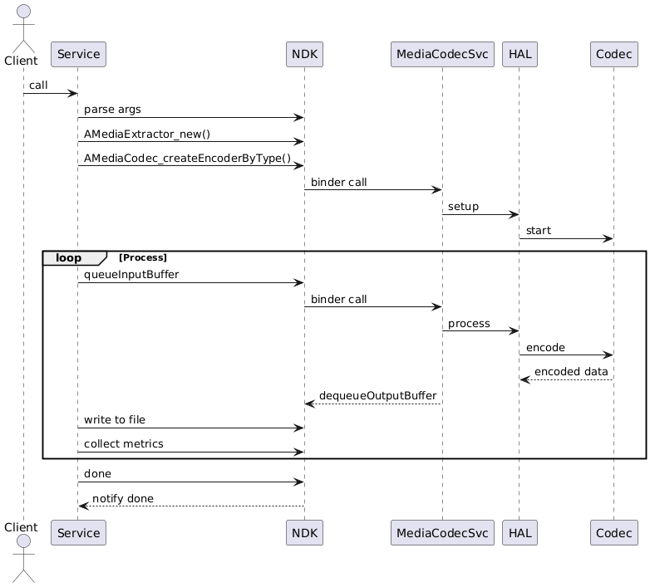

[Client shell/app]
│
▼
[NativePlayerService]
│
▼
[AMediaExtractor & AMediaCodec]
│
▼
[MediaCodecService]
│
▼
[Codec HAL (Codec2 or OMX)]
│
▼
[Hardware or Software Encoder]
│
▼
[Encoded Output File + CSV/JSON Stats]
-----------------------------------------------------------------------------------------------------------------------
[ You (shell command) ]
│
▼
[ NativePlayerService (entry point) ]
│
▼
[ NDK layer (AMediaExtractor + AMediaCodec) ]
│
▼
[ Encoded video file saved to: /sdcard/Download/output.mp4 ]
│
▼
[ JSON/CSV stats saved to: /sdcard/Download/result.json ]
1️. App or shell request
- This is the entry point.
- Example: you run service call command or write a small client app that calls your service via binder.
- This is purely for triggering — no heavy work here.

2️. Your NativePlayerService

What is this?
- A new native service you will write in C++ and register with Android's service manager.
- Lives inside frameworks/av/services or similar (can be anywhere you add).
- Provides APIs like:
  - startEncoding(inputFile, outputFile, codecType)
  - getPerformanceResults()

What it does?
- Takes a file path (e.g., raw video or MP4).
- Initializes and controls encoding flow.
- Collects start time, end time, CPU/memory stats.
- Calls NDK functions.

3️. NDK layer (Your main coding work)

APIs you use
- AMediaExtractor: reads and demuxes video frames from input.
- AMediaCodec: encodes raw frames into compressed video.

Typical flow

AMediaExtractor *extractor = AMediaExtractor_new();
AMediaExtractor_setDataSource(extractor, inputFile);
size_t numTracks = AMediaExtractor_getTrackCount(extractor);
AMediaExtractor_selectTrack(extractor, videoTrackIndex);

AMediaFormat *format = AMediaFormat_new();
// configure encoder
AMediaCodec *codec = AMediaCodec_createEncoderByType("video/avc"); // or "video/hevc" etc.
AMediaCodec_configure(codec, outputFormat, nullptr, nullptr, CONFIGURE_FLAG_ENCODE);
AMediaCodec_start(codec);

// loop to read frames from extractor and feed to codec
while (AMediaExtractor_readSampleData(extractor, buf, bufSize) >= 0) {
// queue input buffer to codec
// dequeue output buffer from codec and write to file
}

What happens under the hood
- You give raw video frames to AMediaCodec.
- It compresses (encodes) them.
- You get encoded buffers back and write to output.

4️. MediaCodecService

What is it?
- Android system service in frameworks/av/media/mediaserver.
- Acts as a broker.
- Takes requests from your AMediaCodec and decides which codec implementation to use.

What it does
- Looks up registered codecs (software or hardware).
- Decides if it can use hardware acceleration (preferred) or fallback to software.
- Sends commands to Codec HAL.

5️. Codec HAL layer

What is it?
- HAL = Hardware Abstraction Layer.
- "Codec2" (newer) or "OMX" (older) interface.

What it does
- Talks directly to vendor hardware encoder (like Qualcomm, MediaTek, etc.).
- Translates generic encode commands into vendor-specific instructions.

6️. Codec implementation (Hardware or Software)

What is it?
- If hardware: dedicated video encoder block (VPU, GPU block).
- If software: pure CPU implementation (e.g., Google software H.264).

What it does
- Takes raw video frames.
- Encodes using codec algorithm (e.g., H.264, HEVC).
- Returns compressed bitstream.

7️. Output

What you do
- In your service, take encoded buffers and write to output file (e.g., MP4 file).
- Record:
  - Total time taken.
  - Frame encoding speed (fps).
  - CPU usage (if you monitor it).
- Save summary in CSV or JSON file.

Summary of flow in words
1️.You send a request (e.g., "start encoding this file") to your NativePlayerService.
2️.The service uses NDK APIs (AMediaExtractor, AMediaCodec) to extract raw frames and encode them.
3️. The NDK AMediaCodec internally talks to MediaCodecService.
4️. MediaCodecService picks the actual codec implementation (hardware or software) through Codec HAL.
5️.Codec HAL talks to vendor-specific hardware encoder or software encoder.
6️.Encoded data is sent back up through buffers to your service.
7️.You write encoded data to file, measure time, collect stats, and export CSV or JSON.

You only work directly with:
- Your NativePlayerService (C++)
- NDK APIs (AMediaExtractor, AMediaCodec)
You do not modify MediaCodecService or HAL.
HAL and codecs are automatically chosen by Android.
Your job is to orchestrate the flow, measure performance, and export results.
/home/mirafra/aosp/out/target/product/emulator_x86_64/system/bin
commands
# Rebuild nativeplayerservice
m nativeplayerservice

[100% 245/245] Install: out/target/product/emulator_x86_64/system/bin/nativeplay

# Push binary to device
adb push out/target/product/emulator_x86_64/system/bin/nativeplayerservice /data/local/tmp/

# Push YUV input
adb push input_640x480.yuv /sdcard/input.yuv

adb shell
cd /data/local/tmp
./nativeplayerservice

adb shell ls -l /sdcard/output.h264
adb shell ls -l /sdcard/encode_profile.csv
adb pull /sdcard/output.h264 .
adb pull /data/local/tmp/encode_profile.csv .
Optional: Advanced Profiling (Next Milestones)
To go deeper into performance:
- Use Android tools:
  - simpleperf – CPU usage
  - systrace / atrace – system trace
  - perfetto – detailed timeline
- Memory profiling:
  - Use valgrind (if native binary is portable)
  - Or Android Studio’s Native Memory Profiler via debug build
- Frame latency heatmaps / jitter graphs from encode_profile.csv

Run nativeplayerservice with simpleperf

$ adb shell
# cd /data/local/tmp
# ./simpleperf record -o perf.data -- ./nativeplayerservice
- It will start the service.
- Then, in another terminal, trigger the encoding using:
bash
CopyEdit
adb shell service call nativeplayerservice 1 s16 "/sdcard/input.yuv" s16 "/sdcard/output.h264" s16 "video/avc"
adb shell
cd /data/local/tmp
simpleperf record -o perf.data -- ./nativeplayerservice
simpleperf report -i perf.data > perf.txt
adb pull /data/local/tmp/perf.txt .
The perf.txt file you attached is a performance profiling report generated using simpleperf inside the Android emulator. Here's a detailed explanation of its contents:

🔹 Structure of perf.txt:
This is a typical simpleperf report format showing:
- Sample percentage — percentage of the total CPU samples attributed to a function.
- Function name — the name of the function where CPU cycles were spent.
- Library — the binary (.so or executable) where the function resides.

🔸 Top Example Entries Explained:

95.69% nativeplayerservice [.] android::NativePlayerService::startEncoding
- 95.69% of the CPU time was spent inside your function:
android::NativePlayerService::startEncoding
- This indicates that the encoder logic is the most CPU-intensive part of the binary — as expected.
- It means the actual encoding work is correctly being measured.

2.06% libmediandk.so [.] AMediaCodec_dequeueInputBuffer
1.13% libmediandk.so [.] AMediaCodec_queueInputBuffer
0.84% libmediandk.so [.] AMediaCodec_getInputBuffer
0.07% libmediandk.so [.] AMediaCodec_dequeueOutputBuffer
- These are Android NDK MediaCodec API calls.
- These percentages show time spent in codec buffer management — input and output buffer queueing and dequeuing.
- You can see that input-side buffering takes significantly more time than output-side.

0.05% libc.so [.] fread
0.03% libc.so [.] fwrite
- Very little CPU time is spent on file I/O (fread, fwrite).
- This means disk read/write isn’t a bottleneck, which is good.

🔹 What This Means for You:
- ✅ Your startEncoding() implementation is working and is the most active part of your code.
- 🔧 You can now optimize encoding performance:
  - Use hardware acceleration if available.
  - Consider profiling further inside startEncoding() using scoped timers or atrace.
- 🧪 If the profile is as expected, you can proceed to compare with other codecs or encoding configurations (bitrate, resolution, etc.).

