1) How linux is used in networking?

**Ans:**

* Linux is a free, open-source operating system
* Linux supports connection to the Internet and any other network.
* It can also be used to directly connect two computers as peers via a modified printer cable.
* It provides and manage routing, bridging, virtual networks and monitoring.

2) What is NS3?

**Ans:**

* Network Simulator
* It helps to create various virtual nodes (i.e., computers in real life) and with the help of various Helper classes it allows us to install devices, internet stacks, application, etc to our nodes.
* Using NS3 we can create PointToPoint, Wireless, CSMA, etc connections between nodes.

3) What is NetAnim?

**Ans:**

* It is an offline animator.
* It animates a previously executed simulation using an XML trace file generated during a simulation.

4) What is Wireshark?

**Ans:**

* Wireshark is a free and open-source **packet analyzer.**
* It captures every packet getting in or out of a network interface and shows them in a nicely formatted text.
* It allows users to **watch all the traffic** being passed over the network
* It is used for network troubleshooting, analysis, to examine security problems
* Troubleshoots malicious activities on network

5) What does first 3 bytes mean in Ip address?

**Ans:**

Class A <128

First byte - network number

Next three bytes - host address

Class B 128-191

First 2 bytes - network number

Next two bytes - host address.

Class C >192

First 3 bytes - network number

Last byte - host address.

6) Pcap file?

**Ans:**

* These are the **data files** which contains packet data of network and are used **to analyze** the network **characteristics** and determines **network status**

7) What is point to point connection?

**Ans:**

* Network consists of direct link between two nodes
* e.g. Basic telephone call

8) CSMA (Carrier Sense Multiple Access)

**Ans:**

* It is based on media access protocol to sense the traffic on a channel (idle or busy) before transmitting the data.
* It means that if the channel is idle, the station can send data to the channel. Otherwise, it must wait until the channel becomes idle.
* Hence, it reduces the chances of a collision on a transmission medium.
* CSMA/CA – Monitors medium while transmitting, avoids collision
* CSMA/CD – Monitors medium after sending the data

9) What is topology

**Ans:**

Mapped network

10) Star topology

**Ans:**

* All other nodes are connected using this central node/ hub.

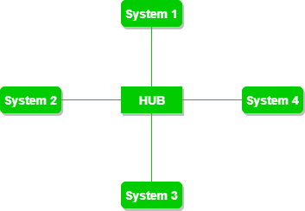

11) Bus topology

**Ans:**

* It uses a single cable which connects all the included nodes

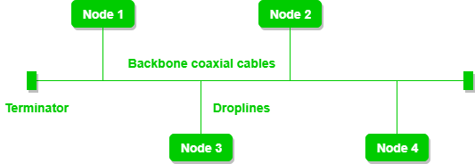

12) Ring topology

**Ans:**

* Every device has exactly two neighboring devices for communication purpose.
* Every computer is connected to another computer.
* Here, the last node is combined with a first one.

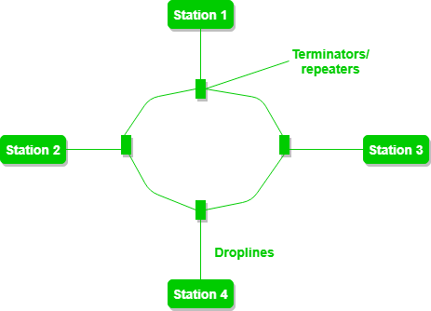

13) Mesh topology

**Ans:**

* It develops a P2P connection between all the devices of the network.
* Partial mesh – Similar to full. The only difference is that few devices are connected with just two or three devices.

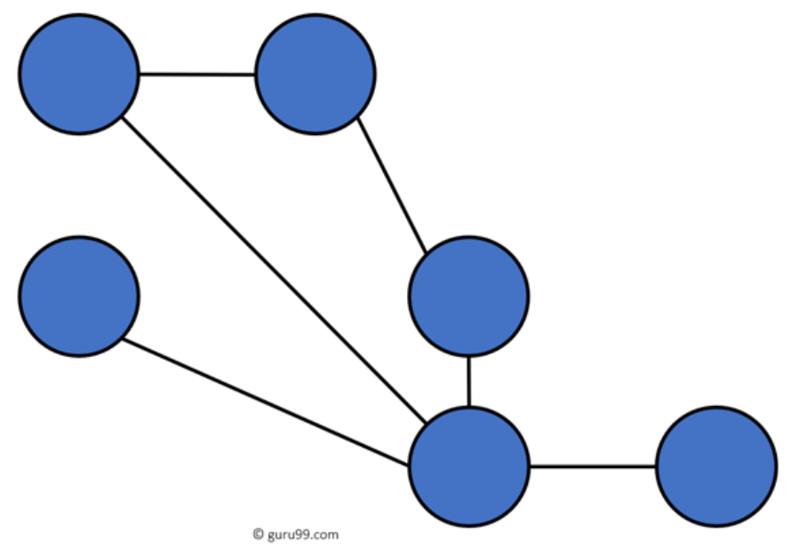

* Full mesh - Every node or device is directly connected with each other

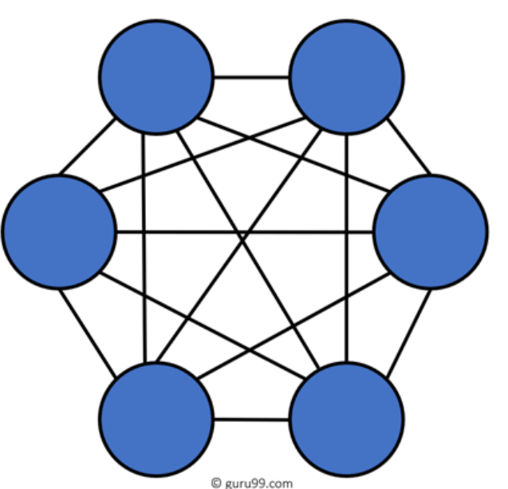

14) Tree topology

**Ans:**

* It has a root node, and all other nodes are connected which form a hierarchy.
* So it is also known as hierarchical topology and star bus topology

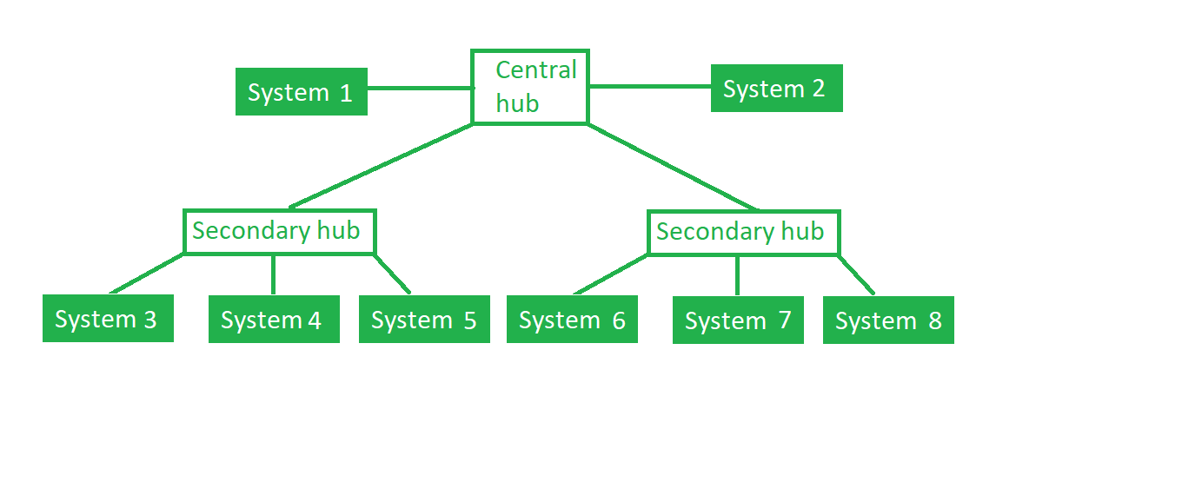

15) TCP vs UDP

**Ans:**

|  |  |
| --- | --- |
| **TCP** | **UDP** |
| Transmission Control Protocol | User Datagram Protocol |
| connection-oriented | connectionless |
| slower | Faster |
| Guarantees delivery of data to destination router | Not guaranteed |
| retransmission of lost data packets is only possible with TCP. | Not possible |
| Used by HTTPS, HTTP, SMTP, POP, FTP | Used by DNS, Video conferencing, VoIP |

16) FTP (File Transfer Protocol)

**Ans:**

* A network protocol used for transferring files from one computer system to another.

17) DHCP (Dynamic Host Configuration Protocol)

**Ans:**

* A DHCP Server is a network server that automatically provides and assigns IP addresses, default gateways and other network parameters to client devices.
* DHCP assigns new IP addresses in each location when devices are moved from place to place, which means network administrators **do not have to** **manually configure** each device with a **valid IP address** or reconfigure the device with a new IP address if it moves to a new location on the network.

18) 3-way handshake? (TCP uses this to establish a reliable connection, full duplex)

**Ans:**

* Client wants to establish connection with server, so it sends a synchronize sequence number (SYN) to inform server that client is likely to start communication
* Server responds to client request with SYN-ACK. ACK signifies response of the segment it received and SYN – sequence number it is likely to start segments
* In final part, client acknowledges the response of server and both establishes a reliable connection with which they will start the actual data transfer

