**Pratiksha Parbat**

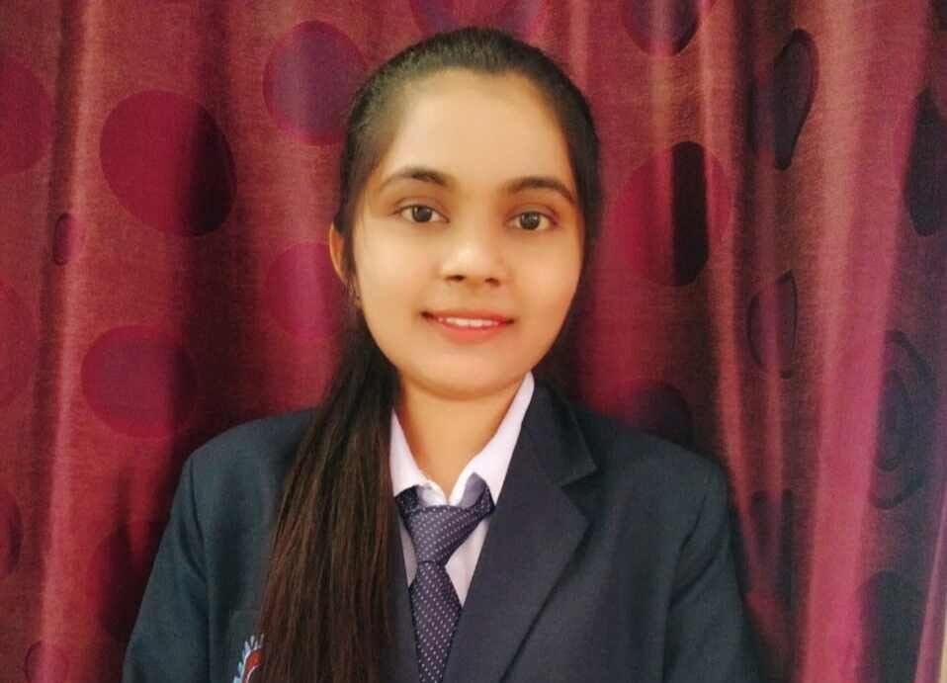

BE Graduate

**EDUCATION:**

**BE**

Sant Gadge Baba Amravati university

Percentage: 78.47%

**HSC 12th**

Maharashtra State Board

Percentage: 62.62%

**SSC 10th**

Maharashtra State Board

Percentage: 67.60%

* 7498265172
* Pratikshaparbat749@gmail.com
* Pune, India

linkedin.com/in/pratiksha-parbat-5b84a9226

**OBJECTIVE:** To have a growth oriented and challenging career, where I can contribute my knowledge and skills to the organization and enhance my experience through continuous learning and teamwork.

**PERSONAL DETAIL:**

Date of birth : 7th July 2000

Gender : Female

Languages Knows : English, Hindi, Marathi

Residental Address : Wadhona Bazar, Sub District- Ralegaon District-Yavatmal-445001(MH).

**DECLARATION:** I hereby certify that the above given data are true and correct to the best of my knowledge and belief.

**Location:** Pune

**(Pratiksha Ashok Parbat )**

**PERSONAL SKILL & STRENGTH**

* Good convincing power
* Completed work within a time
* Discipline
* Accepting my weakness and trying to improve

**Personal Details:**

Father Name :Ashok Parbat

Date of birth :7th July 2000

Residential Address **:** Wadhona Bazar, Sub District-Ralegaon, District-yavatmal-445001(MH).

**TECHNICAL KNOWLEDGE:**

**CORE JAVA SQL PYTHON**

**HTML CSS & JAVASCRIPT**

**PROJECT:**

Solar Power Battery Charging With Reverse Current Protection.