**CONTENTS**

1. **Introduction 1**
2. **Literature Review 3**
3. **Requirement Specification 5**
4. **Problem Statement 8**
5. **System Architecture 10**
6. **System Design 12**
7. **Output 14**
8. **System Testing 18**
9. **Conclusion 21**
10. **References 23**

**11 Annexure……………………………………………………………………….24**



CHAPTER1

### INTRODUCTION

We are looking for a platform that acts as a bridge between farmers and experts, facilitating the sharing of information on crop diseases. An app like this would allow farmers to effortlessly upload photographs of their affected crops and plants. Simultaneously, it enables experts to provide highly effective solutions for these diseases. This kind of application could revolution size the agricultural sector by offering rapid, targeted assistance to farmers facing crop-related challenges.

The farmer faced many problems in agriculture. The major problem is diseases of plants and crops. There are many plants and crops in agriculture and also their diseases, so it is not easy to identify the exact problem and If plants have some disease farmers cannot easily identify that which type of disease the plant have so they cannot get the effective solution. To solve this problem our project will helps to farmers, through our project they can upload the photo of that diseased plant to the expert and expert will give the effective solution, and our project will build the connection between the farmers and experts. Also, through this platform farmer can easily call to the expert and chat with them which makes farmer easy to connect with expert and get the advice from the expert. For this application registration and authentication is most important and for that we have provide some verification services for both the farmer and the expert.

i.e. login and registration this step involve verification of correct password and user name from both the side .

CHAPTER2

Literature Review

Literature Review:

International Journal of Advanced Research in Science, Communication and Technology (IJARSCT) International Open-Access, Double-Blind, Peer-Reviewed, Refereed, Multidisciplinary Online Journal Volume 4, Issue 2, April 2024 Copyright to IJARSCT DOI: 10.48175/IJARSCT-17027 195 www.ijarsct.co.in Impact Factor: 7.53 “Agri Care”- The Farming App Ms. Samrudhi Sanjay Kulkarni1 , Ms. Srushti Vidyadhar Bagale2 , Ms. Bhagyashri Somshekhar Boragi3 , Ms. Sidra Abdul Saeed Shaikh4 , Ms. Sarika C. Nimbalkar5

As India is an agricultural country so it is important to provide some advanced features for the farmers such as upload crop photos, farmer will connect with expert by chat or call. With the help of such features farmer can easily find the solution for their problem and interact with the help of android application easily, Farmers may easily post photos of their plants and crops to this portal, which is mobile friendly. We provide a solution for farmers which helps farmers to increase their products.

Lots of farmer are unaware about the solution about the particular problem so they not able to increase their profit so lots of difficulty they will face in day-to-day life. To overcome from the above drawback, we build android application that helps interact easily. The method is intended to provide these farmers with direct access to certified specialists with knowledge in agriculture, plant and crop diseases, and other related fields. This platform's main objective is to provide farmers with vital support in handling issues pertaining to their plants and crops. Farmers may more easily share photos of their plants with recognized professionals, who can then provide exact advice and recommendations.

Agarwal, B.1994.A Field of One’s Own.Cambridge University Press. Cambridge,572pp.

A Field of one’s Own is pioneering study on gender and property in south Asia. It argus that the gender gap in effectives own ship of property is the single most important economics factor in explaing gender inequities in South Asia ,where land ownership is not only a symbol of economics status but also social prestige and political power.

Bhalla, G.S. 2001. Political Economy of Indian Development in the 20th Century: India's Road to Freedom and Growth. Presidential Address. 83rd Annual Conference of Indian Economic Association, University of Jammu, Jammu.

As India is an agricultural country so it is important to provide some advanced features for the farmers such as upload crop photos, farmer will connect with expert by chat or call. With the help of such features farmer can easily find the solution for their problem and interact with the help of android application easily, Farmers may easily post photos of their plants and crops to this portal, which is mobile friendly. We provide a solution for farmers which helps farmers to increase their products. Lots of farmer are unaware about the solution about the particular problem so they not able to increase their profit so lots of difficulty they will face in day-to-day life. To overcome from the above drawback, we build android application that helps interact easily. The method is intended to provide these farmers with direct access to certified specialists with knowledge in agriculture, plant and crop diseases, and other related fields.

This platform's main objective is to provide farmers with vital support in handling issues pertaining to their plants and crops. Farmers may more easily share photos of their plants with recognized professionals, who can then provide exact advice and recommendations. Birthal S., Pratap, A.K., Ravishankar, A. and Pandey, U .K.. 1999. Sources of Growth in the Livestock Sector. Policy Paper 9. National Centre for Agricultural Economics and Policy Research (ICAR), New Delhi. A study was undertaken to estimate the contribution of technical change to the growth of livestock output in the country. Aggregate indices of livestock output and inputs were constructed. TFP growth was computed as the difference between output and input growth rates. The study revealed that the livestock sectoral output grew at 2.59 percent per annum over 1950-51 to 1995-96. The input index increased by 1.79 percent per annum and TFP grew at about 0.8 percent. There was no TFP growth in the first period (1950-51 to 1970-71) suggesting no technical change. The real upswing started in the eighties when sectoral output growth touched nearly 4 percent per annum and TFP growth jumped to nearly 1.8percent (Table 1), contributing about 45 percent to total output growth. Backed by an improved market and institutional environment, investments in livestock research have begun to pay off. To identify what would drive the future growth in livestock production, another study was undertaken with Karnataka's livestock sector as a case. About two third of the growth in cattle milk production and half of the growth in buffalo milk production is accounted for by productivity and this contribution has been rising over time. Rapid shift in herd structure in favour of high milk yielding species and improved feed fodder supplies and animal health services would facilitate future growth.



Meat production increased at an annual rate of more than 9 percent. However, growth in meat output of almost all the species is on account of increase in slaughter rates. Growth in egg production is also largely due to increase in population of layers. Future growth in egg production would come from a shift in layer population in favour of improved layer and intensive system of poultry production. A study was undertaken to

examine the level and pattern of energy use and its efficiency in soybean based cropping system of Madhya Pradesh using farm level data. Soybean and wheat are the two most important crops in the soybean belt. Wheat is the most energy intensive crop (13980 mega joules per ha). Chickpea, which competes with wheat, requires about half of the energy used in wheat cultivation. Commercial sources of energy account for more than 90 percent of the energy used in cultivation of these crops. Soybean, the Kharif season crop grown largely under rained conditions consumes 7142.5 mega joules per ha of which about 77 percent comes from commercial sources. Maize, sorghum and blackgram compete with soybean and require one-third of the energy used in soybean cultivation. These crops largely derive their energy requirements from non-commercial sources. The findings indicated that technologies such as integrated nutrient management, integrated pest management, etc. should be scaled up as to conserve commercial non-renewable energy whilst maintaining profitability of agriculture.

* 1. Introduction to Plant Disease Diagnosis Apps

-Define the problem: Challenges faced by farmers in identifying and treating plant diseases.

-Introduction to app-based solutions: How mobile apps can assist in disease eco gnition and resolution.

- Plant disease apps can help identify and treat plant disease and can also provide information on crop management.

* 1. Overview of Existing Plant Disease Identification Apps
* List and briefly descry be existing apps (e.g. Plantix, Agrio, etc.).
* Highlight key features such as image recognition, expert advice, and
* Farmer interaction.
* Example:
* -Plantix: It is a popular app -based solution that uses machines learning algorithm to diagnose plant disease.
* A free app that uses machine learning algorithms to diagnose plant diseases. Farmers can take a photo of a diseased plant and upload it to the app, which then provides a diagnosis and treatment recommendations.
* Plantix also provides information on crop management, such as planting and harvesting recommendations.
  1. Farmer- Expert Interaction
* Explore how apps facilitate communication between farmers and agricultural experts.
* Analyze studies on the effectiveness of remote consultations in agriculture.
* A lagre body of work assumes that individuals do in fact make rational economic, political and social decisions.



1. User Experience and Adoption

* Examine user feedback and adoption rate so existing apps.
* Discuss usability studies and user interface design considerations.
* It is growing research filed which has in recent years gained considerable interest from both scholars and practitioners.
* The research filed of user interaction with and experience of a system or a product.

1. Imp acton Agricultural Practices

* Evaluate the impact of plant disease diagnosis apps on farming practices.
* Review case studies show casing successful implementation and outcomes.
* Adverse changes in weed communication are a limiting factors for the adoptions of conservation tillage practice.

1. Challenges and Future Directions

-Identify challenges faced by current apps (e.g., connectivity issues , accuracy limitations).

-Discuss future research directions such as incorporating AI advancements or expanding to newcrops

1. Conclusion

* Summarize key findings from the literature review.
* Highlight the significance of app-based solutions in modern agriculture and potential for future development.
* The community of inquiry framework issues discussed previously have important theoretical and practical implications.
* Understanding the role of social presence is essential in creating a community of inquiry and building group cohesion are essential for productive inquiry.



CHAPTER 3

Requirements

Specification

## Requirements

#### Android:

Android is a mobile operating system based on a modified version of the Linux kernel and other open-source software, designed primarily for touchscreen mobile devices such as smartphones and tablets. Android is developed by a consortium of developers known as the Open Handset Alliance and commercially sponsored by Google.

It is free and open-source software; its source code is known as Android Open- Source Project (AOSP),which is primarily licensed under the Apache License.

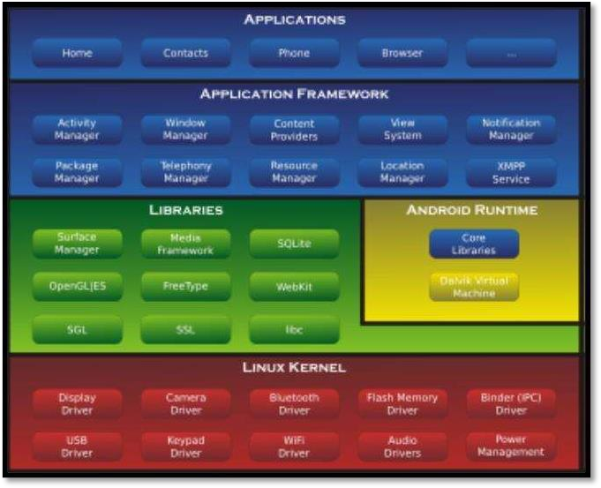

Image1.AndroidArchitecture



#### Visual Studio

Visual Studio Code is a source code and program code editor that can be used with a variety of programming languages to develop and invent something by programming, including [C](https://en.wikipedia.org/wiki/C_(programming_language)),[C#](https://en.wikipedia.org/wiki/C_Sharp_(programming_language)),[C++](https://en.wikipedia.org/wiki/C%2B%2B), [Fortran](https://en.wikipedia.org/wiki/Fortran), [Go](https://en.wikipedia.org/wiki/Go_(programming_language)), [Java](https://en.wikipedia.org/wiki/Java_(programming_language)), [Java Script](https://en.wikipedia.org/wiki/JavaScript) ,[Node. js](https://en.wikipedia.org/wiki/Node.js), [Python](https://en.wikipedia.org/wiki/Python_(programming_language)), [Rust](https://en.wikipedia.org/wiki/Rust_(programming_language)), and [Julia](https://en.wikipedia.org/wiki/Julia_(programming_language)).It is built on the [Electron](https://en.wikipedia.org/wiki/Electron_(software_framework)) framework, which is used to develop [Node. jsweb](https://en.wikipedia.org/wiki/Node.js) [applications](https://en.wikipedia.org/wiki/Web_application) that run on the [Blink layout engine](https://en.wikipedia.org/wiki/Blink_layout_engine). Visual Studio Code employs the same editor component (codenamed "Monaco") used in [Azure DevOps](https://en.wikipedia.org/wiki/Azure_DevOps_Server) (formerly called "Visual Studio Online" and "Visual Studio Team Services").

Out of the box, Visual Studio Code includes basic support for most common programming languages. This basic support includes [syntax highlighting](https://en.wikipedia.org/wiki/Syntax_highlighting), [bracket](https://en.wikipedia.org/wiki/Bracket_matching) [matching](https://en.wikipedia.org/wiki/Bracket_matching), [code folding](https://en.wikipedia.org/wiki/Code_folding), and configurable snippets. Visual Studio Code also ships with [IntelliSense](https://en.wikipedia.org/wiki/Intelligent_code_completion) for Java Script ,Type Script, [JSON](https://en.wikipedia.org/wiki/JSON), [CSS](https://en.wikipedia.org/wiki/CSS), and [HTML](https://en.wikipedia.org/wiki/HTML), as well as debugging support for Node.js. Support for additional languages can be provided by freely available extension so n the VS Code Market place.



Image 2.Visual Studio Code Insiders logo

Instead of a project t system, it allows user stoope none or more directories, which can then

be saved in workspaces for future reuse. This allows it to operate as a [language- agnostic](https://en.wikipedia.org/wiki/Language-agnostic) code editor for any language. It supports many programming languages and a set off eat user that differs per language. Unwanted files and folders can be excluded from the project tree via settings. Many Visual Studio Code features are not exposed through menus or the user interface but can be accessed via the command palette.

The command palette is able to execute virtually every feature the graphical inter face supports, making very keyboard-accessible.



CHAPTER 4

Problem Statement

## **Problem Statement**

App-Based Solution to Identify and Solve Diseases of Plants and Crops. The farmer faced many problems due to agriculture. The major problem is diseases of plants and crops. There are many plants and crops in agriculture and also their diseases. If plants have some disease farmers cannot easily identify that which type of disease the plant have so they cannot get the effective solution. To solve this problem our project will help to farmers, through our project they can upload the photo of that diseased plant to the expert and expert will give the effective solution And our project will build the connection between the farmers and experts.



CHAPTER 5

System Architecture





**DATABASE LAYER**

*Admin*

*VerifyAllinfor*

*Unable tocomplete verification*

**PRESENTAION**

**LAYER**

*Verification Successful*

Farmer SignIn

**BUSINESS LOGICL AYER**

Farmer

Signup

Expert

Signup

Expert Login and Resolve the

Issues posted by Farmers

UploadC ropPhoto

Farmer

Checksolutionand Logoutfromsystem

Other optionsfor

farmercall, chatetc

AdminPanel

Database

Image 4. System Architecture



CHAPTER 6

System Design

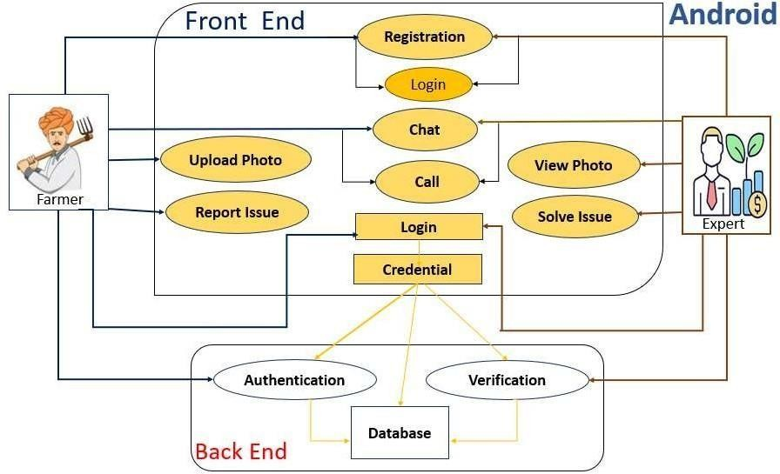

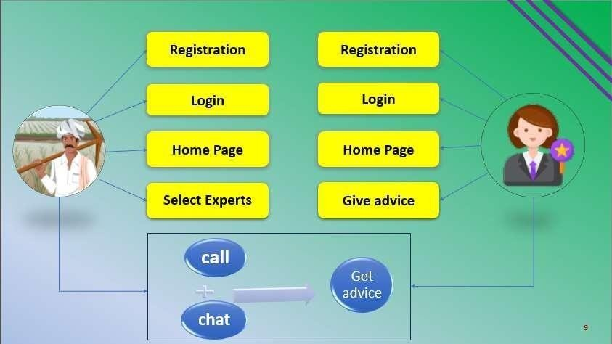

Image5-SystemDesign

CHAPTER 7

Output

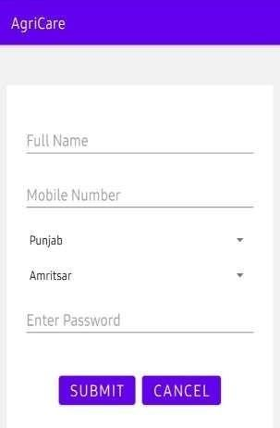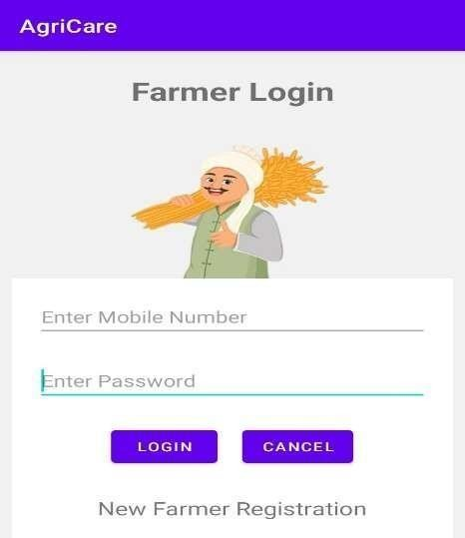

***Figure1****-FarmerRegistration* ***Figure2****- FarmerLogin*

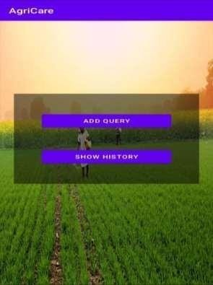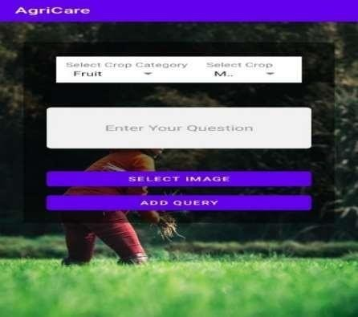

***Figure3****-Farmer Add Query* ***Figure 4****-FarmerAddQuery*

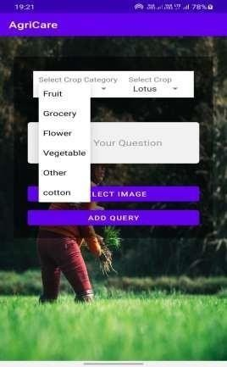 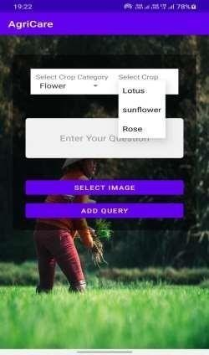

***Figure5****- FarmerAddQuery* ***Figure6****- FarmerAddQuery*

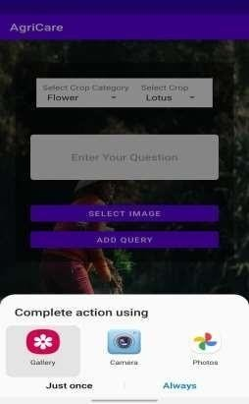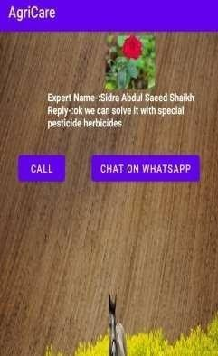

***Figure7****- FarmeruploadImage* ***Figure 8****- ShowHistory*

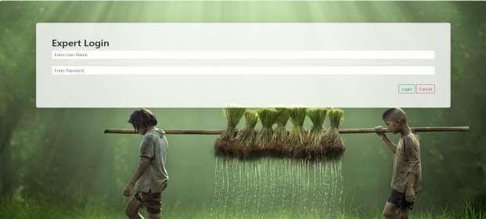

***Figure9****- Expert Login*

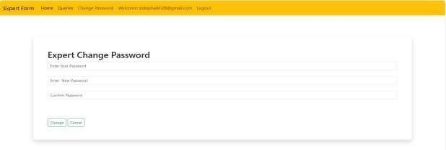

***Figure10****-Expert ChangePassword*

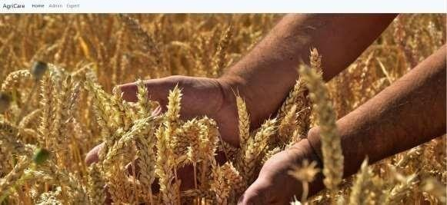

***Figure11****-AdminDashboard*

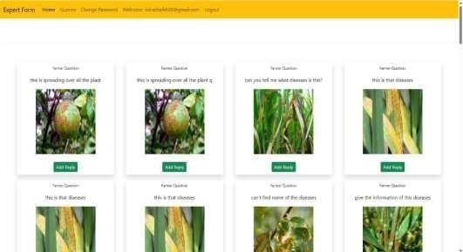

***Figure12****- ViewQuery*

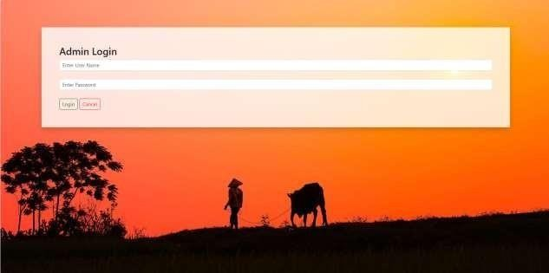

***Figure13****-AdminLogin*

CHAPTER 8

System Testing

|  |  |  |  |  |  |
| --- | --- | --- | --- | --- | --- |
| **Test No.** | **Module Name/Button** | **Action to be performed** | **Expected output** | **Actual output** | **Pass/ Fail** |
| 1. | Registration Page | User will enter all details like name, mobile no etc. | Open the log in page. | Opened log in page. | Pass |
| 2. | Log in Page | User will enter mobile no and password. | It will display add query and | Displayed  the add query and show | Pass |
| Show history page | history page. |
| 3. | Add Query | User will select crop category, crop, add query and upload photo. | It should add query and display  added | Added the query successfully  . | Pass |
| Successfully |
| message. |
| 5. | Show | User can see list | It should | Displayed | Pass |
| History | Of expert a device | Display the | The list of |
|  | With expert name | List of | Expert |
|  | And photo. | Expert | advice. |
|  |  | advice. |  |

CHAPTER9

Conclusion

## Conclusion

* App- Based Solution to Identify and Solve Diseases of Plants and Crops. In agriculture, farmers faced numerous challenges. Plant and crop diseases are in issue. In agriculture, there are many different plants, crops and disease As a result, it can be difficult top in point the precise issue and, in the event that a plant is diseased, to determine the specific sort of disease the plant is suffering from and obtain a suitable remedy Our idea will assist farmers in the solving this issue by allowing them to submit photos of the infected plant to an expert who will then provide an efficient remedy. Additionally, our project will foster communication between farmers and special lists. Additionally, farmers can simply call and chat to the expert. The primary goal of this plat form is to give farmers the essential assistance they need to deal with problems related to their plant sand crops. Farmers can more readily send pictures of their plants to accredited experts, who can subsequently offer precise guidance and suggestions. As a result, grower scan quickly treats plant illnesses . The community of inquiry framework issues discussed previously have important theoretical and practical implications. Understanding the role of social presence is essential in creating a community of inquiry and building group cohesion are essential for productive inquiry.

CHAPTER 10

References

## **References:**

1. Acharya,S.S.2001.Domestic Agricultural Marketing Policies, Incentives and Integration. In S. S Acharya and D.P.Chaudhri. Indian Agricultural Policy at the Crossroads: Priorities and Agenda. Rawat Publications, Jaipur and New Delhi
2. Agarwal,B.1994.A Field of One’s Own.Cambridge University Press. Cambridge,572pp.
3. Bhalla, G.S. 2001. Political Economy of Indian Development in the 20th Century: India's Road to Freedom and Growth. Presidential Address. 83rd Annual Conference of Indian Economic Association, University of Jammu, Jammu.
4. Birthal S., Pratap, A.K., Ravishankar, A. and Pandey, U .K.. 1999. Sources of Growth in the Livestock Sector. Policy Paper 9. National Centre for Agricultural Economics and Policy Research (ICAR), New Delhi.
5. Chand, R. and Jha, D. 2001. Trade Libera lisati on, Agricultural Prices and Social Welfare. In S.S. Acharya and D.P.Chaudhri. Indian Agricultural Policy at the Crossroads: Priorities and Agenda. Rawat Publications, Jaipur and New Delhi.

**CHAPTER**

**11**

**Annexure**

I **ANNEXURE**

COURSE OUTCOME FOR PROJECT WORK

After completion of project work students should be able to

:

CO1. Identify and formulating engineering problem addressing needs of industry & society.

CO2. Conduct investigation of engineering problem formulated by engineering sciences.

CO3. Design and develop solution(s) for engineering problem with due consideration to

CO4. Work as individual and in team for communicating and managing the project work and its finances.

CO5. Create, select and apply modern tools for investigating, designing and developing solutions to engineering problem.

CO6. Develop ability for independent & lifelong learning.

CO7 Apply professional ethics while identifying the problem, investigating the problem

Designing a solution to the problem, working as an individual or team for communicating and managing the project work and its finances.

**CO-PO MAPPING FOR PROJECT**

I

**CO-PO MAPPING FOR PROJECT**