



A PROJECT REPORT

ON “AGRICARE”-THE FARMING APP

**SUBMITTED BY**

|  |  |
| --- | --- |
| **Student Name** | **PRN No** |
| Ms. Madhuri Badave | (T2162191242526) |
| Ms. Rutika Avachare | (T2162191242517) |
| Ms. Pratiksha Parkarwar | (T2162191242516) |
| Mr. Mazin Madki | (T2162191242512) |
| Mr. Akash Mudkanna | (T2162191242528) |

**UNDER THE GUIDENCE OF PROF.C.M.JADHAV**



## DEPARTMENT OF COMPUTER SCIENCE AND ENGINEERING BHARAT RATNA INDIRA GANDHI COLLEGE OF ENGINEERING, SOLAPUR

**AFFILIATED TO**

**DR. BABASAHEB AMBEDKAR TECHNOLOGICALUNIVERSITY, LONERE 2023-2024**



# CERTIFICATE

This is certify that the project entitled **“AGRICARE”-THE FARMING APP** has been completed by following students of B.tech (Computer Science And Engineering) class in satisfactory manner under my guidance.

|  |  |
| --- | --- |
| **Student Name** | **PRN No** |
| Ms. Madhuri Badave | (T2162191242526) |
| Ms. Rutika Avachare | (T2162191242517) |
| Ms. Pratiksha Parkarwar | (T2162191242516) |
| Mr. Mazin Madki | (T2162191242512) |
| Mr. Akash Mudkanna | (T2162191242528) |

Has been carried out by the student of final year under the guidance of Prof. C.M. Jadhav during the year 2023-24 in partial fulfilment for the award of Degree, Bachelor of Engineering in Computer Science Engineering as per requirements of Dr. Babasaheb Ambedkar Technological University.

## (Pro .C.M. Jadhav ) (Dr. Najmuddin Aamer) GUIDE HOD

**(DR.S.G. Pasha) PRINCIPAL**





# PROJECT APPROVAL SHEET

The project entitled **“AGRICARE”-THE FARMING APP** submitted by following students :

|  |  |
| --- | --- |
| **Student Name** | **PRN No** |
| MS. Madhuri Badave | (T2162191242526) |
| MS. Rutika Avachare | (T2162191242517) |
| MS. Pratiksha Parkarwar | (T2162191242516) |
| MR. Mazin Madaki | (T2162191242512) |
| MR. Akash Mudkanna | (T2162191242528) |

Is hereby approved in partial fulfilment for the Bachelor’s Degree of Engineering in Computer Science Engineering and is carried out by

## EXAMINER

**1.--------------------------------------------**

**2.-------------------------------------------- DEPARTMENT OF COMPUTER SCIENCE AND ENGINEERING BHARAT RATNA INDIRA GANDHI COLLEGE OF ENGINEERING,**

**KEGAON, SOLAPUR-413255.**

**2023-2024**





# DECLARATION

We are Department of Computer Science and Engineering, of Bharat Ratna Indira Gandhi College of Engineering, Solapur, is here with submitting my seminar report on ““Agri Care”- The Farming App”. We declare that the work has been carried out under the guidance of **Prof.C.M Jadhav** Bharat Ratna Indira Gandhi College of Engineering , Solapur.

|  |  |
| --- | --- |
| **Student Name** | **PRN No** |
| MS. Madhuri Badave | (T2162191242526) |
| MS. Rutika Avachare | (T2162191242517) |
| MS. Pratiksha Parkarwar | (T2162191242516) |
| MR. Mazin Madaki | (T2162191242512) |
| MR. Akash Mudkanna | (T2162191242528) |





# ACKNOWLEDGEMENT

It gives us immense pleasure in thanking all those who have helped us in successful completion of the project titled

## “Agri Care”-“The Farming App”

This project itself as an acknowledgement to the intensity, drive and technical competency of many individuals, who have completed it.

First and foremost, we sincerely thank our Guide Prof. C.M. Jadhav for showing keen interest, the true spirit of engineering and guiding us on the various aspects of our project without which it would have been impossible for us to complete the project.

We are also thankful to the faculty of department concerned directly or indirectly with our project for their help and guidance. We would like to thank our Head of department, Dr. Najmuddin Aamer for supporting us and guiding us to complete our project successfully.

We sincerely thank our principal Dr. Syed Gilani Pasha for his wholehearted co-operation in the completion of this project. We would also like to thank all staff members for their wholehearted co- operation in completing this project.

**DEPARTMENT OF COMPUTER SCIENCE ENGINEERGING, BHARAT RATNA INDIRA GANDHI COLLEGE OF ENGINEERING, KEGAON, SOLAPUR-413255.**

**(2023-2024)**



**CONTENTS**

## Introduction 1

## Literature Review 3

## Requirement Specification 5

## Problem Statement 8

## System Architecture 10

## System Design 12

## Output 14

## System Testing 18

## Conclusion 21

## References 23

**11 Annexure 24**



CHAPTER1

## INTRODUCTION

We are looking for a platform that acts as a bridge between farmers and experts, facilitating the sharing of information on crop diseases. An app like this would allow farmers to effortlessly upload photographs of their affected crops and plants. Simultaneously, it enables experts to provide highly effective solutions for these diseases. This kind of application could revolution size the agricultural sector by offering rapid, targeted assistance to farmers facing crop-related challenges.

The farmer faced many problems in agriculture. The major problem is diseases of plants and crops. There are many plants and crops in agriculture and also their diseases, so it is not easy to identify the exact problem and If plants have some disease farmers cannot easily identify that which type of disease the plant have so they cannot get the effective solution. To solve this problem our project will helps to farmers, through our project they can upload the photo of that diseased plant to the expert and expert will give the effective solution, and our project will build the connection between the farmers and experts. Also, through this platform farmer can easily call to the expert and chat with them which makes farmer easy to connect with expert and get the advicefrom the expert. For this application registration and authentication is most important and for that we have provide some verification services for both the farmer and the expert.

i.e. login and registration this step involve verification of correct password and user name from both the side .

CHAPTER2

Literature Review

Literature Review:

International Journal of Advanced Research in Science, Communication and Technology (IJARSCT) International Open-Access, Double-Blind, Peer-Reviewed, Refereed, Multidisciplinary Online Journal Volume 4, Issue 2, April 2024 Copyright to IJARSCT DOI: 10.48175/IJARSCT-17027 195 [www.ijarsct.co.in](http://www.ijarsct.co.in/) Impact Factor: 7.53 “Agri Care”- The Farming App Ms. Samrudhi Sanjay Kulkarni1 , Ms. Srushti Vidyadhar Bagale2 , Ms. Bhagyashri Somshekhar Boragi3 , Ms. Sidra Abdul Saeed Shaikh4 , Ms. Sarika C. Nimbalkar5

As India is an agricultural country so it is important to provide some advanced features for the farmers such as upload crop photos, farmer will connect with expert by chat or call. With the help of such features farmer can easily find the solution for their problem and interact with the help of android application easily, Farmers may easily post photos of their plants and crops to this portal, which is mobile friendly. We provide a solution for farmers which helps farmers to increase their products.

Lots of farmer are unaware about the solution about the particular problem so they not able to increase their profit so lots of difficulty they will face in day-to-day life. To overcome from the above drawback, we build android application that helps interact easily. The method is intended to provide these farmers with direct access to certified specialists with knowledge in agriculture, plant and crop diseases, and other related fields. This platform's main objective is to provide farmers with vital support in handling issues pertaining to their plants and crops. Farmers may more easily share photos of their plants with recognized professionals, who can then provide exact advice and recommendations.

Agarwal, B.1994.A Field of One’s Own.Cambridge University Press. Cambridge,572pp.

A Field of one’s Own is pioneering study on gender and property in south Asia. It argus that the gender gap in effectives own ship of property is the single most important economics factor in explaing gender inequities in South Asia ,where land ownership is not only a symbol of economics status but also social prestige and political power.

Bhalla, G.S. 2001. Political Economy of Indian Development in the 20th Century: India's Road to Freedom and Growth. Presidential Address. 83rd Annual Conference of Indian Economic Association, University of Jammu, Jammu.

As India is an agricultural country so it is important to provide some advanced features for the farmers such as upload crop photos, farmer will connect with expert by chat or call. With the help of such features farmer can easily find the solution for their problem and interact with the help of android application easily, Farmers may easily post photos of their plants and crops to this portal, which is mobile friendly. We provide a solution for farmers which helps farmers to increase their products. Lots of farmer are unaware about the solution about the particular problem so they not able to increase their profit so lots of difficulty they will face in day-to-day life. To overcome from the above drawback, we build android application that helps interact easily. The method is intended to provide these farmers with direct access to certified specialists with knowledge in agriculture, plant and crop diseases, and other related fields.

This platform's main objective is to provide farmers with vital support in handling issues pertaining to their plants and crops. Farmers may more easily share photos of their plants with recognized professionals, who can then provide exact advice and recommendations. Birthal S., Pratap, A.K., Ravishankar, A. and Pandey, U .K.. 1999. Sources of Growth in the Livestock Sector. Policy Paper 9. National Centre for Agricultural Economics and Policy Research (ICAR), New Delhi. A study was undertaken to estimate the contribution of technical change to the growth of livestock output in the country. Aggregate indices of livestock output and inputs were constructed. TFP growth was computed as the difference between output and input growth rates. The study revealed that the livestock sectoral output grew at 2.59 percent per annum over 1950-51 to 1995-96. The input index increased by 1.79 percent per annum and TFP grew at about 0.8 percent. There was no TFP growth in the first period (1950-51 to 1970-71) suggesting no technical change. The real upswing started in the eighties when sectoral output growth touched nearly 4 percent per annum and TFP growth jumped to nearly 1.8percent (Table 1), contributing about 45 percent to total output growth.

Backed by an improved market and institutional environment, investments in livestock research have begun to pay off. To identify what would drive the future growth in livestock production, another study was undertaken with Karnataka's livestock sector as a case. About two third of the growth in cattle milk production and half of the growth in buffalo milk production is accounted for by productivity and this contribution has been rising over time. Rapid shift in herd structure in favour of high milk yielding species and improved feed fodder supplies and animal health services would facilitate future growth.

Meat production increased at an annual rate of more than 9 percent. However, growth in meat output of almost all the species is on account of increase in slaughter rates. Growth in egg production is also largely due to increase in population of layers. Future growth in egg production would come from a shift in layer population in favour of improved layer and intensive system of poultry production. A study was undertaken to

examine the level and pattern of energy use and its efficiency in soybean based cropping system of Madhya Pradesh using farm level data. Soybean and wheat are the two most important crops in the soybean belt. Wheat is the most energy intensive crop (13980 mega joules per ha). Chickpea, which competes with wheat, requires about half of the energy used in wheat cultivation. Commercial sources of energy account for more than 90 percent of the energy used in cultivation of these crops. Soybean, the Kharif season crop grown largely under rained conditions consumes 7142.5 mega joules per ha of which about 77 percent comes from commercial sources. Maize, sorghum and blackgram compete with soybean and require one-third of the energy used in soybean cultivation. These crops largely derive their energy requirements from non-commercial sources. The findings indicated that technologies such as integrated nutrient management, integrated pest management, etc. should be scaled up as to conserve commercial non-renewable energy whilst maintaining profitability of agriculture.

* 1. Introduction to Plant Disease Diagnosis Apps

-Define the problem: Challenges faced by farmers in identifying and treatingplant diseases.

-Introduction to app-based solutions: How mobile apps can assist in disease eco gnition and resolution.

- Plant disease apps can help identify and treat plant disease and can also provide information on crop management.

* 1. Overview of Existing Plant Disease Identification Apps
* List and briefly descry be existing apps (e.g. Plantix, Agrio, etc.).
* Highlight key features such as image recognition, expert advice, and
  + Farmer interaction.
  + Example:
  + -Plantix: It is a popular app -based solution that uses machines learning algorithm to diagnose plant disease.
  + A free app that uses machine learning algorithms to diagnose plant diseases. Farmers can take a photo of a diseased plant and upload it to the app, which then provides a diagnosis and treatment recommendations.
  + Plantix also provides information on crop management, such as planting and harvesting recommendations.
  1. Farmer- Expert Interaction
* Explore how apps facilitate communication between farmers and agricultural experts.
* Analyze studies on the effectiveness of remote consultations in agriculture.
* A lagre body of work assumes that individuals do in fact make rational economic, political and social decisions.

1. User Experience and Adoption

* Examine user feedback and adoption rate so existing apps.
* Discuss usability studies and user interface design considerations.
* It is growing research filed which has in recent years gained considerable interest from both scholars and practitioners.
* The research filed of user interaction with and experience of a system or a product.

1. Imp acton Agricultural Practices

* Evaluate the impact of plant disease diagnosis apps on farming practices.
* Review case studies show casing successful implementation and outcomes.
* Adverse changes in weed communication are a limiting factors for the adoptions of conservation tillage practice.

1. Challenges and Future Directions

-Identify challenges faced by current apps (e.g., connectivity issues , accuracy limitations).

-Discuss future research directions such as incorporating AI advancements orexpanding to newcrops

1. Conclusion

* Summarize key findings from the literature review.
* Highlight the significance of app-based solutions in modern agriculture and potential for future development.
* The community of inquiry framework issues discussed previously have important theoretical and practical implications.
* Understanding the role of social presence is essential in creating a community of inquiry and building group cohesion are essential for productive inquiry.

CHAPTER 3

Requirements Specification

Requirements

* 1. Android:

Android is a mobile operating system based on a modified version of the Linux kernel and other open-source software, designed primarily for touchscreen mobile devices such as smartphones and tablets. Android is developed by a consortium of developers known as the Open Handset Alliance and commercially sponsored by Google.

It is free and open-source software; its source code is known as Android Open- Source Project (AOSP),which is primarily licensed under the Apache License.

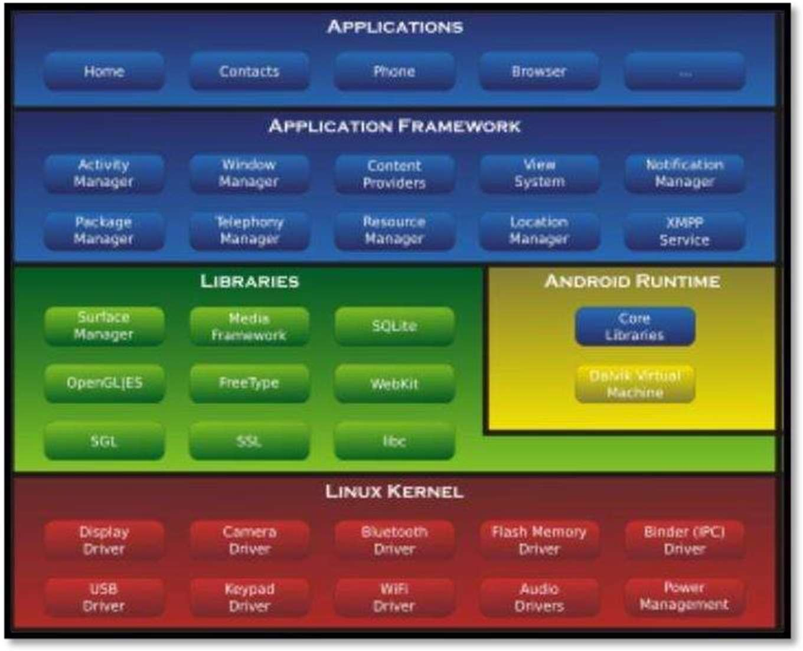

Image1.AndroidArchitecture

* 1. Visual Studio

Visual Studio Code is a source code and program code editor that can be used with a variety of programming languages to develop and invent something by programming, including C,C#,C++, Fortran, Go, Java, Java Script ,Node. js, Python, Rust, and Julia .It is built on the Electron framework, which is used to develop Node. Js web applications that run on the Blink layout engine. Visual Studio Code employs the same editor component (codenamed "Monaco") used in Azure DevOps (formerly called "Visual Studio Online" and "Visual Studio Team Services").

Out of the box, Visual Studio Code includes basic support for most common programming languages. This basic support includes syntax highlighting, bracket matching, code folding, and configurable snippets. Visual Studio Code also ships with IntelliSense for Java Script ,Type Script, JSON, CSS, and HTML, as well as debugging support for Node.js. Support for additional languages can be provided by freely available extension so n the VS Code Market place.



Image 2.Visual Studio Code Insiders logo

Instead of a project t system, it allows user stoope none or more directories, whichcan then

be saved in workspaces for future reuse. This allows it to operate as a language- agnostic code editor for any language. It supports many programminglanguages and a set off eat user that differs per language. Unwanted files and folders can be excluded from the project tree via settings. Many Visual Studio Codefeatures are not exposed through menus or the user interface but can be accessed via the command palette.

The command palette is able to execute virtually every feature the graphical inter face supports, making very keyboard-accessible.

CHAPTER 4

Problem Statement

## Problem Statement

App-Based Solution to Identify and Solve Diseases of Plants and Crops. The farmer faced many problems due to agriculture. The major problem is diseases of plants and crops. There are many plants and crops in agriculture and also their diseases. If plants have some disease farmers cannot easily identify that which type of disease the plant have so they cannot get the effective solution. To solve this problem our project will helpto farmers, through our project they can upload the photo of that diseased plant to the expert and expert will give the effective solution And our project will build the connection between the farmers and experts.

CHAPTER 5

System Architecture



**DATABASE LAYER**

Expert Signup

*Admin VerifyAllinfor*

*Unable tocomplete verification*

**PRESENTAION**

**LAYER**

*Verification Successful*

Farmer SignIn

**BUSINESS LOGICL AYER**

Expert Login and Resolve the

Issues posted by Farmers

Farmer Checksolutionand Logoutfromsystem

UploadC ropPhoto

Other optionsfor

farmercall, chatetc

AdminPanel

Farmer Signup

Database

Image 4. System Architecture

CHAPTER 6

System Design

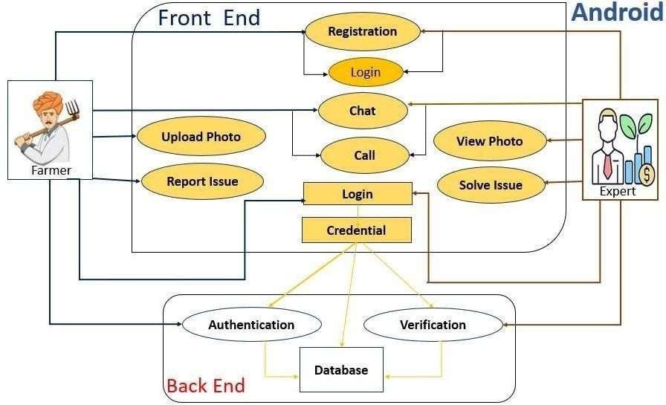

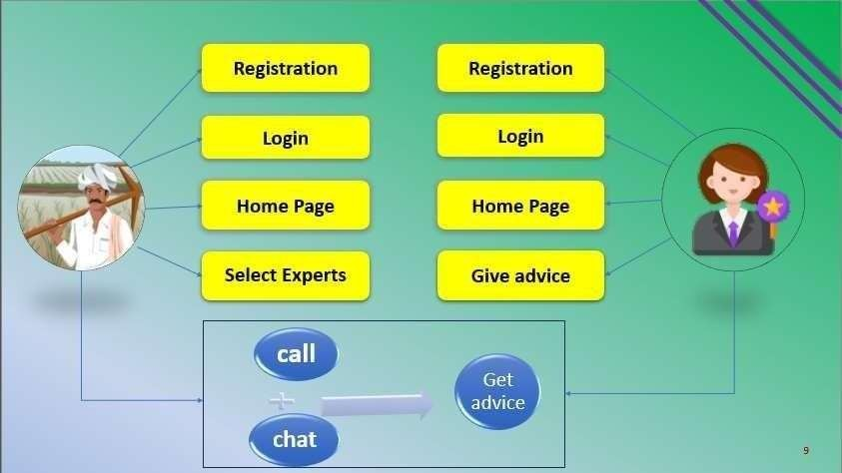

Image5-SystemDesign

CHAPTER 7

Output

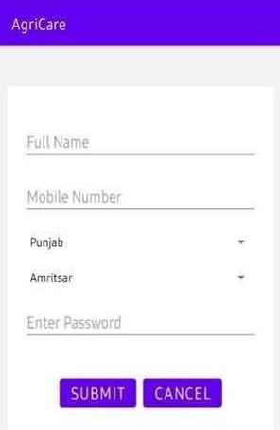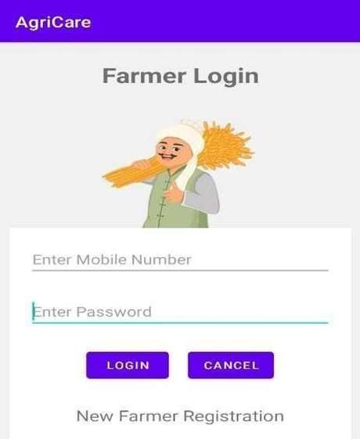

***Figure1****-FarmerRegistration* ***Figure2****- FarmerLogin*

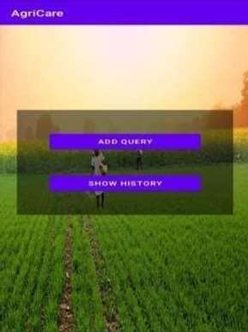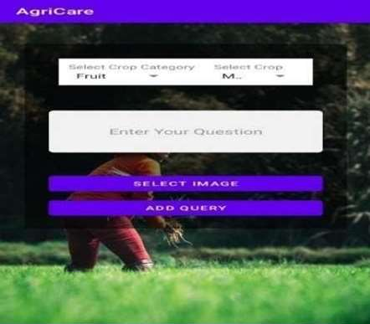

***Figure3****-Farmer Add Query* ***Figure 4****-FarmerAddQuery*

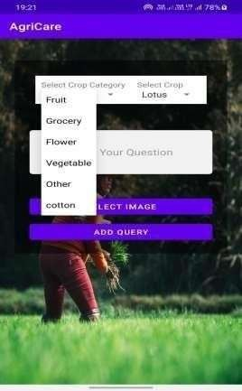 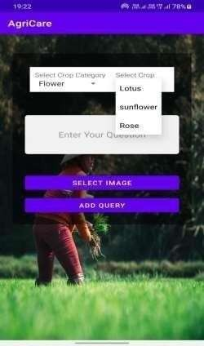

***Figure5****- FarmerAddQuery* ***Figure6****- FarmerAddQuery*

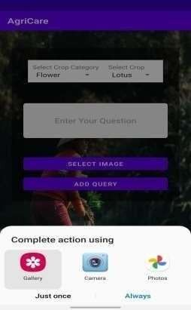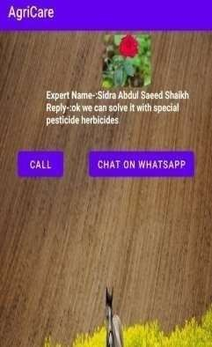

***Figure7****- FarmeruploadImage* ***Figure 8****- ShowHistory*

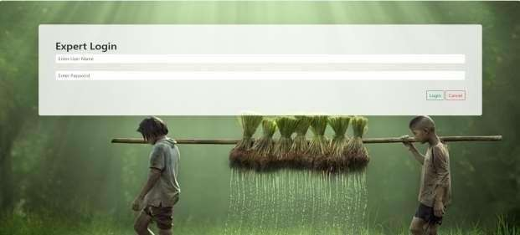

***Figure9****- Expert Login*

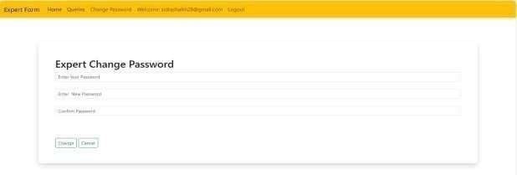

***Figure10****-Expert ChangePassword*

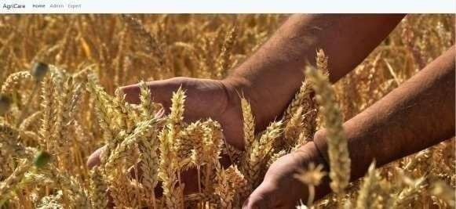

***Figure11****-AdminDashboard*

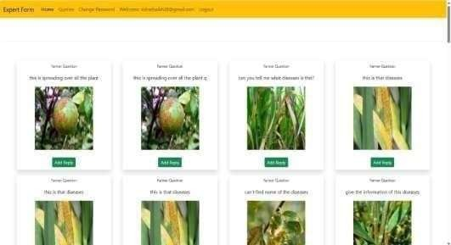

***Figure12****- ViewQuery*

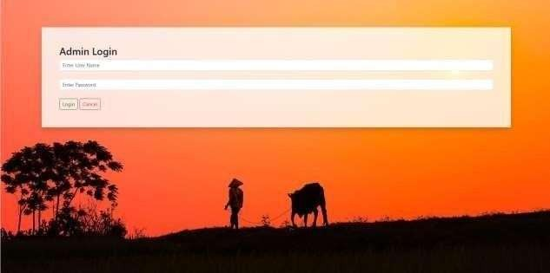

***Figure13****-AdminLogin*

CHAPTER 8

System Testing

|  |  |  |  |  |  |  |
| --- | --- | --- | --- | --- | --- | --- |
| **Test No.** | **Module Name/Button** | **Action to be performed** | **Expected output** | | **Actual output** | **Pass/ Fail** |
| 1. | Registration Page | User will enter all details like name,mobile no etc. | Open log page. | the in | Opened log in page. | Pass |
| 2. | Log in Page | User will enter mobile no and password. | It will display add query and  Show history page | | Displayed  the add query and show  history page. | Pass |
| 3. | Add Query | User will select crop category, crop, add query and upload photo. | It should add query and display  added | | Added the query successfully  . | Pass |
|  |  |  | Successfully | |  |  |
|  |  |  | message. | |  |  |
| 5. | Show  History | User can see list  Of expert a device | It should  Display the | | Displayed  The list of | Pass |
|  |  | With expert name | List of | | Expert |  |
|  |  | And photo. | Expert | | advice. |  |
|  |  |  | advice. | |  |  |

CHAPTER9

Conclusion

Conclusion

* App- Based Solution to Identify and Solve Diseases of Plants and Crops. In agriculture, farmers faced numerous challenges. Plant and crop diseases are in issue. In agriculture, there are many different plants, crops and disease As a result, it can be difficult top in point the precise issue and, in the event that a plant is diseased, to determine the specific sort of disease the plant is suffering from and obtain a suitable remedy Our idea will assist farmers in the solving this issue by allowing them to submit photos of the infected plant to an expert who will then provide an efficient remedy. Additionally, our project will foster communication between farmers and special lists. Additionally, farmers can simplycall and chat to the expert. The primary goal of this plat form is to give farmers the essential assistance they need to deal with problems related to their plant sand crops. Farmers can more readily send pictures of their plants to accredited experts, who can subsequently offer precise guidance and suggestions. As a result, grower scan quickly treats plant illnesses . The community of inquiry framework issues discussed previously have important theoretical and practical implications. Understanding the role of social presence is essential in creating a community of inquiry and building group cohesion are essential for productive inquiry.

CHAPTER 10

References

## References:

1. Acharya,S.S.2001.Domestic Agricultural Marketing Policies, Incentives and Integration. In S. S Acharya and D.P.Chaudhri. Indian Agricultural Policy at the Crossroads: Priorities and Agenda. Rawat Publications, Jaipur and New Delhi
2. Agarwal,B.1994.A Field of One’s Own.Cambridge University Press. Cambridge,572pp.
3. Bhalla, G.S. 2001. Political Economy of Indian Development in the 20th Century: India's Road to Freedom and Growth. Presidential Address. 83rd Annual Conference of Indian Economic Association, University of Jammu, Jammu.
4. Birthal S., Pratap, A.K., Ravishankar, A. and Pandey, U .K.. 1999. Sources of Growth in the Livestock Sector. Policy Paper 9. National Centre for Agricultural Economics and Policy Research (ICAR), New Delhi.
5. Chand, R. and Jha, D. 2001. Trade Libera lisati on, Agricultural Prices and Social Welfare. In S.S. Acharya and D.P.Chaudhri. Indian Agricultural Policy at the Crossroads: Priorities and Agenda. Rawat Publications, Jaipur andNew Delhi.



**CHAPTER**

**11**

**Annexure**

I **ANNEXURE**

COURSE OUTCOME FOR PROJECT WORK

After completion of project work students should be able to

:

CO1. Identify and formulating engineering problem addressing needs of industry & society. CO2. Conduct investigation of engineering problem formulated by engineering sciences.

CO3. Design and develop solution(s) for engineering problem with due consideration to

CO4. Work as individual and in team for communicating and managing the project work and its finances. CO5. Create, select and apply modern tools for investigating, designing and developing solutions to engineering problem.

CO6. Develop ability for independent & lifelong learning.

CO7 Apply professional ethics while identifying the problem, investigating the problem

Designing a solution to the problem, working as an individual or team for communicating and managing the project work and its finances.

# CO-PO MAPPING FOR PROJECT

|  |  |  |  |  |
| --- | --- | --- | --- | --- |
| **Course Outcomes(COs)** | | | |  |
| **Students will able to:** | | | |
| CO1 | | Identify and formulate engineering problem addressing needs of industry and society. | |
| CO2 | | Conduct investigations of the engineering problem formulated by using engineering sciences. | |
| CO3 | | Design and develop solutions for engineering problem with due consideration to public health, safety, culture, society, environment and sustainability. | |
| CO4 | | Create, select and apply modern tools of investigating, designing and developing solutions to engineering problem. | |
| CO5 | | Work as individual and in team for communicating and managing the project work and its finances. | |
| CO6 | | Apply professional ethics while identifying the problem, investigating the problem, designing a solution to the problem, working as an individual or team for communicating and managing the project work and its finances | |
| CO7 | | Develop ability for independent & lifelong learning. | |
|  | **Sr No.** | | **Program Outcomes(Pos)** | |

|  |  |  |  |  |  |
| --- | --- | --- | --- | --- | --- |
| 1 | **Engineering knowledge:** Apply the knowledge of mathematics, science, engineering fundamentals, and an engineering specialization in the solution of complex engineering problems. | | | | |
| 2 | **Problem analysis**: Identify, formulate, review research literature, and analyze complex engineering problems reaching substantiated conclusions using first principles of mathematics, natural sciences and engineering sciences. | | | | |
| 3 | **Design/development of solutions:** Design solution for complex engineering problems and design system components or processes that meet the specified needs with appropriate consideration for the public health and safety, and the cultural, societal, and environmental consideration. | | | | |
| 4 | **Conduct investigation of complex problems:** Use research-based knowledge and research methods including design of experiments, analysis and interpretation of data, and synthesis of the information to provide valid conclusion. | | | | |
| 5 | **Modern tool usage:** Create, select and apply appropriate techniques, resources and modern engineering and IT tools including prediction and modeling to complex engineering activities with an understanding of the limitations. | | | | |
| 6 | **The engineering and society:** Apply reasoning informed by the contextual knowledge to assess societal, health, safety, legal and cultural issues and the consequent responsibilities relevant to the professional engineering practice. | | | | |
| 7 | **Environment and sustainability:** Understand the impact of the professional engineering solutions in societal and environmental context, and demonstrate the knowledge of and need for sustainable development. | | | | |
| 8 | **Ethics:** Apply ethical principles and commit responsibilities and norms of the engineering practice. | to | professional | ethics | and |
| 9 | **Individual and team work:** Function effectively as an individual and as a member or leader in diverse teams, and in multidisciplinary settings. | | | | |
| 10 | **Communication:** Communication effectively on complex engineering activities with the engineering community and with society at large, such as, being able to comprehend and write effective reports and design documentation, make effective presentations, and give and receive clear instruction. | | | | |