SELECT *

FROM olist_customers_dataset

LIMIT 10;

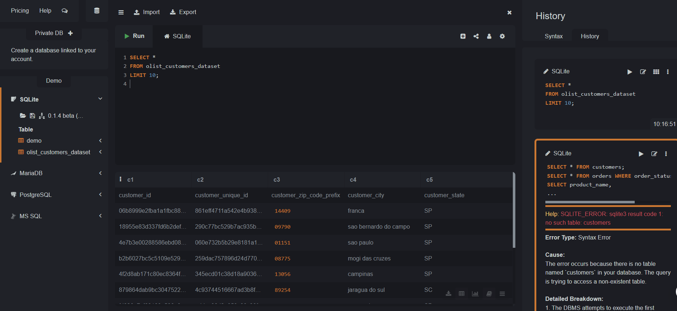

SELECT *

FROM olist_customers_dataset

WHERE c5 = 'SP';

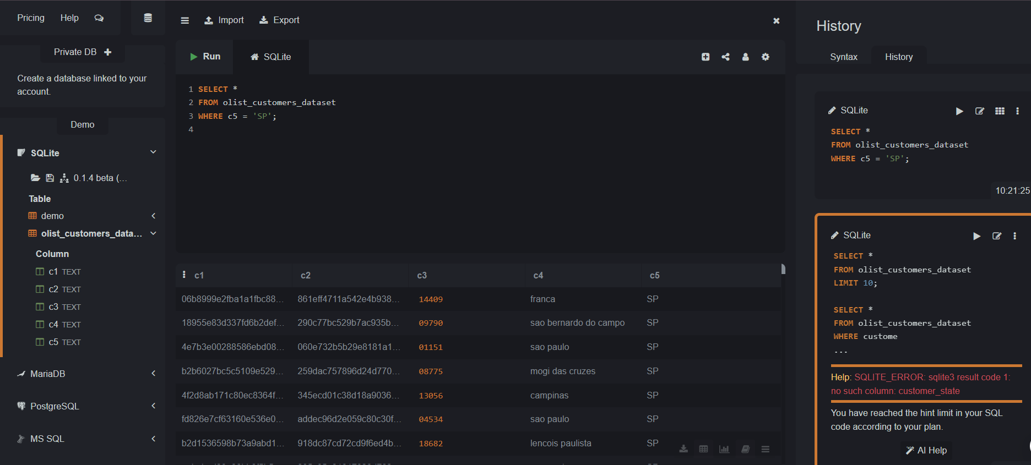

SELECT c5 AS customer_state, COUNT(*) AS total_customers

FROM olist_customers_dataset

GROUP BY c5

ORDER BY total_customers DESC;

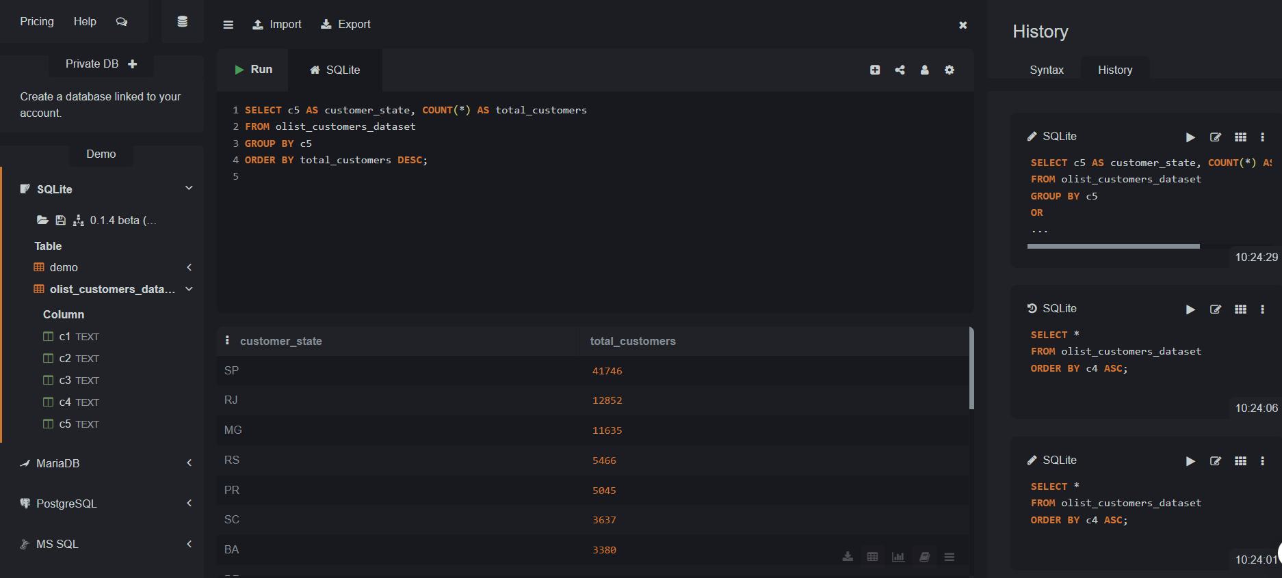

SELECT *

FROM olist_customers_dataset

ORDER BY c4 ASC;

