1. display all suppliers who statys in state either in california or Texas or Arkansas.

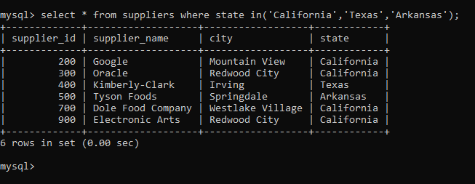

2. find all suppliers with supplierid >=200 and <=700

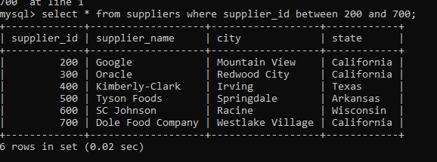

3. find all suppliers with supplierid not >=200 and not <=700

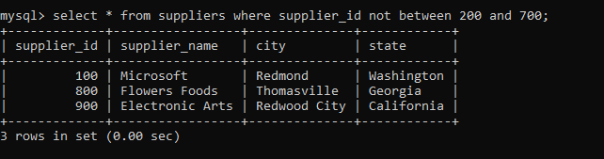

4.list all suppliers who does not stay in Springdale

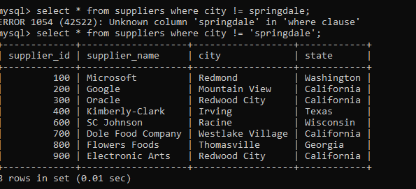

==============================================

5.find orderid and customerid for orders place on date 18-feb-16

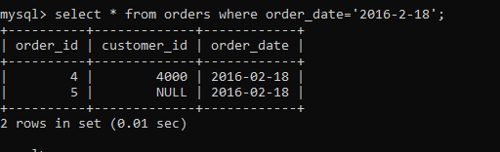

6.find orderid and customerid for orders place on feb 2016

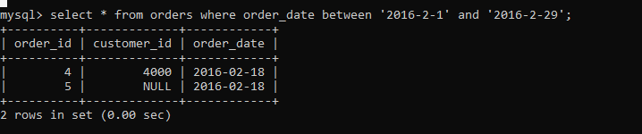

7.find all customers with name 'Reynolds', or Anderson

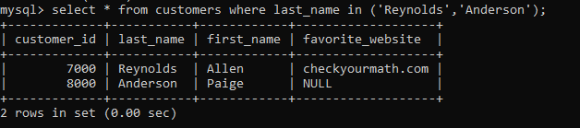

**8. find all customers for whome favorite_website is not given**

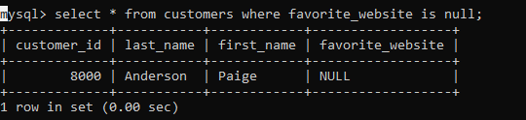

**9. find all customers for whome favorite_website is given**

