Different kinds of Charts and Graphs

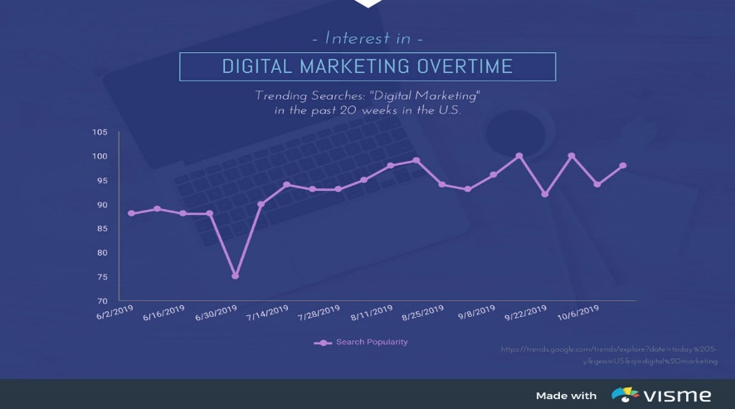

**Line graph,** are powerful visual tools that illustrate trends in data over a period of time or a particular correlation. Multiple trends can be compared by plotting lines of various colors.

**Bar graph,**the simplest and and most straightforward way to compare various categories.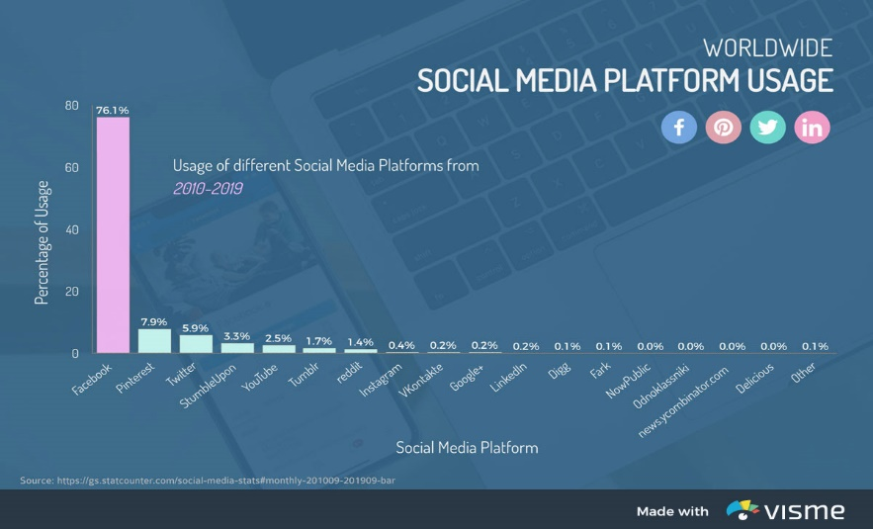

**Pie charts**,are the simplest and most efficient visual tool for comparing parts of a whole. For example, a pie chart can quickly and effectively compare various budget allocations, population segments or market-research question responses.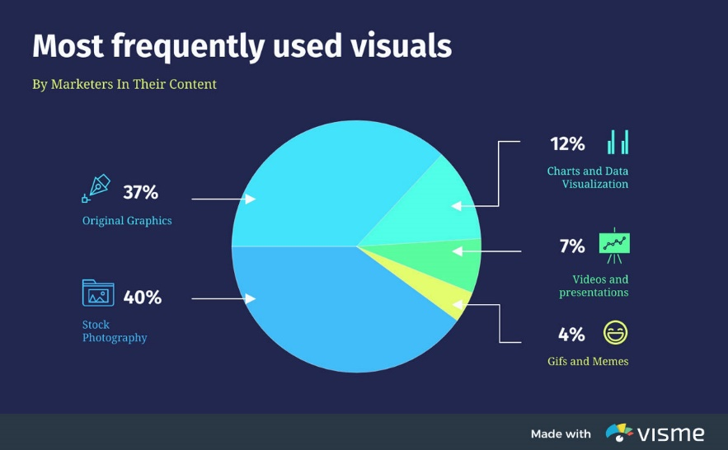

**Mekko Charts,**to compare multiple variables or multiple categories at the same time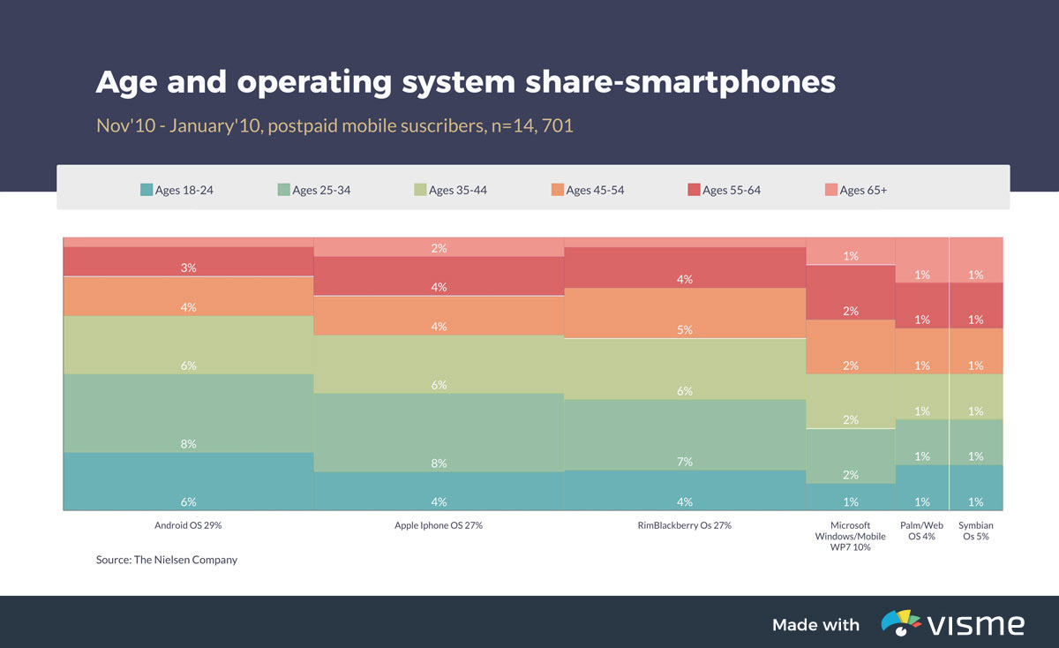

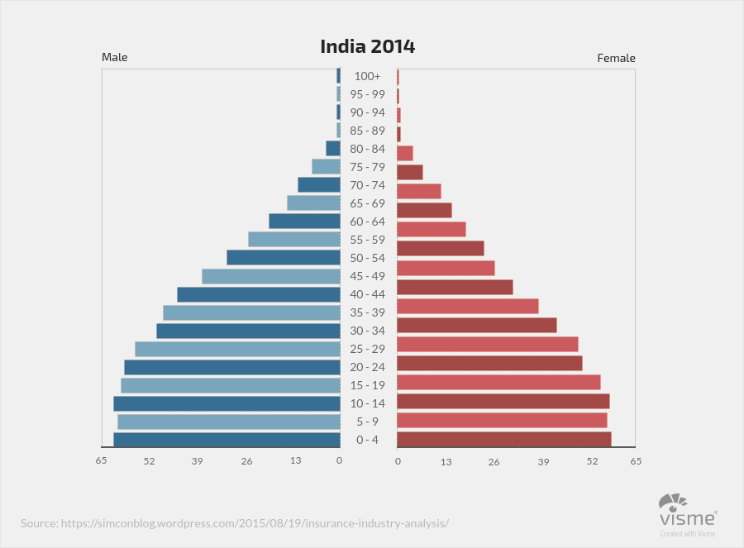

Pyramid chart, a population pyramid is a type of pyramid graph that shows the distribution of age groups for a particular country, area, or group. The graphs tends to be shaped like a pyramid because, everyone is born at age 0.The top of the pyramid usually around 90 to 100 years old contains a tiny fraction of the population.

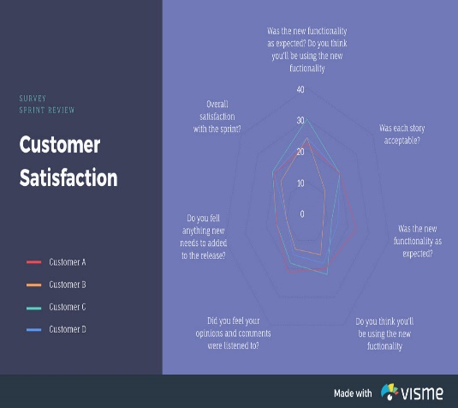

Spider chart, it isvisually compare three or more quantitative variables, he or she might choose to use a [radar chart](https://visme.co/blog/types-of-charts/), also known as a spider or star chart. The chart usually consists of a series of radii, each representing a different category, that splay out from a center point like spokes.

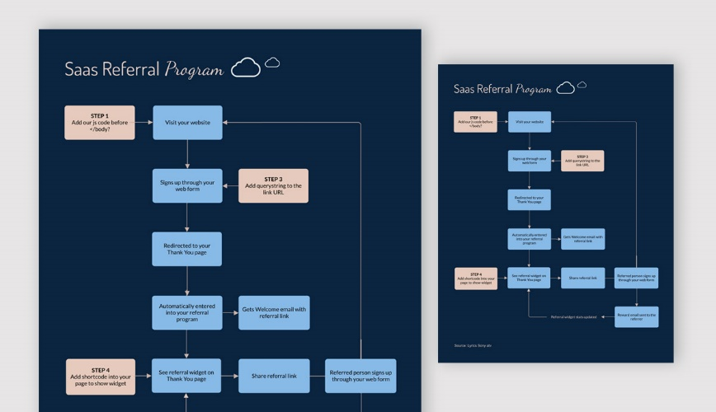**Flow chart**,allows a process to be sequenced step-by-step, from beginning to end, for the purpose of analyzing, designing, documenting or managing it.These flow charts can even feature multiple beginnings and ends, with countless pathways and journeys in between.

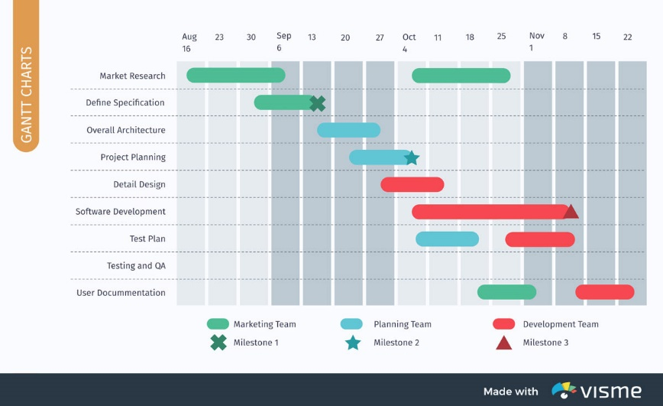

**Gantt charts,**are special types of bar graphs used to diagram projects and schedules. The use of colored bars of varying lengths reflect not only a project’s start and end dates, but also important events, tasks, milestones and their timeframes.

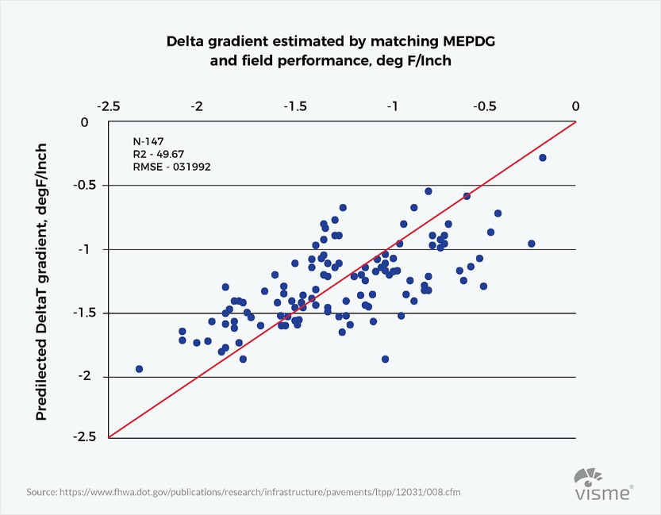

**A scatter plot** or scattergram chart will show the relationship between two different variables or it can reveal the distribution trends. It should be used when there are many different data points, and you want to highlight similarities in the data set. This is useful when looking for outliers or for understanding the distribution of your data.

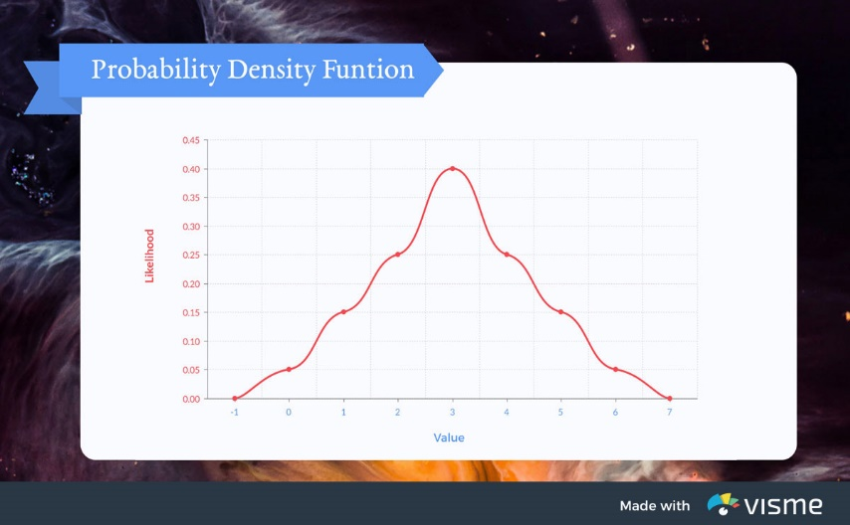

**Probability Density Function,**need to determine the value of an equation by graphing its result. The graph of a function is the set of all points whose coordinates satisfy the equation

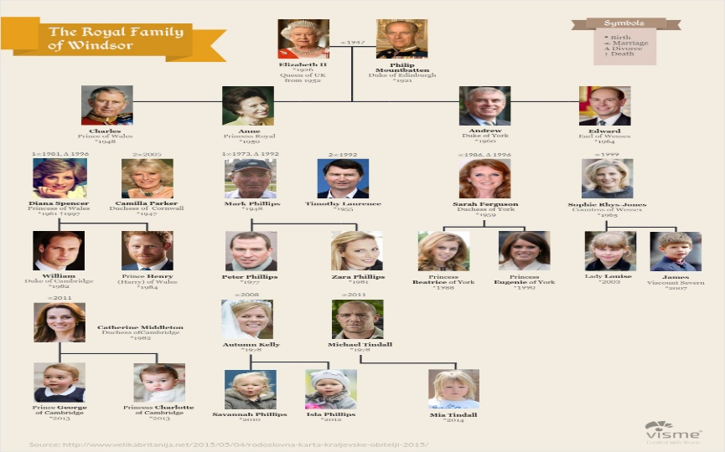**Tree Chart,**a form of hierarchical diagram, a genealogical tree illustrates the structure of a family. It can either begin with an ancestor, then diagram his or her descendants, their siblings, marriages and children, and so on.

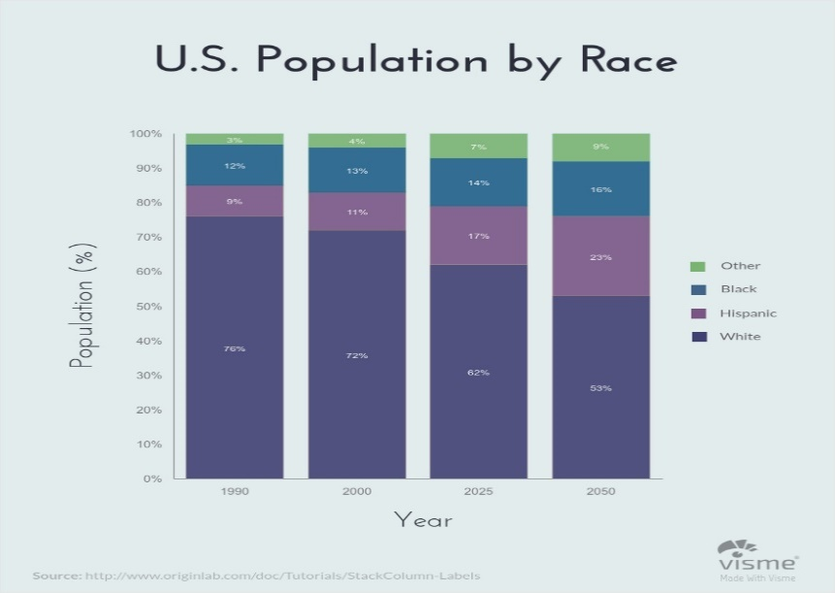

**Stacked bar graph**,combines elements of the traditional bar graph and the pie graph to communicate totals, trends and proportions in a single illustration.

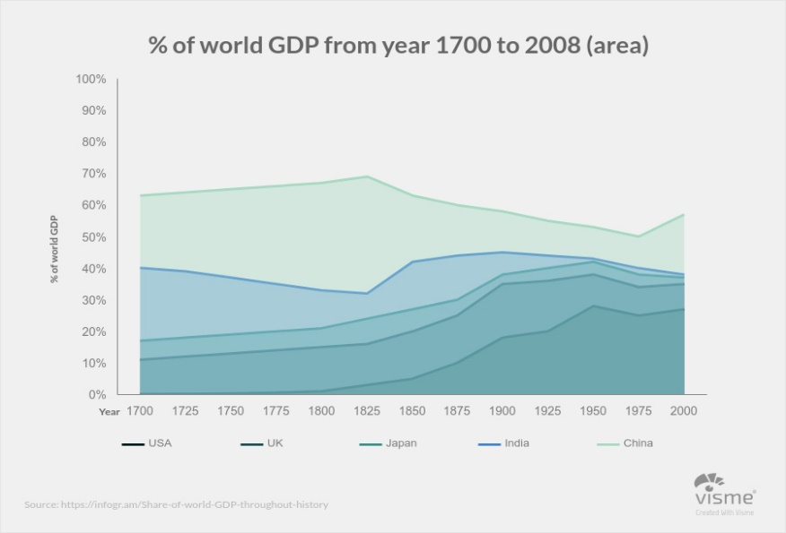**Stacked area charts**, are ideal for comparing values that would normally require multiple line graphs. Each line represents a different category, and the area below each line is generally shaded a designated color so each data set can be easily compared.

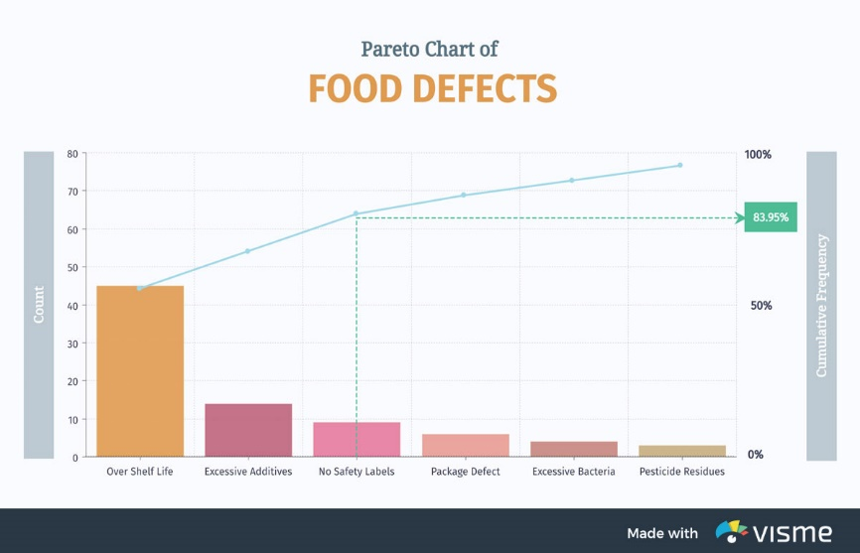**Pareto Chart,**Sometimes a basic graph doesn’t display enough information to draw the necessary conclusion. A Pareto chart combines a bar graph with a line graph to illustrate not only categories’ individual values, but also the cumulative total of the entire set.

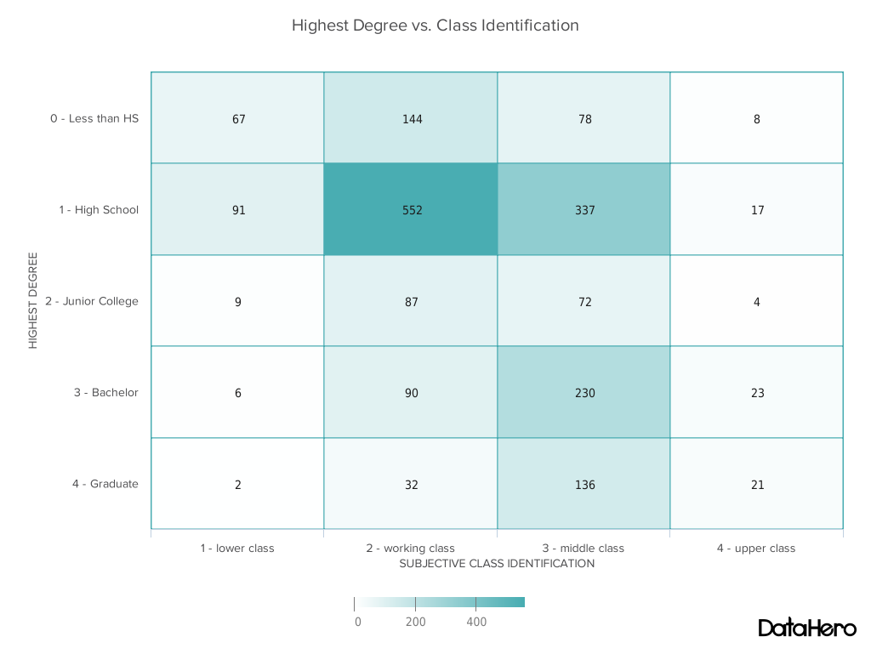

**Heat map**,shows the relationship between two items and provides rating information, such as high to low or poor to excellent. The rating information is displayed using varying colors or saturation.