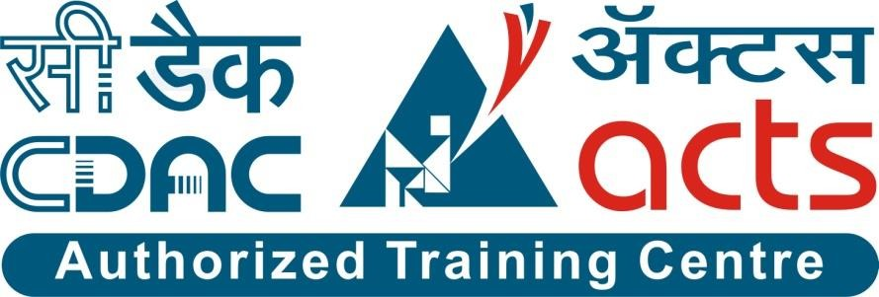

Project Name: NEST FIND Branch DAC march 2024s

Documentation On

**“VEHICLE SERVICE MANAGEMENT SYSTEM”**

DAC MARCH 2024

**Guided By: SNEHAL SOMVANSHI**

Submitted By :

**Group No: 09**

* **Jaykumar Rathod 220943020044**
* **Prachi More 220943020069**
* **Shubham Ramshe 220943020097**
* **Pratiksha Kale 220943020076**

**Table of Contents**

## Introduction 5

* 1. Document Purpose **5**
  2. Project Background **5**
  3. Aim & Objectives **5**

## Business Requirements Overview 6

1. **Functional Requirements 6**
   1. Renter Module **6**
   2. Landlord Module **7**
   3. Admin Module **7**

## Non-Functional Requirement 7

1. **Use Case Diagram 8**
   1. Renter **8**
   2. Landlord **9**
   3. Admin **10**
2. **Project Architecture Diagram 11**

## Database Design 12

* 1. Renter **12**
  2. Landlord **12**
  3. Vehicle **13**
  4. Login **13**
  5. Package Details **13**
  6. Transactions **14**
  7. Invoice **14**
  8. Security Questions **14**
  9. Service Requests **15**
  10. Service Progress **15**
  11. Area **15**
  12. Roles **16**
  13. Packages **16**
  14. Facilities **16**
  15. City **16**
  16. Brands **16**
  17. Ratings **17**

1. **E-R Diagram 18**

## Snapshots 19

## Conclusion and Future scope 29

**List of Figures**

## Use Case Diagrams 17

Fig 1 Project Architecture …………………………………………………………………..

Fig 2 Customer 8

Fig 3 Service Center 9

Fig 4 Admin 10

Fig 5 ER Diagram 14

# Introduction:

## Document Purpose:

This document communicates the business requirements and scope

for developing find.

The scope of this document is to define the functional and non functional

requirements, business rules and other constraints requirements.

## Project Background:

1. A House rental is a house that can be used temporarily for a period of time with a fee. Renting a house assists people to live in a comfortable house when they do not have access to build their own personal homes/houses or. The individual who want to rent a house/room/apartment/home/flat must first contact the House rental company for the desire House/Home/apartment. This can be done online. At this point, this person has to supply some information such as; dates of rental, and type of house. After these details are worked out .Most companies throughout the industry make a profit based of the type of house that are rented.The rental houses are categorized into modern Homes, Colonial, apartment, Rentals etc. And customers are free to choose any house of their choice based on their purse and availability of such houses at the time of booking

## Aim & Objectives:

•Eco-friendly: The monitoring of the Housing activity and the overall business becomes easy and includes the least of paper work.

•The software acts as an office that is open 24/7.

•It increases the efficiency of the management at offering quality services to the customers.

• It provides custom features development and support with the software.

# Business Requirements Overview:

The advancement in Information Technology and internet penetration has greatly enhancedvarious business processes and communication between companies (services provider) and their customers of which Real Estate/House Rentals industry is not left out. This House Rental System is developed to provide the following services:•Enhance Business Processes: To be able to use internet technology to project the rental company to the global world instead of limiting their services to their local domain alone,thus increase their return on investment.

•Online House/Room Booking: A tools through which customers can book availableRooms/House/Apartment online prior to their date of using the house instead of walkingaround and asking for a vacant house.

•Customer’s registration: A registration portal to hold customer’s details, monitor their transaction and used same to offer better and improve services to them and user accountwhere he/she can view her/his details instead of the poor existing systems where only theadministrators control their customer details.

•Rentals Notice and Blog: A tool where customers can see and view the details of nearbyavailable House for rent/sale, and also view the current economic design of houses/apartments

# Functional Requirements Overview:

1. Renter Module
2. Landlord Module
3. Admin Module

# Renter Module

Renter can register.

Renter can login to the system.

Renter can see properties,

Renter can search properties based on his preferences

Renter can book property.

Renter can view booked property.

# Landlord Module

* Landlord can registration.
* Landlord can login to the system.
* Landlord can upload information about their facilities.
* Landlord can upload information about different properties offered.
* Landlord can update the preperty availablibity.

# Admin Module

* + - Administrator will approve the registration request of service centers.
    - Create/update the list of standard tasks.
    - Could generate a report about completed servicing tasks.

# Non-Functional Requirement:

* The website should use professional design, look and feel and color scheme.
* Users will have no limitations for accessing the application through the Internet. The portal being an internet application, it is difficult to specify an exact number of visitors or users. Hence, we will target the system to support sufficient users on the launch of phase 1.
* Being a public website, the site must follow general usability guidelines for menus, navigation, colors, links and other actions provided on the screens.
* The system should be designed in such a manner that the user will be able to complete tasks in a minimum number of steps.

# Use-Case Diagram

## Customer:

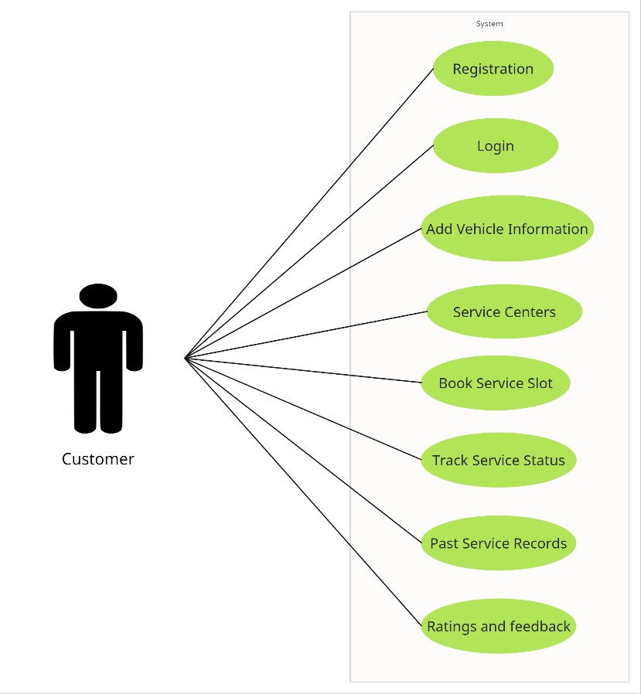

Fig. Use-Case Diagram for Customer

## Service Center:

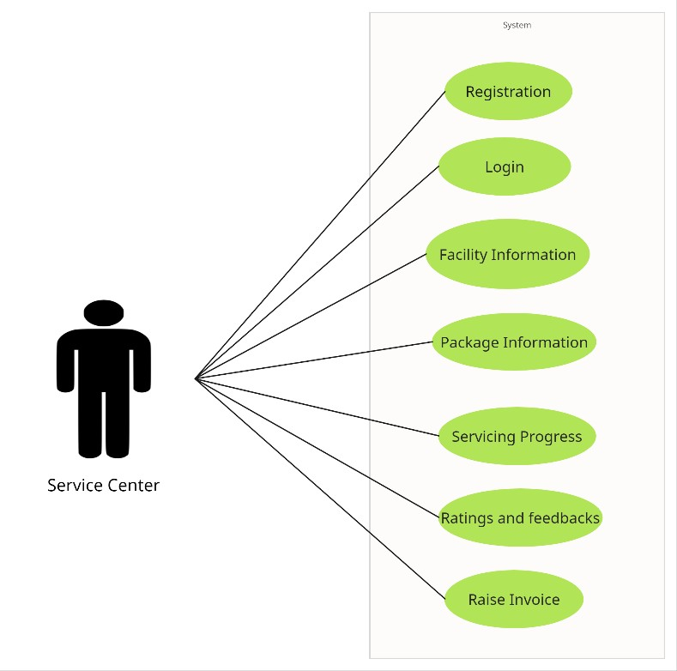

Fig. Use-Case Diagram for Service Center

* 1. **: Admin :**

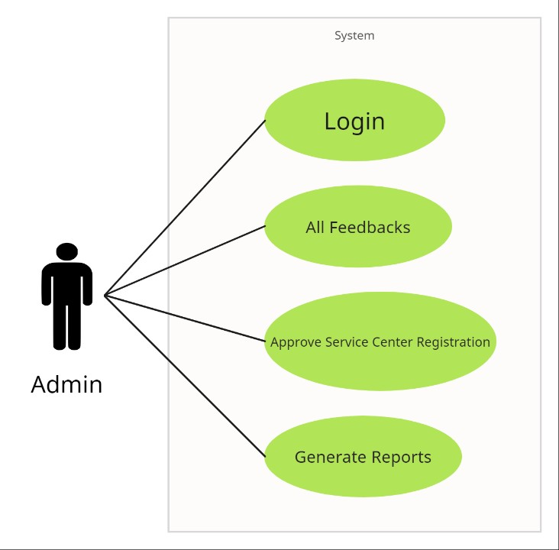

Fig. Use-Case Diagram for Admin

# Project Architecture Diagram:

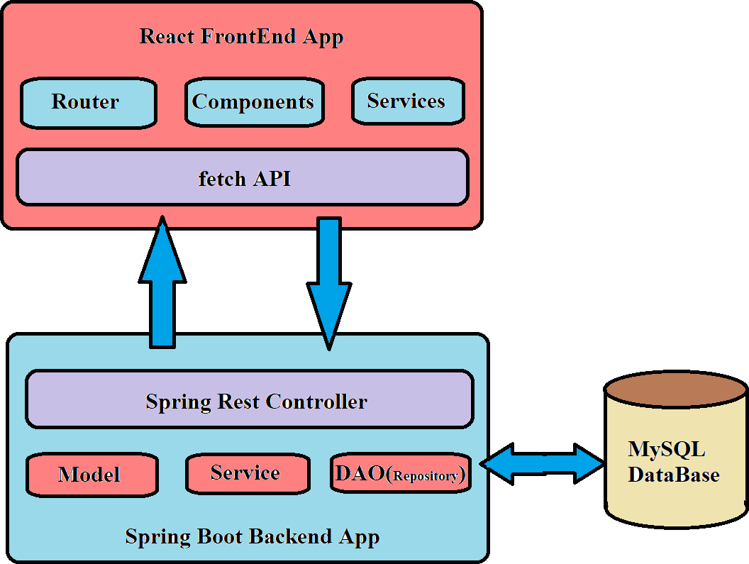

Fig. Project Architecture Diagram

# Database Design:

## User table:

|  |  |  |  |  |  |
| --- | --- | --- | --- | --- | --- |
| **Field** | **Type** | **Null** | **Key** | **Default** | **Description** |
| User_id | Integer |  | Primary  Key | Null | Unique customer ID |
| firstname | Varchar(255) |  |  | Null | First name of customer |
| lastname | Varchar(255) |  |  | Null | Last name of customer |
| Role_id | int |  | mul | Null | Roll of custemer |
| Adhar_no | Varchar(45) |  | uni | Null | Contact number of customer |
| Email_id | Varchar(45) |  | uni | Null | email id of customer |
| Pan_no | Varchar(45) |  |  | Null | Pan no of custemer |
| mobile | Varchar(45) |  |  | Null | Mobile no of customer |
| User_name | Varchar(45) |  |  | Null | User name of customer |
| password | Varchar(45) |  |  | Null | Password of custemer |

1. **Booking table:**

|  |  |  |  |  |  |
| --- | --- | --- | --- | --- | --- |
| **Field** | **Type** | **Null** | **Key** | **Default** | **Description** |
| Booking_id | Int |  | Primary key | Null | Unique ID of booking |
| Property_id | Int |  | MUL | Null |  |
| B_date | date |  |  | Null | Booking date |
| Start_date | date |  |  | Null | Start of rent agreement |
| End_date | date |  |  | Null | End of rent agreement |
| Rent_price | double |  |  | Null | Rent price |
| Deposit | double |  |  | Null | Deposit of house |
| Pay_id | Integer |  |  | Null | Unique ID |
| User_id | Integer |  |  | Null | User ID |

## Amenities table:

|  |  |  |  |  |  |
| --- | --- | --- | --- | --- | --- |
| **Field** | **Type** | **Null** | **Key** | **Default** | **Description** |
| Amenities_id | Integer |  | Primary key | Null |  |
| Amenities_name | Varchar(225) |  | UNI | Null |  |

1. **Area table:**

|  |  |  |  |  |  |
| --- | --- | --- | --- | --- | --- |
| **Field** | **Type** | **Null** | **Key** | **Default** | **Description** |
| Area_id | Integer |  | Primary key | Null |  |
| Area_name | Varchar(100) |  |  | Null |  |
| Pin_code | Varchar(10) |  | UNI | Null |  |
| City_id | Varchar(10) |  |  |  |  |

## City table

|  |  |  |  |  |  |
| --- | --- | --- | --- | --- | --- |
| **Field** | **Type** | **Null** | **Key** | **Default** | **Description** |
| City_id | Integer |  | Primary key | Null | Unique ID about package details |
| State_id | Integer |  | MUL | Null | Name of the package |
| City_name | Varchar(255) |  |  | Null | Price of the package |

1. **Location table:**

|  |  |  |  |  |  |
| --- | --- | --- | --- | --- | --- |
| **Field** | **Type** | **Null** | **Key** | **Default** | **Description** |
| Location_id | Integer |  | Primary key | Null | Unique ID of location |
| Property_id | Int |  | UNI | Null | Unique ID of property |
| Area_id | Int |  | MUL | Null | Unique ID of Area |
| Address | Varchar(255) |  | UNI | Null | Unique ID of Address |
| Property_id | Integer |  |  | Null | Unique ID of Property |

## Payment table:

|  |  |  |  |  |  |
| --- | --- | --- | --- | --- | --- |
| **Field** | **Type** | **Null** | **Key** | **Default** | **Description** |
| Pay_id | Integer |  | Primary key | Null | Unique pay ID generated |
| Pay_mode | Varchar(255) |  |  | Null |  |
| Pay_date | date |  |  | Null |  |
| Amount | double |  |  | Null |  |

1. **Photos table:**

|  |  |  |  |  |  |
| --- | --- | --- | --- | --- | --- |
| **Field** | **Type** | **Null** | **Key** | **Default** | **Description** |
| Photo_id | Integer | NO | Primary key | Null | Auto_increment |
| Property_id | Integer | NO | Mul | Null |  |
| Images | Longblob | Yes |  | Null |  |

## Property aminities table:

|  |  |  |  |  |  |
| --- | --- | --- | --- | --- | --- |
| **Field** | **Type** | **Null** | **Key** | **Default** | **Description** |
| Property_ameninties_id | Integer |  | Primary key | Null | Auto_increment |
| Property_id | Integer |  | Mul | Null |  |
| User_id | Integer |  | Mul | Null |  |

1. **Role table:**

|  |  |  |  |  |  |
| --- | --- | --- | --- | --- | --- |
| **Field** | **Type** | **Null** | **Key** | **Default** | **Description** |
| Role_id | Integer |  | Primary key | Null | Auto_increment |
| Role_name | Varchar(50) |  |  | Null |  |

## State table:

|  |  |  |  |  |  |
| --- | --- | --- | --- | --- | --- |
| **Field** | **Type** | **Null** | **Key** | **Default** | **Description** |
| State_id | Integer |  | Primary key | Null | Auto_increment |
| State_name | Varchar(255) |  |  | Null |  |

# ER-Diagram:

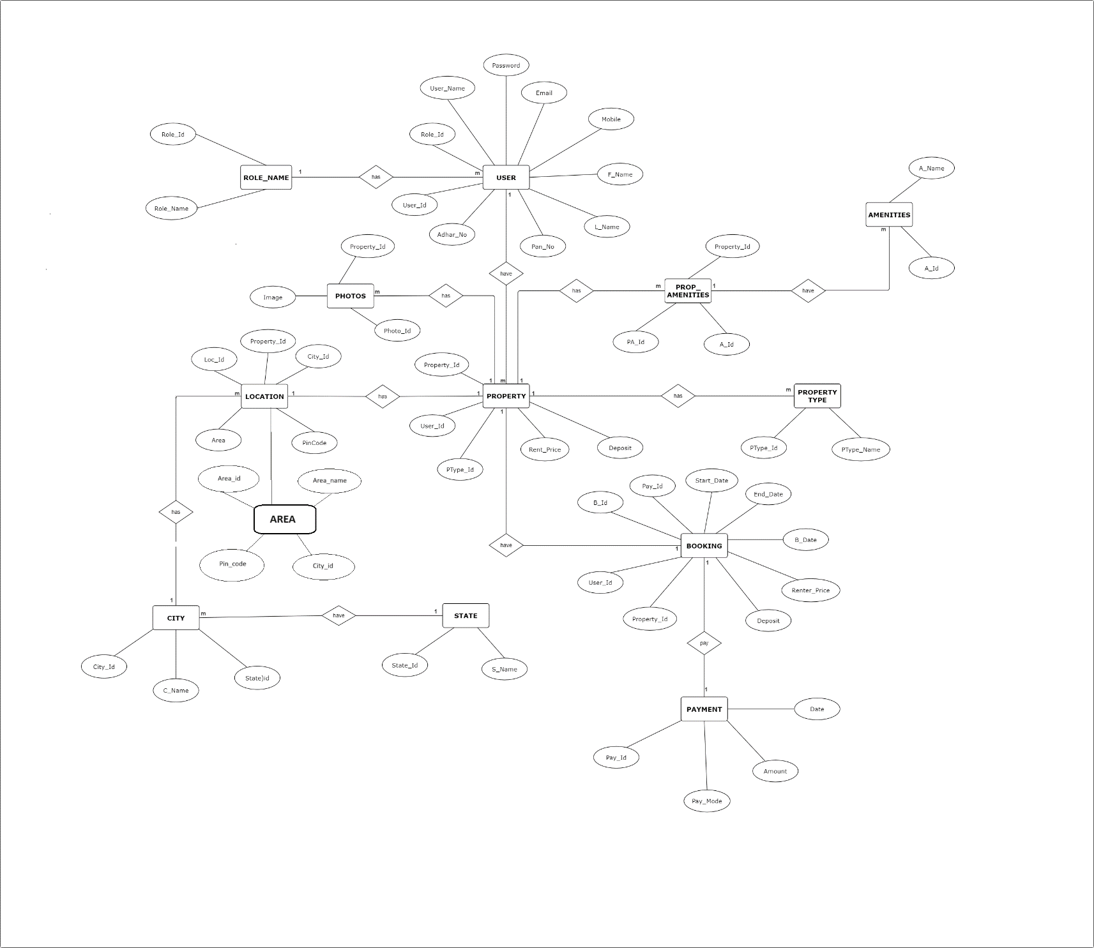

Fig. E-R diagram shows database of Nest find

# Snapshots:

* 1. **Home Page:**

Following snapshot shows the Home page for Nestfind

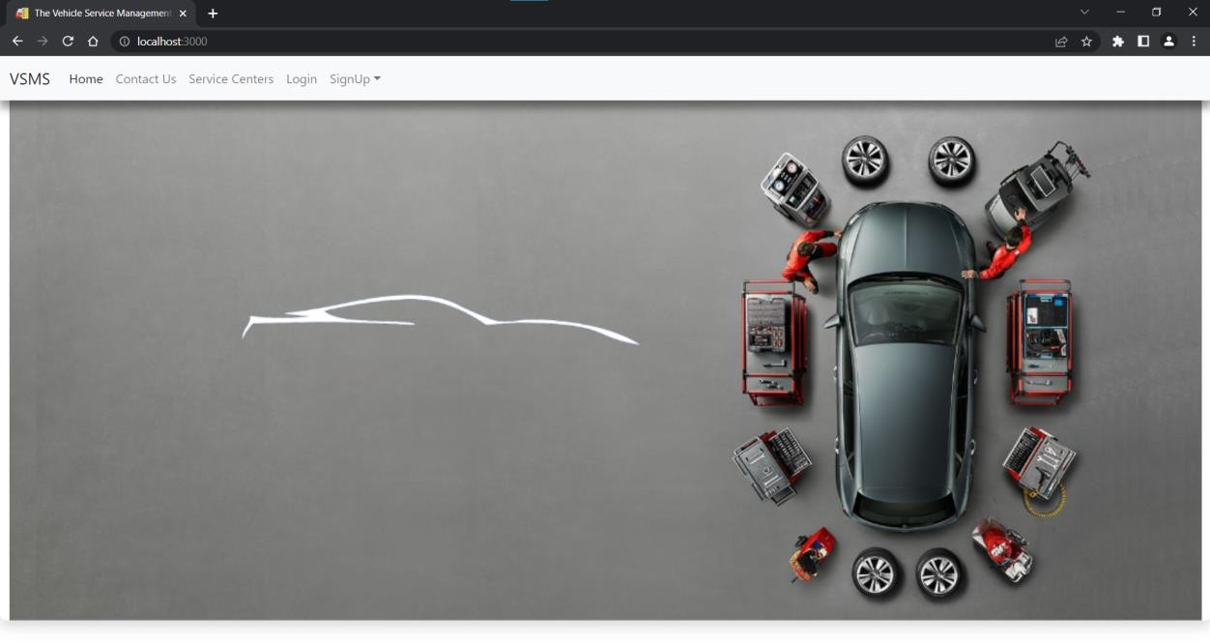

This page contains following controls

* + - Home
    - Contact Us
    - Service Centers
    - Login
    - Sign Up
      * User

# Service Centers Page:

Following snapshot shows the Service Center page for Vehicle Service Management System

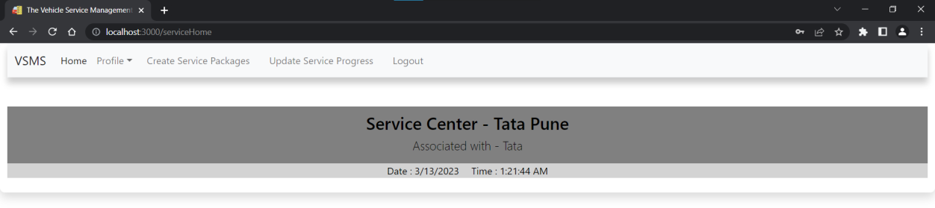

# Login Page:

Following snapshot shows the Login page for Nestfind.

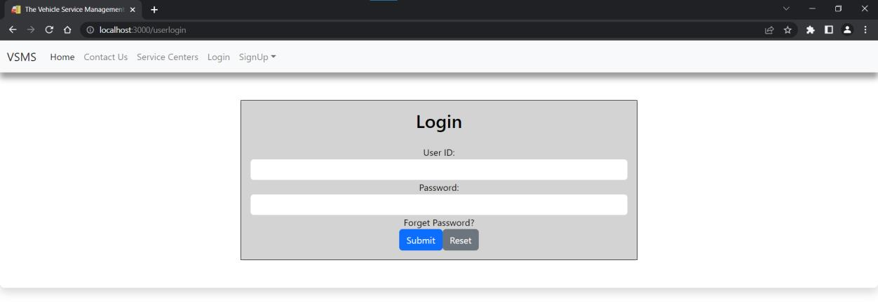

# Sign Up Page:

Following snapshot shows the Sign Up page for Nestfind.

* + - Renter Registration Page:

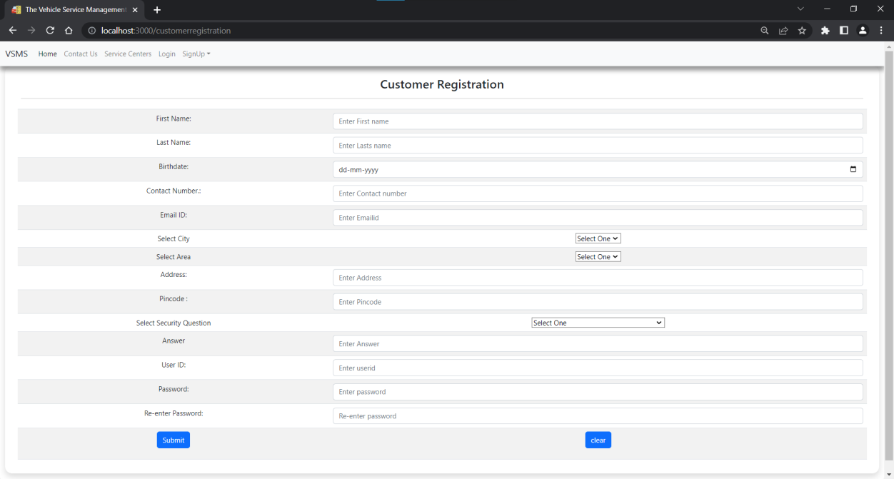

* + - Landlord Registration page:

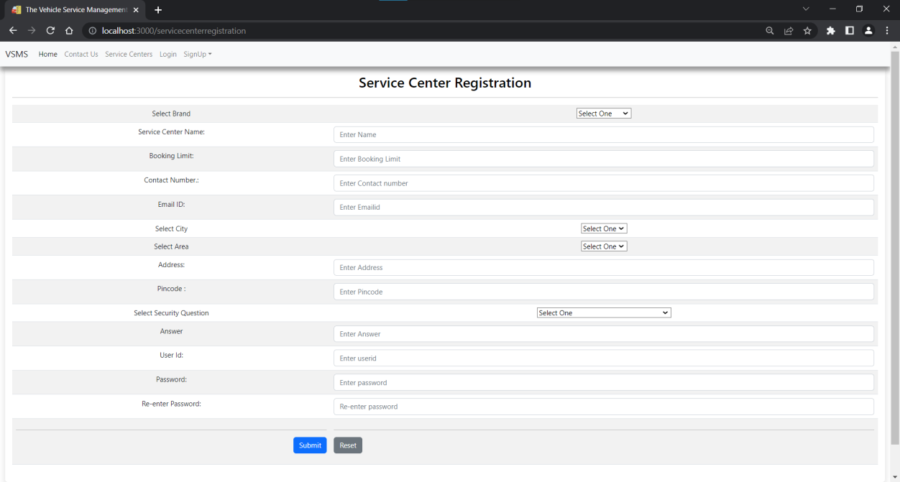

# User login Page:

Following snapshot shows the User Login page for Nestfind

This page contains following controls

* + - Profile
      * Update profile
      * Change password

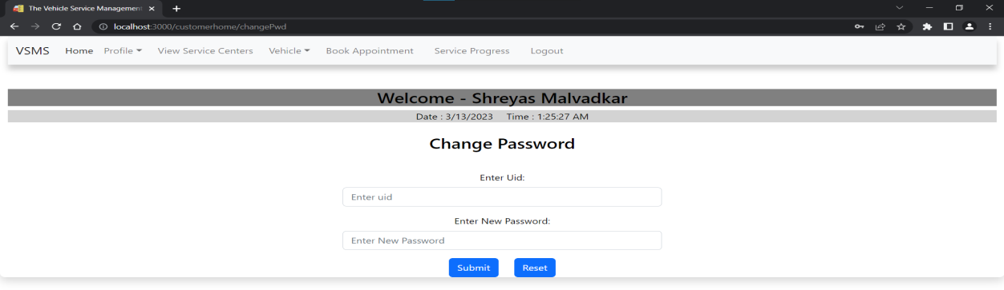

* + - View Service Centers

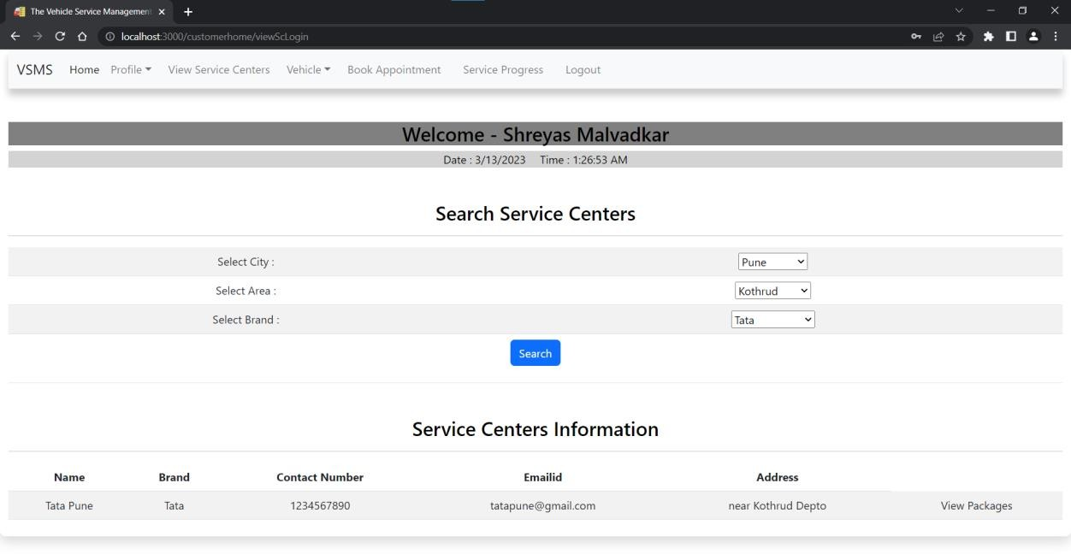

* + - Vehicle registration

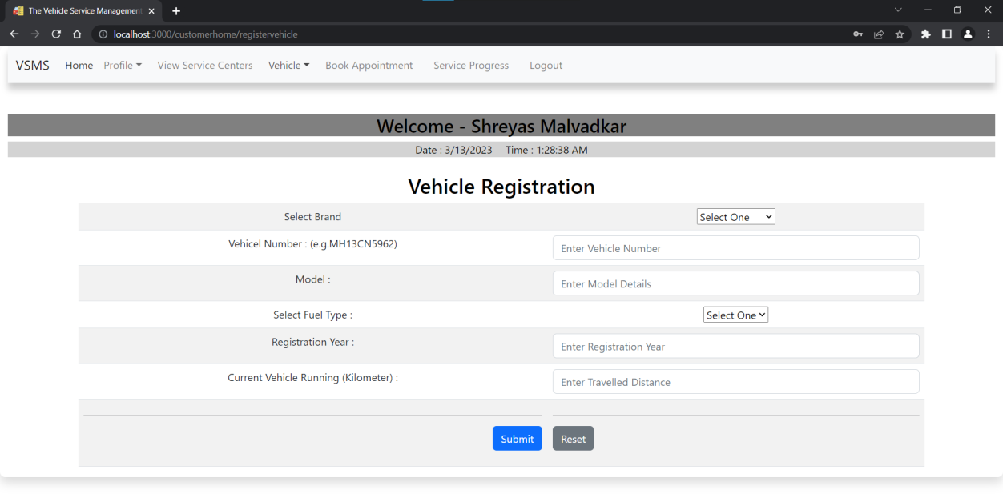

* + - Vehicle information

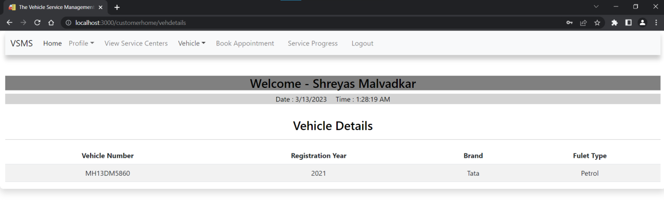

* + - Packages information

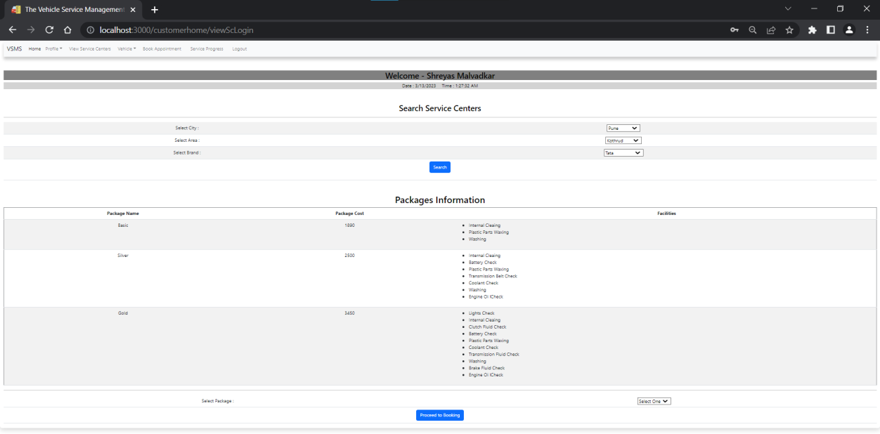

* + - Book Appointment

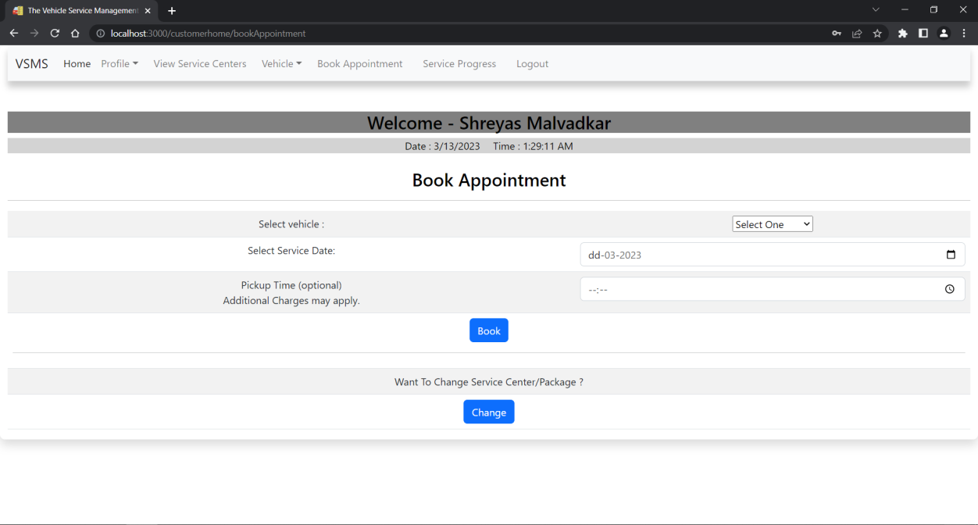

* + - Service Progress

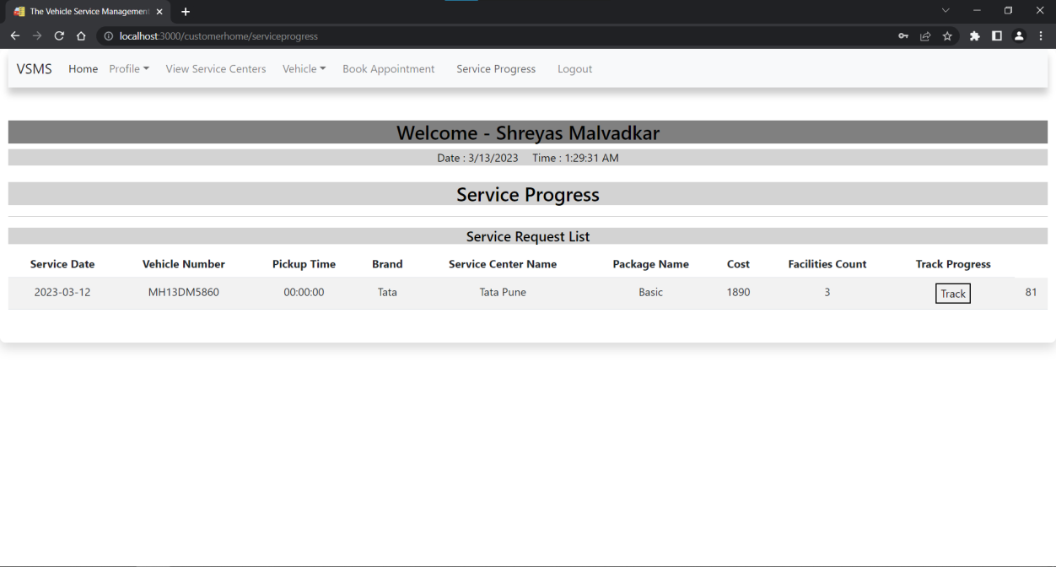

# Service Center Login Page:

Following snapshot shows the Service Center Login page for Vehicle Service Management System

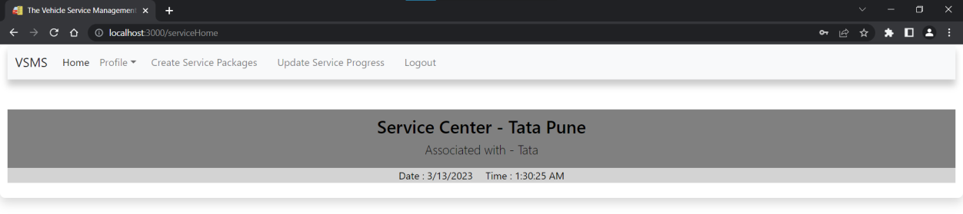

This page contains following controls

* + - Profile
      * Update profile
      * Change password

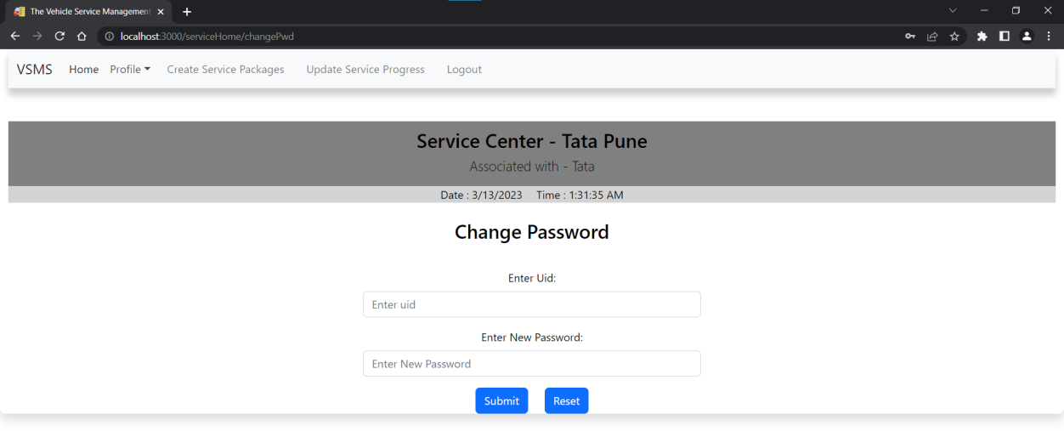

* + - View bookings

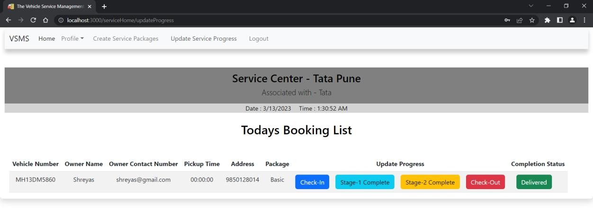

* + - Update service progress

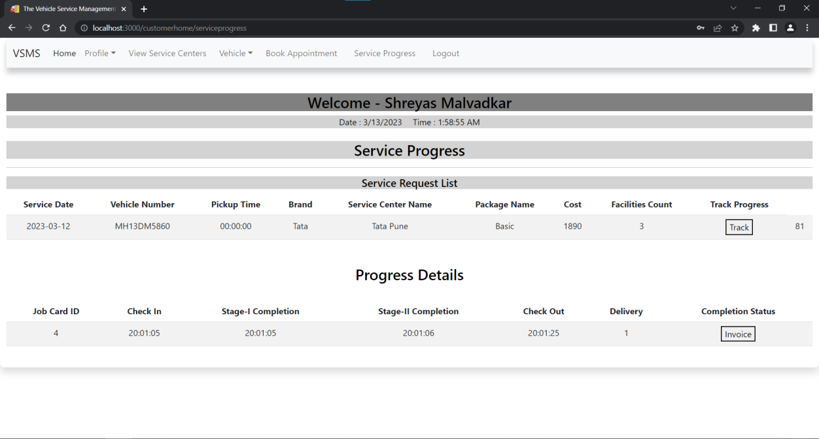

* + - Transaction details

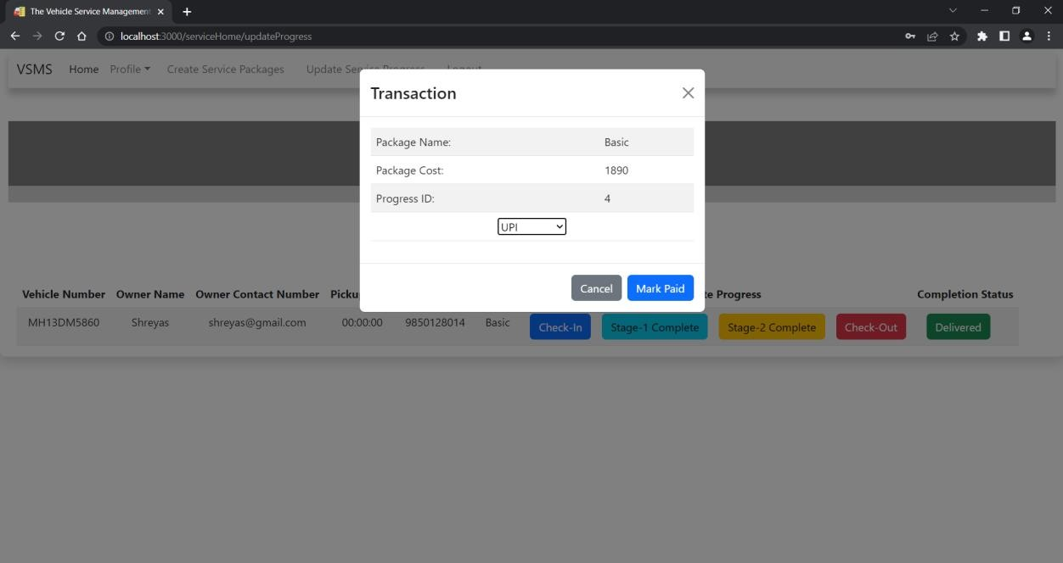

* + - Invoice details

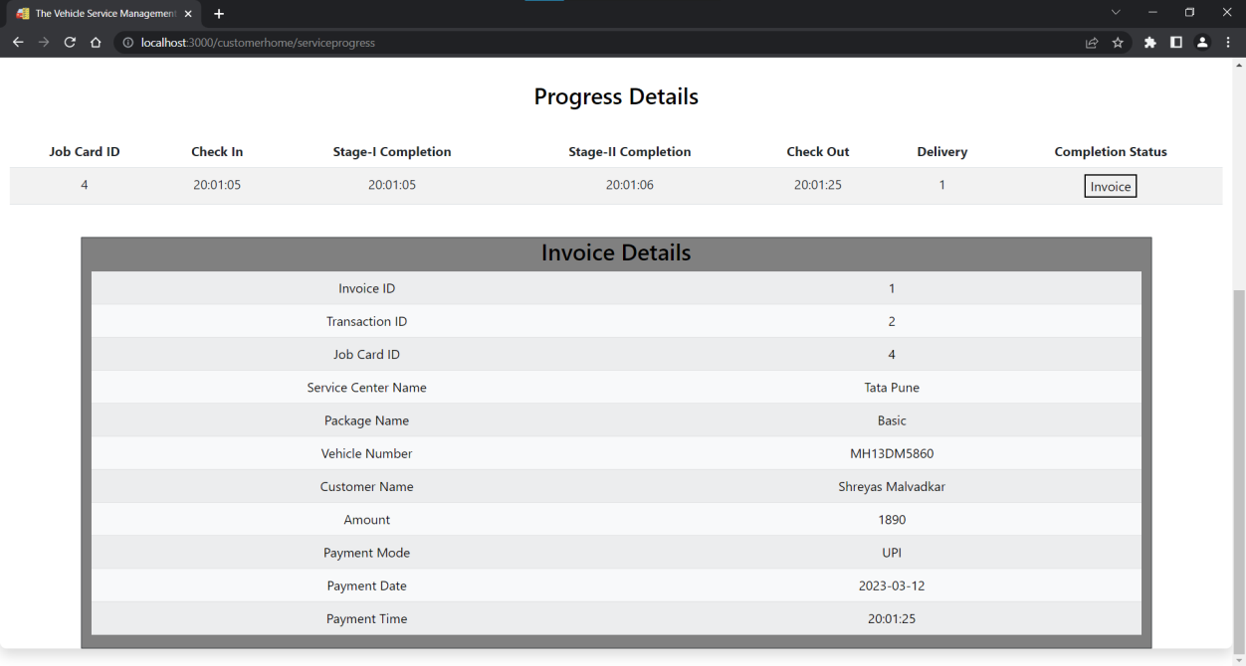

# CONCLUSION AND FUTURE SCOPE

Vehicle Service Management System provides better service platform to get customers and service centers connected.

Our system provides a very user-friendly platform where customer can easily register vehicle, login, search packages, book appointments, also service center will provide current status of the service progress.

Our system is aimed to do efficient management of various tasks like update profile, change password, create service packages, view bookings, update service progress, generate invoice and generate deliver message after service completion.

It digitally manages the service provision on a single platform.

Few things which we have kept aside for right now as our platform is new in the market but in future we desire to add are to establish this service provision across pan India, to create flexible packages as per customer’s requirement and to notify customer about vehicle’s service progress, service completion via SMS or email.