

**A Project Report On**

**Covid-19 Vaccination Analysis using Python**

**By**

**Pratiksha.N.Kokare**

**BE(Computer Science)**

**Batch : 2021 – 5127**

**Center: Pune**

**Under the Guidance of,**

**Mr. Mathivanan Balakrishnan**

**Technical Trainer**

**EduBridge**

(School of coding)

**Contents:**

* Software Requirements
* Introduction
* Data Analysis And Visualization

1. Bar Plot
2. Horizontal Bar Plot
3. Line Plot
4. Scatter Plot
5. Pie chart
6. Multiseries Bar Chart with Pandas
7. Stacked Bar Chart
8. Multiseries Bar Chart with Numpy
9. Line Chart
10. Histogram

* Conclusion

**Software Requirments:**

* Software : Anaconda Navigator , Jupyter
* Operating System : Windows 10 , 64-bit
* Browser : Best Result on Google Chrome
* DataBase : CSV file Dataset

**Introduction:-**

The Covid-19 pandemic is the most crucial health disaster that has surrounded the world for the past year. Predicting the COVID-19 vaccination trend has become a challenging issue. Many health professionals, statisticians, researchers, and programmers have been tracking the spread of the virus in different regions of the world using various approaches. The rise in various vaccines developed by talented scientists spurred curiosity about learning more about ongoing vaccine programs and a keen interest in finding meaningful insights from data drove me to work on this particular endeavor.

The project aims to convey the analysis of different ongoing vaccination programs around the globe by using the inferences discovered from the scraped data from the internet. The python libraries used in the exploratory data analysis include NumPy, Pandas, Matplotlib, Seaborn, and .The objectives for the following project include:

**Data Preparation & Cleaning**

We read the data file and aggregate the data on a few fields (Date, State , Total Registered Cases ,Total Vaccinated, Total Doses Administered — that is the vaccination scheme used in a certain S). Data Cleaning is the most crucial step towards a successful data analysis project. In most of the cases, the dataset has few “NaN”(not a number) values, some empty rows(having value 0) as well as redundant columns which could be removed using and configuring drop function and changing NaN values to 0 or removing the entire row as per need.

**1.Bar Plot**

**A.In which State Maximum number of Cases Registered**

For plotting, we need a set of values from the data to be arranged in a particular manner. It can be achieved by using methods like groupby(), max(), sort_values(), etc. Also, we will compare the first 10 countries for neat visualization. After arranging them we can plot them using seaborn built-in functions as shown below.

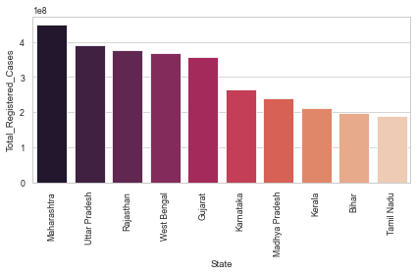

fig.Bar plot of Total Registered cases Vs top 10 State

**B.In which State Maximum number of vaccination conducted**

For plotting, we need a set of values from the data to be arranged in a particular manner. It can be achieved by using methods like groupby(), max(), sort_values(), etc. Also, we will compare the first 10 countries for neat visualization. After arranging them we can plot them using seaborn built-in functions as shown below.

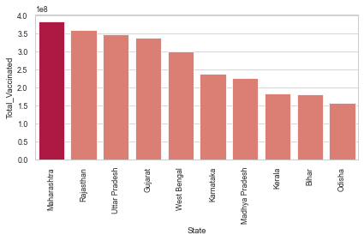

Fig. Bar plot of Total Registered cases Vs top 10 State

**2.Horizontal Bar plot**

**Horizontal Bar plot of covid-19 vaccination data**

For plotting, we need a set of values from the data to be arranged in a particular manner. After arranging them we can plot them using seaborn built-in functions as shown below.

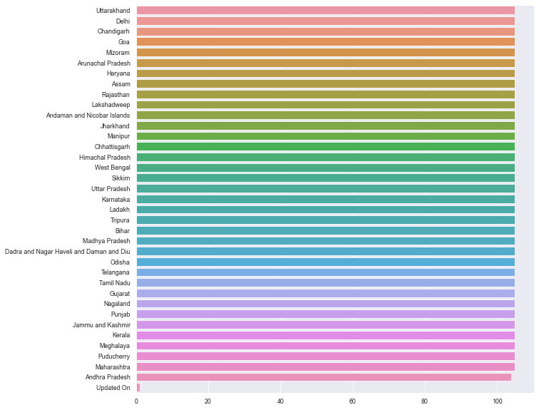

Fig. Horizontal Bar plot of State Vs Count

**3.Line Plot**

For plotting, we need a set of values from the data to be arranged in a particular manner. After arranging them we can plot them using Mathplot built-in functions as shown below.

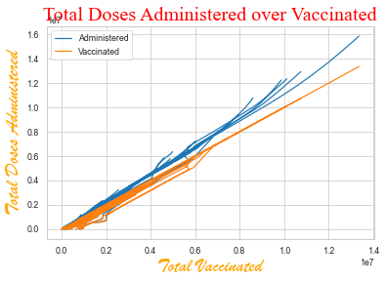

Fig. Line Chart of Total Vaccinated Vs Total doses Admistered

**4.Scatter plot**

For plotting, we need a set of values from the data to be arranged in a particular manner. It can be achieved by using methods like groupby(), max(), sort_values(), etc. Also, we will compare the first 10 countries for neat visualization. After arranging them we can plot them using seaborn built-in functions as shown below.

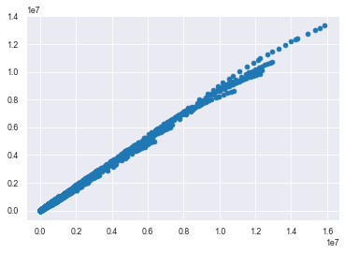

Fig. Scatter plot of Totale Registered Doces Vs Total vaccinated

**5.Pie Chart**

**In which region minimum number of vaccination conducted**

For plotting, we need a set of values from the data to be arranged in a particular manner. It can be achieved by using methods like groupby(), max(), sort_values(), etc. Also, we will compare the first 10 countries for neat visualization. After arranging them we can plot them using Mathplot library built-in functions as shown below.

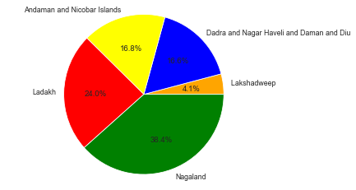

Fig.Pie chart of minimum number of vaccination conducted in which state

**6.Multiseries Bar Chart**

**1.Multiseries bar plot of Male,Female,Transgender of vaccination data**

For plotting, we need a set of values from the data to be arranged in a particular manner. It can be achieved by using methods like groupby(), max(), sort_values(), etc. Also, we will compare the first 10 countries for neat visualization. After arranging them we can plot them using Mathplot And pandas library built-in functions as shown below.

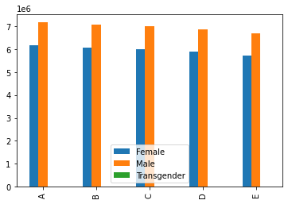

Fig.Multiseries bar plot of Male,Female,Transgender

### 

### 7. Stacked Bar Charts

**Stacked Bar Charts of Covaxin and CoviShield from vaccination data**

For plotting, we need a set of values from the data to be arranged in a particular manner. It can be achieved by using methods like groupby(), max(), sort_values(), etc. Also, we will compare the first 10 countries for neat visualization. After arranging them we can plot them using Mathplot And pandas library built-in functions as shown below.

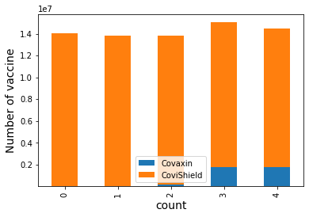

Fig.Stacked Bar Charts of Covaxin and CoviShield

### 8. Multiseries Bar Chart

### Multiseries Bar Chart of first and second vaccination dose

For plotting, we need a set of values from the data to be arranged in a particular manner. It can be achieved by using methods like groupby(), max(), sort_values(), etc. Also, we will compare the first 10 countries for neat visualization. After arranging them we can plot them using Mathplot And Numpy library built-in functions as shown below.

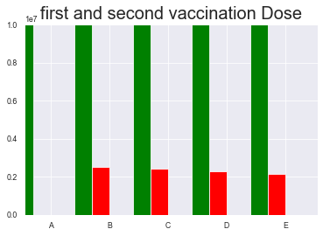

### Fig. Multiseries Bar Chart of first and second vaccination dose

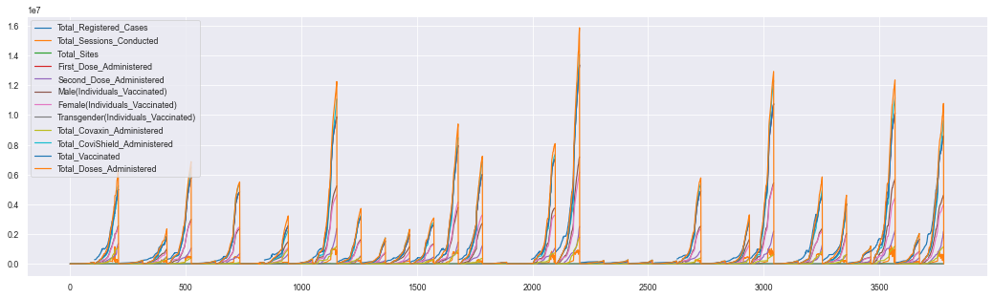**9.Line Plot**

Fig.Line plot of all the columns of the csv file

**10.Histogram:**

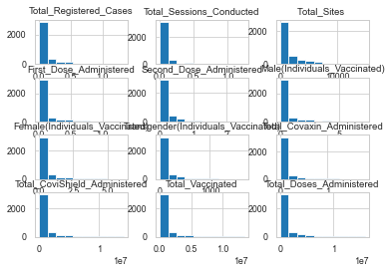

Fig. Histogram of all the columns

**Conclusion**

From the above Analysis ,it can be concluded that people from all parts of the India are educating themselves and willingly taking the vaccines under the governments’ free vaccination program. Also, these vaccines have been proved effective against COVID-19 (till now). If the rate of people taking the vaccine continues to grow then all the States can vaccinate their people before the end of this year.