1. Create a Custom VPC
- Go to VPC Dashboard in AWS Console.
- Click Create VPC → Choose VPC and more.
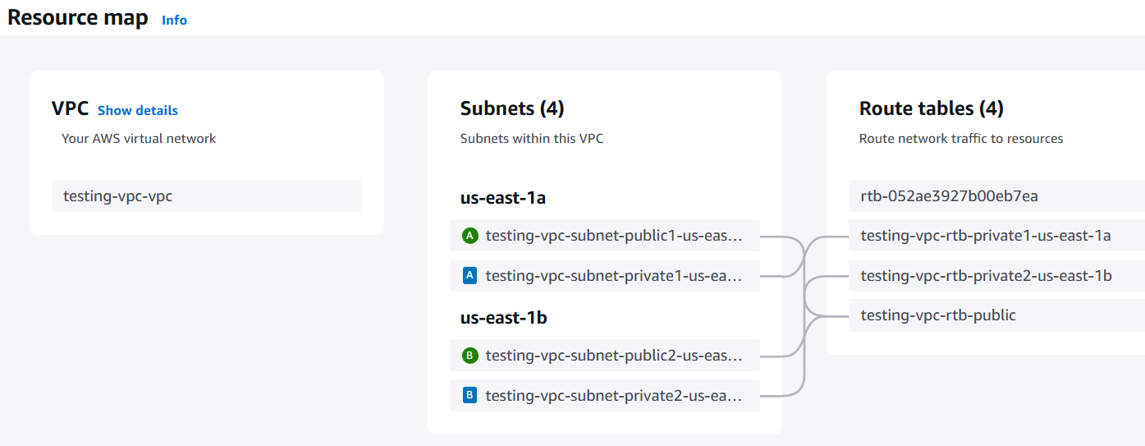
2. Launch EC2 Instance
- Go to EC2 → Launch Instance
- Name: testing-server
- AMI: amazon/Windows_Server-2022-English-Full-SQL_2019_Standard-2025.05.15
- Instance Type: c5.xlarge

- Network:
  - VPC: project-vpc
  - Subnet: Public Subnet
  - Auto-assign public IP: Enable
- Key Pair: Create/Select .pem file
- Security Group:
  - Allow RDP (3389) from your IP
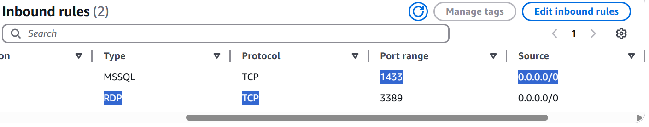
🟢 Connect using RDP from your local machine.
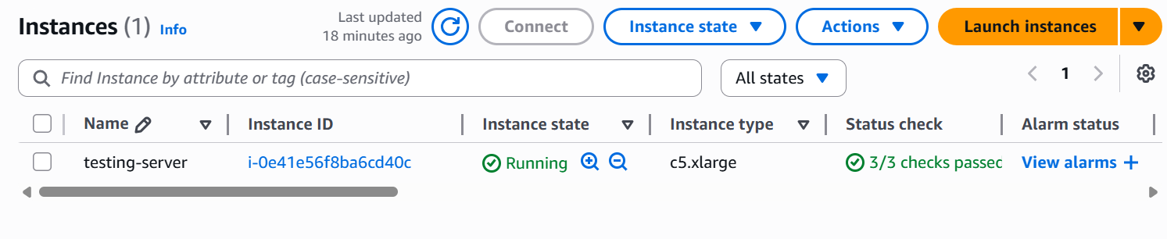
3. Connect EC2 to RDS via SSMS
- On EC2, download and install SQL Server Management Studio (SSMS)
- Connect using:
  - Server name: <RDS-endpoint>,1433
  - Authentication: SQL Server auth
  - Username/Password as configured
- CREATE DATABASE CompanyDB;
- USE CompanyDB;
- CREATE TABLE Employees (
- EmployeeID INT IDENTITY(1,1) PRIMARY KEY,
- Name NVARCHAR(100),
- Department NVARCHAR(50),
- HireDate DATE
- );
- INSERT INTO Employees (Name, Department, HireDate)
- VALUES
- ('John Doe', 'IT', '2022-01-15'),
- ('Jane Smith', 'HR', '2023-03-22'),
- ('Mike Brown', 'Finance', '2021-08-30');

Steps 4: Take Full Backup of CompanyDB via SSMS GUI with Timestamp

🪟 Step 1: Open SQL Server Management Studio (SSMS)
- Connect to your SQL Server instance.
- Expand the Databases node in Object Explorer.
- Right-click on CompanyDB.
- Go to Tasks → Click on Back Up…
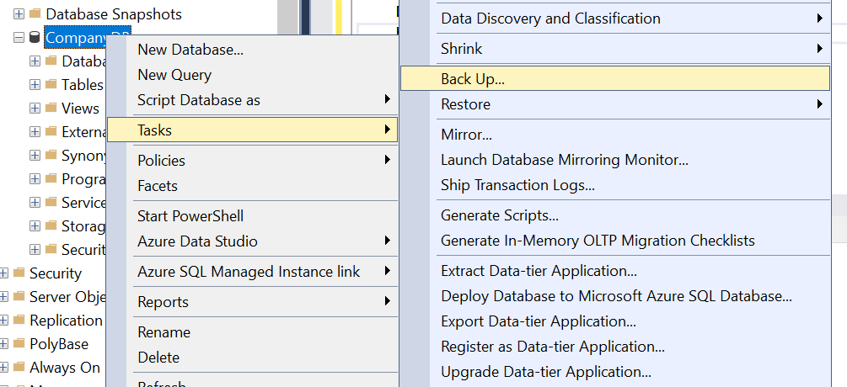

💽 Step 5: Configure the Backup Settings
- In the Back Up Database window:
  - Database: Should be CompanyDB
  - Backup type: Select Full
  - Backup component: Select Database
- Backup set name: You can leave as default or rename (e.g., CompanyDB Full Backup)

Step 6: Set the Destination and Filename
- In the Destination section:
  - Remove any existing path by clicking Remove
  - Click Add…
- In the Select Backup Destination window:
  - Type the full path with a timestamped filename.
Example:
C:\DBBackups\CompanyDB_2025_06_02.bak
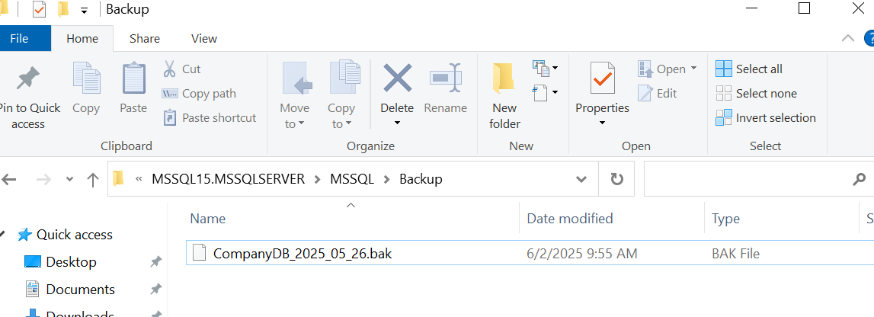
Step 7: Create a New SQL Server Agent Job
- In Object Explorer, expand SQL Server Agent
- Right-click Jobs → Click New Job

➤ General Tab
- Name: Backup_CompanyDB_Daily
- Description: Daily backup of CompanyDB with timestamped filename

Part 8: Create Scheduled Backup Job Using SQL Server Agent
Add a Job Schedule
- Go to Schedules → New
- Name: Daily_11AM
- Frequency: Daily
- Occurs Once At: 11:00 AM
- Click OK
