1. Create a Custom VPC
2. Launch EC2 Instance

3. Connect EC2 to RDS via SSMS
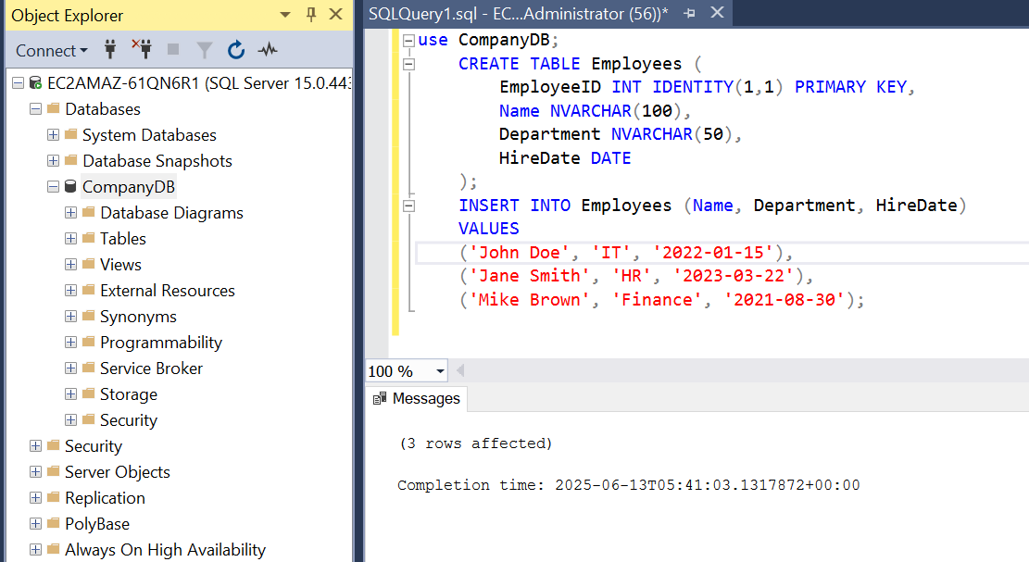
Backup
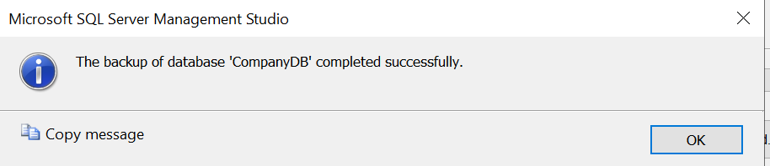

Database stored as:
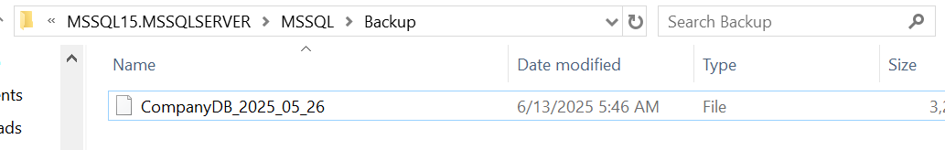

Step 4: Restore as CompanyDB_TestRestore
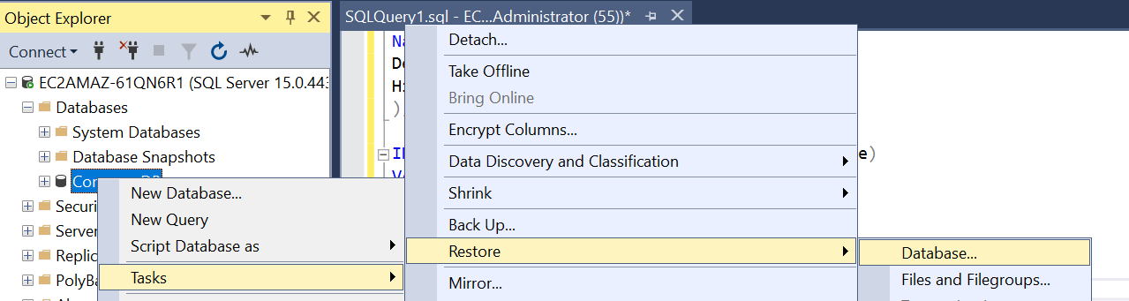

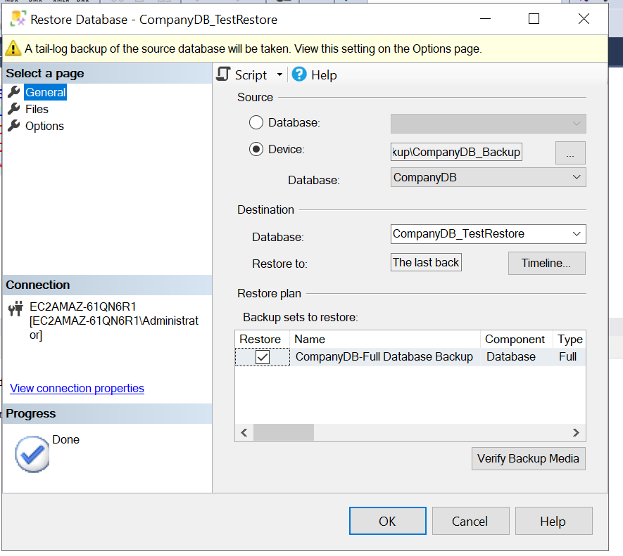
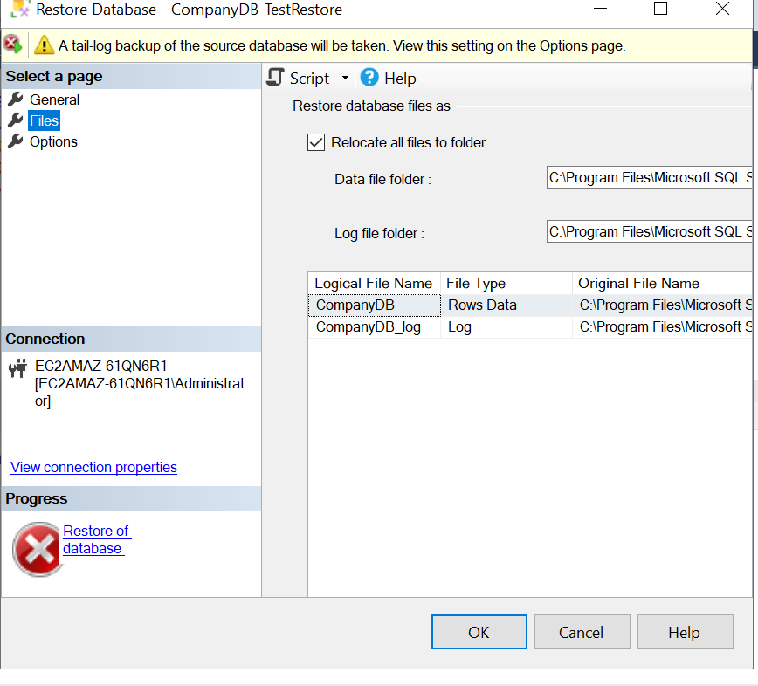
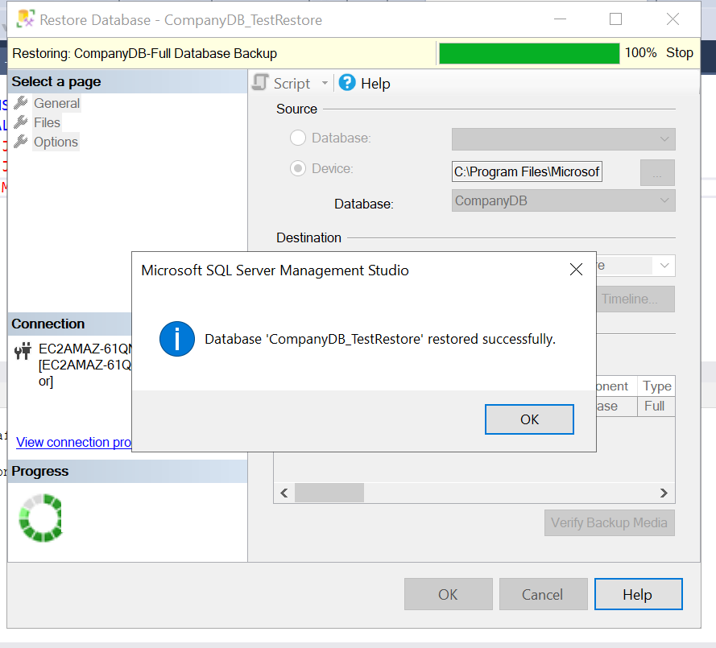

Step 5: Create Scheduled Backup Job
