Azure VM DR Setup (Active–Passive)
1. Create Resource Groups
Central India:
- Name: RG-CentralIndia
South India:
- Name: RG-SouthIndia
2. Create Virtual Networks and Subnets
Central India:
- VNet: VNet-Central1
- Subnet: Subnet-Central
South India:
- VNet: VNet-South
- Subnet: Subnet-South
📌 In each subnet, allow inbound RDP (port 3389) or SSH (port 22).
For South:
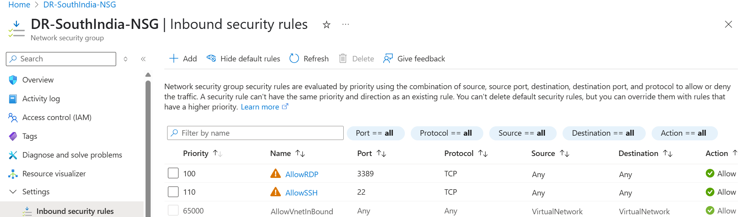
3. Set Up VNet Peering
In both VNets:
From VNet-Central:
- Go to "Peerings" → + Add
- Name: CentralToSouth
- Peer VNet: VNet-South
- Allow virtual network access: ✅ Enabled
From VNet-South:
- Add peering back to VNet-Central the same way.
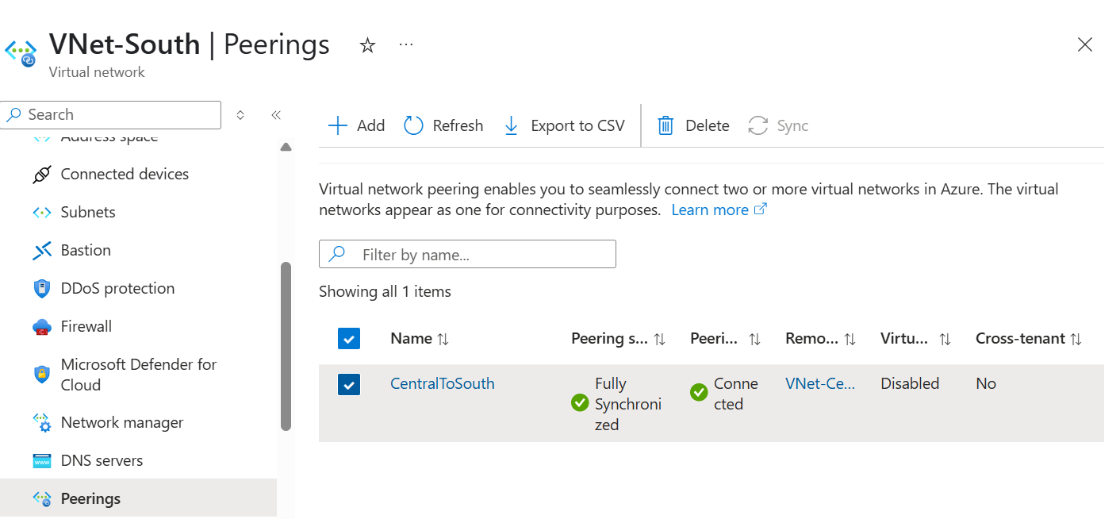
4. Create Network Security Groups (NSGs)
Create NSGs in both regions:
NSG-Central in Central India
NSG-South in South India
Add rules to allow:
- RDP or SSH
- Intra-VNet communication
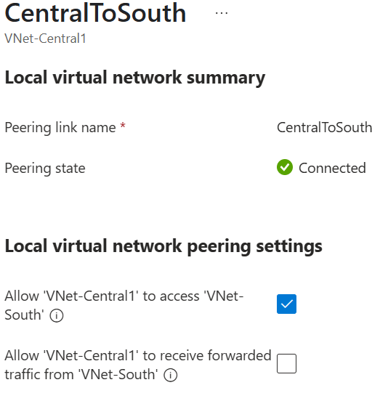
Associate NSGs to each subnet.
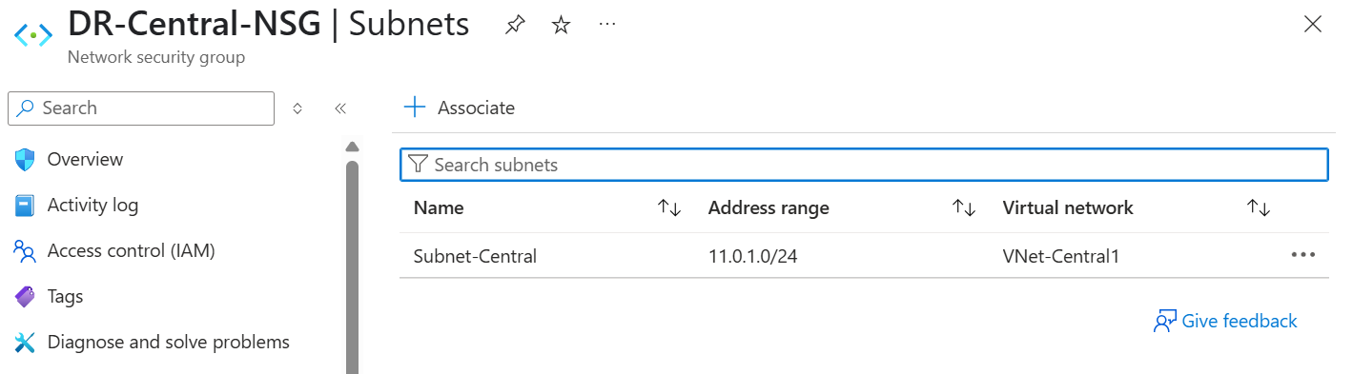
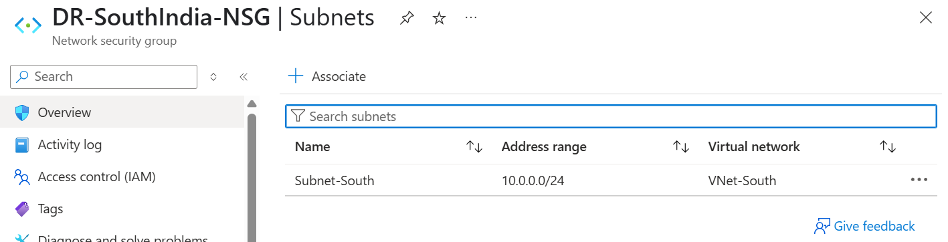
6. Deploy Primary VM in Central India
Create your main VM:
- Region: Central India
- Resource Group: RG-CentralIndia
- VNet/Subnet: VNet-Central / Subnet-Central
- NSG: NSG-Central
- Public IP: Optional (recommend using Bastion instead)
- OS: Windows or Linux

7. Access the Primary VM (via Public IP)
Once deployed:
- Go to the VM → Overview
- Copy the Public IP address
- Connect using:
  - RDP (Windows): Use Remote Desktop
  - SSH (Linux): Use SSH client or tool like Xshell
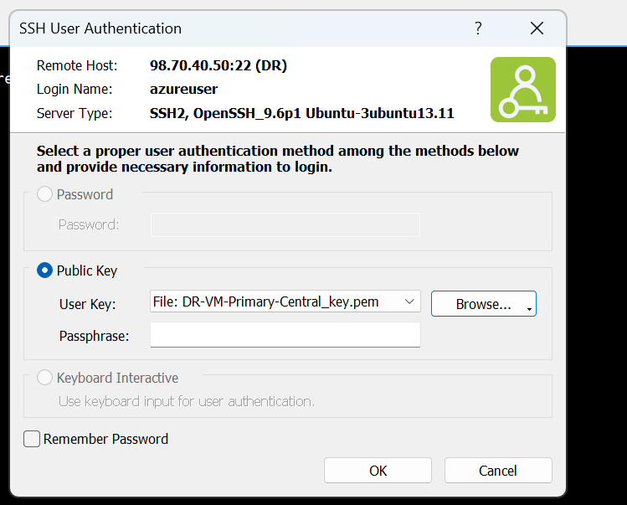

8. Create Recovery Services Vault
- Go to Azure Portal > Recovery Services vaults
- Click + Create
- Name: Vault-South
- Region: South India
- Resource Group: RG-SouthIndia
- Click Review + Create

9. Enable Replication for the VM
Enable Site Recovery
- Go to Vault-South
- Click on Site Recovery
- Under Azure virtual machines, click Enable replication
💻 Configure replication:
- Source location: Central India
- Source RG: RG-CentralIndia
- Target location: South India
- Target RG: RG-SouthIndia
- Target VNet: VNet-South
- Target Subnet: Subnet-South
- Replication policy: Use default or create custom
✅ Click Enable Replication

10. Monitor Replication Health
- Go to Vault-South > Site Recovery > Replicated Items
- Wait until status becomes ✅ Protected
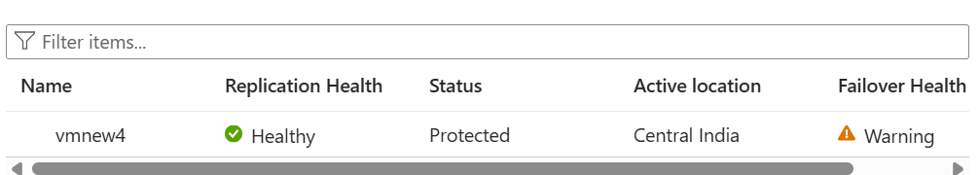

FAILOVER & TEST STEPS (Same)
🔍 Test Failover
- Validates if the DR VM boots in South India
- Go to Replicated Items → Test Failover
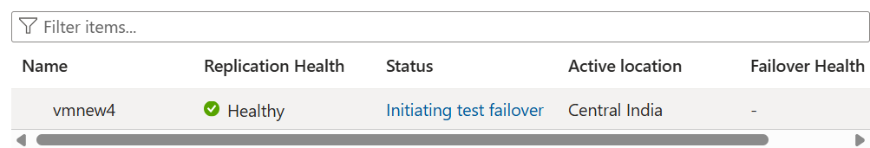
- Assign manual public IP for access
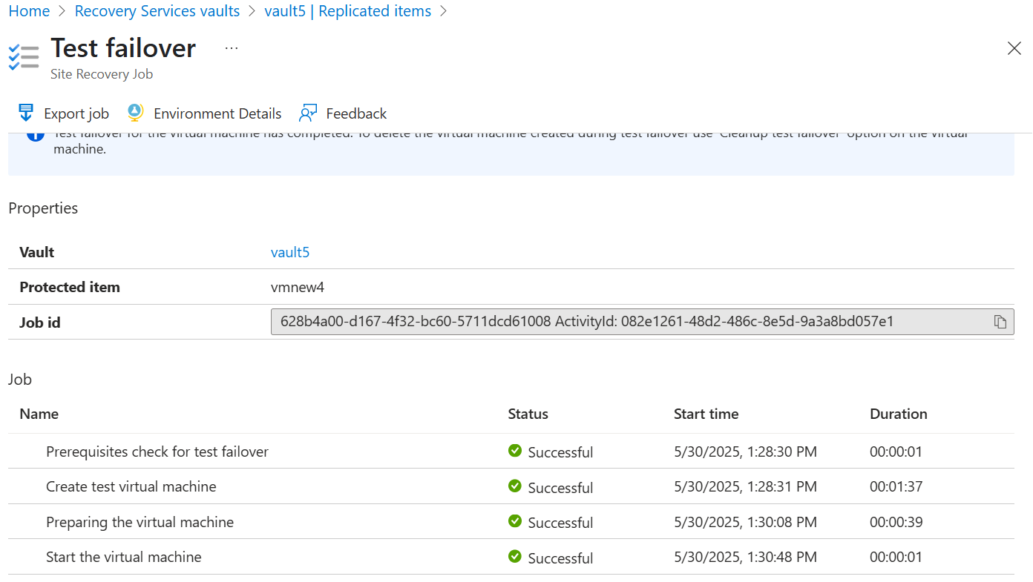
Final test DR:

