DR-DB
South Subnet:

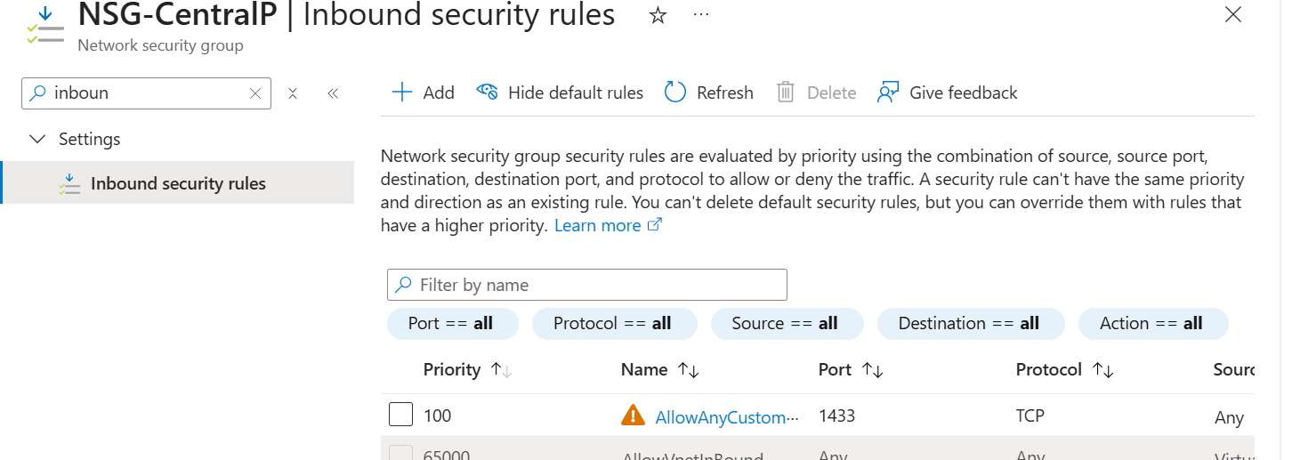
For South

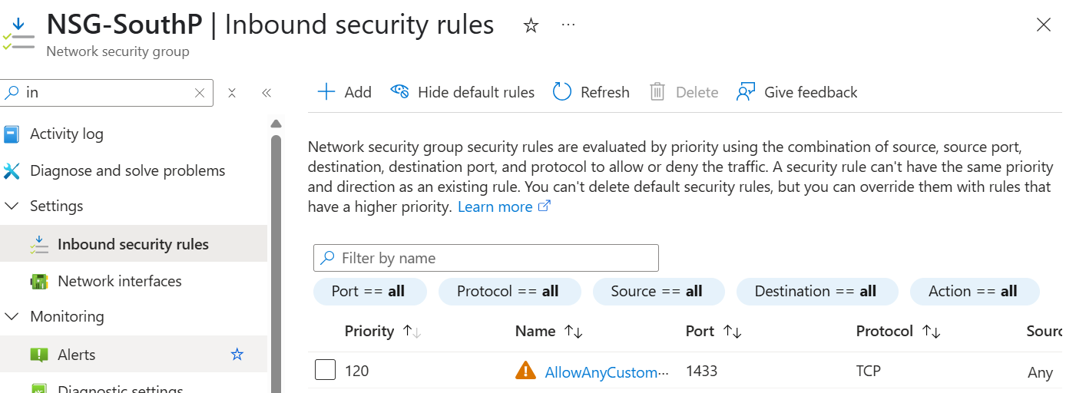

Peering:
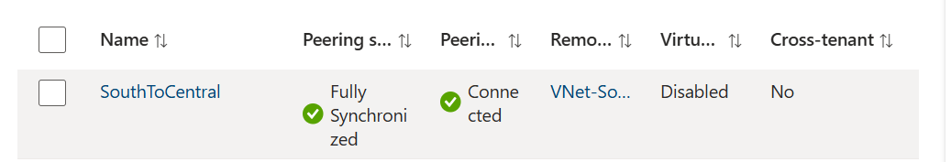
Create Route Tables in Both regions:
perform subnet Association:
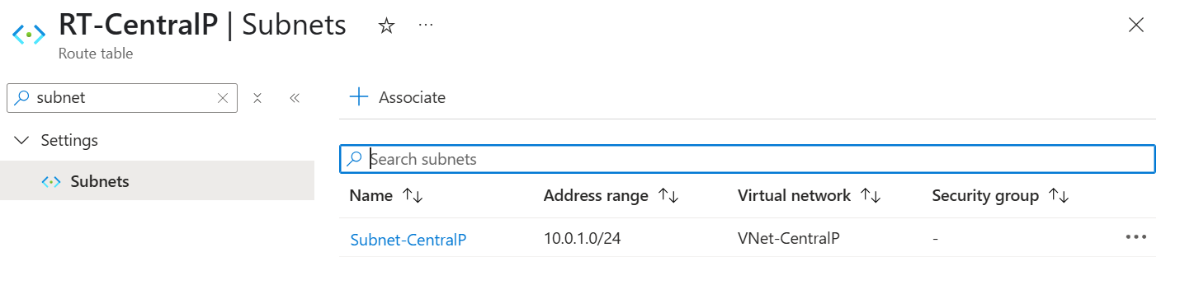
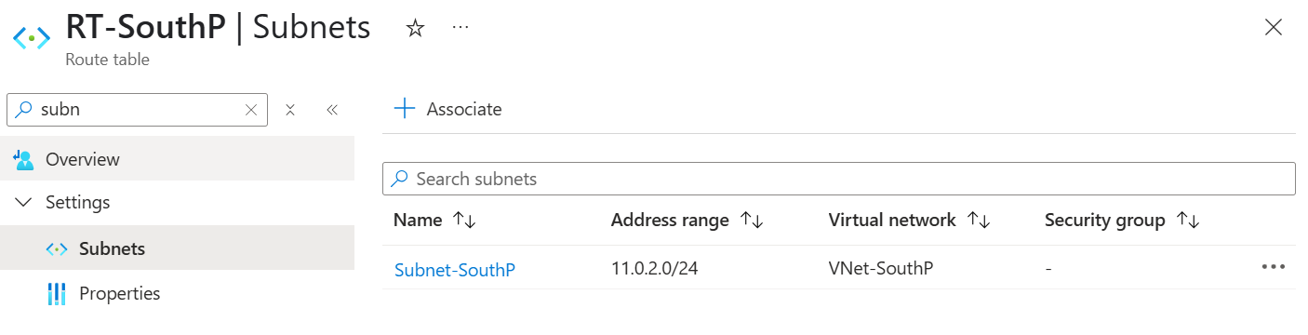
Step 6: Deploy SQL Managed Instances
In both regions:
- Go to Azure SQL → + Create → SQL Managed Instance
- Name: sqlmi-central (Central), sqlmi-south (South)
- Disable Public Endpoint
- Choose correct VNet and subnet
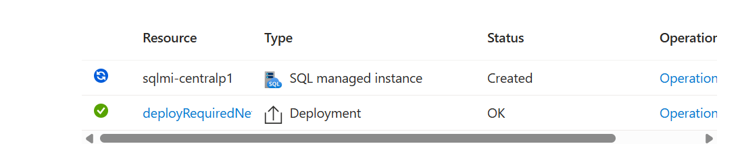
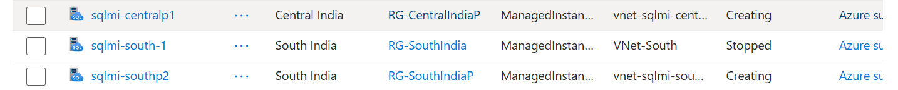
Step 7: Deploy Bastion Host (Jump Box)
- In Central India VNet
- Use to securely access VMs inside the VNet

Jump subnet:
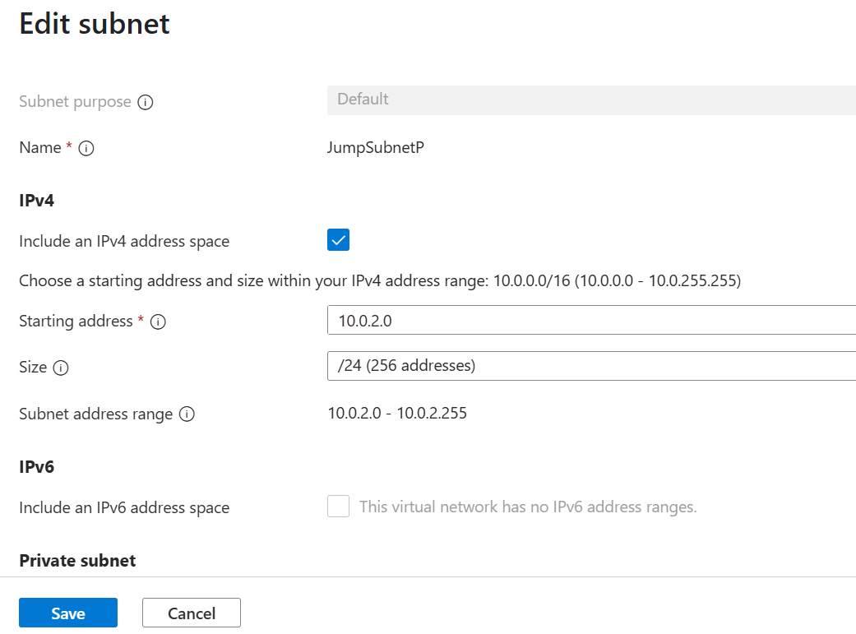
Next Step: Create the VM (Jump Server)
Step : Connect to VM via Azure Bastion
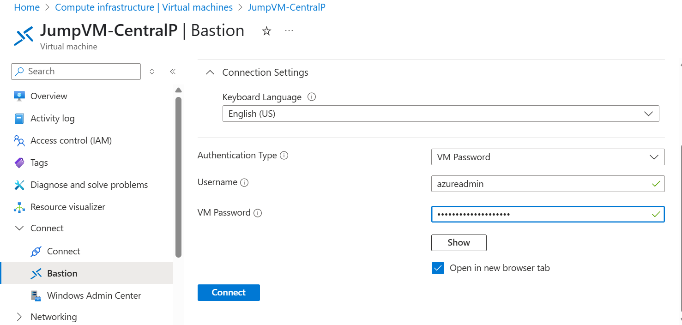
Step 7: Install SQL Server Management Studio (SSMS)
- Open Microsoft Edge inside the VM.
- Download SSMS:
https://aka.ms/ssmsfullsetup
- Install with default options.
