PROJECT REPORT
Website Performance Analysis
A Data Analytics Project on Website Traffic, User Behavior & Channel Performance
Prepared by
Pratik Kumar Prajapati
B.Tech, Computer Science & Engineering
Apollo Institute of Technology, Kanpur
github.com/pikuwa | linkedin.com/in/pratikxdev
September 2026

Table of Contents
1. Introduction 3
2. Objectives 3
3. About the Dataset 3
4. Tools & Technologies Used 3
5. Methodology: Data Cleaning & Preparation 4
6. Exploratory Data Analysis 4
6.1 Sessions & Users Over Time 4
6.2 Total Users by Channel 5
6.3 Average Engagement Time by Channel 5
6.4 Engagement Rate Distribution by Channel 6
6.5 Engaged vs. Non-Engaged Sessions 6
6.6 Traffic by Hour and Channel 7
6.7 Engagement Rate vs. Sessions Over Time 7
7. Key Findings 8
8. Skills Demonstrated 8
9. Conclusion 8
10. Author & Contact 8

1. Introduction
This report documents an end-to-end data analysis project I carried out on hourly website performance data, in the style of a Google Analytics 4 export. The goal of the project was to practice the full workflow of a real analytics task: taking a raw, messily formatted export, cleaning and structuring it, exploring it visually, and converting the results into insights that a marketing or product team could actually act on.
The work was done independently in a Jupyter Notebook using Python's data science stack, and reflects my ongoing focus on Python development and data analytics as part of my B.Tech coursework and self-study.

2. Objectives
- Clean and restructure a raw, multi-header analytics export into an analysis-ready dataset.
- Compare acquisition channels (Direct, Organic Social, Organic Search, Referral, Email, etc.) on both traffic volume and engagement quality.
- Identify time-of-day patterns in traffic and engagement across the full data window.
- Translate the statistical output into clear, decision-ready findings.

3. About the Dataset
The dataset contains 3,182 hourly records spanning April 6 – May 3, 2024 (about four weeks), with each row representing one channel's traffic in one hour. The key fields are described below.
Column | Description
Channel group | Acquisition channel (Direct, Organic Social, Organic Search, Referral, Email, Organic Video, Unassigned)
DateHour | Date and hour of the record
Users | Unique users in that hour
Sessions | Total sessions in that hour
Engaged Sessions | Sessions with meaningful interaction
Avg engagement time/session | Average active time per session (seconds)
Engagement rate | Share of sessions that were engaged
Events per session / Event count | Interaction volume per session and in total

4. Tools & Technologies Used
- Python — core language for the entire analysis
- Pandas & NumPy — data cleaning, type conversion, aggregation
- Matplotlib & Seaborn — all charts and statistical visualizations
- Jupyter Notebook — analysis environment

5. Methodology: Data Cleaning & Preparation
The raw export was not analysis-ready: it shipped with a broken two-row header and every numeric column typed as text. My cleaning process was:
- Rebuilt clean column names from the malformed header row and dropped the redundant first row.
- Parsed the DateHour field (format YYYYMMDDHH) into proper datetime objects.
- Coerced all metric columns to numeric types, safely handling any conversion errors.
- Engineered a new Hour feature from the timestamp to enable time-of-day analysis.
- Validated the cleaned dataset with .info() and .describe() — confirming 3,182 non-null rows across 11 columns with zero missing values.
Post-cleaning dataset summary:
Metric | Mean | Min | Max
Users / hour | 41.9 | 0 | 237
Sessions / hour | 51.2 | 1 | 300
Engagement rate | 50.3% | 0% | 100%
Events / session | 4.68 | 1.0 | 56.0

6. Exploratory Data Analysis
With a clean dataset in place, I built seven visualizations to examine traffic trends, channel quality, and time-based patterns.

6.1 Sessions & Users Over Time
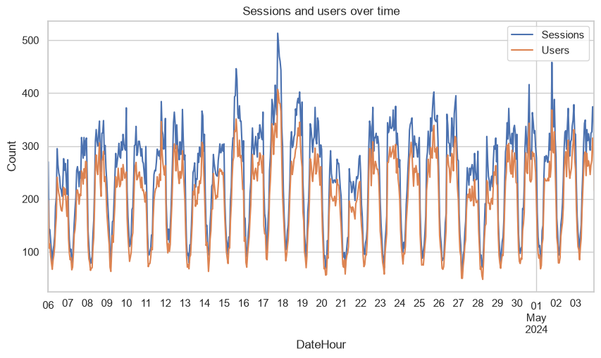
Figure 1: Hourly sessions and users across the full 4-week window
Traffic follows a strong, repeating daily cycle rather than an upward or downward trend — sessions swing from lows of around 50 to peaks of 300–500 every single day, with sessions consistently tracking above users, as expected since one user can open multiple sessions.

6.2 Total Users by Channel
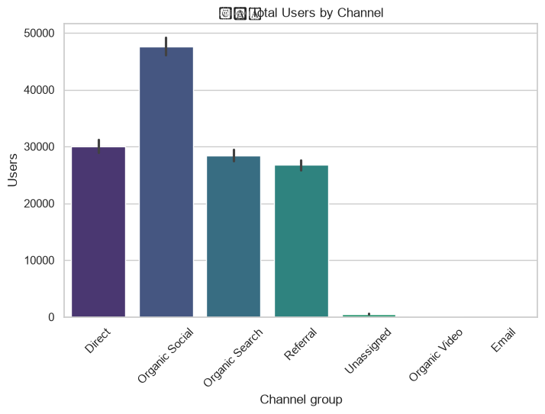
Figure 2: Total users acquired per channel across the analysis window
Organic Social is the dominant acquisition channel with roughly 48,000 users, ahead of Direct (~30,000), Organic Search (~28,000), and Referral (~27,000). Organic Video, Email, and Unassigned contribute negligible volume in this dataset.

6.3 Average Engagement Time by Channel
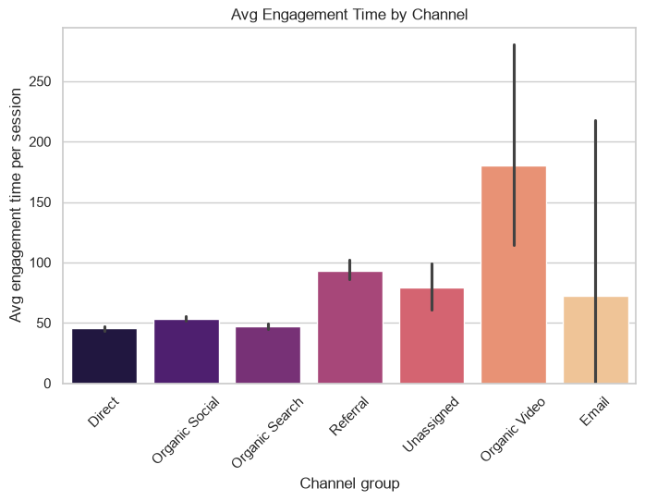
Figure 3: Average time spent per session, by channel
Organic Video and Email show the highest average engagement time, but from a very small sample — the wide confidence intervals mean these aren't reliable signals yet. Among the high-volume channels, Referral sessions run the longest (~93 seconds on average), ahead of Direct, Organic Social, and Organic Search (45–55 seconds).

6.4 Engagement Rate Distribution by Channel
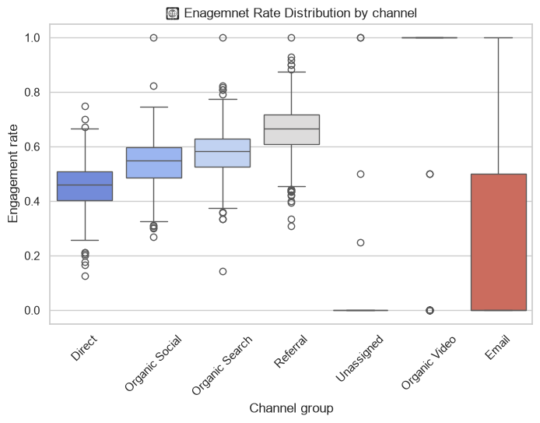
Figure 4: Spread of engagement rate values per channel
Referral traffic shows the best engagement quality of any high-volume channel, with a median engagement rate of roughly 65–68%, followed by Organic Search and Organic Social (~55–58%). Direct has the lowest median engagement rate at around 45%, despite being the second-largest channel by volume.

6.5 Engaged vs. Non-Engaged Sessions
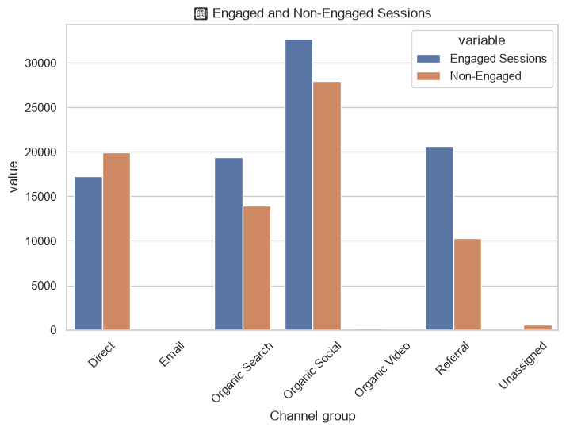
Figure 5: Engaged vs. non-engaged session counts by channel
This confirms the pattern above: Direct is the only major channel where non-engaged sessions outnumber engaged ones, while Organic Search, Organic Social, and especially Referral skew toward engaged sessions.

6.6 Traffic by Hour and Channel
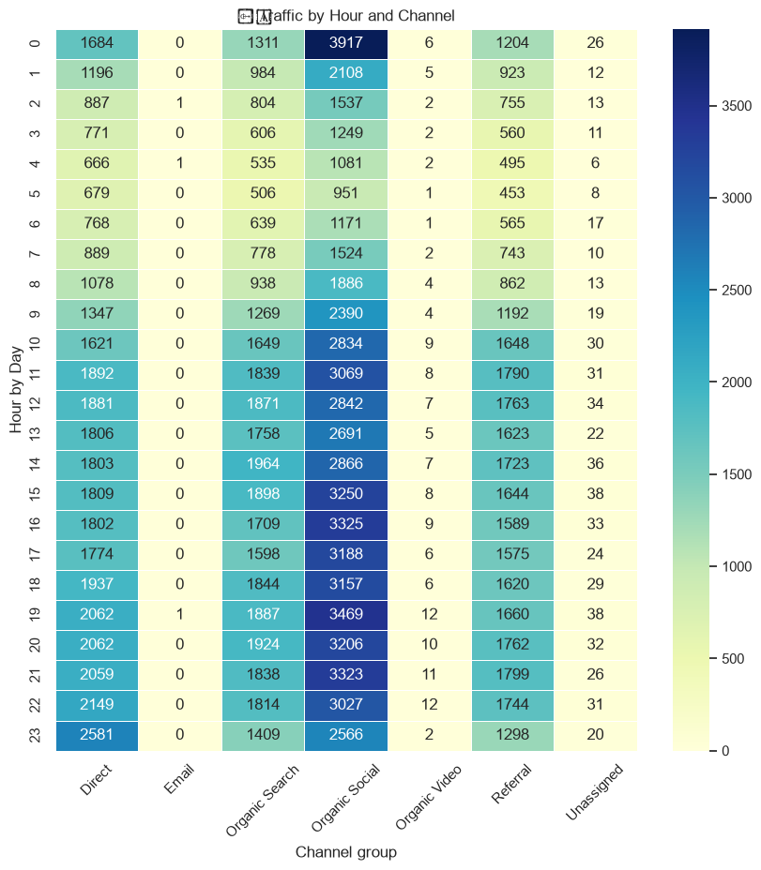
Figure 6: Session volume by hour of day and channel
A clear diurnal rhythm emerges across every channel: traffic bottoms out between roughly 2–6 AM and climbs steadily to a peak in the 9 PM–midnight window. Organic Social shows the sharpest peak, reaching nearly 3,900 sessions at midnight — more than double its early-morning low.

6.7 Engagement Rate vs. Sessions Over Time
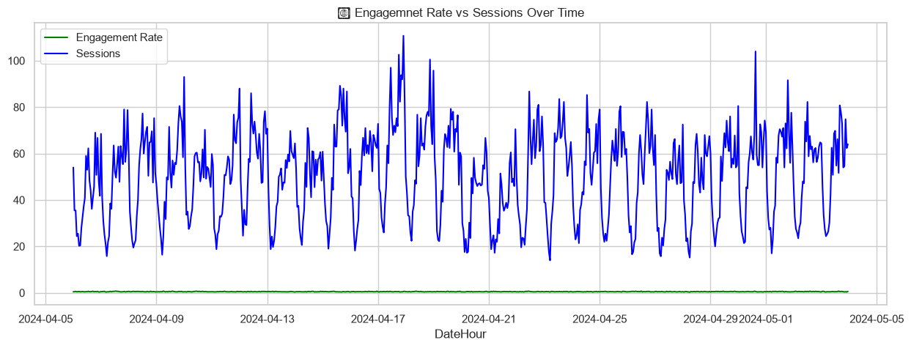
Figure 7: Engagement rate compared against session volume over time
Despite session volume swinging by 5–10x within a single day, the engagement rate stays remarkably flat at around 50% throughout the entire period — traffic quality holds steady even during high-volume hours, suggesting the site handles peak demand without any drop-off in visitor engagement.

7. Key Findings
- Organic Social drives the most traffic, but Referral drives the best traffic — it has the highest engagement rate and the longest sessions among high-volume channels.
- Direct traffic is a volume channel, not a quality channel — it is the only major source where most sessions are non-engaged, which is worth investigating further (bookmarks, app traffic, or brand searches potentially misattributed as Direct).
- Traffic is highly time-of-day dependent, peaking in the evening and troughing overnight — useful for scheduling content pushes, campaigns, or server capacity planning.
- Engagement quality is stable and volume-independent, indicating the site experience does not degrade under peak load.

8. Skills Demonstrated
- Data cleaning and wrangling of a messy, real-world analytics export (Pandas)
- Feature engineering — datetime parsing and hour extraction
- Exploratory data analysis and statistical summarization
- Multi-chart visualization design (line, bar, box plot, grouped bar, heatmap) with Matplotlib and Seaborn
- Translating raw metrics into channel-level and time-based business insights

9. Conclusion
This project let me apply the complete data analysis workflow — cleaning, exploration, visualization, and insight generation — on a realistic, messy dataset. Beyond the technical steps, it reinforced how important it is to look past surface-level volume metrics (like Organic Social's lead in total users) and examine engagement quality, which told a more useful story about where Referral traffic was quietly outperforming. I plan to build on this by extending the analysis to conversion and revenue data where available.

10. Author & Contact
Pratik Kumar Prajapati
B.Tech, Computer Science & Engineering — Apollo Institute of Technology, Kanpur
GitHub: github.com/pikuwa LinkedIn: linkedin.com/in/pratikxdev

