9.3 Predicting Prices of Used Cars (Regression Trees)
Dataset Used: ToyotaCorolla.csv
Target Variable: Price
Data Split: 60% training, 40% holdout
Preprocessing Step: Fuel_Type was converted into dummy variables using the Nominal to Numerical operator.
ANSWERS
a.i Most Important Specifications
When running a full-grown regression tree (with pruning turned off), the model produced the following most important variables:
- Age_08_04 (Car Age): The most dominant variable. Car prices drop as the car gets older.
- KM (Mileage): The second most important factor. Cars with more kilometers on them are less valuable.
- HP (Horsepower): Higher horsepower is linked to higher prices.
- Automatic_airco: Features such as automatic air conditioning also added value.

Explanation: This makes sense because age and mileage directly show how much a car has been used, which buyers care about most. Other features like horsepower and comfort options matter, but not as much as age and usage.

a.ii Training vs Holdout Errors
The prediction errors were compared between the training and holdout sets.
- Training RMSE: Almost 0. The tree fits the training data perfectly.
- Holdout RMSE: About 1,458, which is much larger.
Why this happens:
A full tree grows very deep and ends up memorizing the training data. That is why training errors are zero. But this overfitting causes the model to perform poorly on new, unseen data.
Boxplot observation:
- Training error boxplot shows errors all at zero (a perfect fit).
- Holdout error boxplot shows a wider spread with larger errors, which clearly proves overfitting.

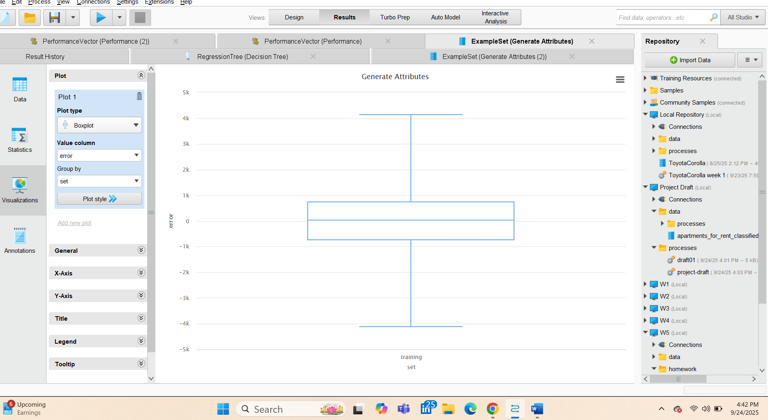
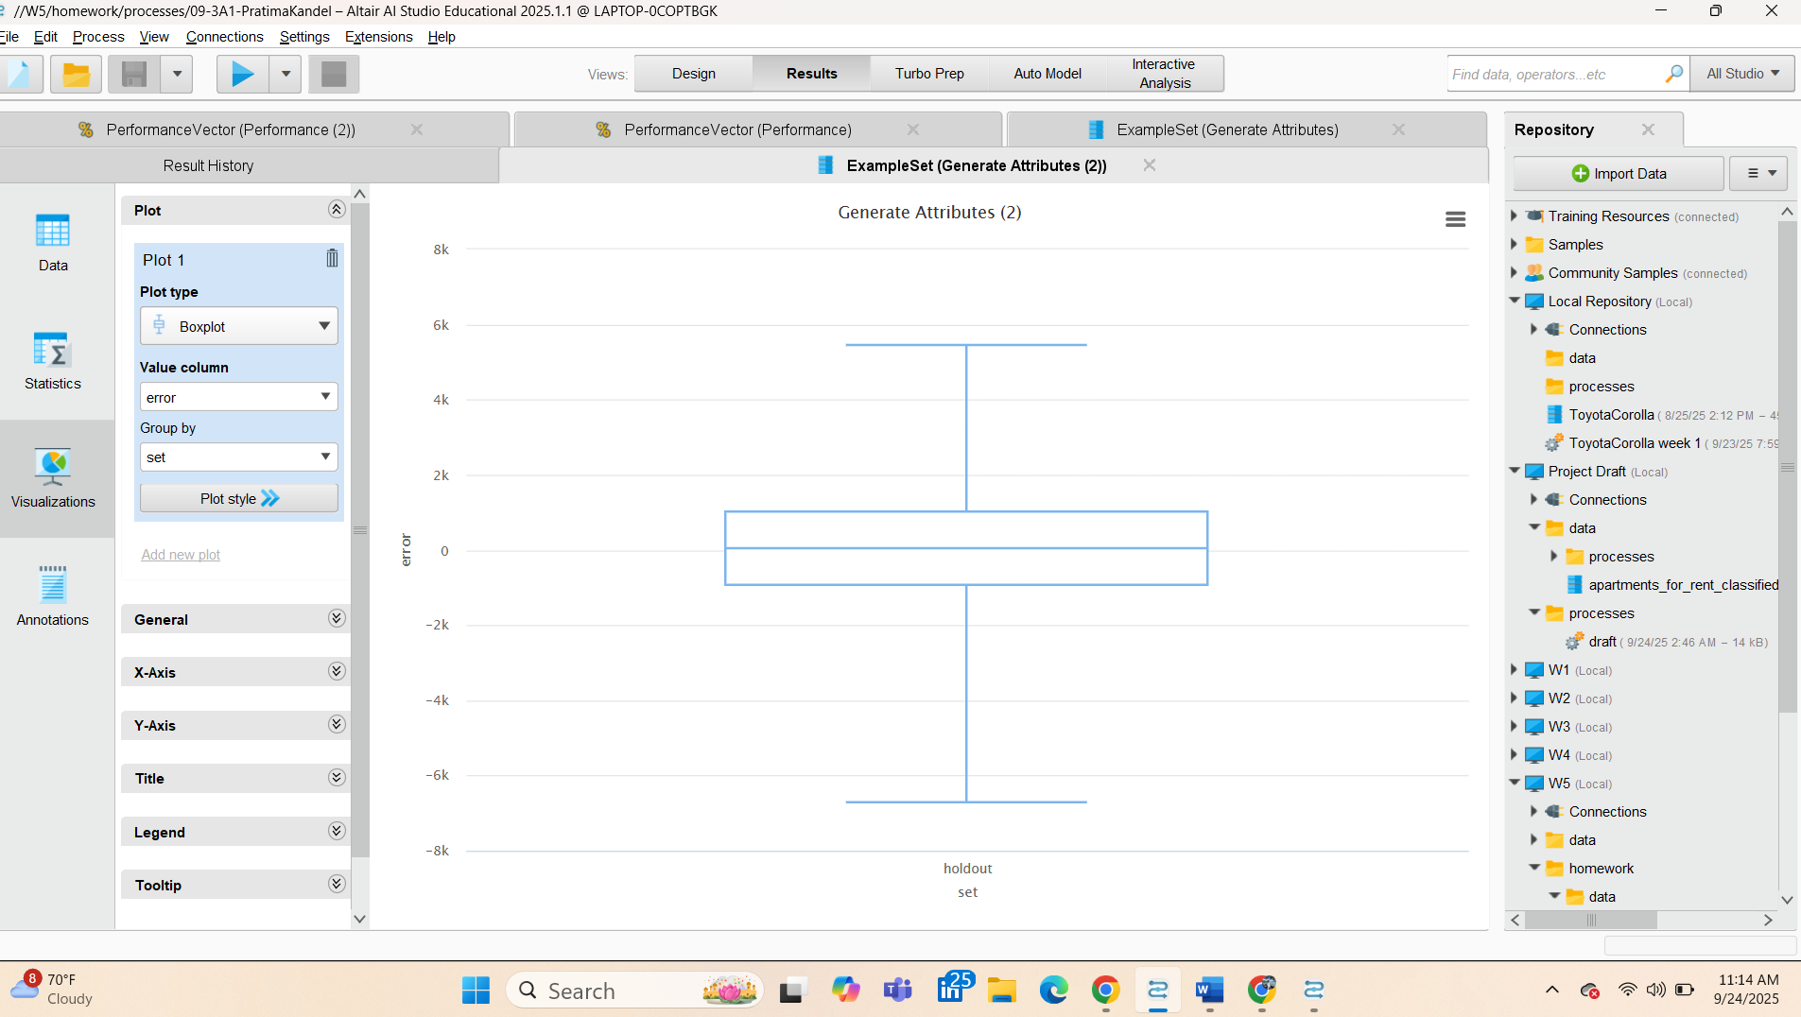
a.iii Improving Holdout Performance
To make the model perform better on the holdout set, we need to simplify the tree. This means intentionally stopping the tree from growing too complex. Some ways to do this are:
- Limit the maximum depth of the tree.
- Increase the minimum leaf size so that leaves don’t just memorize one or two points.
- Apply post-pruning to remove unnecessary splits.
- Use cross-validation to choose the right parameters.
In short: By allowing some training errors, the model avoids overfitting and predicts better on unseen cars.

a.iv Smaller Tree with Optimize Parameters (Grid)
Using the Optimize Parameters (Grid) operator with 5-fold cross-validation, the decision tree was tuned.
- The best configuration found was maximum depth and minimum leaf size = 5.
- The training RMSE increased compared to the full-grown tree.
- The holdout RMSE improved and became more balanced.
Compared to the full-grown tree, the optimized tree no longer overfit. It generalized better to unseen data, even though the training error increased. The main predictors remained consistent, with Age, KM, and HP as the strongest variables.

Interpretation: The smaller, optimized tree sacrifices some training accuracy but generalizes much better. This shows that tuning the parameters results in a model that works better for prediction on new data.

Conclusion
- The most important predictors were Age, KM, HP, and Automatic_airco.
- The full-grown tree gave perfect accuracy on training data but failed on holdout data due to overfitting.
- By simplifying and tuning the tree, the holdout error improved a lot, which is more important for real-world prediction.
- This exercise shows why we should always balance model complexity and generalization.

