**Project Name:** Medicare

**Project Background**

---------------------------------------

Project Name: Medicare is a company that supplies medicines and a couple of other healthcare essentials at an affordable price. It was established in 2012 in Delhi, India. It had been serving fine all these years, however, the business analysts noticed a decline in sales since 2017. They found out that online ordering of medicines with companies, such as 100mg and mfine are gaining more profits by eliminating middlemen from the equation. As a result, the team decided to hire a Full Stack developer to develop a healthcare web application with a rich and user-friendly interface.

**TO DO:**

**Admin Portal:**

The admin portal deals with all the backend data generation and product information. The admin user should be able to:

* Add or remove medicine details from the application to build a rich product line
* Edit medicine details like name, price, seller, product description, and offers to keep the product information updated with the current prices
* Enable or disable a medicine product

**User Portal:**

It deals with the user activities. The end-user should be able to:

* Sign-in to the application to maintain a record of activities
* Search for products based on the search keyword
* Apply filters and sort results based on different cuisines to get the best deals
* Add all the selected food items to the cart and customize the purchase at the end
* Perform a seamless payment gateway
* Get an order summary details page once the payment is complete

**SOLUTION:**

Tools Used:

Backend: Intellij, Java, SpringBoot, Hibernate JPA, MySQL, Apache Maven, Postman, JDBC, Exception Handling List Interface

Frontend: VScode, Material Design, HTML, CSS

Sprint Table:

Sprint 1: Backend Development 5 Days.

Sprint 2: Frontend Development 5 Days.

GitHub Repository:

Run Process:

At Backend: 1. Clone git project,

2. Create Database with name meicare_db

3. open the backend project in Intellij

Right click on the main class and run the program.

At Frontend: 1. Open the frontend project in VScode

2. Type ng serve on the terminal

Open the URL http://localhost:4200/

This will open the project home page.

Output of the Project

This is the top page of the project

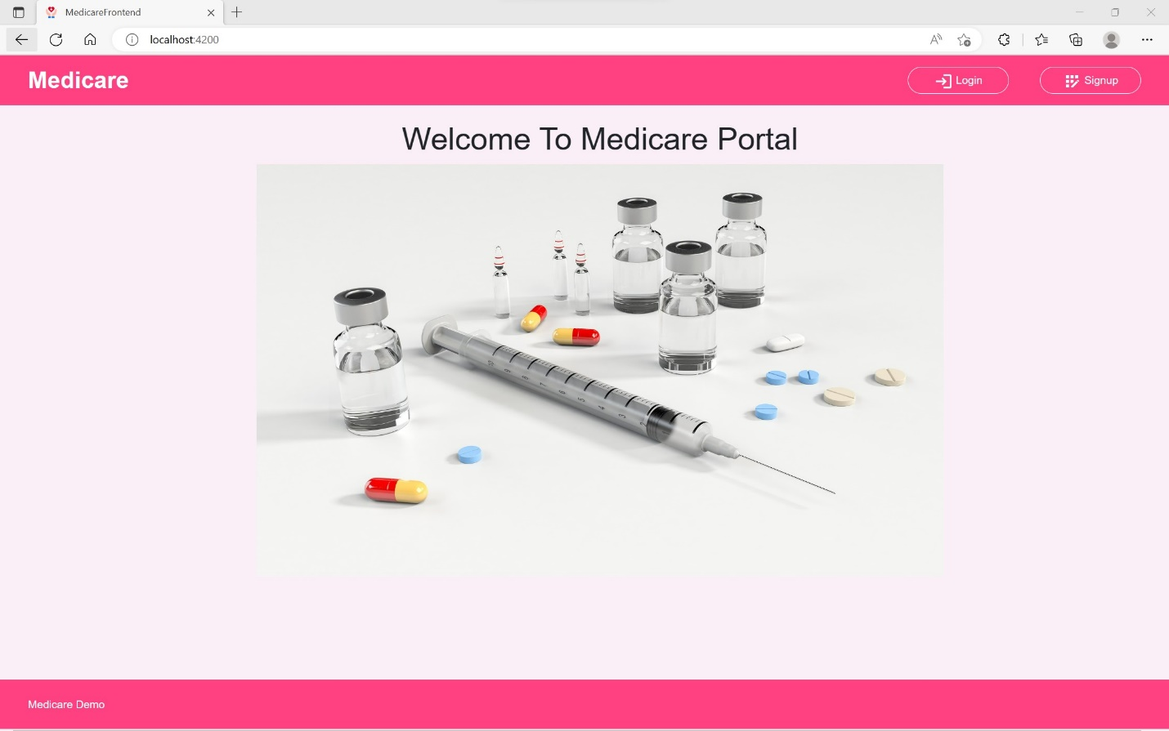

Login Page of the Project

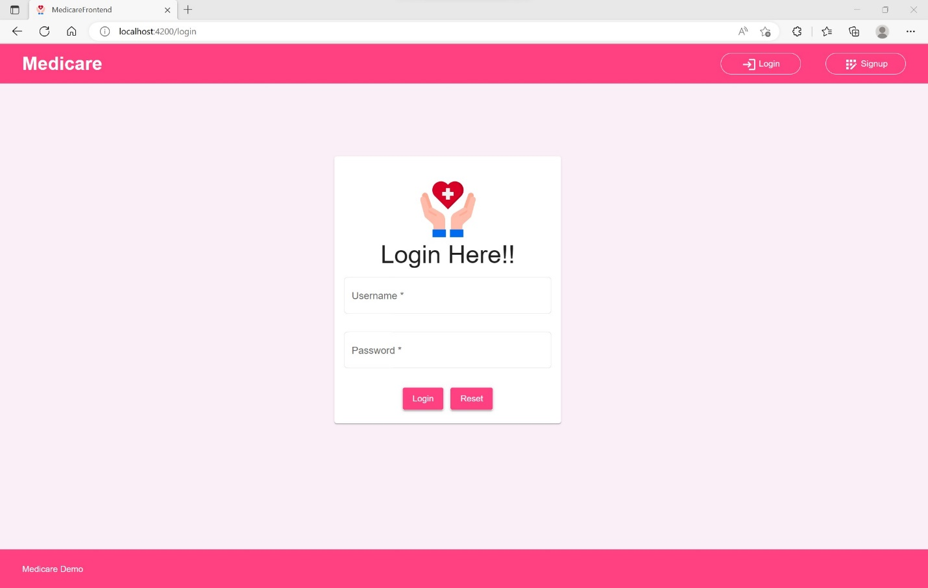

Admin Login

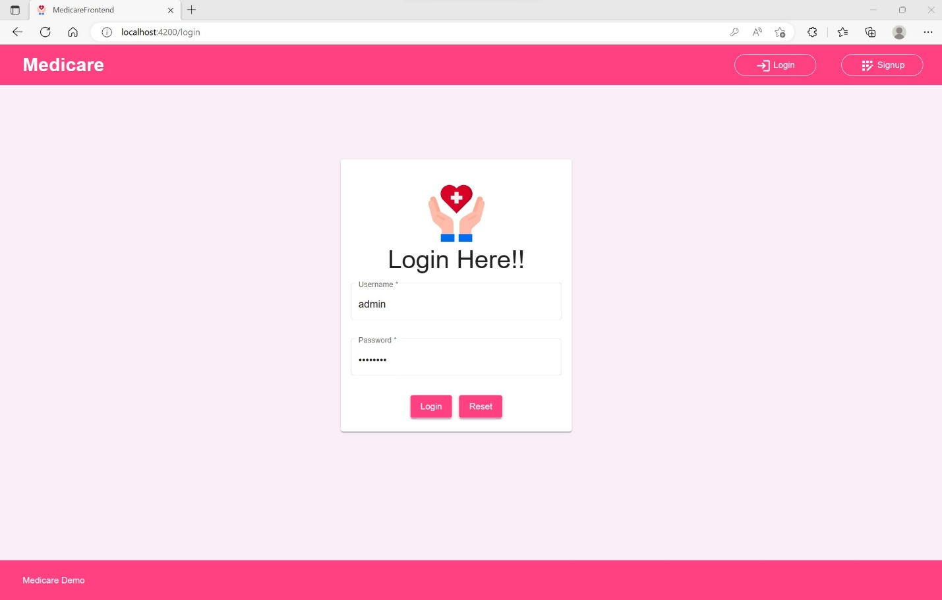

Admin Login Error when the credential is not matched in Backend Database

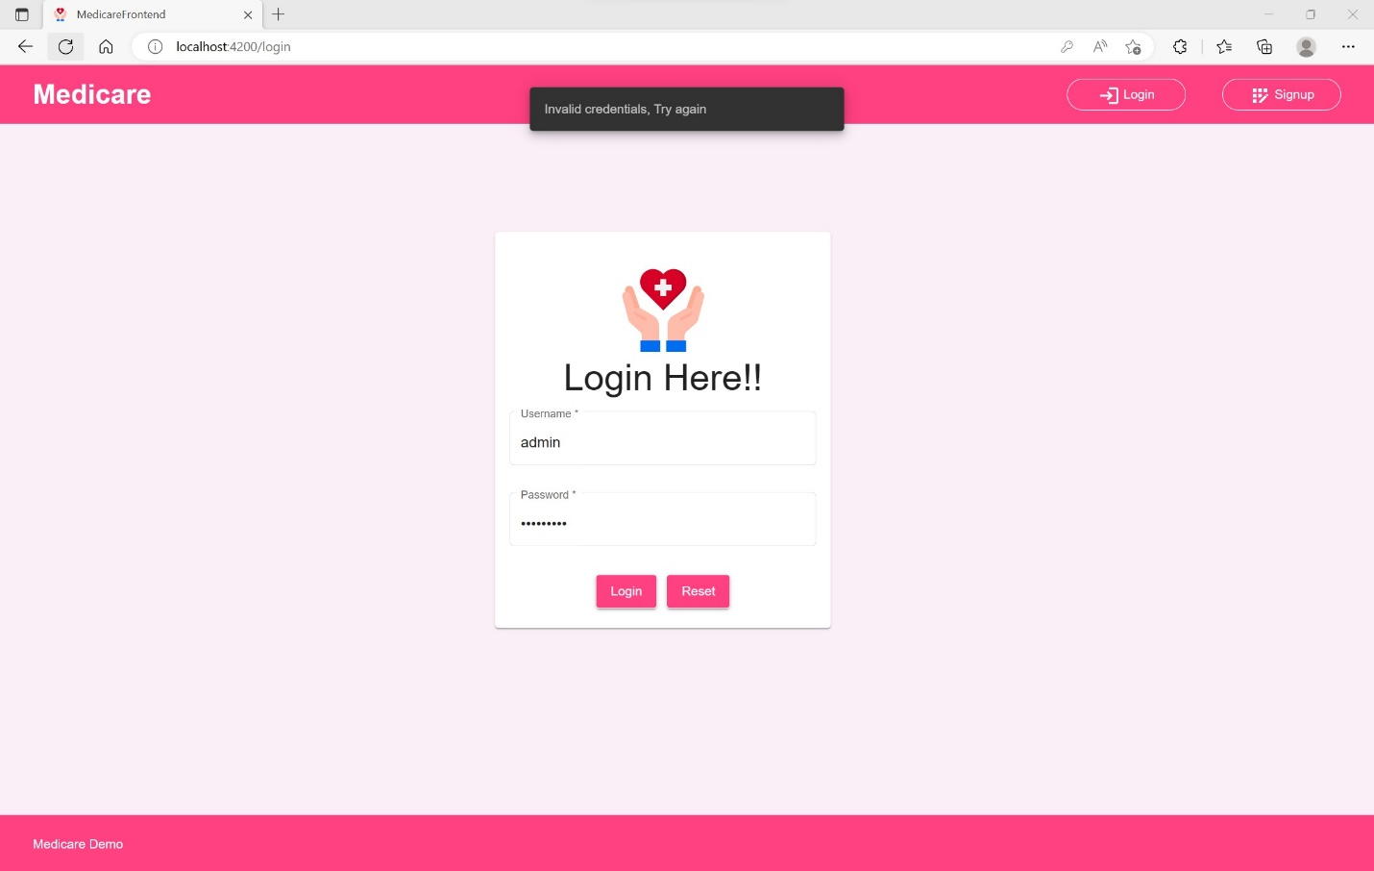

Admin Login Success which navigates to the Admin Dashboard

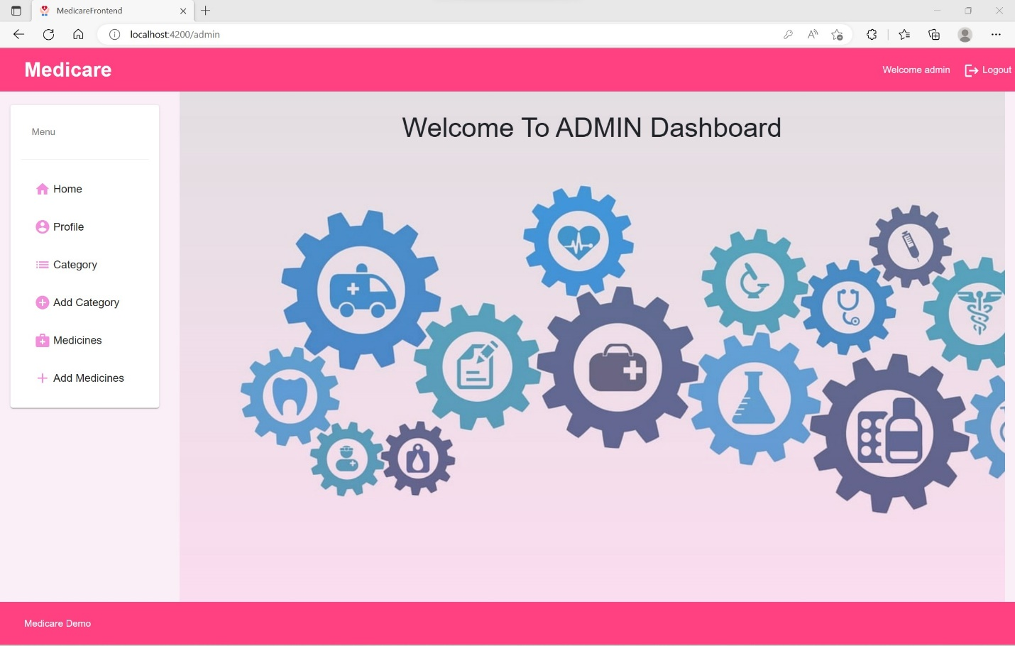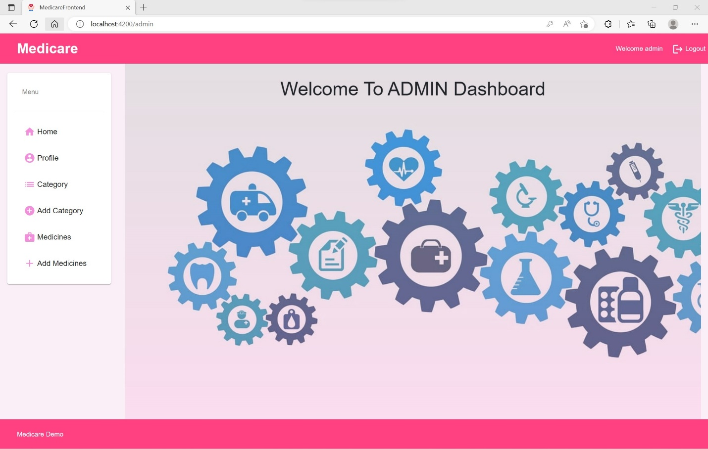

Admin Profile Information being shown from Database

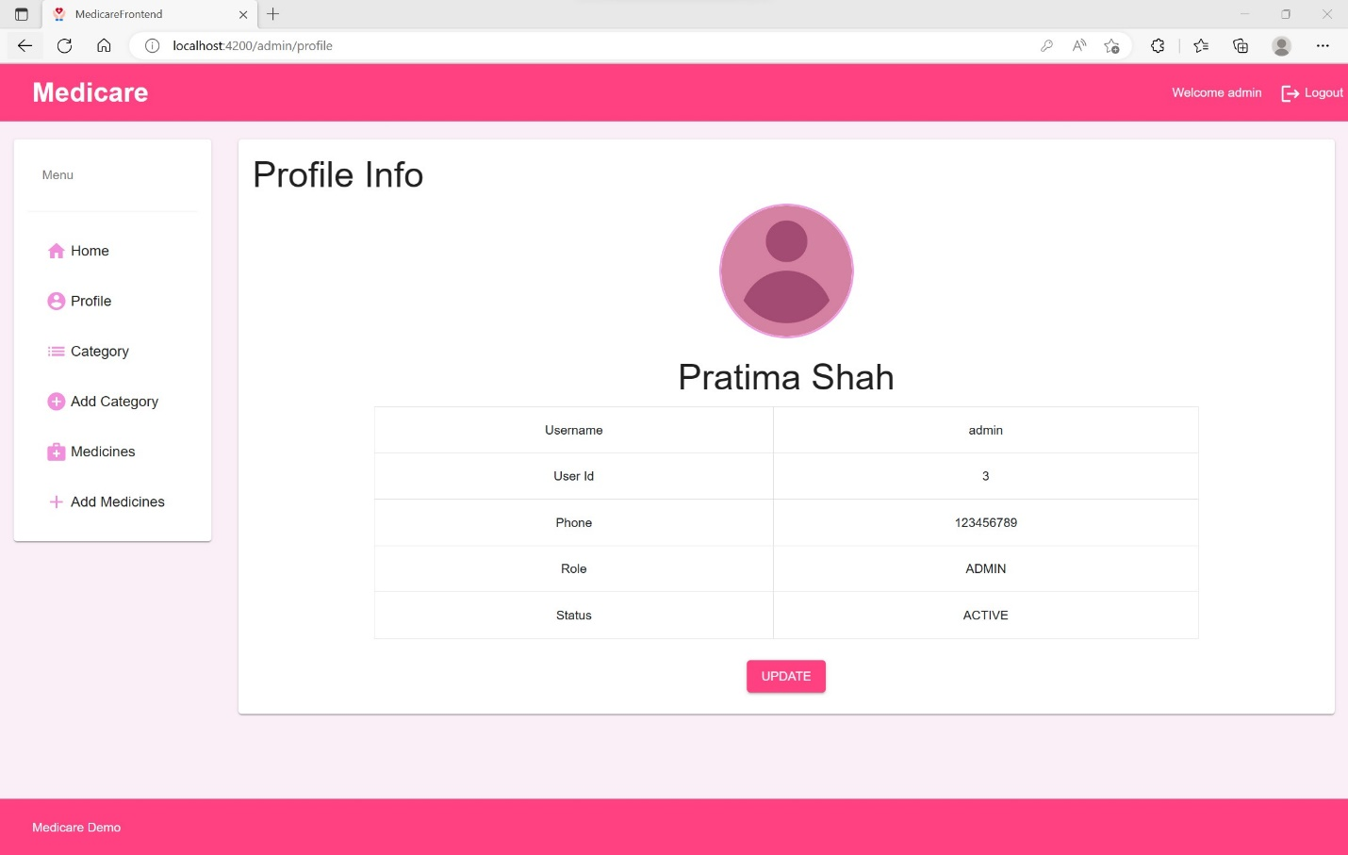

Admin can view categories List

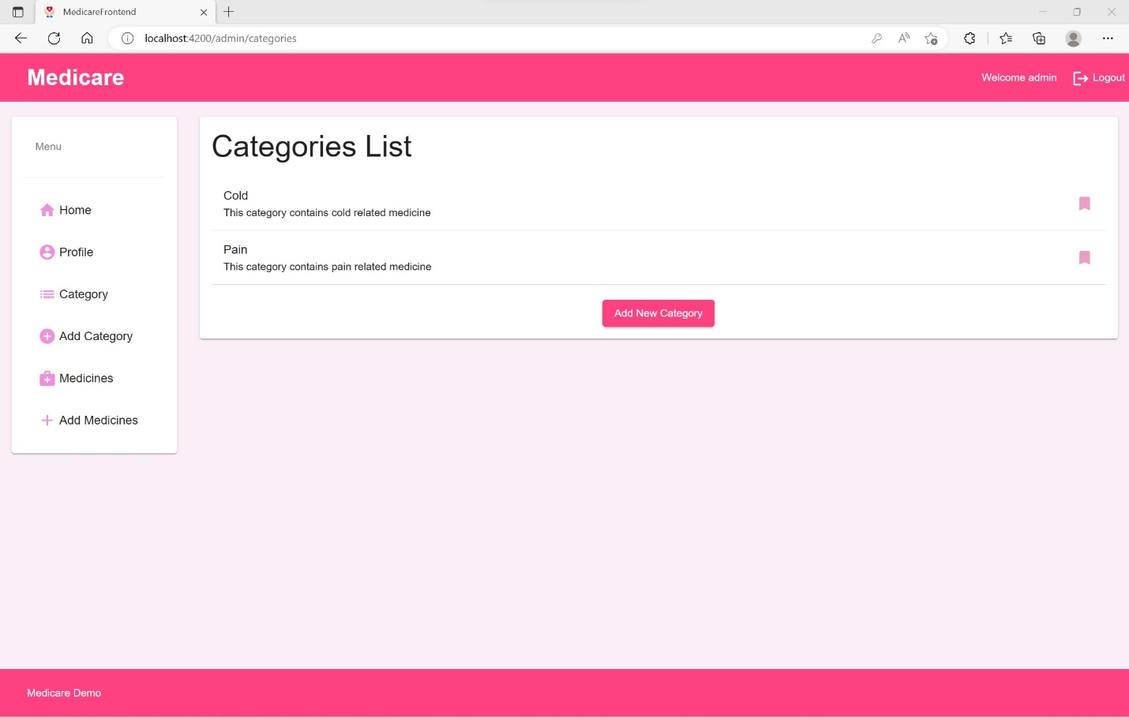

Admin Can Add New Category

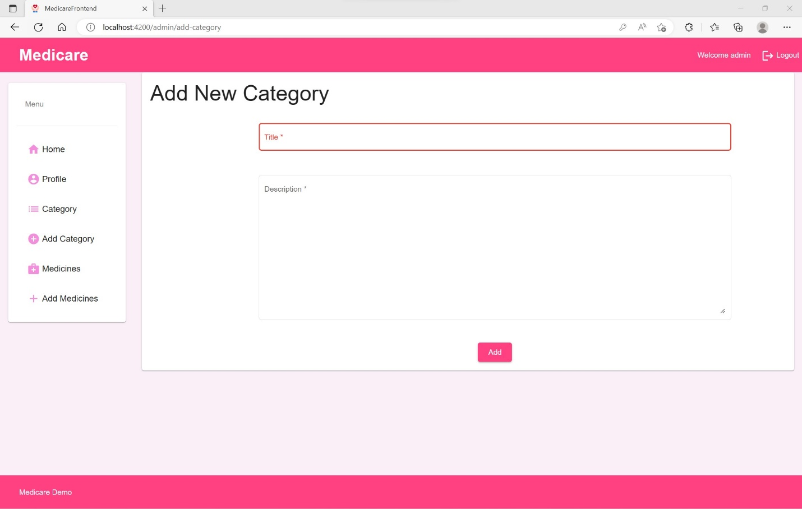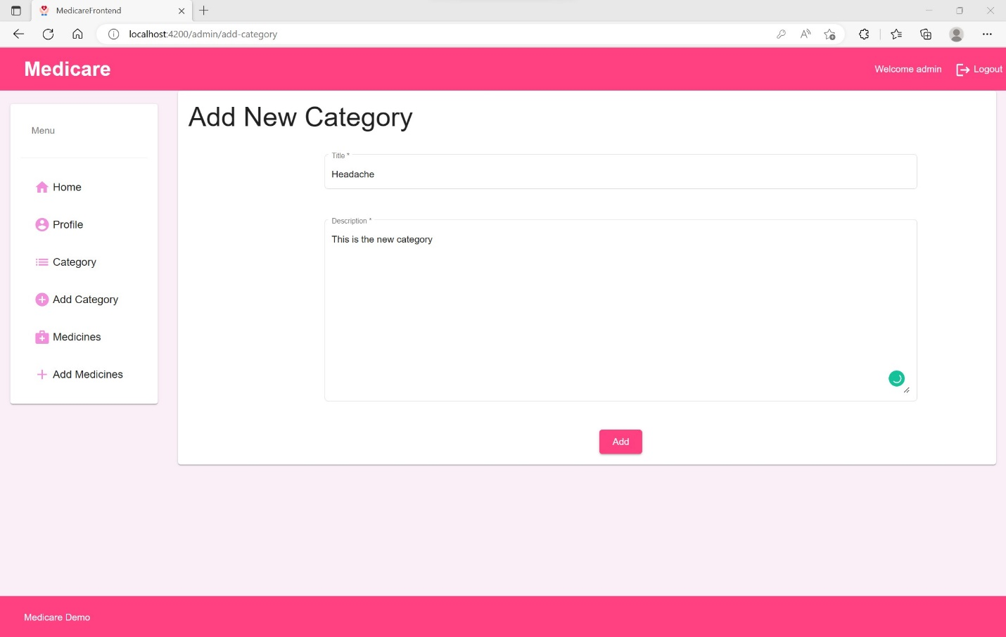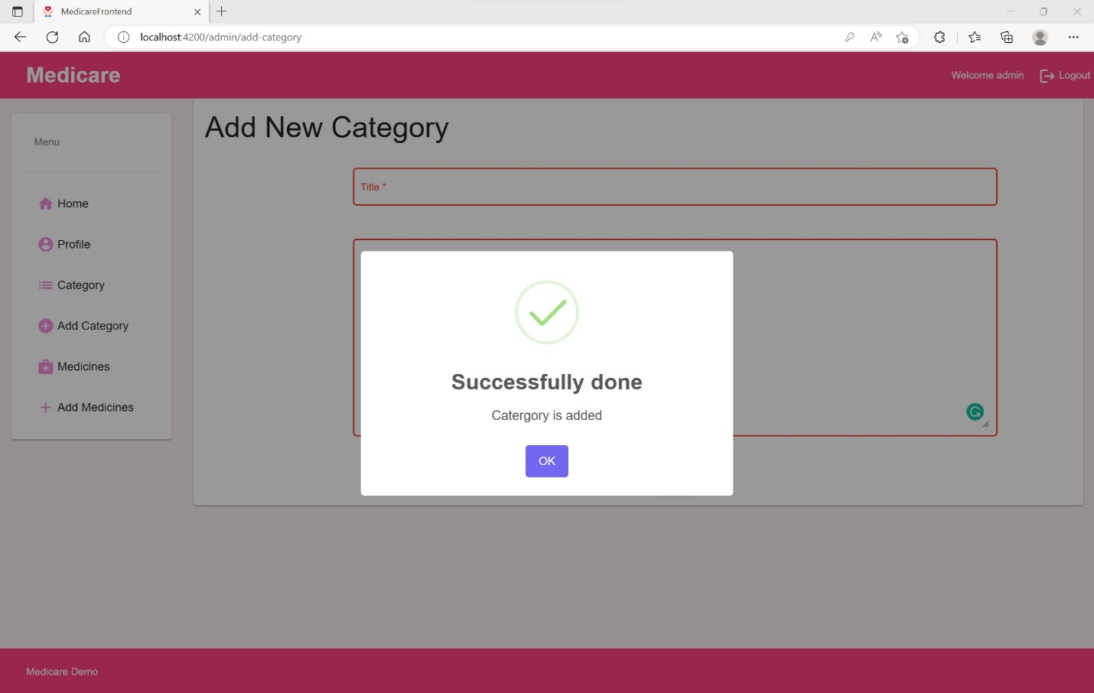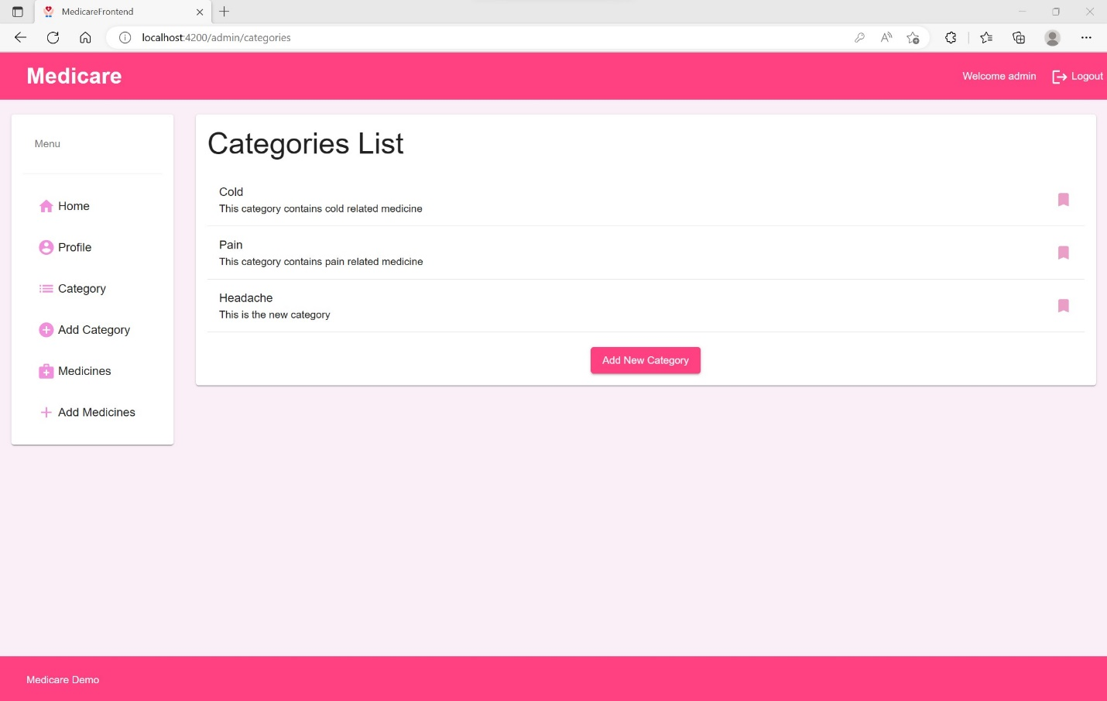

Admin Can View the medicine List

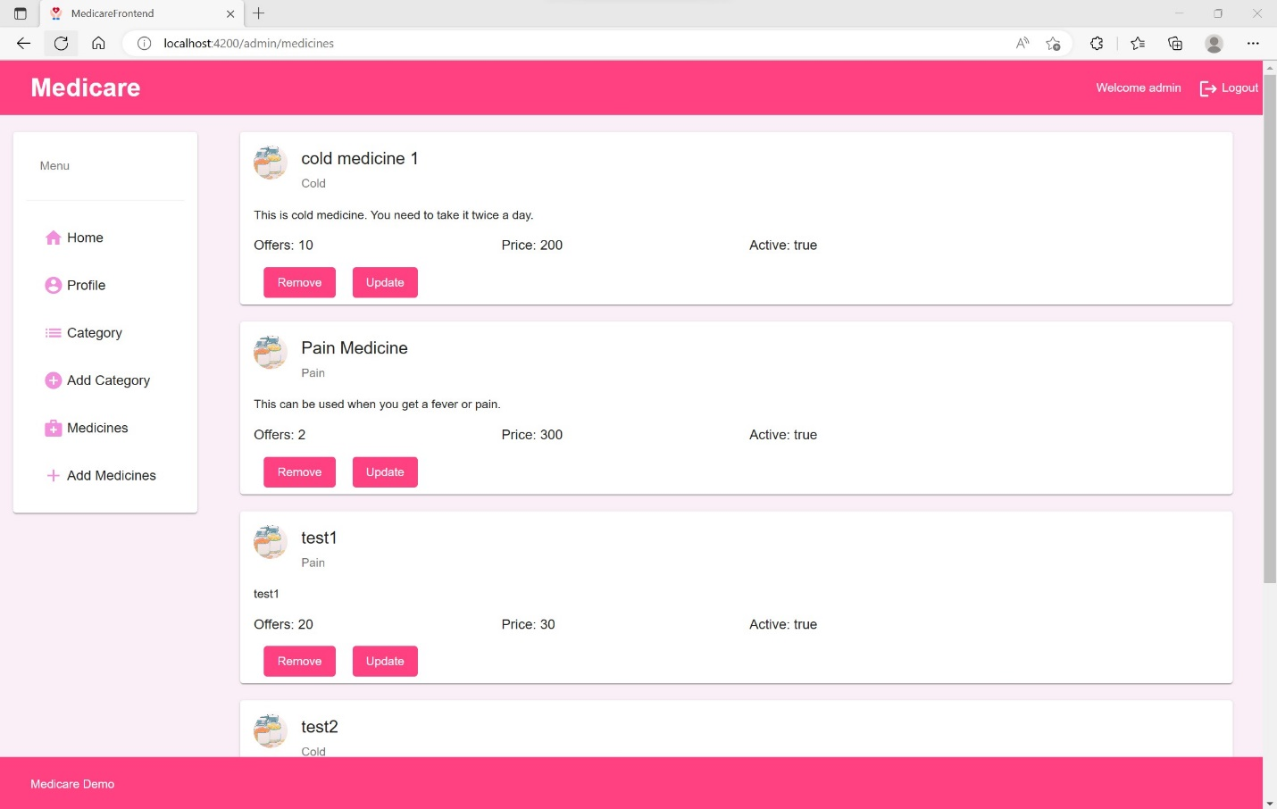

Admin can add New Medicine

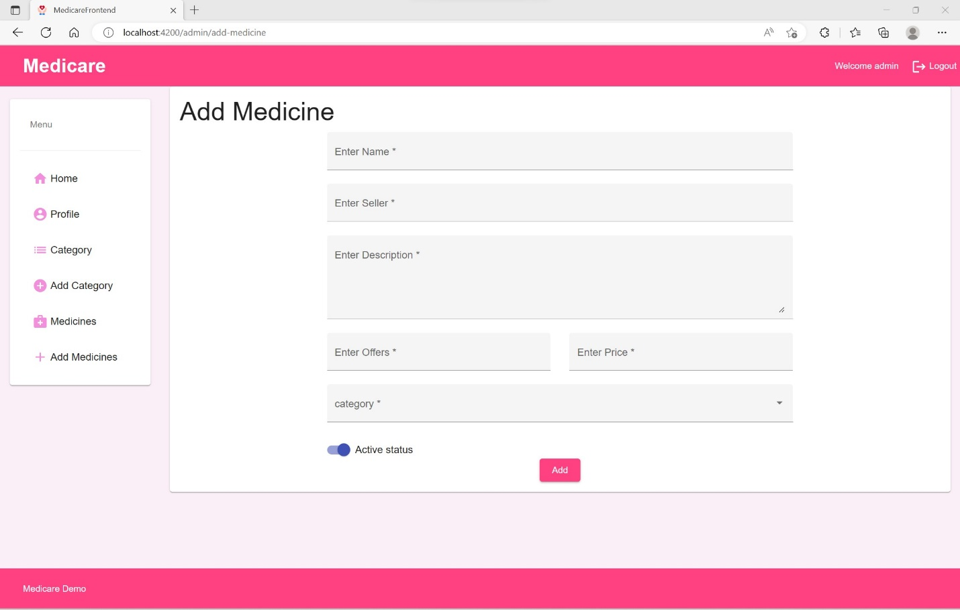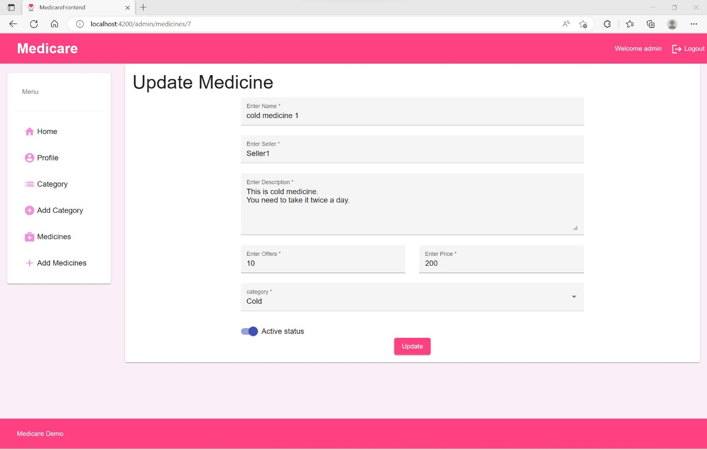

Admin can delete the medicine from list after clicking the Remove button

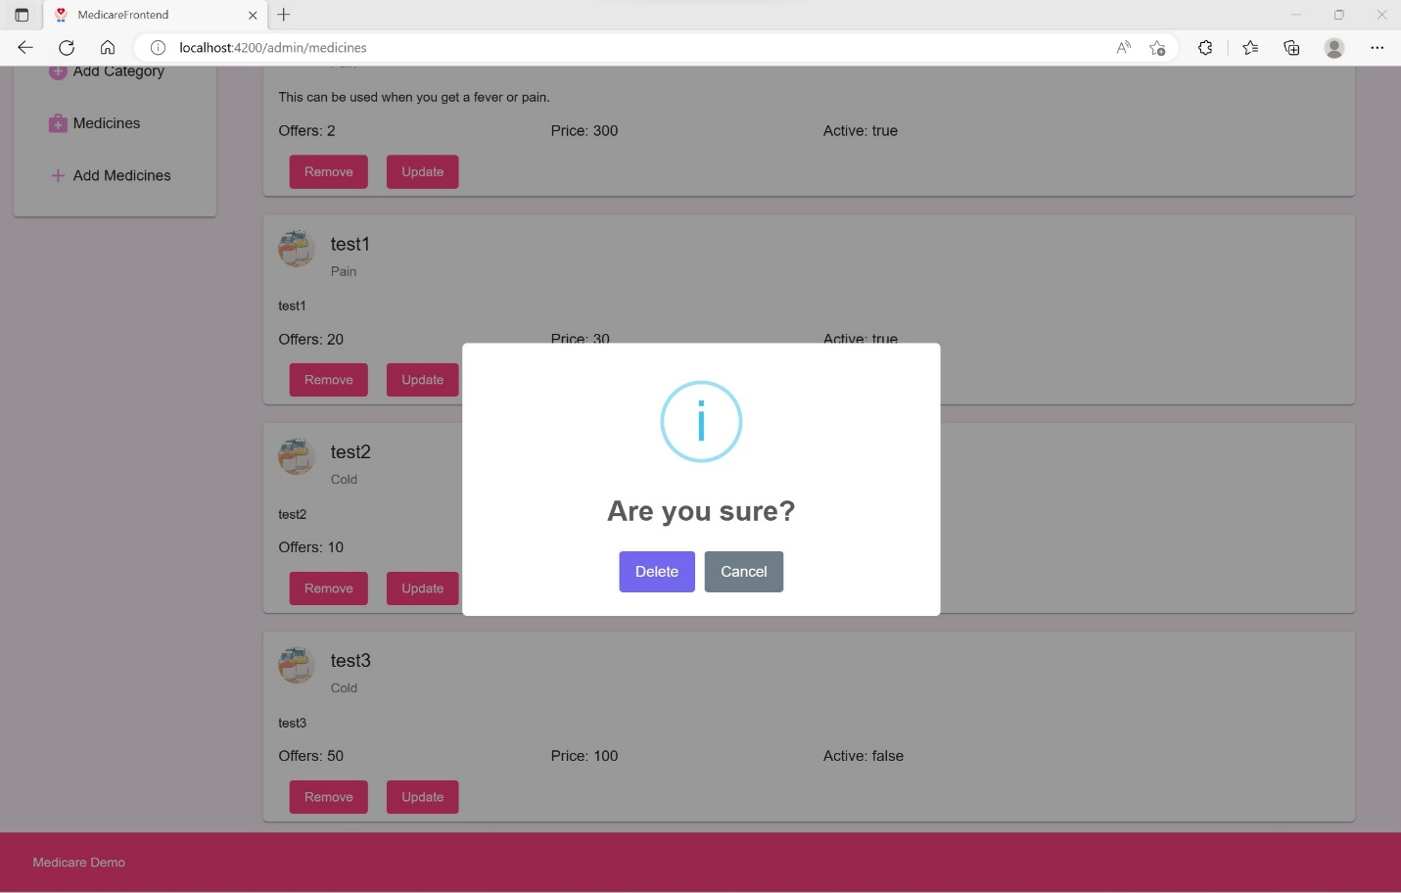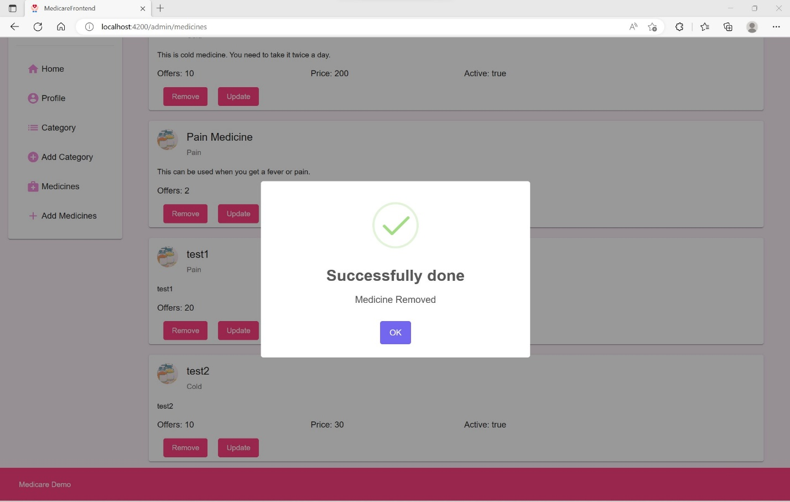

USER LOGIN Start

User can login using the user credentials which will lead him to the user Dashboard

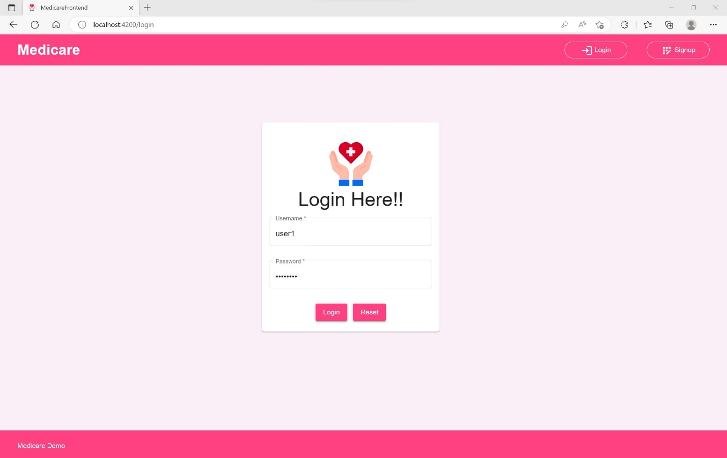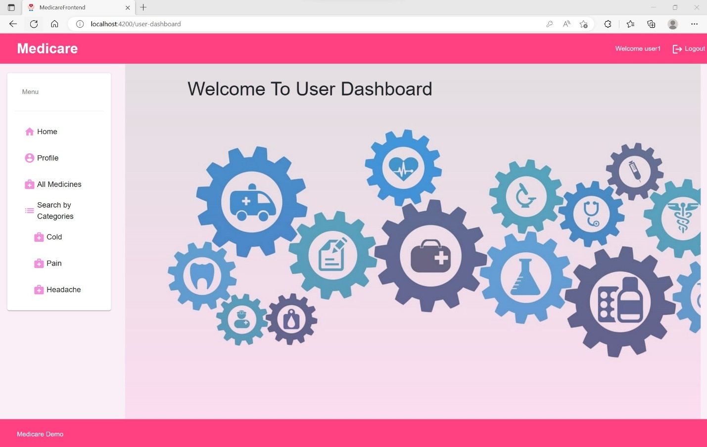

User can view the User Profile Information

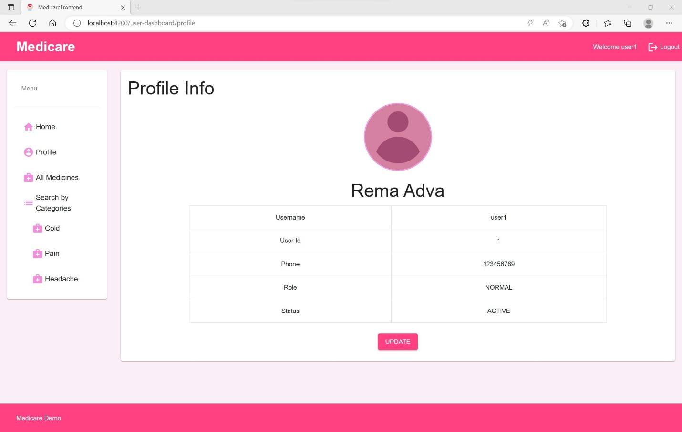

User can view the medicine list

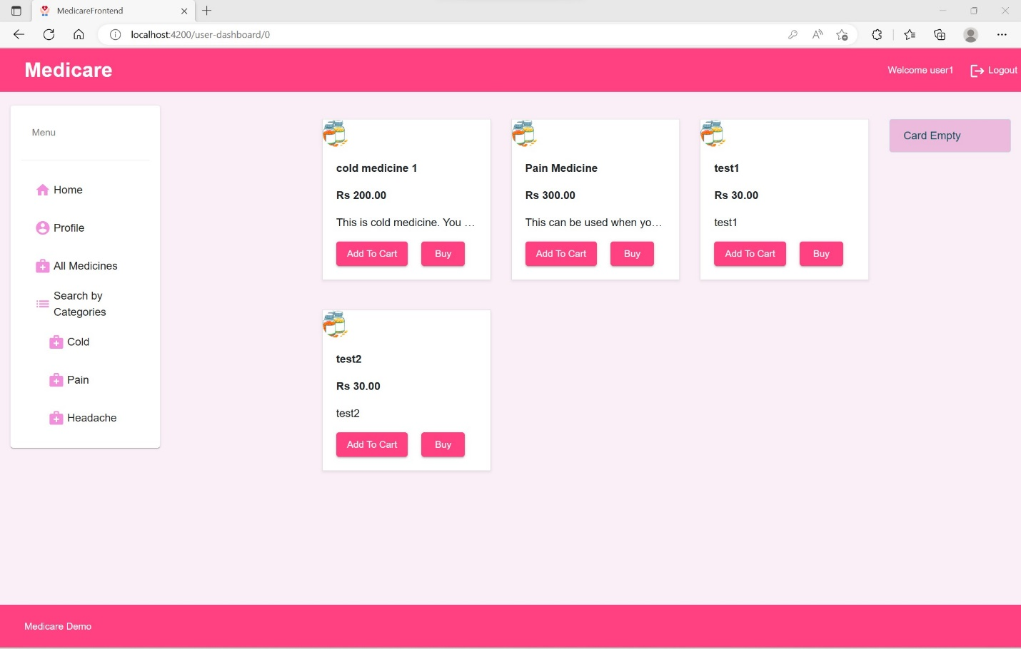

User Can Search the Listed Medicines by Categories. Here in this screenshot user is viewing the cold categories.

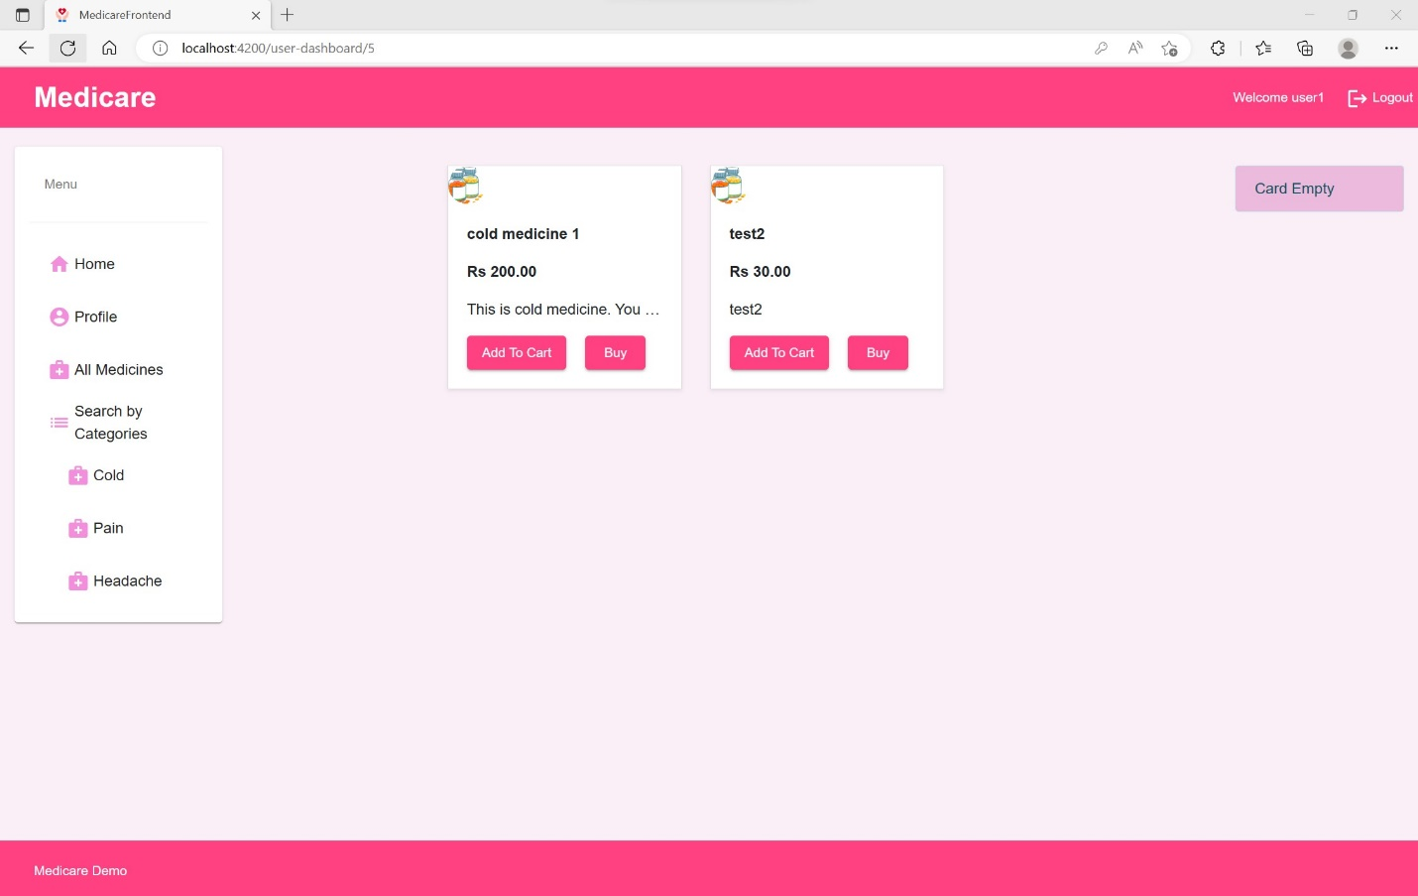

Here in this screenshot user is viewing the pain categories.

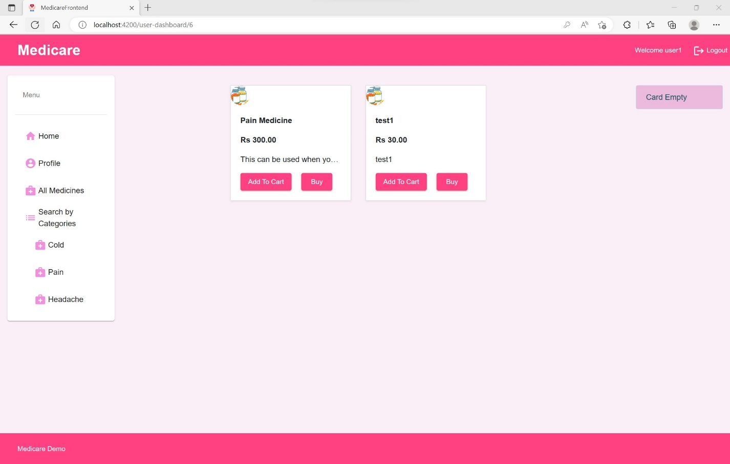

When there is no medicine listed in the category the user will see No medicine found message

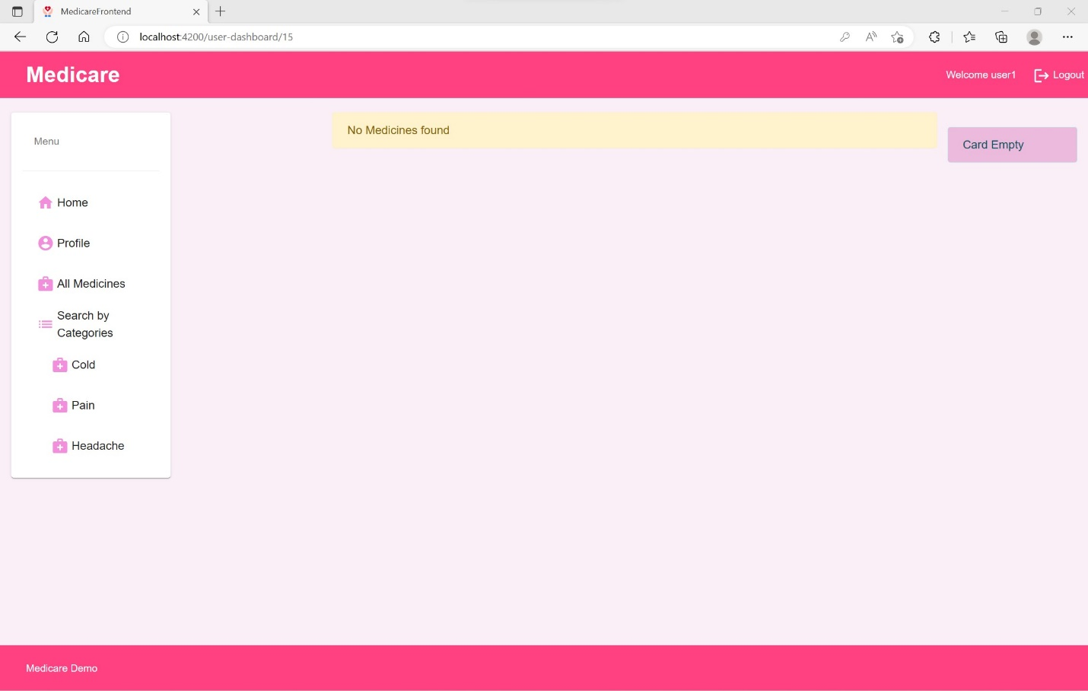

User Can ADD the Medicine IN the Cart by just clicking Add To Cart Button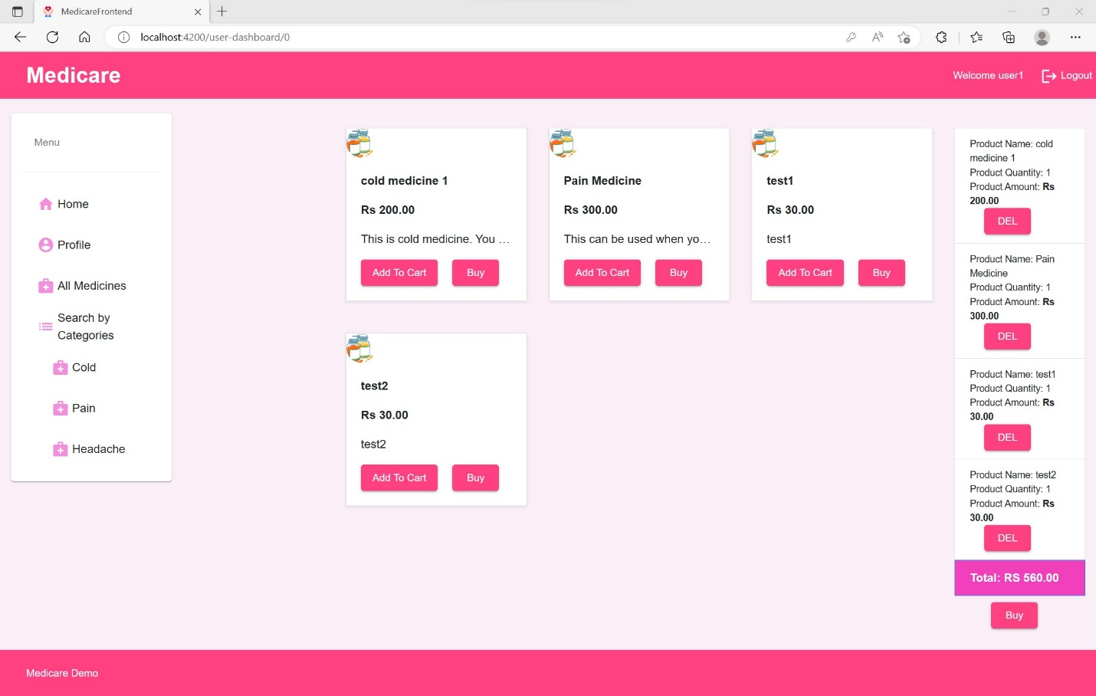

Finally, User can confirm the medicine added in the cart and enter the information to but the added product.

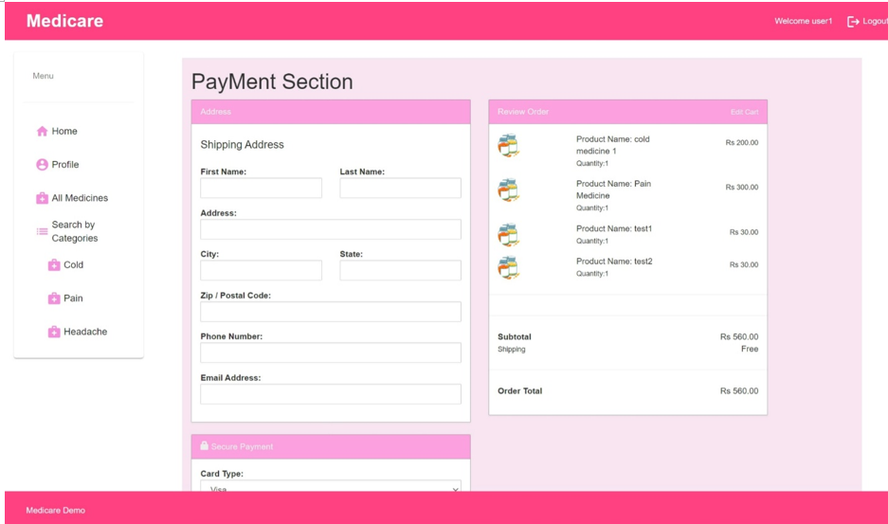

After adding the Information, user can click the Place order button to bur the product.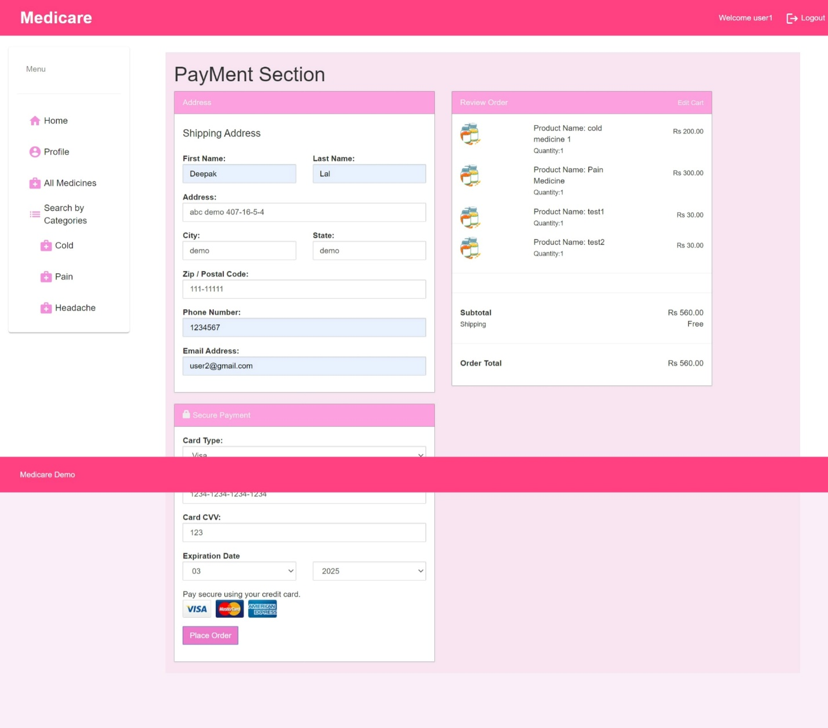

At last User can see the Successfully done message after successfully bought

