**AJAY KUMAR GARG ENGINEERING COLLEGE, GHAZIABAD**



SESSION: 2020-2021

Project Report on

**JOY OF PROGRAMMING USING PYTHON**

FOR TOPIC:

**EMAIL SLICER**

**UNDER THEGUIDANCE OF:**

Dr. PRATIMA SINGH Mr. BINAYAK PARASHAR

**SUBMITTED BY:**

* DIVYANSH RAJ (1900270110020)
* DIVYANSHI SINGH (1900270110021)
* GARIMA MITTAL (1900270110022)
* ISHIKA LAMBA (1900270110027)

**TABLE OF CONTENTS:**

1. ABSTRACT
2. CODE
3. INPUT FORMAT
4. OUTPUT FORMAT
5. EXAMPLE & OUTPUT
6. SAMPLE TEST CASE

**ABSTRACT:**

This is a convenient program that has a lot of use in the future. The program helps get you the username and domain name from an email address. You can even customize the application and send message the host with this information. Quick and easy way to extract email username and email domain from an email address input by the user. Project uses the string methods slice and index to accomplish the task.

**CODE:**

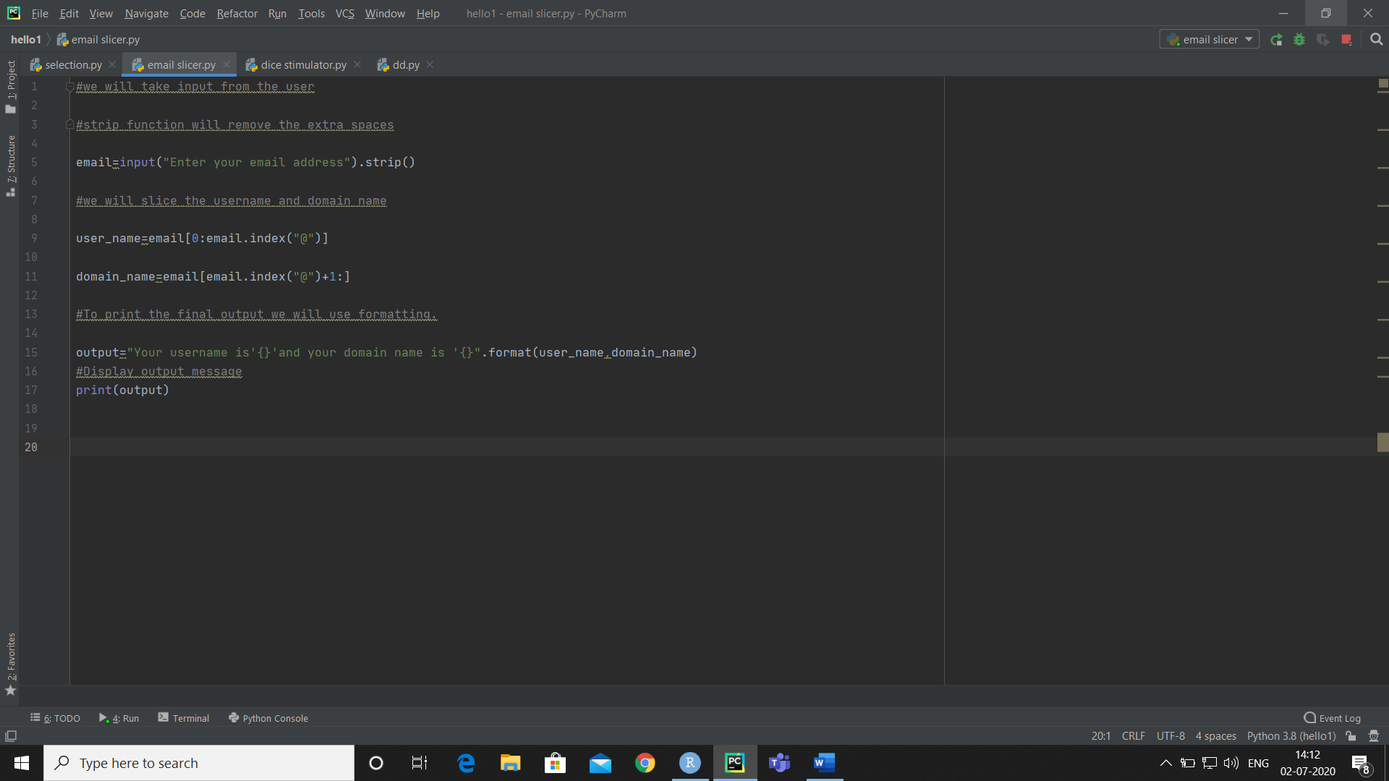

**INPUT FORMAT:**

**ENTER THE EMAIL ADDRESS YOU WANT TO SLICE.**

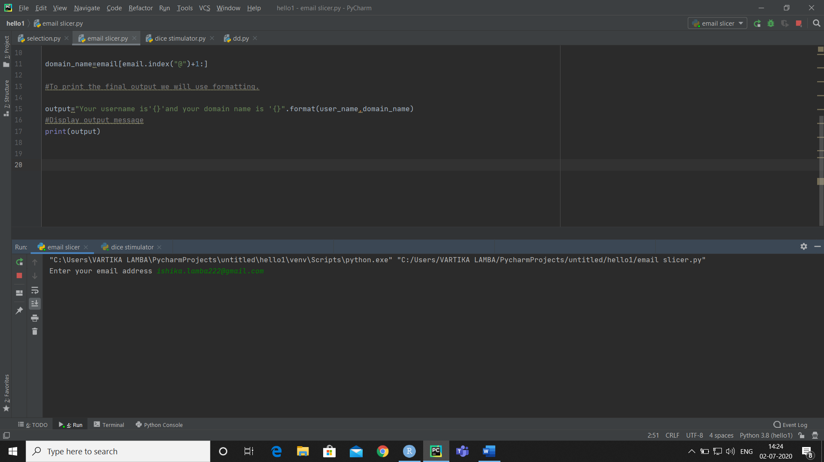

**OUTPUT FORMAT:**

**THE PROGRAM OUTPUT WILL BE:**

**YOUR EMAIL USERNAME IS – ‘ ishika.lamba222 ‘**

**YOUR SERVER DOMAIN NAME IS – ‘ gmail.com ‘**

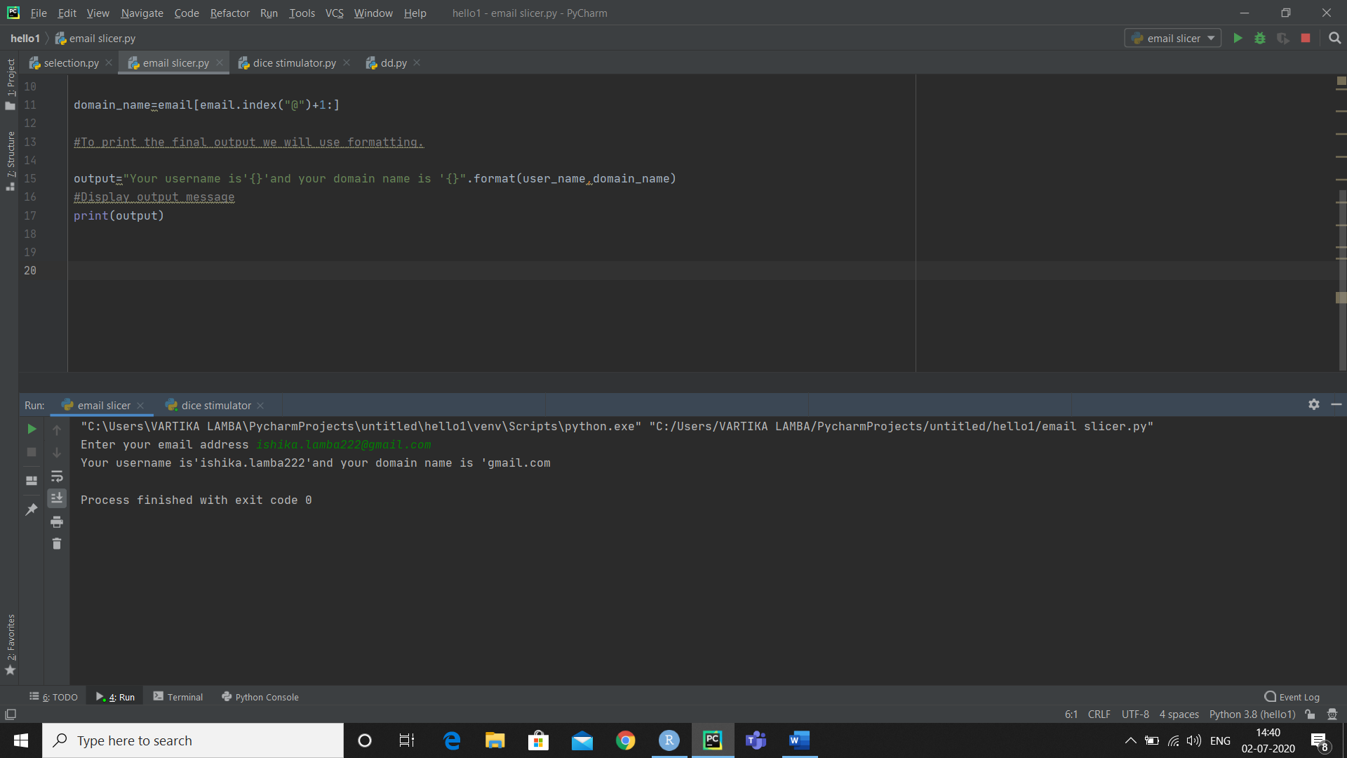

**EXAMPLE AND OUTPUT:**

* **INPUT-** [**somemailaddy@gmail.com**](mailto:somemailaddy@gmail.com)
* **OUTPUT:**
* **Your username is- somemailaddy**
* **Your domain name is- gmail.com**
* **INPUT-** [**www.sports@icloud.com**](http://www.sports@icloud.com)
* **OUTPUT:**
* **Your username is- www.sports**
* **Your domain name is- icloud.com**
* **INPUT-** [**ramkumar124@gmail.com**](mailto:ramkumar124@gmail.com)
* **OUTPUT:**
* **Your username is- ramkumar124**
* **Your domain name is- gmail.com**

**SAMPLE TEST CASES:**

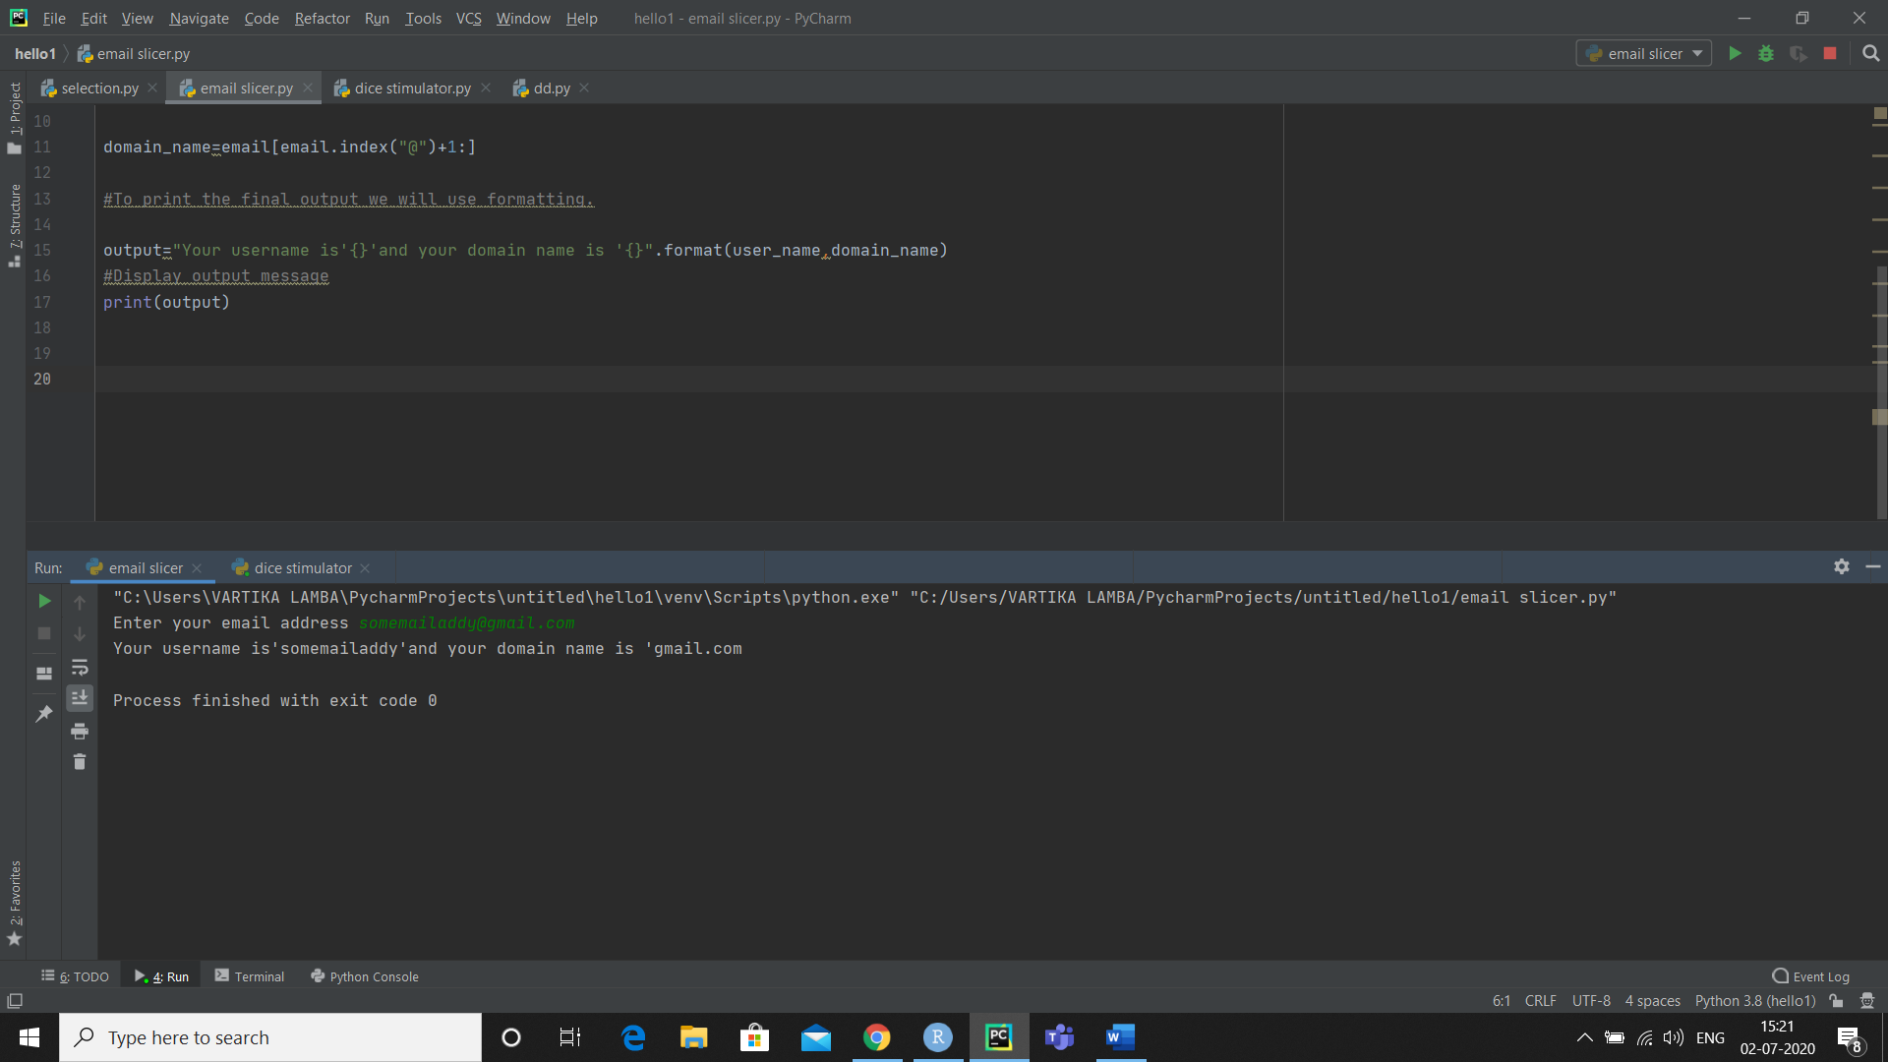

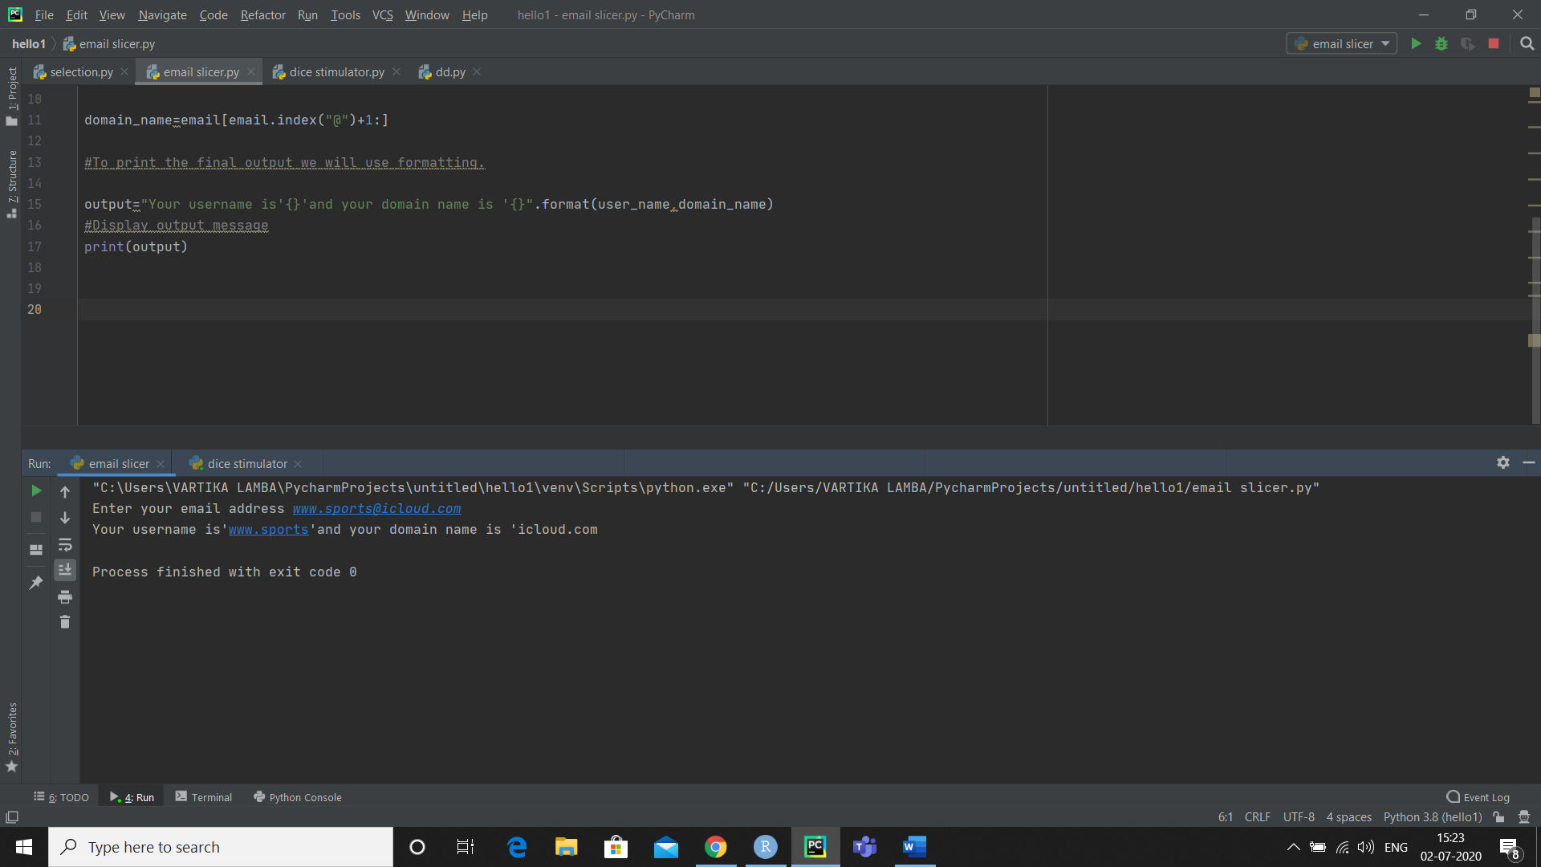

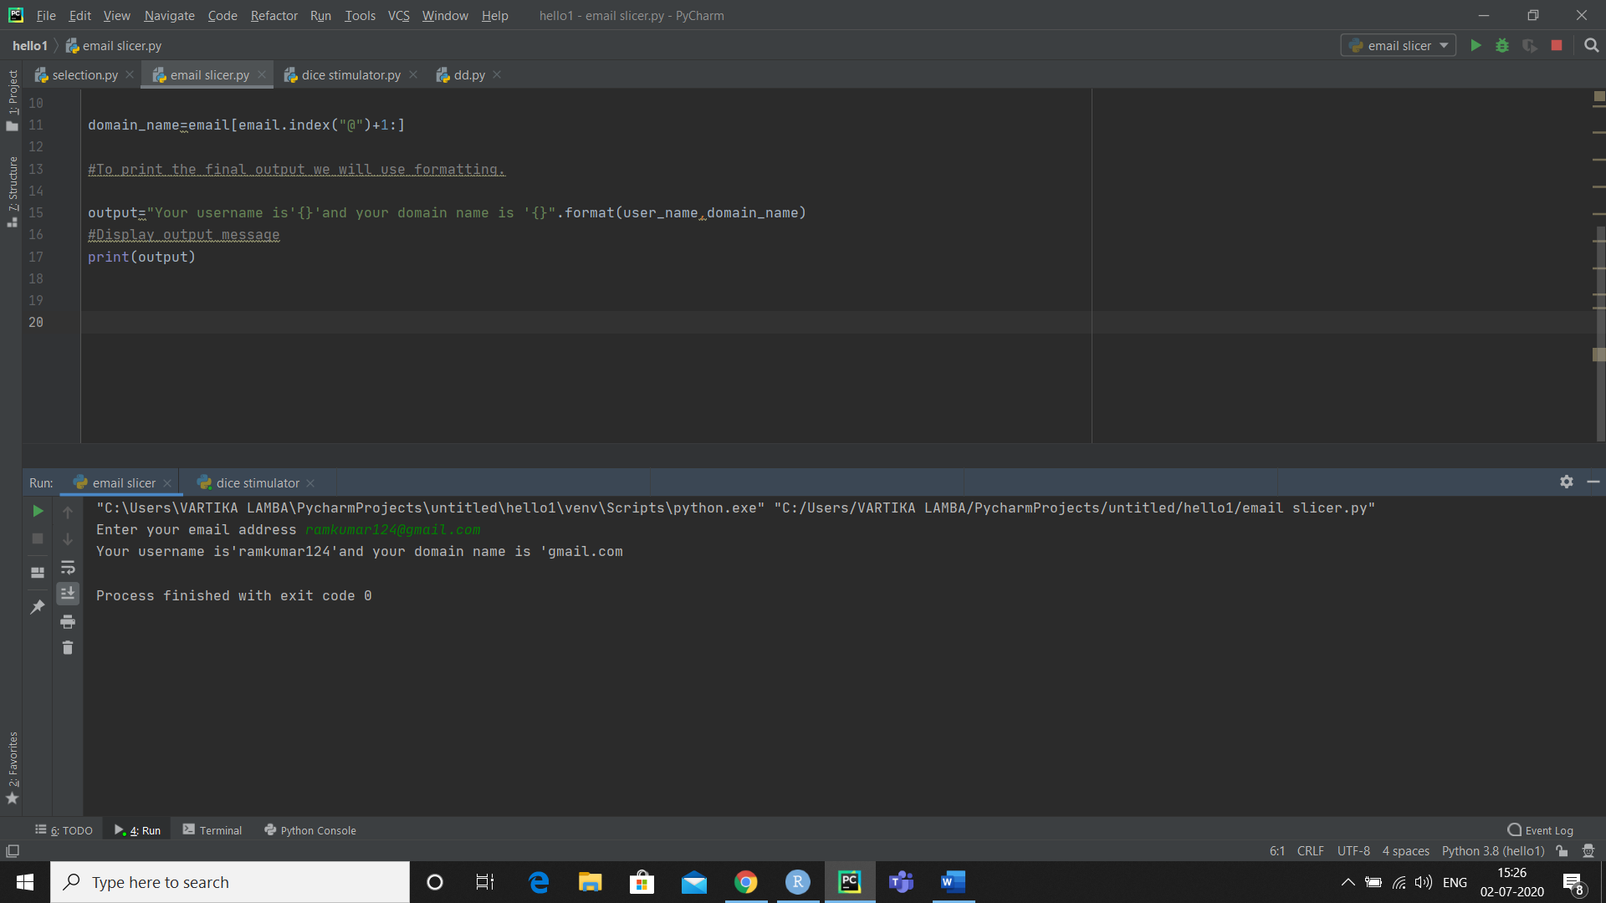

**CONCLUSION:**

* **strip() in built function of python is used to remove all the leading and trailling spaces from a string.**
* **You can customize and send a message to the user with this information.**
* **The built in format() method returns a formatted representation of the given value controlled by the format specifier.**

**REFERENCE:**

* **GeeksForGeeks**
* **Youtube**
* **Wikipedia**
* **Summer internship program on python**

**ASSIGNMENT:**

**Q.1) Write a python program that multiplies all the items in a list.**

**CODE:**

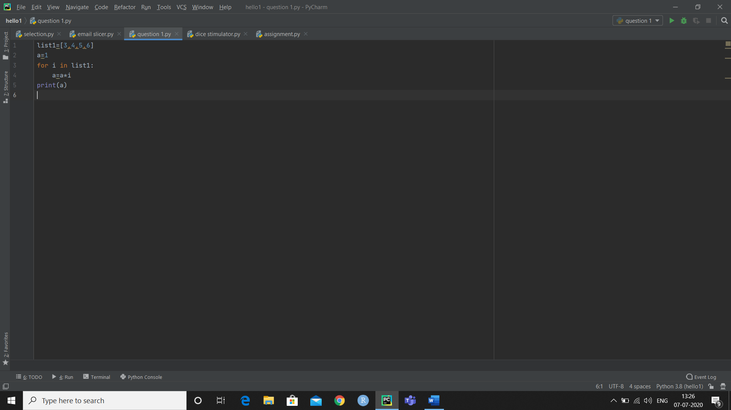

**OUTPUT:**

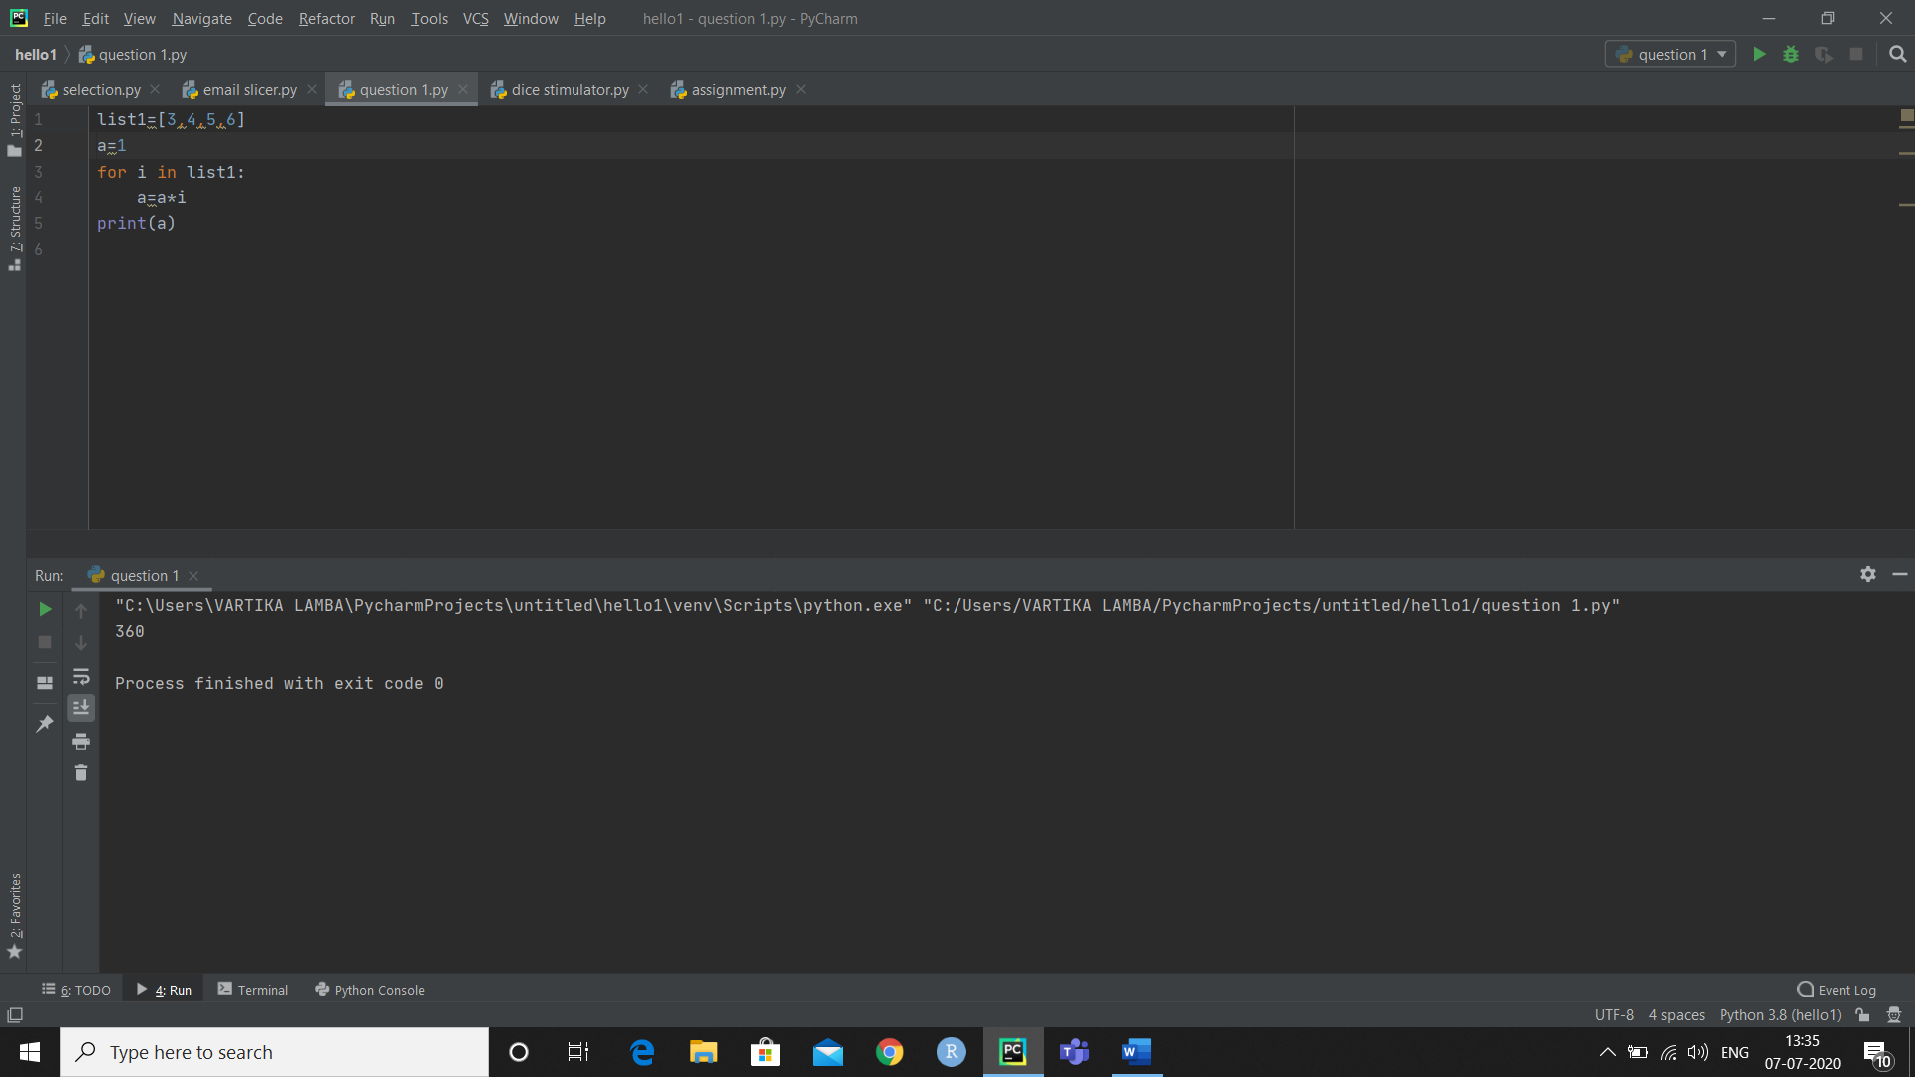

**Q.4) Write a python program to print the numbers of a specified list after removing even numbers from it.**

**CODE:**

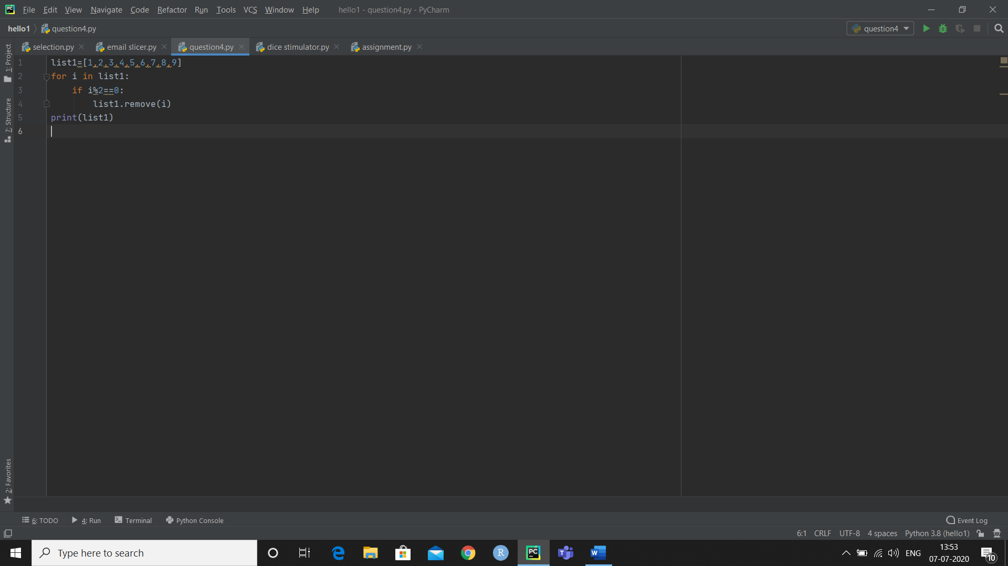

**OUTPUT:**

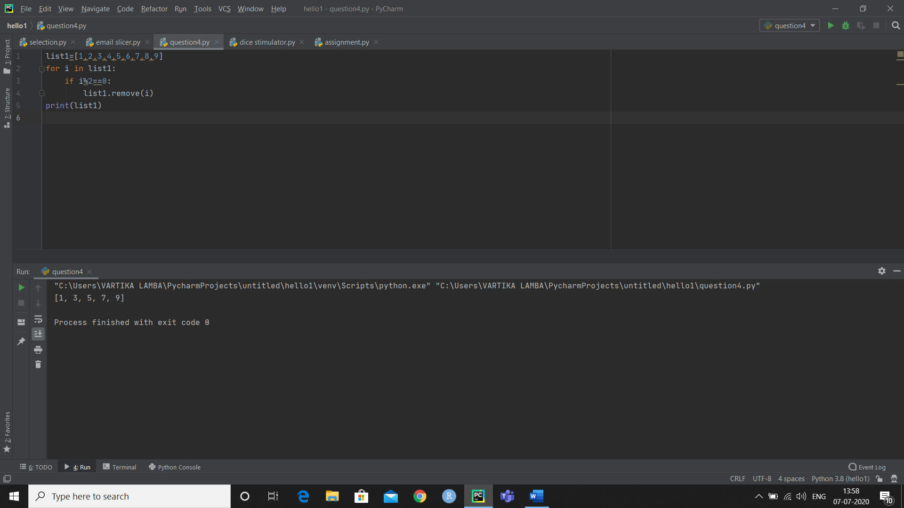

**Q.8) Write a python program to sort the elements of list in descending order.**

**CODE:**

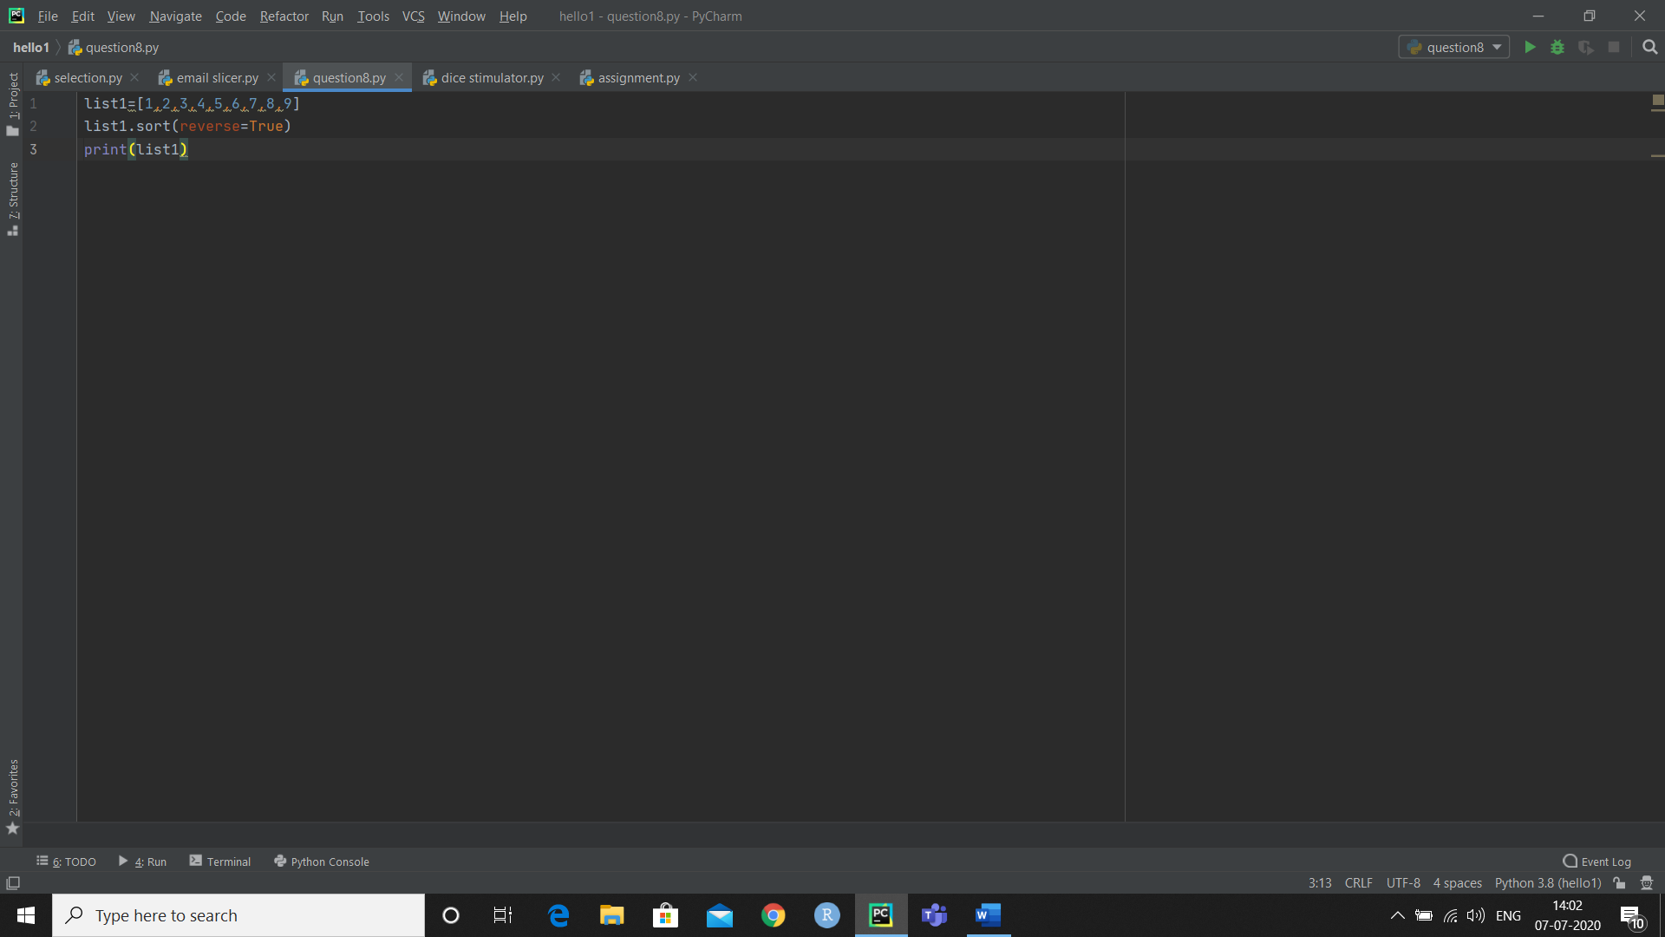

**OUTPUT:**

