Introduction:
Vprofile is a multi-tier web app written in Java. It consists of multiple services like nginx, apache Tomcat(Java servlet), mysql, RabbitMQ, Memcached. We will be deploying this product on 5 different local VMs. We will use IaC and automate the whole process
Tools needed:
- Hypervisor- Oracle Virtualbox for Windows
- Automation- Vagrant VM manager
- CLI- Git Bash for windows
- IDE- VS Code or any other of your choice
Architecture of project services:
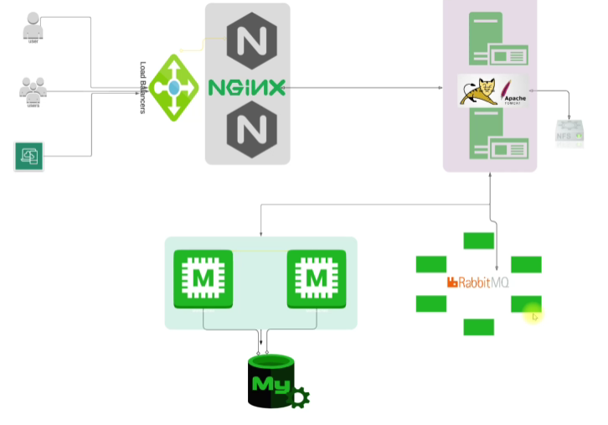
- NGINX: Web service for load balancing that will route request to Apache Tomcat server
- Apache Tomcat: Java web-app server for hosting. The java apps would be sitting here.
- NFS: for external storage in Java app
- Rabbit MQ: Dummy service in this project. It is actually a message broker or queuing agent to stream data
- Memcached: Database cache connected to the Mysql server.
- Mysql: Database
Setting up web application stack:
- Cd into Vagrant directory
- Bring up VMs
- Validate
- Setup all the services:
- Mysql
- Memcached
- Rabbit MQ
- Tomcat
- NGINX
- App build & deploy
- Verify from browser
Setting up VMs manually VagrantFile:
- Install hostmanager plugin
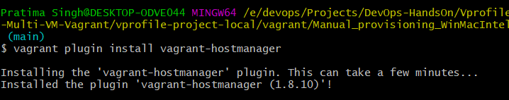
The vagrant-hostmanager is a Vagrant plugin that manages the /etc/hosts file on guest virtual machines and optionally the host machine, enabling name resolution in multi-machine environments where IP addresses might not be known in advance or change frequently.
In a multi-machine environment, "name resolution" is the process of translating human-readable hostnames (like web-server or db-node) into the numeric IP addresses (like 192.168.56.10) that computers use to communicate
- Bring up all the VMs
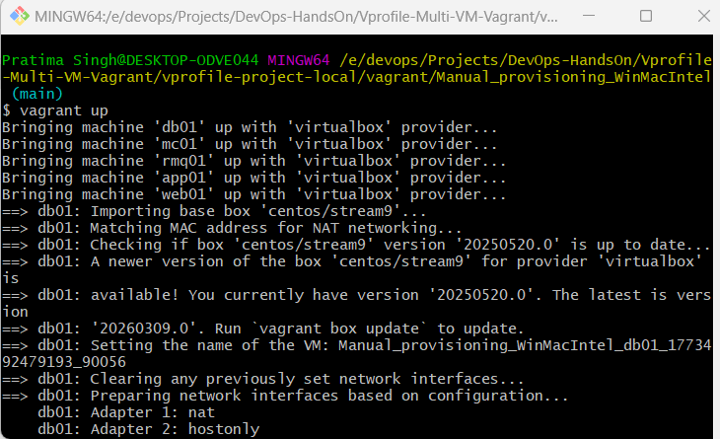
- All the vm’s hostname and /etc/hosts file entries will be automatically updated.
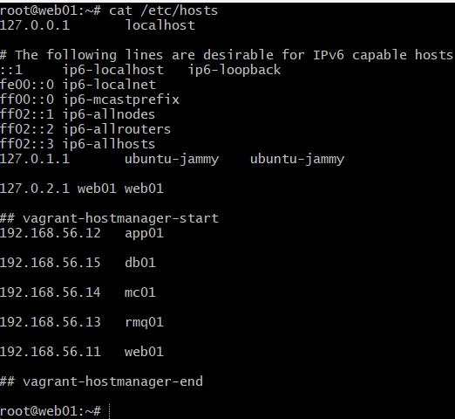
You can check name resolution working or not by pinging to ‘app01’ host
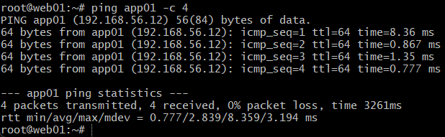
Database setup – MySQL VM
- Login to db01 VM and switch to root user
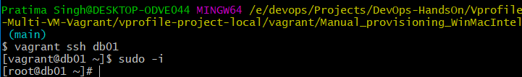
- Update OS with latest patches
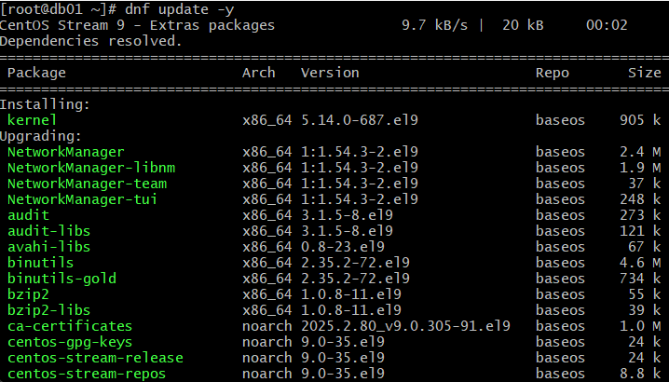
This checks all enabled repositories for newer versions of your installed software and updates them, along with their dependencies. These repositories serve as central storage locations for software packages and their metadata
DNF reads its repository configurations from specific files on your local disk:
- Individual Repo Files: Most repository definitions are stored in the /etc/yum.repos.d/ directory as files ending in .repo.
- Main Configuration: Global settings for DNF are located in /etc/dnf/dnf.conf
- Install epel-release repo. This repo provides a wide range of popular software packages not included in the default RHEL repositories
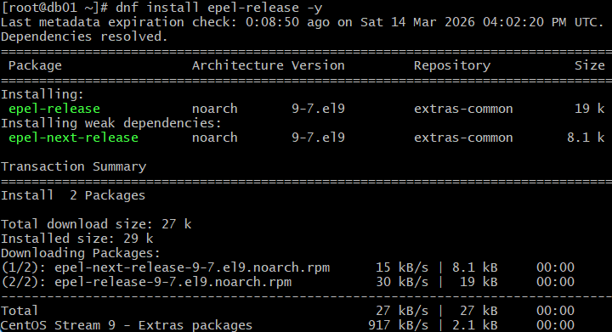
- Install mariadb-server. In CentOS mysql can be installed via maria-db
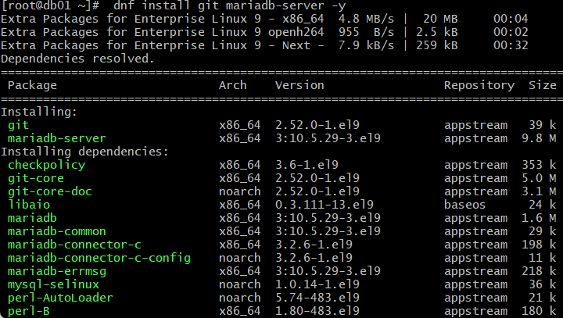
- Start and enable mariadb service
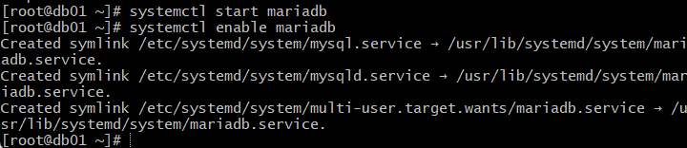
- Check status of mariadb
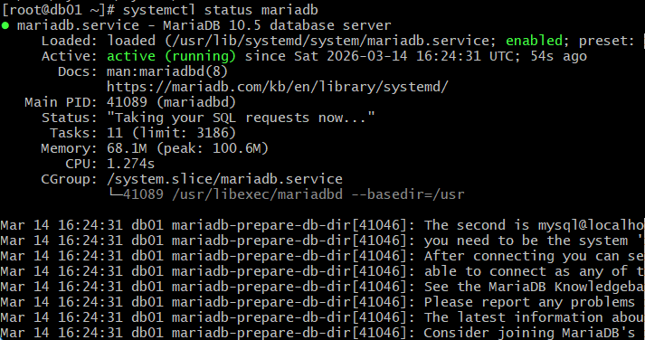
- Add secure installation of db
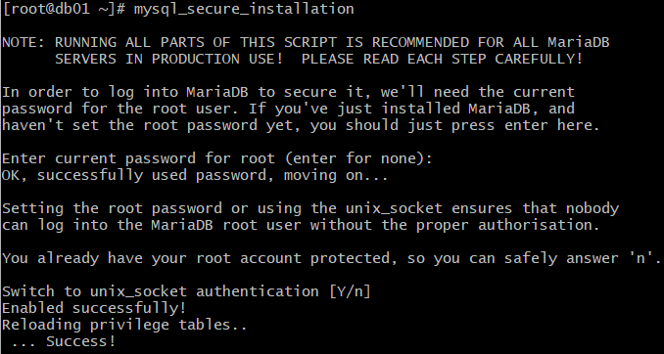
- Login to mysql as root, with password you have set
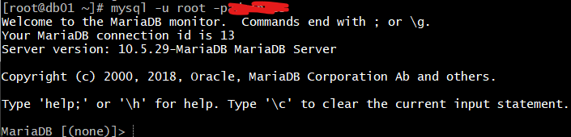
- Create database accounts
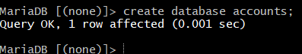
- Grant all privileges to ‘admin’ user locally on ‘account’ database
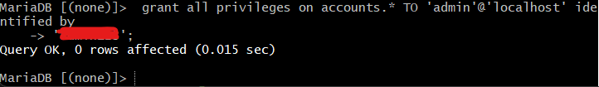
- Grant all privileges to ‘admin’ user on remote machine(%), on ‘account’ database
- Reload grant tables responsible for storing info. on privileges, roles, etc
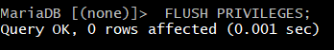
- Initialize ‘accounts’ database
- Login directly to accounts database
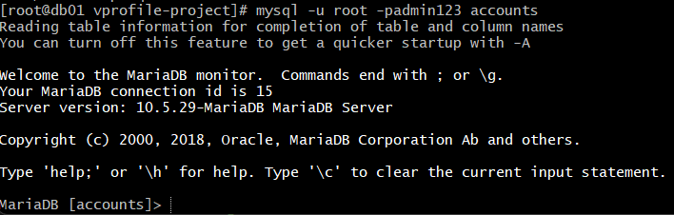
- Check tables in ‘accounts’
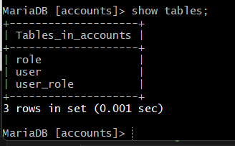
Memcached service setup
- Login to VM and switch to root user
- Update OS with latest patches
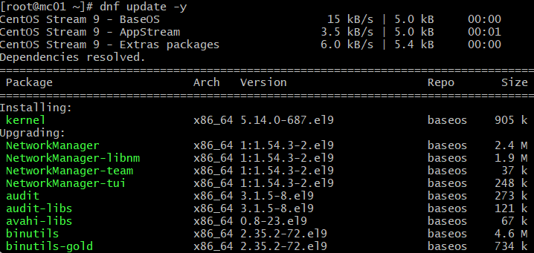
- Install epel-release repository
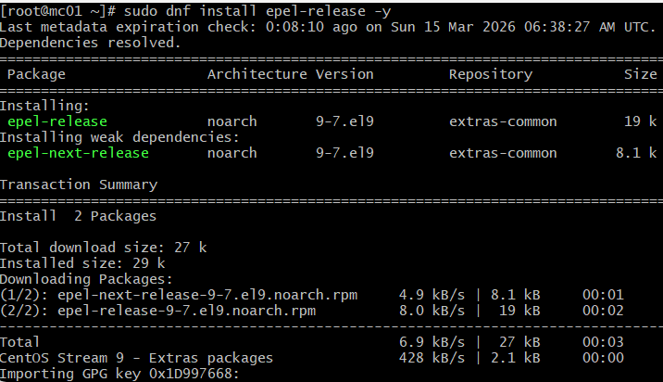
- Install Memcached package
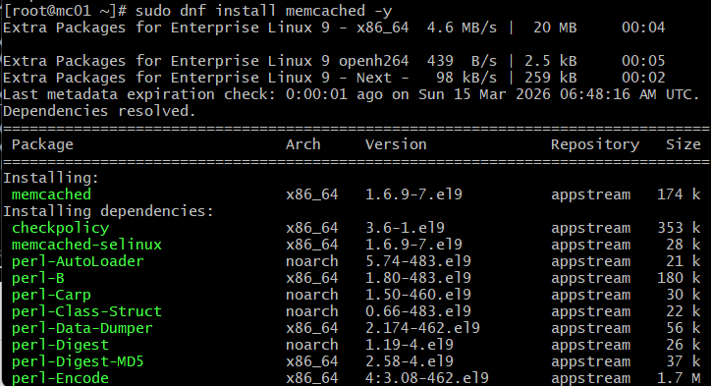
- Start and enable Memcached
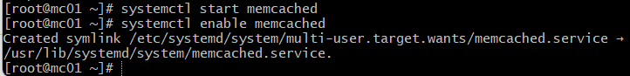
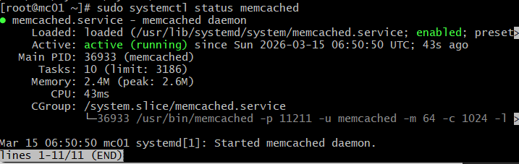
- Replace localhost IP to 0.0.0.0 (means allow any IP) in /etc/sysconfig/Memcached. By default it’s set to 127.0.0.1 which doesn’t allow external connection.
- Assign TCP port to Memcached, assign UDP port and run the process as a daemon (-d)
RabbitMQ package setup on VM
- Login to VM and switch to root user
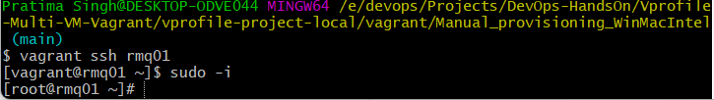
- Update OS with latest patches. dnf update -y
- Install epel-release repository
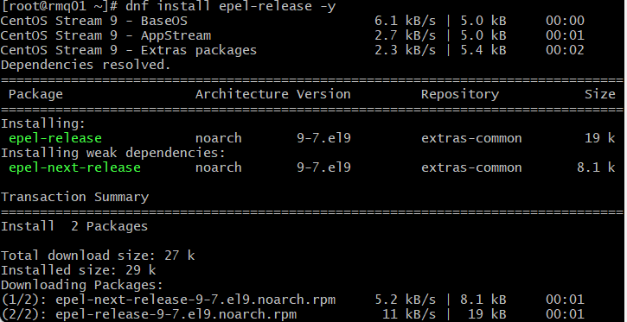

- Install repository for downloading rabbitmq package
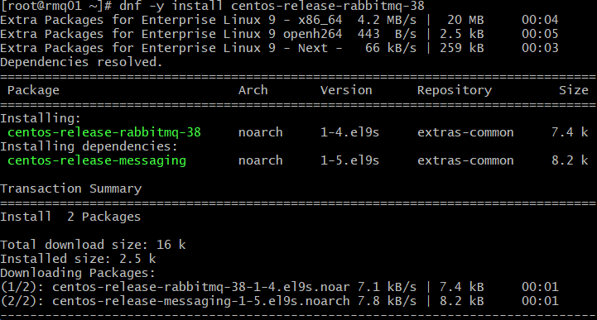
- Enable this repository and install rabbitmq package from the same
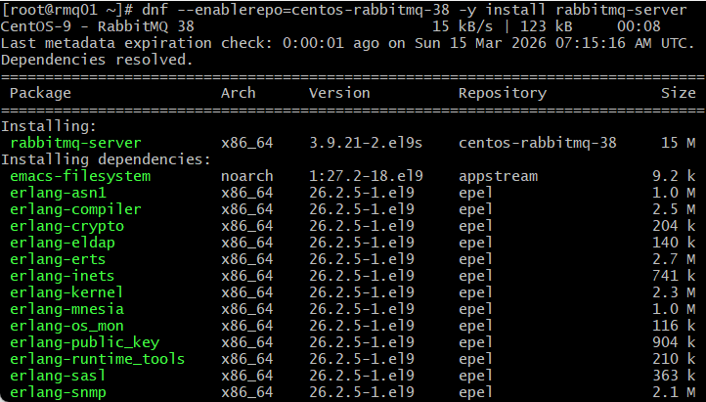
- Enable the rabbitmq service
- Allow remote connections to rabbitmq by setting loopback_users to an empty list ([]). By default, RabbitMQ restricts the guest user
- Create user test for rabbitmq
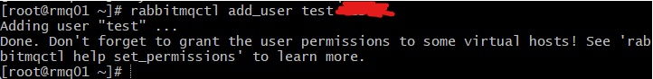
- Give this user ‘administrator’ tag
- Set permissions for user ‘test’ on the rabbitmq exchanges and queue
The regex ".*" means "match everything." By applying it to all three categories, you are giving the user test unrestricted access to configure, write to, and read from every resource in the / virtual host.
- Restart rabbitmq service
Tomcat service setup
Follow the same steps in systemctl 101
Maven setup – Maven is used to build java apps
- Download Maven binary
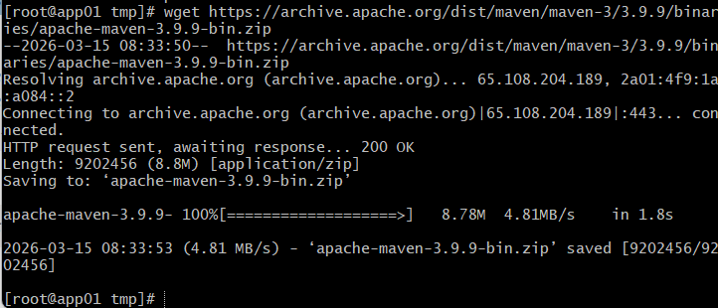
- Unzip the binary
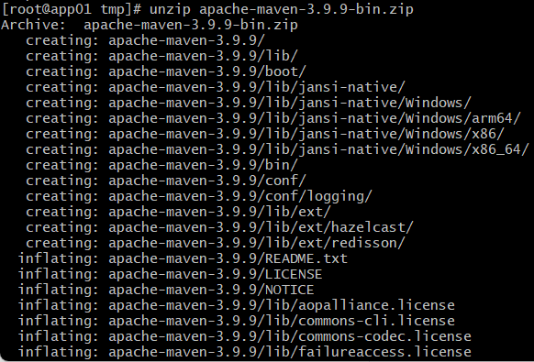
- Copy all the extracted content to maven home directory
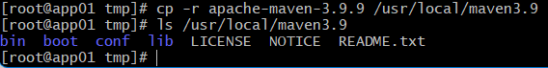
- Set required RAM memory to 512MB
Note: application.properties contains information about other services to connect to them. IP, passwords, etc. It will located inside src/main/resources/
- To build the code, make sure you are in your code directory. Then run the mvn install to build. Mvn is a binary. This will produce your software artifact.
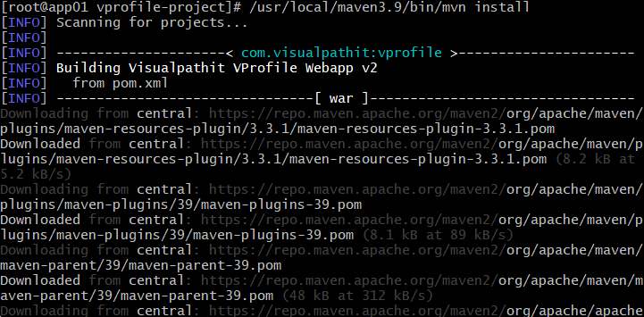
Your artifact will be saved in target/ inside current directory with .war extension (war is an archive in Java)
- Now, to deploy this artifact on tomcat server, you’ve got to replace the ROOT folder inside /usr/local/tomcat/webapps with this artifact like so.
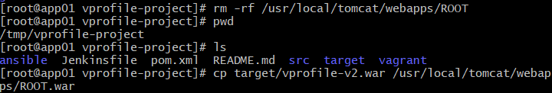
- Change ownership of webapps/ to tomcat user
- Restart the tomcat service and check if active
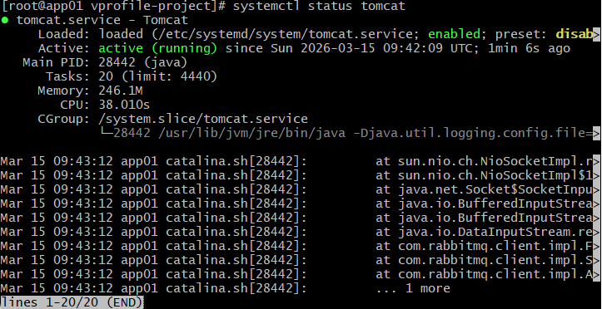
NGINX Setup – Load balancer
This service will be installed on Ubuntu VM
- Login to web01 VM and switch to root user
- Apply latest patches
- Install nginx package
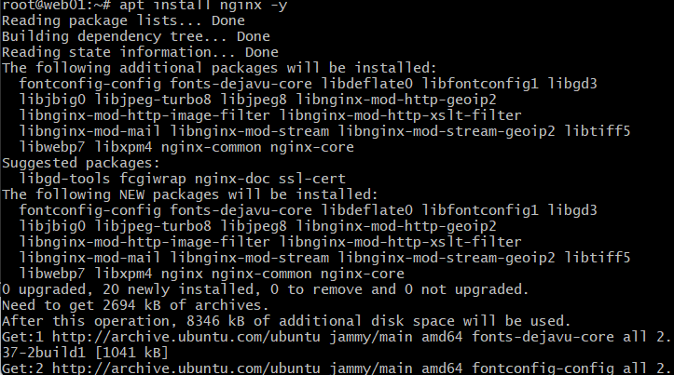
FYI: In web servers like Apache and Nginx (on Debian-based systems), the sites-available directory stores all configuration files, while the sites-enabled directory contains only symbolic links to the configuration files of the websites that are currently active and being served
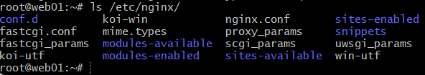
- Create a conf file inside sites-available with below code. Code explanation below
upstream vproapp { server app01:8080; } server { listen 80; location / { proxy_pass http://vproapp; } }
Server block: If any requests come to port 80, then pass it to the mentioned url.
Upstream block: Any request to vproapp, it will be forwarded to ‘app01’ server on port 8080
- Remove default nginx conf. And create link in sites-enabled to activate website
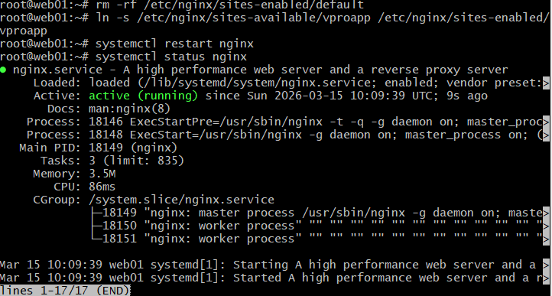
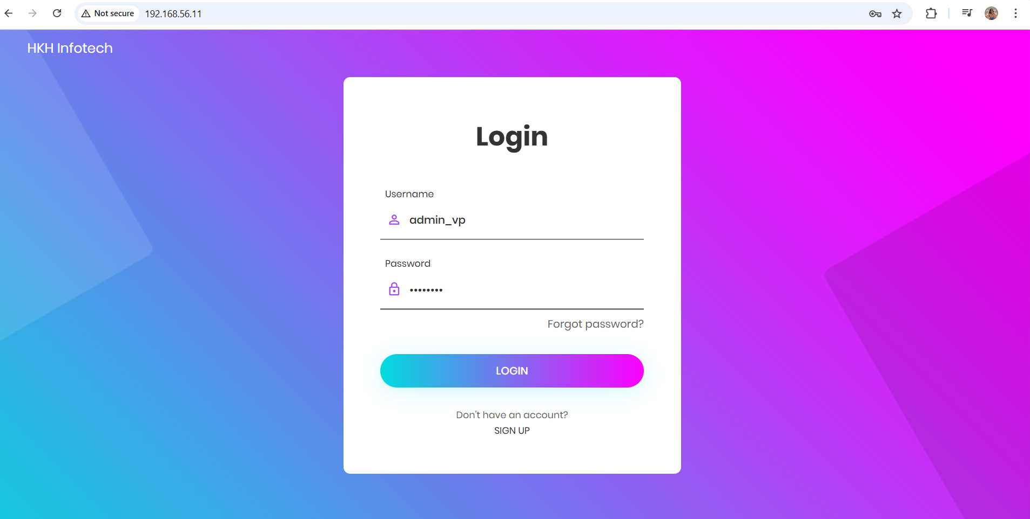
Use the credentials stored in database to login
Website HomePage
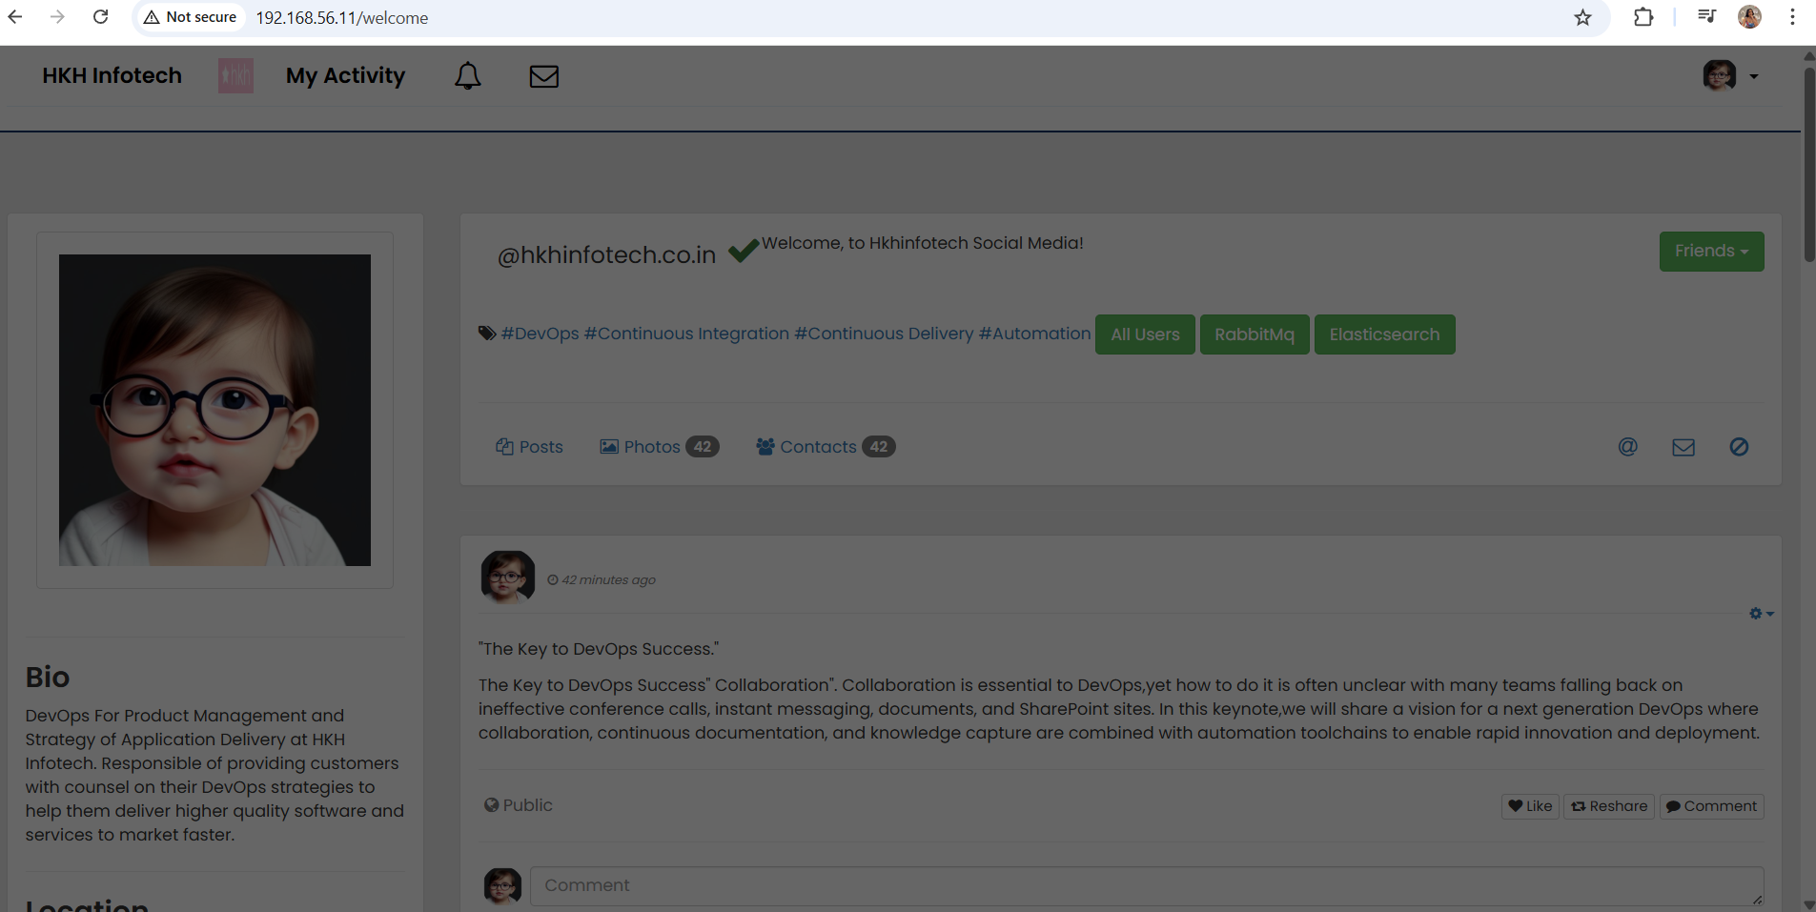
Click on RabbitMQ button to initialise it
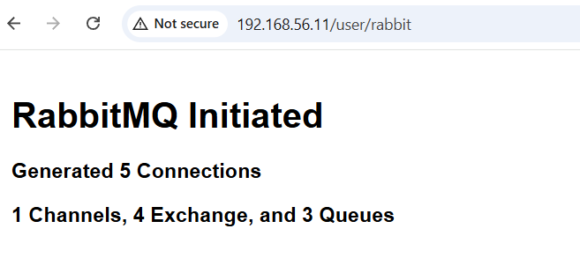
Click on Users button to view all the users
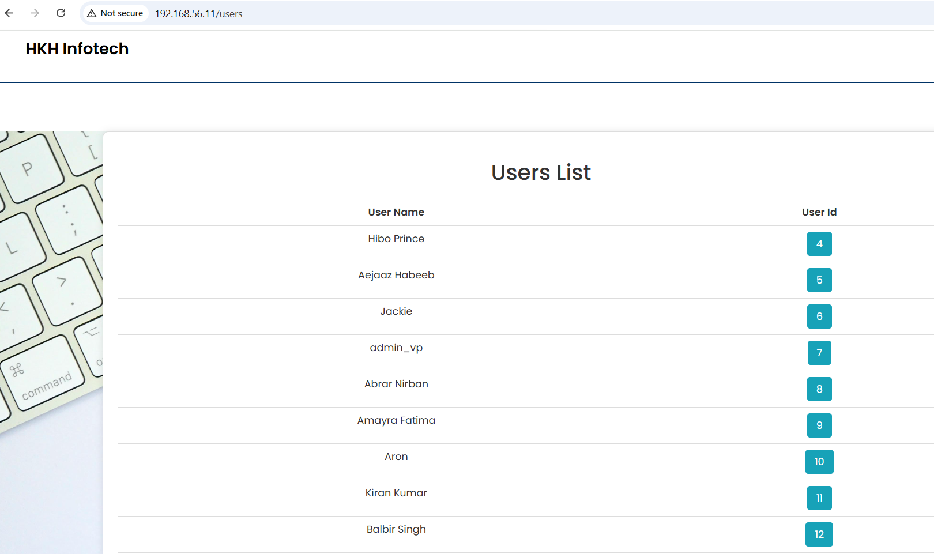
Viewing a particular user’s page for the first time. The data is inserted in database cache.
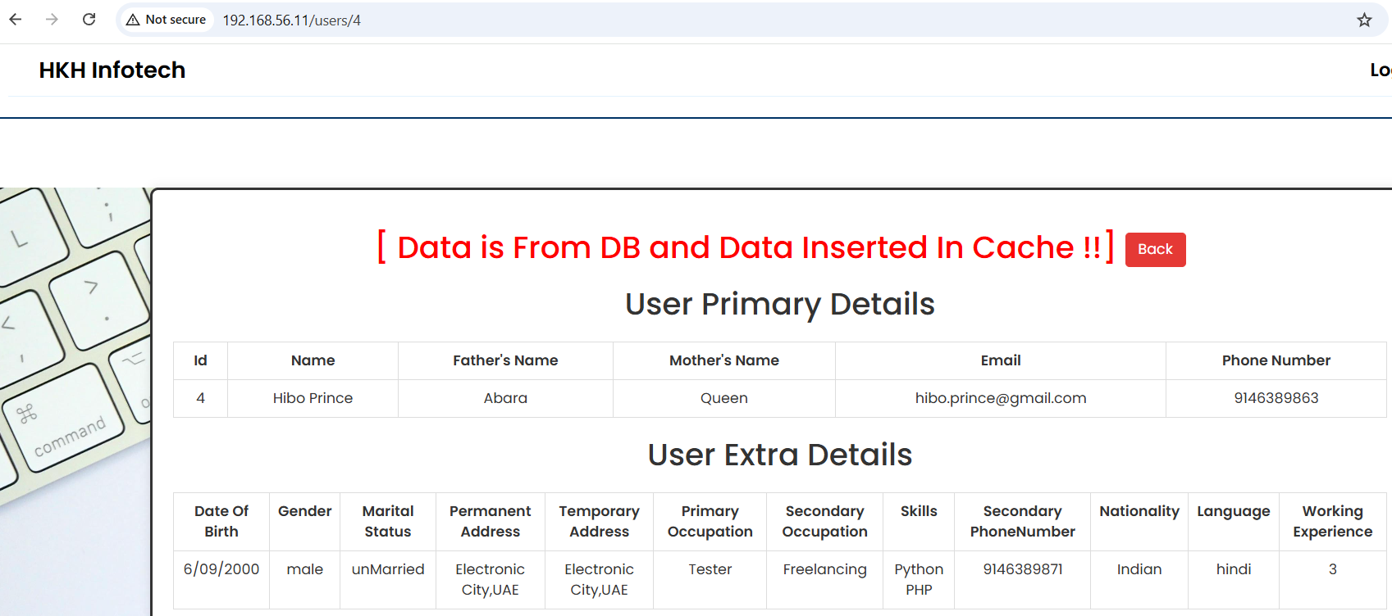
Click back. And then view the same user again and you will see the heading “Data from cache” meaning the data for this user was fetched from database cache directly

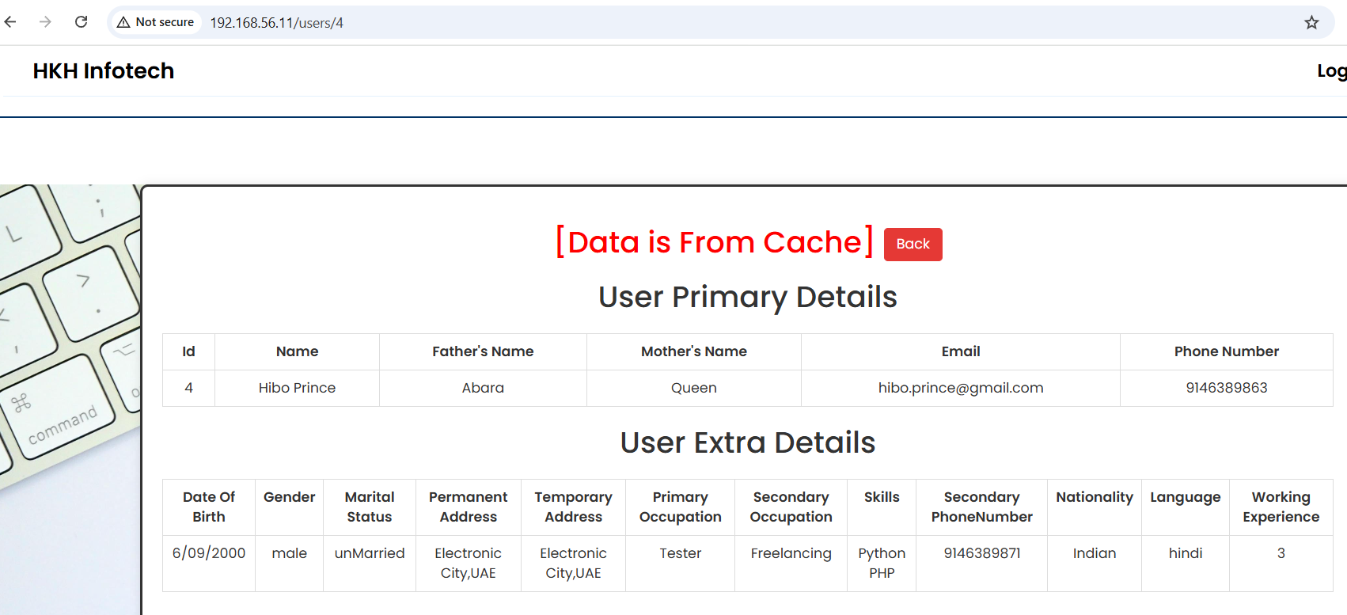

Automatic Setup of services on VM
  - Vagrant up inside automatic-provisioning folder
- 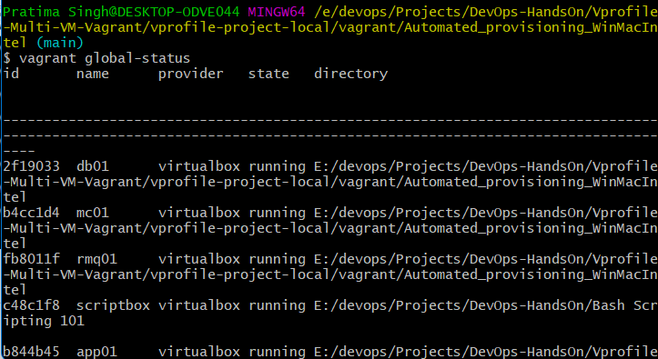
2. Access the webpage using IP of nginx server

