If you have an application stack that needs to run multiple services like database, application service, frontend service, etc. on different VMs, then you can make use of a multi-VM VagrantFile for convenience.
VagrantFile result. Vagrant up:
VM1
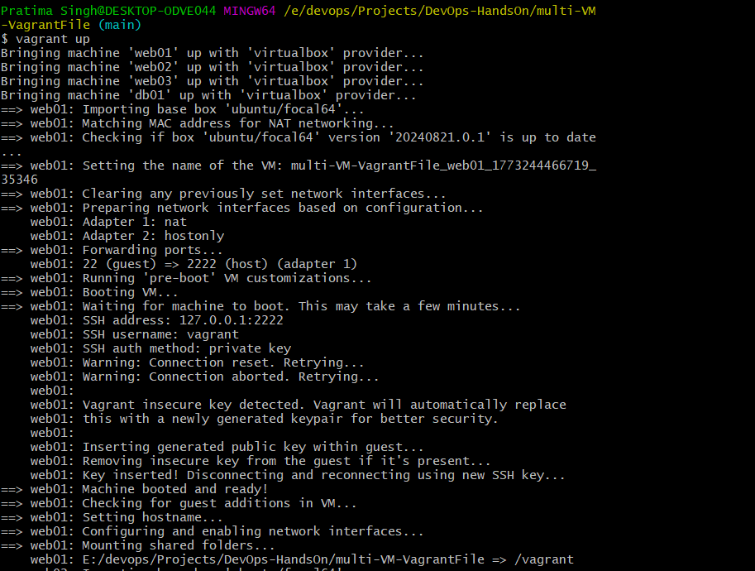
VM 2
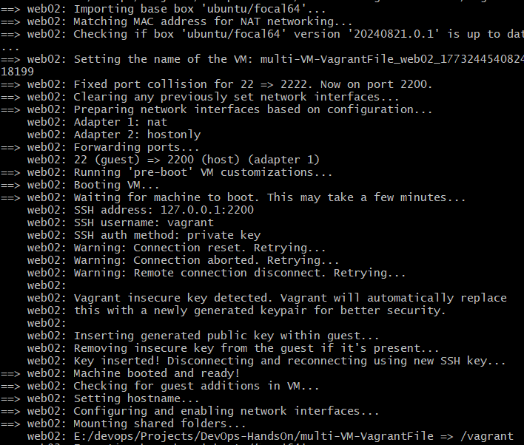
VM 3
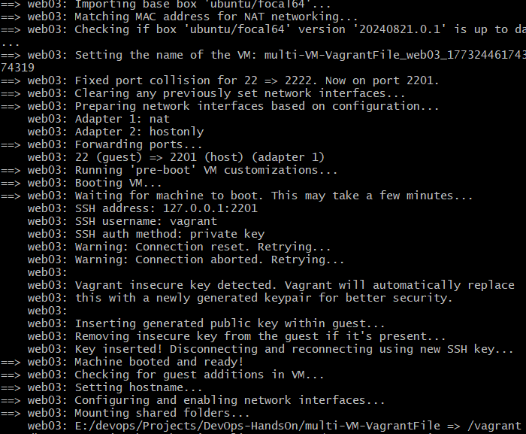

VM 4 – Database VM
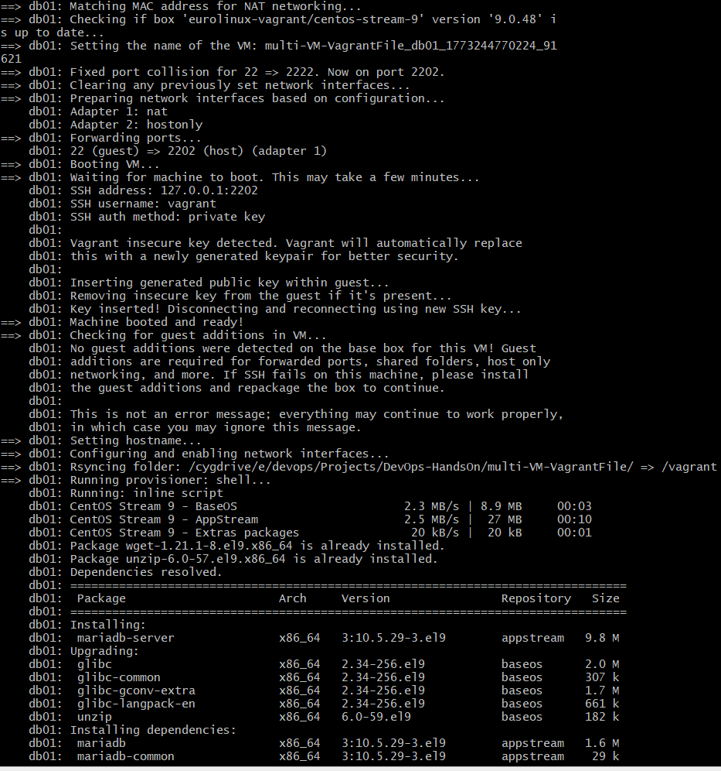

To login to any VM:
vagrant ssh <vm-name>

