New resource

1st VM:

Create load balancer

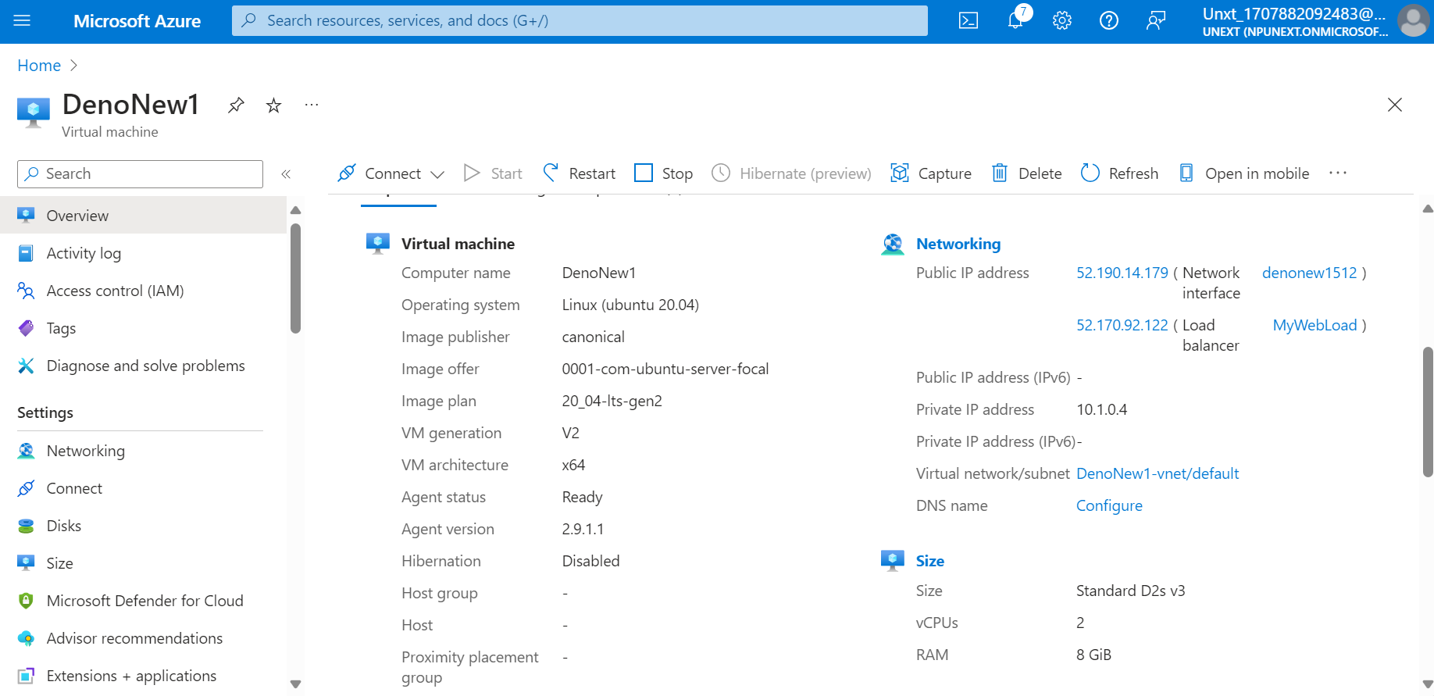

New Vm2:

Same load balancer

Again new VM in Same resource:

New Load balancer

Load balancer:

