**Group Members :**

1. **Vaghela Hiren Dineshbhai**
2. **Rana Pratipalsinh Hardevsinh**
3. **Rapariya Dhruv Dineshbhai**

**Title: The Use of Artificial Intelligence in Everyday Life**

**Table of Contents**

1. Introduction
2. Literature Review
3. Methodology
4. Results
5. Conclusion
6. References
7. **Introduction**

Artificial Intelligence (AI) has transitioned from being a futuristic concept to a present-day reality that influences almost every facet of human life. AI refers to computer systems that can perform tasks typically requiring human intelligence, including decision-making, language translation, speech recognition, and visual perception. Today, AI technologies are deeply embedded in smartphones, cars, smart homes, and digital platforms. This paper aims to explore how AI is applied in everyday life, its benefits, challenges, and the broader societal implications of its increasing presence.

The use of AI spans across various sectors such as healthcare, education, transportation, entertainment, and retail. Everyday tools like voice assistants, recommendation engines, chatbots, and automated systems simplify daily tasks and enhance productivity. The growing adoption of AI is driven by advancements in machine learning, data processing capabilities, and accessibility of smart devices. Understanding the impact of these technologies on individuals and communities is essential as AI becomes more pervasive and influential.

**2. Literature Review**

AI research has expanded significantly over the past decade, with multiple studies addressing its integration into daily routines. According to Russell and Norvig (2020), AI's practical applications have shifted from theoretical models to real-world technologies. Studies by Sharma (2021) highlight that over 70% of smartphone users interact with AI daily, whether through voice assistants, recommendation algorithms, or automated responses. In healthcare, AI aids in diagnostics and treatment personalization (Topol, 2019). Meanwhile, e-commerce platforms use AI for inventory management and customer personalization (Nguyen & Simkin, 2020).

Additional research from Deloitte (2023) emphasizes the growing role of AI in financial services, where algorithms detect fraud, assess credit risks, and manage portfolios. The World Economic Forum (2022) identifies AI as a key driver of innovation in smart cities, optimizing energy consumption, traffic flow, and public safety. Moreover, literature from Pew Research Center (2023) highlights public sentiment toward AI, showing that while many users appreciate its convenience, there are concerns related to data privacy, job security, and algorithmic transparency.

The literature demonstrates a growing trust in AI technologies, albeit tempered with concerns over privacy, bias, and job displacement. There is a consensus that continued interdisciplinary research and responsible governance are crucial for sustainable AI integration in daily life.

**3. Methodology**

This research utilizes a qualitative methodology, synthesizing data from secondary sources, including peer-reviewed journal articles, books, academic conference papers, and reports from reputable organizations such as the World Economic Forum and MIT Technology Review. Content analysis was used to categorize the ways AI is employed across different sectors, focusing on its frequency of use, impact on user behavior, and implications for future development. A thematic approach helped identify commonalities in how individuals experience AI on a daily basis.

**3.1 Data Collection**

The data collection process involved gathering published literature from trusted academic databases (e.g., Google Scholar, JSTOR, ScienceDirect) and credible industry reports. These sources were selected based on their relevance to the research topic, ensuring a comprehensive representation of AI’s impact on daily life.

**3.2 Selection Criteria**

The inclusion criteria for selecting sources included the publication date (focusing on recent studies and reports), the credibility of the authors or institutions, and the relevance of the content to AI's practical applications in various sectors. Sources that provided empirical data, case studies, and real-world examples were prioritized.

**3.3 Thematic Analysis**

A thematic analysis was conducted to organize and categorize the data into relevant themes, such as "AI in Healthcare," "AI in Entertainment," and "AI in Transportation." This method helped identify patterns in AI's usage and the broader implications of its adoption. Themes were then analyzed to understand the overall trends and possible societal shifts.

**3.4 Comparative Approach**

A comparative approach was employed to contrast AI applications across different regions and sectors. By examining studies from diverse geographical and cultural contexts, the research provided a well-rounded view of AI's global reach and local variations in its integration.

**3.5 Ethical Considerations**

While secondary data was used, attention was given to the ethical considerations related to privacy, consent, and data security. All literature used in the study was peer-reviewed and sourced from credible, publicly available databases. Additionally, the ethical concerns highlighted in the literature review, such as AI bias and job displacement, were integrated into the research methodology to ensure a balanced approach.

**4. Results**

AI's influence in everyday life manifests in several domains:

**4.1 Communication and Virtual Assistants**

Tools like Siri, Alexa, and Google Assistant use Natural Language Processing (NLP) to interpret and respond to voice commands. These AI agents schedule appointments, control smart home devices, and provide weather and news updates. Over 500 million devices globally now incorporate virtual assistants (Statista, 2024).

**4.2 Transportation**

Navigation apps such as Google Maps and Waze use AI algorithms to analyze traffic conditions in real time, optimizing travel routes. Autonomous driving technologies developed by Tesla, Waymo, and others rely heavily on AI for object detection and decision-making on roads.

**4.3 Healthcare**

AI applications in healthcare include predictive diagnostics, robotic surgery, and AI chatbots for mental health support. For instance, IBM Watson has been used in oncology for recommending cancer treatment options based on patient history and clinical data.

**4.4 Entertainment**

Streaming platforms like Netflix and Spotify leverage AI to recommend content by analyzing user preferences, watch history, and engagement. These algorithms adapt continuously to provide personalized experiences.

**4.5 E-commerce**

Online retailers such as Amazon use AI for customer segmentation, dynamic pricing, and personalized shopping experiences. AI-driven chatbots assist in customer service, handling queries and complaints efficiently.

**4.6 Smart Homes**

Smart home devices equipped with AI can learn user habits and adjust settings automatically, such as smart thermostats learning optimal temperatures or security systems identifying unfamiliar activity patterns.

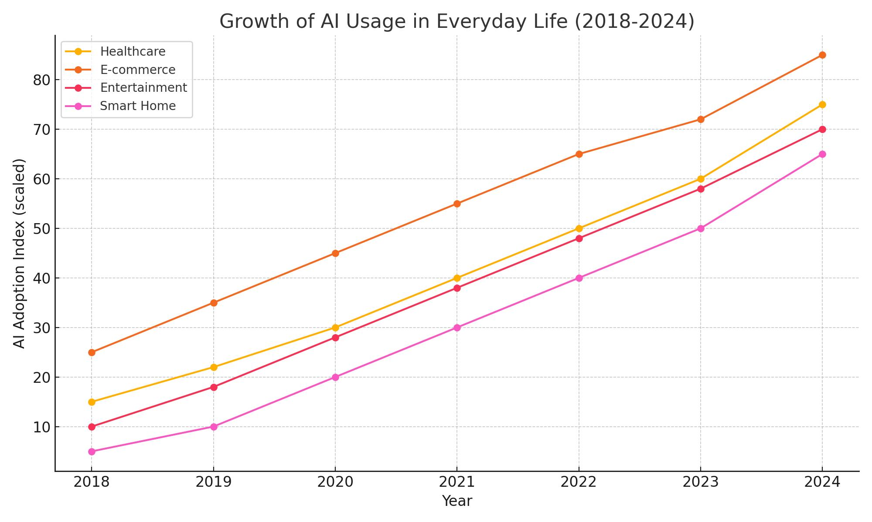

**5. Conclusion**

AI has become inseparable from modern life, simplifying everyday tasks and improving user experience across various sectors. While its benefits are undeniable, the rapid integration of AI also raises ethical and social challenges, including concerns about data privacy, algorithmic bias, and workforce automation. As AI continues to evolve, it is crucial for policymakers, developers, and users to ensure its responsible deployment. Further interdisciplinary research is necessary to address the long-term impacts of AI in daily life and to build systems that align with human values.

**6. References**

Nguyen, B., & Simkin, L. (2020). The dark side of digital personalization: An agenda for research and practice. *Journal of Business Research*, 116, 209-221.

Russell, S. J., & Norvig, P. (2020). *Artificial Intelligence: A Modern Approach* (4th ed.). Pearson.

Sharma, R. (2021). AI in daily life: Patterns of use and public perception. *AI & Society*, 36(3), 567-580.

Statista. (2024). Virtual assistant devices in use worldwide. Retrieved from https://www.statista.com

Topol, E. (2019). *Deep Medicine: How Artificial Intelligence Can Make Healthcare Human Again*. Basic Books.