Problem Solution Summary
Pratipalsinh Jadeja
NetSage AI — AI-Assisted Network Troubleshooting Assistant

Team
Team | NetSage — Group 1
This document | Pratipalsinh Jadeja
Teammates | Rushabh Tolia

Problem Statement
Network troubleshooting often requires connecting a visible symptom with configuration evidence spread across VLANs, routing, DHCP, DNS, ACL, NAT and wireless settings. NetSage AI is designed as an AI-assisted troubleshooting layer for Cisco-style Packet Tracer labs. It produces a structured diagnosis and next steps, but the final decision remains with a human reviewer.

Solution Overview
The project follows a four-part pipeline: a case dataset supplies realistic network evidence; a structured AI prompt converts that evidence into a consistent diagnosis; a Python rule checker independently catches common configuration mistakes; and a human-review stage approves, edits or rejects the AI result.

Case Coverage
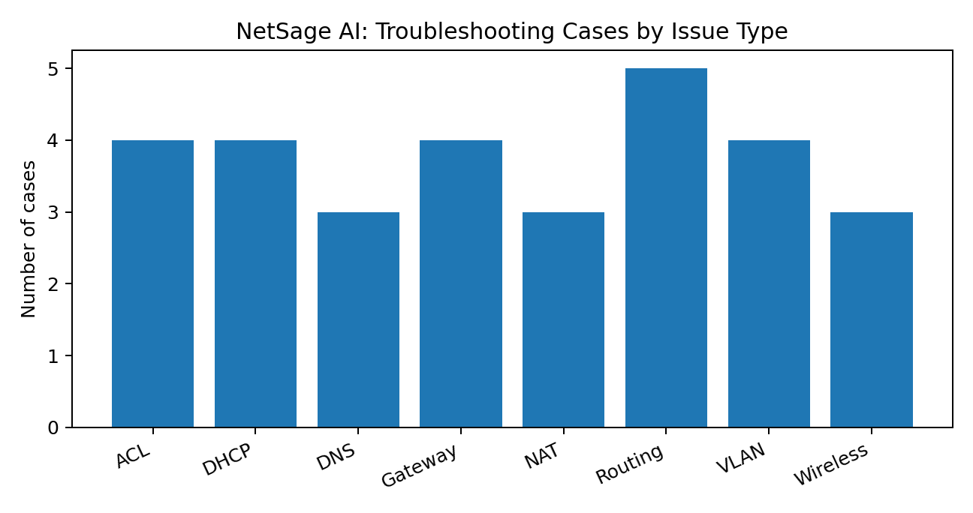
The solution covers 30 troubleshooting cases distributed across eight network fault categories, giving the assistant a broad set of Packet Tracer scenarios to diagnose.
Issue Type | Cases | Representative Faults
ACL | 4 | ACL ordering, missing permits, VTY access-class gaps
DHCP | 4 | Missing relay, incorrect pool subnet, scope exhaustion, static/DHCP conflicts
DNS | 3 | Unreachable resolver, ACL blocking, stale cache
Gateway | 4 | Wrong gateway, down subinterface, subnet/host mismatch
NAT | 3 | Missing overload, incomplete NAT ACL, missing port forwarding
Routing | 5 | Missing return route, OSPF mismatch, bad next-hop, link failure, unadvertised subnet
VLAN | 4 | Missing VLAN, trunk pruning, missing voice VLAN, VTP revision overwrite
Wireless | 3 | Guest VLAN relay issue, AP trunk pruning, err-disabled AP port

Severity and Human Review
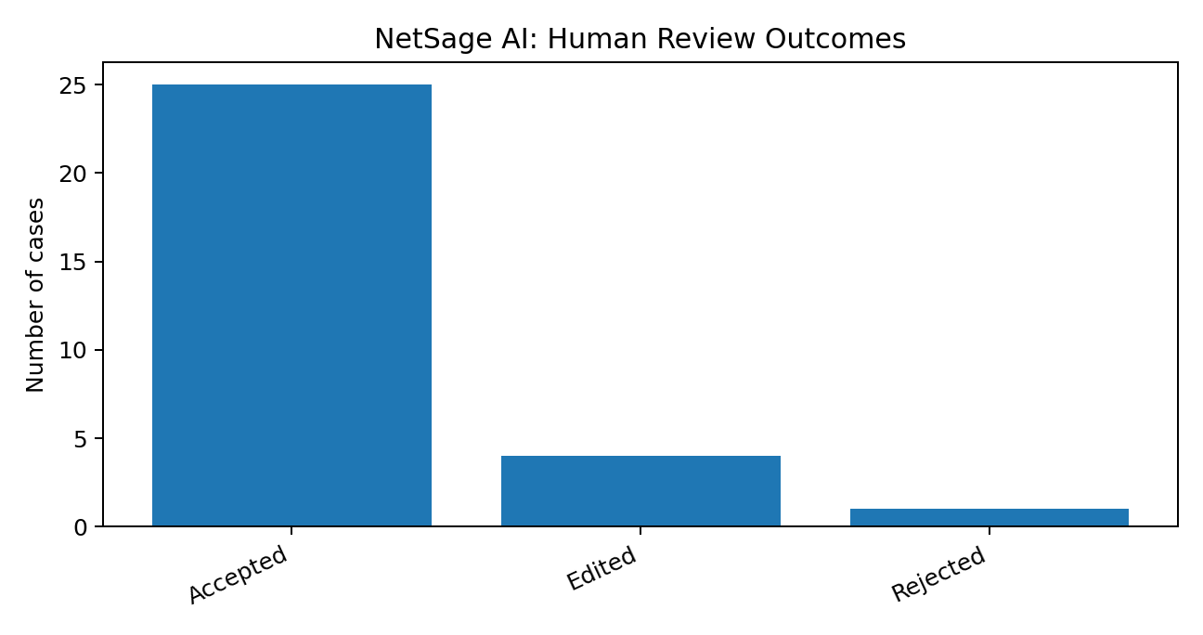
Every diagnosis is reviewed by a human before a fix is accepted. The recorded outcomes are 25 Accepted, 4 Edited, and 1 Rejected, giving an 83.3% as-is AI agreement rate. Five cases required correction, satisfying the responsible-AI requirement. Five cases were marked security-related.

Verdict | Count | Percentage
Accepted | 25 | 83.3%
Edited | 4 | 13.3%
Rejected | 1 | 3.3%

Responsible AI Corrections — Tabular Record
Case | Human Verdict | Correction Made
C005 | Edited | Voice-VLAN confidence raised from medium to high because the available evidence was conclusive.
C009 | Rejected | The AI confused an incorrect host address with an incorrect subnet; the root cause and fix were rewritten.
C013 | Edited | The fix order was changed to check stale DHCP leases before resizing the address pool.
C016 | Edited | Confidence was gated on the ACL text actually being supplied before relying on that evidence.
C022 | Edited | The fix sequence was changed to check for an existing dynamic routing protocol before adding a static route.

Solution Architecture and Deliverables
Component | What it Provides
Case dataset (cases.csv) | 30 realistic lab cases containing symptoms, topology details, CLI/show-command evidence, expected faults, OSI layer, concept and severity.
AI diagnosis engine (diagnose_prompt.md) | A structured prompt approach that returns root cause, OSI layer, security flag, confidence, evidence, next commands and fix steps as JSON; fixes are not applied automatically.
Deterministic rule checker (rule_checker.py) | Independent Python checks for duplicate IPs, mask mismatches, gateway mismatches, interfaces down, missing VLANs and missing routes.
Human review layer | Each AI result is classified as Accepted, Edited or Rejected, with corrections documented in the responsible-AI log.
Dashboard | A spreadsheet/chart view summarizing issue types, severity, review outcomes, AI agreement and security-related cases.
Demo and documentation | Materials demonstrate a broken lab being diagnosed, reviewed, fixed and verified.

All Members' Contributions
Team Member | Primary Area | Contribution Summary
Rushabh Tolia | Case development and lab evidence | 30-case dataset, Packet Tracer scenarios/topologies, realistic show-command evidence, OSI/concept/severity tagging.
Pratipalsinh Jadeja | Workflow validation and review support | Scenario organization, diagnosis-result validation, human-review checks, responsible-AI review support, dashboard/demo presentation support.

Individual Contribution — Pratipalsinh Jadeja
My contribution centered on organizing the solution workflow, validating diagnosis results and supporting the human-review and presentation aspects of the project.
- Supported the construction and organization of the NetSage AI troubleshooting workflow and its case-based evaluation.
- Worked on arranging scenario information so symptoms, topology details, expected faults and troubleshooting evidence could be consumed consistently.
- Contributed to reviewing AI diagnosis outputs against the known troubleshooting outcomes and identifying where human judgment was required.
- Assisted with the responsible-AI review process by checking confidence, evidence quality and the order of recommended troubleshooting actions.
- Contributed to presenting the overall workflow through the dashboard/demo material and ensuring the project deliverables matched the problem statement.

Conclusion
The project shows how AI can assist junior engineers without removing human responsibility from network troubleshooting. By combining case evidence, structured AI responses, rule-based validation and a documented review process, NetSage AI creates an auditable troubleshooting workflow. The recorded review outcomes also demonstrate why confidence, evidence and fix sequencing should be checked before a network change is authorized.

